
CCDA Database Project Overview:
CCDA developed the Electronic Data Collection Project to make its review of pre-litigation letters and complaints for construction-related accessibility claims more efficient and environmentally-friendly, and to promote better data analysis. In 2019, CCDA entered the second phase of this effort through the creation of a secure database and a web-based form that will allow the legal community to submit claims electronically online to CCDA. The online submission portal was officially launched on December 2019 and is currently live on the Commission’s website.
Since the launch of the online submission portal, CCDA has 23 law firms and 34 different users currently registered. In the month of December 2019 alone, CCDA has received 164 Pre-litigation Letter and Complaint submissions. Staff anticipate the number of submission to increase as the system becomes more optimized and user friendly.
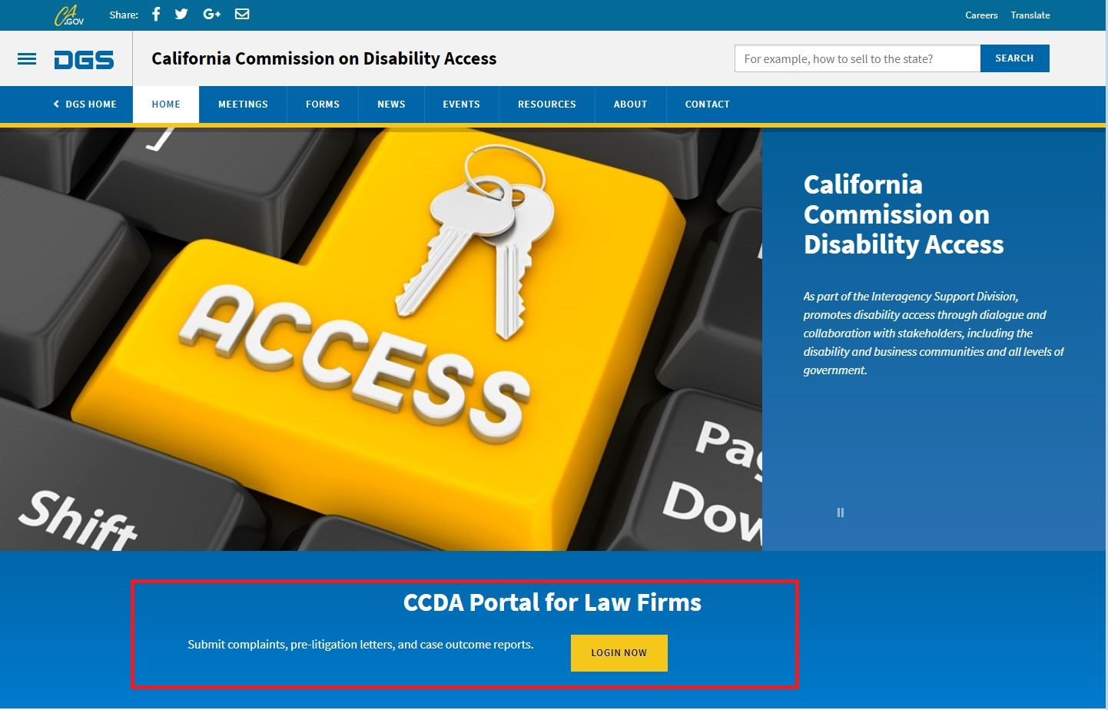
Picture 1. The location of the online submission portal on CCDA’s website.

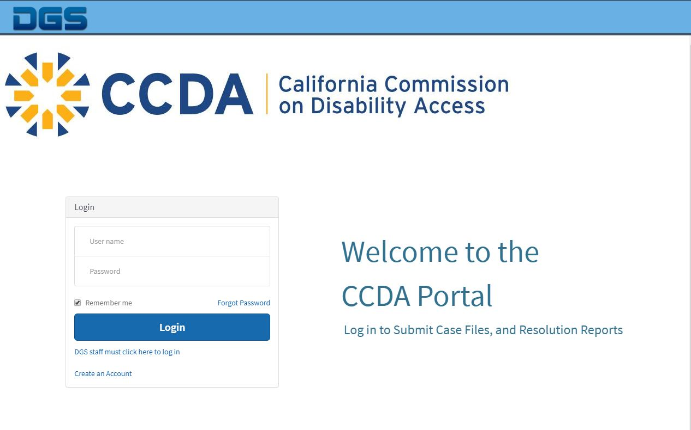
Picture 2. A screenshot of the portal login.

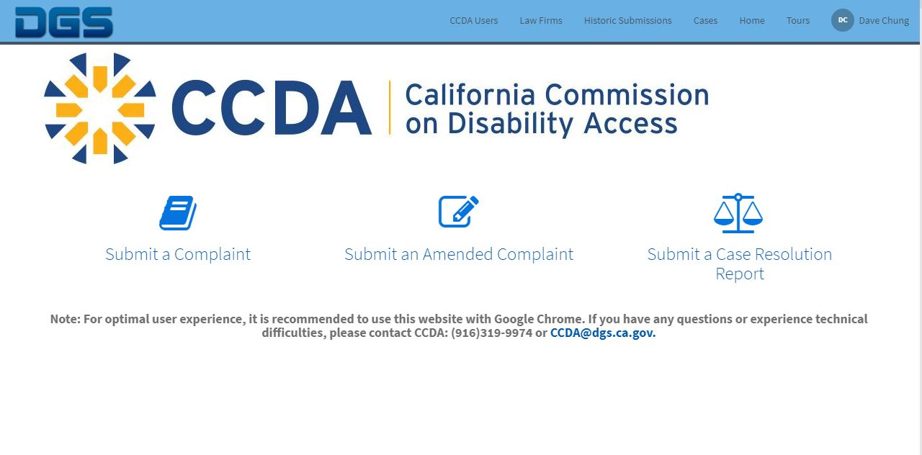
Picture 3. A screenshot of the submission options.

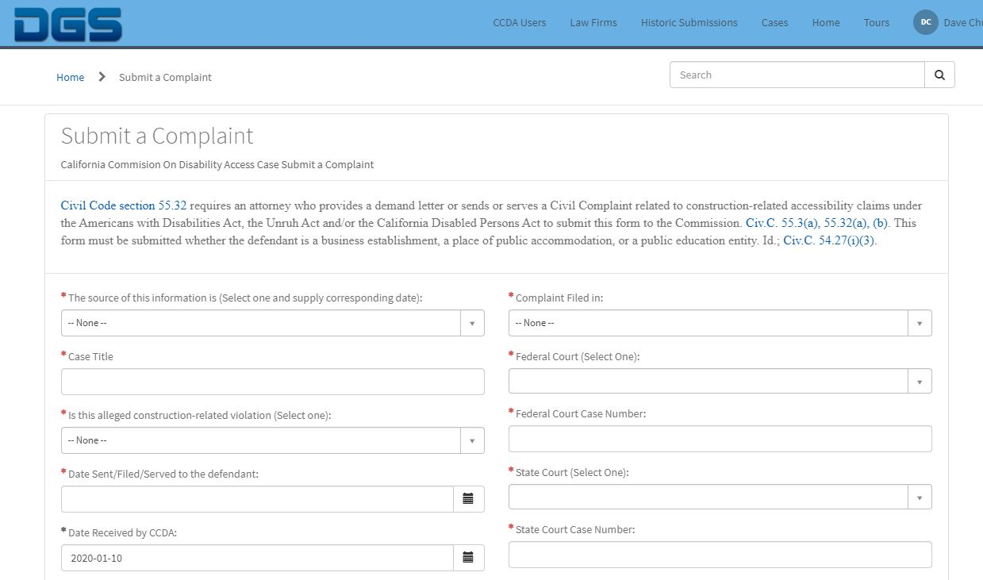
Picture 4. Screenshot of the “Submit a Complaint” form.

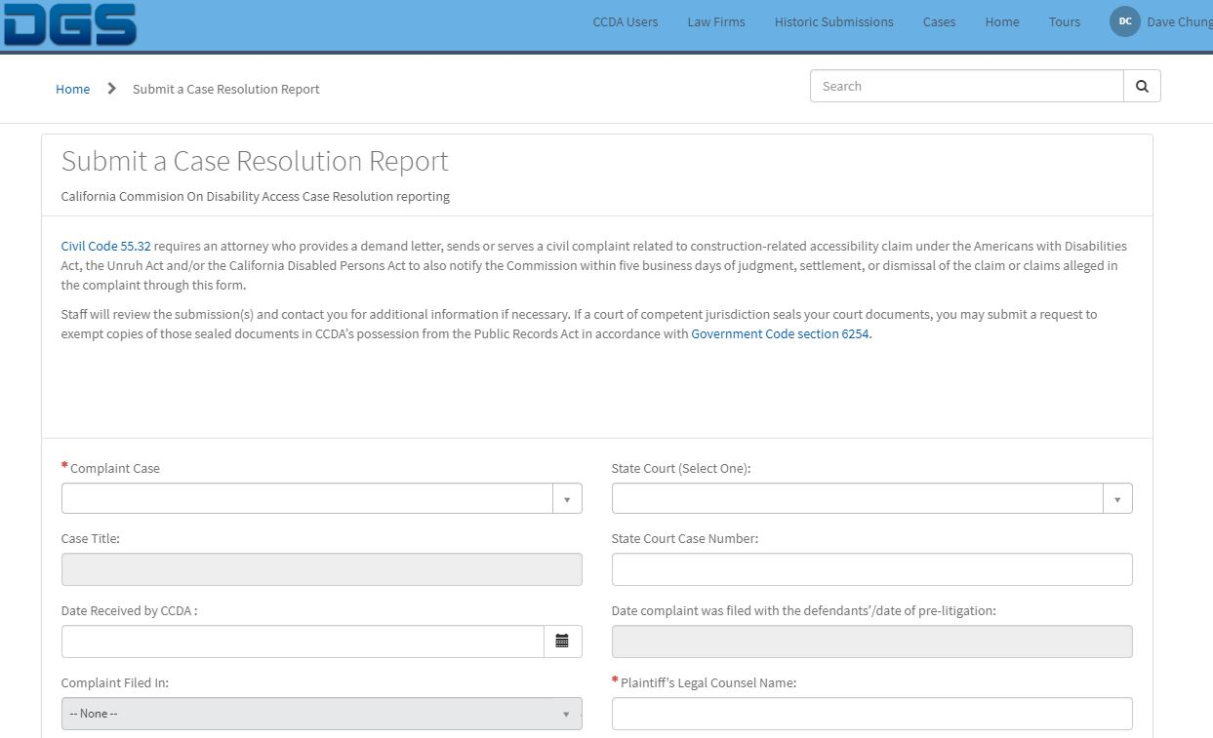
Picture 5. Screenshot of the “Submit a Case Resolution Report” form.

The screenshot is for preview purposes only.
“Submit an Amended Complaint” form uses the same question as “Submit a Complaint” form.

