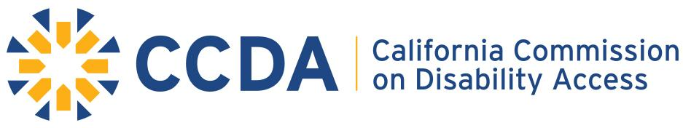
FY 19 - 20 Budget Highlights
(July – September 2019)
Expenditure Authority
Authorized Positions (PYs): 5.0
Personnel Services (Wages & Staff Benefits): $538,000
Operating Expenses & Equipment: $435,000
Total Authorized Budget: $973,000

Personnel Services
Expenditures and Encumbrances: $128,785
Remaining Balance: $409,215
- Current budget supports Executive Director, one Staff Services Manager (SSM I), and two Staff Services Analysts (SSAs).
- One SSA supported by Interagency Support Division (ISD) through blanket position until CCDA is fully funded for all 5.0 positions.

Operating Expenses and Equipment
Expenditures and Encumbrances: $448,329
Remaining Balance (Shortfall): ($14,329)
- Current budget does not allot for facility operations or program costs (i.e. educational outreach events).

Total Expenditures for Q1 (July – September 2019)
Expenditures and Encumbrances: $577,114
Remaining Authorized Budget: $395,886
Notes
- DGS ISD committed to supporting CCDA’s program costs in FY 19 – 20.
- CCDA established Special Fund account to receive gifts, donations, and grants to support the Commission’s mandated education and outreach efforts.
- CCDA received technical adjustments to account for employee compensation & benefits increases, as well as Distributed Admin to pay fair share of overhead costs.

