Parking Code Regulations

  - California Building Code (CBC)
  - Title 24 Part 2

CHAPTER 2:

SECTION 202 DEFINITIONS

ACCESS AISLE. [DSA-AC] An accessible pedestrian space adjacent to or between parking spaces that provides clearances in compliance with this code.

ACCESSIBLE ROUTE. [DSA-AC] A continuous unobstructed path connecting accessible elements and spaces of an accessible site, building or facility that can be negotiated by a person with a disability using a wheelchair, and that is also safe for and usable by persons with other disabilities. Interior accessible routes may include corridors, hallways, floors, ramps, elevators and lifts. Exterior accessible routes may include parking access aisles, curb ramps, crosswalks at vehicular ways, walks, ramps and lifts.

VEHICULAR WAY. [DSA-AC] A route provided for vehicular traffic, such as in a street, driveway, or parking facility.

CHAPTER 4: SPECIAL DETAILED REQUIREMENTS BASED ON USE AND OCCUPANCY

SECTION 406

MOTOR-VEHICLE-RELATED OCCUPANCIES

406.4 Public parking garages.

406.4.1 Clear height. The clear height of each floor level in vehicle and pedestrian traffic areas shall be not less than 7 feet (2134 mm). [DSA-AC] The clear height of vehicle and pedestrian areas required to be accessible shall comply with Chapter 11A or 11B, as applicable

DSA

Advisory 406.4.1 Clear height. While the minimum height is required to be 7’-0’’ by this section, greater vertical clearance is required at van-accessible parking spaces, standard accessible parking spaces, the vehicular routes to these spaces, and passenger drop-off and loading zones. Refer to Chapters 11A and 11B for requirements in these areas.

CHAPTER 11B:

Division 1 Administration
11B-108 Maintenance of accessible features
A public accommodation shall maintain in operable working condition those features of facilities and equipment that are required to be accessible to and useable by persons with disabilities. Isolated or temporary interruptions in service or accessibility due to maintenance or repairs shall be permitted.

DSA

11B-10B Maintenance of accessible features. Features for accessibility must be permanently functional, unobstructed and may not be removed. It is not sufficient to provide features such as accessible features such as accessible routes, parking, elevators, ramps or signage if those features are not maintained in a manner that enables individuals with disabilities to use them. Inoperable elevators, locked accessible doors, or “accessible” routes that are not obstructed by furniture, filing cabinets or potted plants are not accessible to nor usable by persons with disabilities.

Division 2 Scoping

11B-206 Accessible routes

11B-206.2.1 Site arrival points. At least one accessible route shall be provided within the site from accessible parking spaces and accessible passenger drop-off and loading zones; public streets and sidewalks; and public transportation stops to the accessible building or facility entrance they serve. Where more than one route is provided, all routes must be accessible

11B-206.4.2 Parking structure entrances. Where direct access is provided for pedestrians from a parking structure to a building or facility entrance, each direct access to the building or facility entrance shall comply with Section 11B-404.

11B-208 Parking spaces

11B-208.1 General. Where parking spaces are provided, parking spaces shall be provided in accordance with Section 11B-208. For the purposes of this section, electric vehicle charging stations are not parking spaces; see Section 11B-228.
Exception: Parking spaces used exclusively for buses, trucks, other delivery vehicles, or vehicular impound shall not be required to comply with Section 11B-208 provided that lots accessed by the public are provided with a passenger drop-off and loading zone complying with Section 11B-503.

11B-208.2 Minimum number. Parking spaces complying with Section 11B-502 shall be provided in accordance with Table 11B-208.2 except as required by Sections 11B-208.2.1, 11B-208.2.2, and 11B-208.2.3. Where more than one parking facility is provided on a site, the number of accessible spaces provided on the site shall be calculated according to the number of spaces required for each parking facility.

Table 11B-208.2 Parking Spaces

Total Number of Parking Spaces Provided in Parking Facility | Minimum Number of Required Accessible Parking Spaces
1 to 25 | 1
26 to 50 | 2
51 to 75 | 3
76 to 100 | 4
101 to 150 | 5
151 to 200 | 6
201 to 300 | 7
301 to 400 | 8
401 to 500 | 9
501 to 1000 | 2 percent of total
1001 and over | 20, plus 1 for each 100, or fraction thereof, over 1000

USDOJ

Advisory 11B-208.2 Minimum number. The term “parking facility” is used in Section 11B-208.2 instead of the term “parking lot” so that it is clear that both parking lots and parking structures are required to comply with this section. The number of parking spaces required to be accessible is to be calculated separately for each parking facility; the required number is not to be based on the total number of parking spaces provided in all of the parking facilities provided on the site.

11B-208.2.1 Hospital outpatient facilities. Ten percent of patient and visitor parking spaces provided to serve hospital outpatient facilities, and free-standing buildings providing outpatient clinical services of a hospital, shall comply with Section 11B-502.

USDOJ

Advisory 11B-208.2.1 Hospital outpatient facilities. The term “outpatient facility” is not defined in this code but is intended to cover facilities or units that are located in hospitals and that provide regular and continuing medical treatment without an overnight stay. Doctors’ offices, independent clinics, or other facilities not located in hospitals are not considered hospital outpatient facilities for purposes of this chapter.

DSA

Advisory 11B-208.2.1 Hospital outpatient facilities. The higher percentages required for hospital outpatient facilities or rehabilitation facilities specializing in treating conditions that affect mobility and outpatient physical therapy facilities (indicated in section 11B-208.2.2 below) are intended primarily for visitor and patient parking. If there are separate lots for visitors or patients and employees, the 10% or 20% requirement shall be applied to the visitor/patient lot while accessible parking could be provided in the employee lot according to the general scoping requirement in Table 11B-208.2. if a lot serves both visitors or patients and employees, 10% or 20% of the spaces intended for use by visitors or patients must be accessible.

At hospitals of other facilities where parking does not specifically serve am outpatient unit, only a portion of the lot would need to comply with the 10% scoping requirement. A local zoning code that requires a minimum number of parking spaces according to occupancy type and square footage may be an appropriate guide in assessing the number of spaces in the lot that “belong” to the outpatient unit. These spaces would be held to the 10% requirement while the rest of the lot would be subject to the general scoping requirement in the table. Those accessible spaces required for the outpatient unit should be located at the accessible entrance serving the unit. This method may also be used in applying the 20% requirement to hospitals or other facilities where only a portion or unit provides specialized rehabilitation or physical therapy treatment or services for persons with mobility impairments.

11B-208.2.2 Rehabilitation facilities and outpatient physical therapy facilities. Twenty percent of patient and visitor parking spaces provided to serve rehabilitation facilities specializing in treating conditions that affect mobility and outpatient physical therapy facilities shall comply with Section 11B-502.

USDOJ

Advisory 11B-208.2.2 Rehabilitation facilities and outpatient physical therapy facilities. Conditions that affect mobility include conditions requiring the use or assistance of a brace, cane, crutch, prosthetic device, wheelchair, or powered mobility aid; arthritic, neurological, or orthopedic conditions that severely limit one’s ability to walk; respiratory diseases and other conditions which may require the use of portable oxygen; and cardiac conditions that impose significant functional limitation.

11B-208.2.3 Residential facilities. Parking spaces provided to serve residential facilities shall comply with Section 11B-208.2.3.

11B-208.2.3.1 Parking for residents. Where at least one parking space is provided for each residential dwelling unit, at least one parking space complying with Section 11B-502 shall be provided for each residential dwelling unit required to provide mobility features complying with Sections 11B-809.2 through 11B-809.4. Where fewer than one parking space is provided for each residential dwelling unit, parking spaces complying with Section 11B-502 shall be provided in accordance with Table 11B-208.2.

11B-208.2.3.2 Additional parking spaces for residents. Where the total number of parking spaces provided for each residential dwelling unit exceeds one parking space per residential dwelling unit, 2 percent, but no fewer than one space, of all the parking spaces not covered by Section 11B-208.2.3.1 shall comply with Section 11B-502.

11B-208.2.3.3 Parking for guests, employees, and other non-residents. Where parking spaces are provided for persons other than residents, parking shall be provided in accordance with Table 11B-208.2.
NOTE: When assigned parking is provided, Chapter 11A indicates designated accessible parking for the adaptable residential dwelling units shall be provided on requests of residents with disabilities on the same terms and with the full range of choices (e.g., off-street parking, carport or garage) that are available to other residents.

11B-208.2.4 Van parking spaces. For every six or fraction of six parking spaces required by Section 11B-208.2 to comply with Section 11B-502, at least one shall be a van parking space complying with Section 11B-502.

11B-208.3 Location. Parking facilities shall comply with Section 11B-208.3.

11B-208.3.1 General. Parking spaces complying with Section 11B-502 that serve a particular
building or facility shall be located on the shortest accessible route from parking to an entrance complying with Section 11B-206.4. Where parking serves more than one accessible entrance, parking spaces complying with Section 11B-502 shall be dispersed and located on the shortest accessible route to the accessible entrances. In parking facilities that do not serve a particular building or facility, parking spaces complying with Section 11B-502 shall be located on the shortest accessible route to an accessible pedestrian entrance of the parking facility.
Exceptions:
1. All van parking spaces shall be permitted to be grouped on one level within a multi-story parking facility.
2. Parking spaces shall be permitted to be located in different parking facilities if substantially equivalent or greater accessibility is provided in terms of distance from an accessible entrance or entrances, parking fee, and u ser convenience.

USDOJ

Advisory 11B-208.2.2 Rehabilitation facilities and outpatient physical therapy facilities. Conditions that affect mobility include conditions requiring the use or assistance of a brace, cane, crutch, prosthetic device, wheelchair, or powered mobility aid; arthritic, neurological, or orthopedic conditions that severely limit one’s ability to walk; respiratory diseases and other conditions which may require the use of portable oxygen; and cardiac conditions that impose significant functional limitation.

DSA

Advisory 11B-208.3.1 Location. Accessible spaces can be provided in other facilities or locations, or, in the case of parking structures, on one level only when equal or greater access is provided in terms of proximity to an accessible entrance, cost, and convenience. For example, accessible spaces required for outlying parking facilities may be located in a parking facility closer to an accessible entrance. The minimum number of spaces must still be determined separately for each facility even if the spaces are to be provided on other facilities or locations. Accessible spaces may be grouped on one level of a parking structure in order to achieve greater access. However, where parking levels serve different building entrances, accessible spaces should be dispersed so that access is provided to each entrance.

11B-208.3.2 Residential facilities. In residential facilities containing residential dwelling units required to provide mobility features complying with Sections 11B-809.2 through 11B-809.4, and adaptable features complying with Chapter 11A, Division IV parking spaces provided in accordance with Section 11B-208.2.3.1 shall be located on the shortest accessible route to the residential dwelling unit entrance they serve. Spaces provided in accordance with Section 11B-208.2.3.2 shall be dispersed throughout all types of parking provided for the residential dwelling units.
Exception: Parking spaces provided in accordance with Section 11B-208.2.3.2 shall not be required to be dispersed throughout all types of parking if substantially equivalent or greater accessibility is provided in terms of distance from an accessible entrance, parking fee, and user convenience.

USDOJ

Advisory 11B-208.3.2 Residential facilities Exception. Factors that could affect “user convenience” include, but are not limited to, protection from the weather, security, lighting, and comparative maintenance of the alternative parking site.

11B-208.3.3 Private garages accessory to residential dwelling units. Private garages accessory to residential dwelling units shall comply with Section 11B-208.3. Private garages include individual garages and multiple individual garages grouped together.

11B-208.3.3.1 Detached private garages accessory to residential dwelling units, shall be accessible as required by Section 11B-208.3.

11B-208.3.3.2 Attached private garages directly serving a single residential dwelling unit shall provide at least one of the following options:
1. A door leading directly from the residential dwelling unit which immediately enters the garage.
2. An accessible route from the residential dwelling unit to an exterior door entering the garage.
3. An accessible route from the residential dwelling unit's primary entry door to the vehicular entrance at the garage.

11B-209 Passenger drop-off and loading zones and bus stops

11B-209.1
Excerpted from: Title 24, Part 2 Effective date: January 1, 2020 110 of 349
Exception: Parking spaces provided in accordance with Section 11B-208.2.3.2 shall not be required to be dispersed throughout all types of parking if substantially equivalent or greater accessibility is provided in terms of distance from an accessible entrance, parking fee, and user convenience.

Advisory 11B-208.3.2 Residential facilities Exception. Factors that could affect "user convenience" include, but are not limited to, protection from the weather, security, lighting, and comparative maintenance of the alternative parking site.

11B-208.3.3 Private garages accessory to residential dwelling units. Private garages accessory to residential dwelling units shall comply with Section 11B-208.3. Private garages include individual garages and multiple individual garages grouped together.

11B-208.3.3.1 Detached private garages accessory to residential dwelling units, shall be accessible as required by Section 11B-208.3.

11B-208.3.3.2 Attached private garages directly serving a single residential dwelling unit shall provide at least one of the following options:
1. A door leading directly from the residential dwelling unit which immediately enters the garage.
2. An accessible route from the residential dwelling unit to an exterior door entering the garage.
3. An accessible route from the residential dwelling unit's primary entry door to the vehicular entrance at the garage.

11B-209 Passenger drop-off and loading zones and bus stops

11B-209.1 General. Passenger drop-off and loading zones shall be provided in accordance with Section 11B-209.

11B-209.2 Type. Where provided, passenger drop-off and loading zones shall comply with Section 11B-209.2.

11B-209.2.1 Passenger drop-off and loading zones. Passenger drop-off and loading zones, except those required to comply with Sections 11B-209.2.2 and 11B-209.2.3, shall provide at least one passenger drop-off and loading zone complying with Section 11B-503 in every continuous 100 linear feet (30480 mm) of drop-off and loading zone space, or fraction thereof.

11B-209.2.2 Bus loading zones. In bus loading zones restricted to use by designated or specified public transportation vehicles, each bus bay, bus stop, or other area designated for lift or ramp deployment shall comply with Section 11B-810.2.

USDOJ

Advisory 11B-209.2.2 Bus loading zones. The terms “designated public transportation” are defined by the Department of Transportation at 49 CFR 37.3 regulations implementing the Americans with Disabilities Act. These terms refer to public transportation services provided by public or private entities, respectively. For example, designated public transportation vehicles include buses and vans operated by public transit agencies, while specified public transportation vehicles include tour and charter buses, taxis and limousines, and hotel shuttles operated by private entities.

11B-209.2.3 On-street bus stops. On-street bus stops shall comply with Section 11B-810.2 to the maximum extent practicable.

11B-209.3 Medical care and long-term care facilities. At least one passenger drop-off and loading zone complying with Section 11B-503 shall be provided at an accessible entrance to licensed medical care and licensed long-term care facilities where the period of stay may exceed twenty-four hours.

11B-209.4 Valet parking. Parking facilities that provide valet parking services shall provide at least one passenger drop-off and loading zone complying with Section 11B-503. The parking requirements of Section 11B-208.1 apply to facilities with valet parking.

DSA

Advisory 11B-209.4 Valet parking. Valet parking does not eliminate the requirement to provide accessible parking spaces. Some vehicles may be adapted with hand controls or lack a driver’s seat, and may not be operable by a valet parking attendant. The parking space requirements of Sections 11B-208 and 11B-502 apply to facilities with valet parking, including the requirement for an accessible route of travel to the entrance of the facility. In addition, when valet parking is provided, a passenger drop-off and loading zone complying with Section 11B-503 shall be located on an accessible route of travel to the entrance of the facility.

11B-209.5 Mechanical access parking garages. Mechanical access parking garages shall provide at least one passenger drop-off and loading zone complying with Section 11B-503 at vehicle drop-off and vehicle pick-up areas.

Signs
11B-216.5 Parking. Signs identifying parking spaces and signs within parking facilities shall comply with Section 11B-216.5.

11B-216.5.1 Parking spaces. Parking spaces complying with Section 11B-502 shall be identified by signs complying with Sections 11B-502.6 and 11B-502.8.
Exceptions:
1. Reserved.
2. In residential facilities, where parking spaces are assigned to specific residential dwelling units, identification of accessible parking spaces shall not be required.

11B-216.5.2 Parking facilities. Signs within parking facilities shall comply with Section 11B-216.5.2.

11B-216.5.2.1 Signs intended for use by pedestrians. Signs intended for use by pedestrians within parking facilities, including directional or informational signs indicating parking sections or levels, shall comply with the requirements of Section 11B-216.

11B-216.5.2.2 Additional signs. Signs within parking facilities containing parking spaces complying with Section 11B-502 shall comply with Section 11B-502.8.

Curb Ramps
11B-406.5.1 Location. Curb ramps and the flared sides of curb ramps shall be located so that they do not project into vehicular traffic lanes, parking spaces, or parking access aisles. Curb ramps at marked crossings shall be wholly contained within the markings, excluding any flared sides.

Technical Specifications

11B-502 Parking spaces

11B-502.1 General. Car and van parking spaces shall comply with Section 11B-502. Where parking spaces are marked with lines, width measurements of parking spaces and access aisles shall be made from the centerline of the markings.
Exception: Where parking spaces or access aisles are not adjacent to another
parking space or access aisle, measurements shall be permitted to include the full width
of the line defining the parking space or access aisle.

11B-502.2 Vehicle spaces. Car and van parking spaces shall be 216 inches (5486 mm) long minimum. Car parking spaces shall be 108 inches (2743 mm) wide minimum and van parking spaces shall be 144 inches (3658 mm) wide minimum, shall be marked to define the width, and shall have an adjacent access aisle complying with Section 11B-502.3.
Exception: Van parking spaces shall be permitted to be 108 inches (2743 mm) wide minimum where the access aisle is 96 inches (2438 mm) wide minimum.

Figure 11B-502.2
Vehicle Parking Spaces

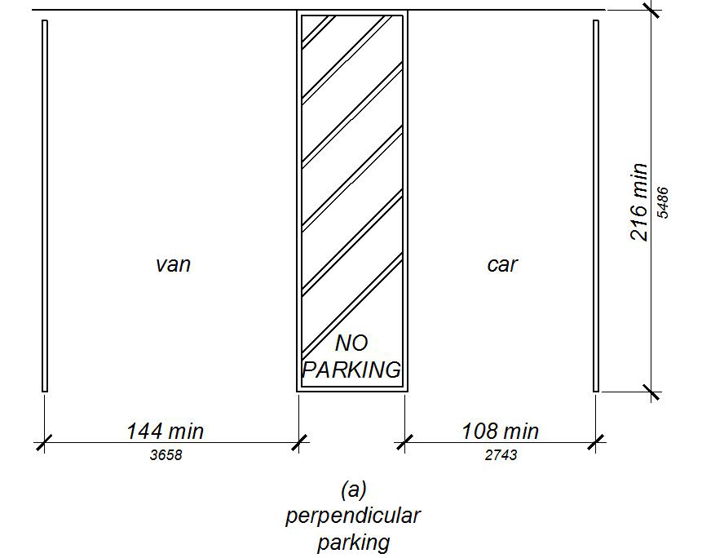
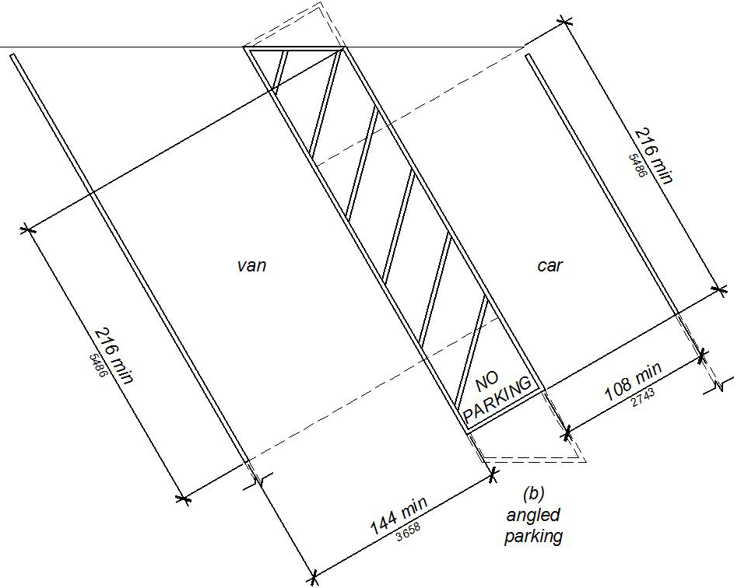
11B-502.3 Access aisle. Access aisles serving parking spaces shall comply with Section 11B-502.3. Access aisles shall adjoin an accessible route. Two parking spaces shall be permitted to share a common access aisle.

USDOJ

Advisory 11B-502.3 Access aisle. Accessible routes must connect parking spaces to accessible entrances. In parking facilities where the accessible route must cross vehicular traffic lanes, marked crossings enhance pedestrian safety, particularly for people using wheelchairs and other mobility aids. Where possible, it is preferable that the accessible route not pass behind parked vehicles.

Figure 11B-502.3
Parking Space Access Aisle

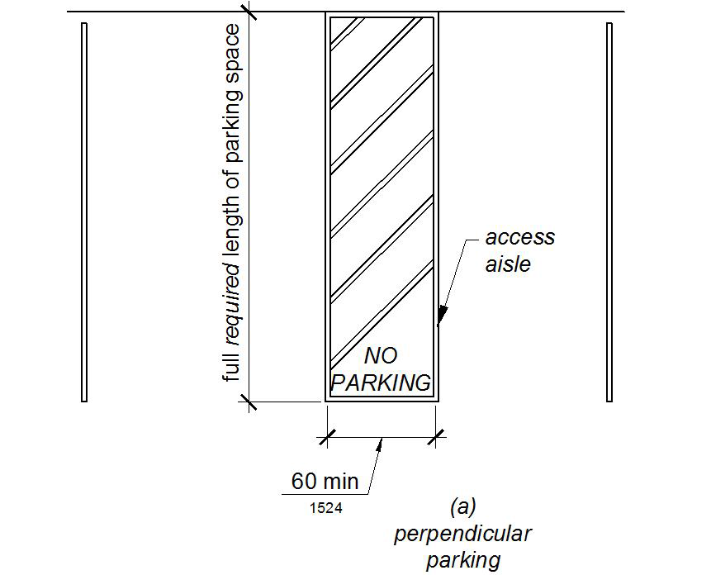

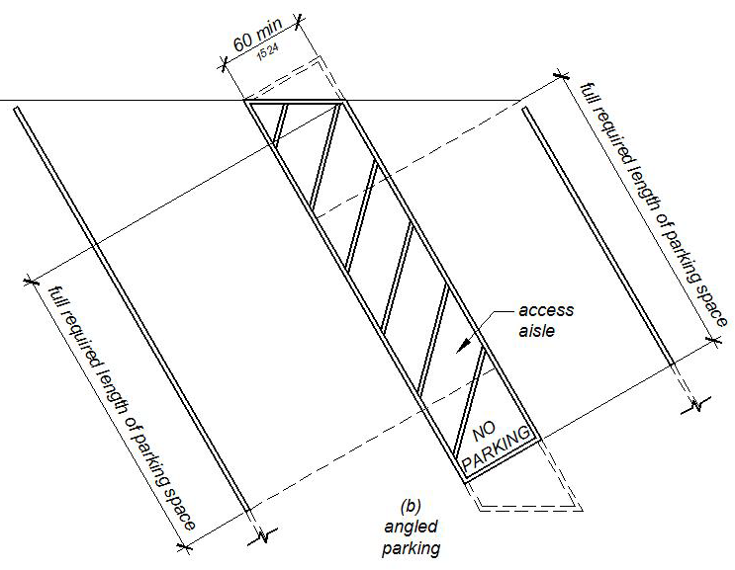

11B-502.3.1 Width. Access aisles serving car and van parking spaces shall be 60 inches (1524 mm) wide minimum.

11B-502.3.2 Length. Access aisles shall extend the full required length of the parking spaces they serve.

11B-502.3.3 Marking. Access aisles shall be marked with a blue painted borderline around their perimeter. The area within the blue borderlines shall be marked with hatched lines a maximum of 36 inches (914 mm) on center in a color contrasting with that of the aisle surface, preferably blue or white. The words "NO PARKING" shall be painted on the surface within each access aisle in white letters a minimum of 12 inches (305 mm) in height and located to be visible from the adjacent vehicular way. Access aisle markings may extend beyond the minimum required length.

DSA

Advisory 11B-502.3.3 Marking. The requirement that the hatching at the loading and unloading access aisle be a suitable contrasting color to the parking space is intended to ensure that the hatching is visually distinct from the background to which it is applied, and thus can be more easily seen. As hatching is generally recognized as a no-parking area, this difference in contrast assists drivers by providing a conspicuous visual deterrent to parking in the loading and unloading access aisle.

Asphalt is often the parking surface material used at accessible parking spaces. Asphalt is generally considered to be fairly dark in appearance. In order to provide a suitable contrasting color at the hatched area of the loading and unloading access aisle, a light color hatching should be used at locations where asphalt is the parking surface material. Although white paint is preferred (and traditionally the color most often used), its use is not mandatory under the California Building Code (CBC).

In order to provide a suitable contrast at the hatched area of the loading and unloading access aisle in locations where light concrete is used as the parking surface material (such as at concrete parking garages), a dark color hatching should be used. Although blue paint is preferred, its use is not mandatory under the California Building Code (CBC).

Figure 11B-502.3.3
Angled and Perpendicular Parking Identification

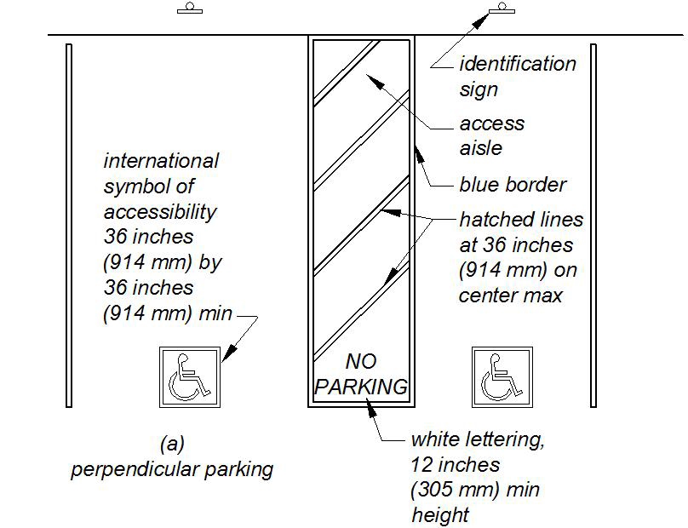

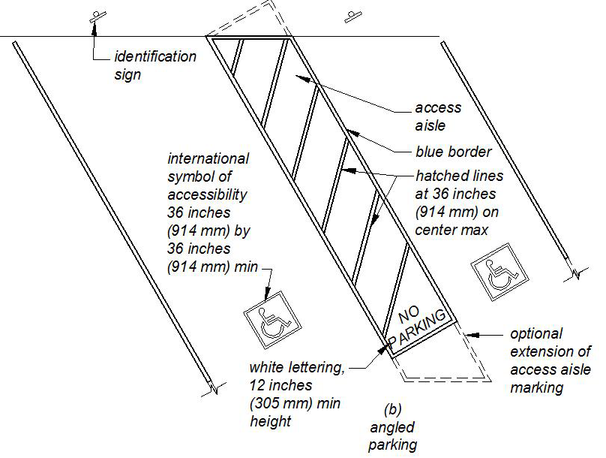

11B-502.3.4 Location. Access aisles shall not overlap the vehicular way. Access aisles shall be permitted to be placed on either side of the parking space except for van parking spaces which shall have access aisles located on the passenger side of the parking spaces.

USDOJ

Advisory 11B-502.3.4 Location. Wheelchair lifts typically are installed on the passenger side of vans. Many drivers, especially those who operate vans, find it more difficult to back into parking spaces than to back out into comparatively unrestricted vehicular lanes. Where a van and care share an access aisle, the van space must be located with the access aisle on the passenger side of the van space.

11B-502.4 Floor or ground surfaces. Parking spaces and access aisles serving them shall comply with Section 11B-302. Access aisles shall be at the same level as the parking spaces they serve. Changes in level are not permitted.
Exception: Slopes not steeper than 1:48 shall be permitted.

USDOJ

Advisory 11B-502.4 Floor or ground surfaces. Access aisles are required to be nearly level in all directions to provide a surface for a wheelchair transfer to and from vehicles. The exception allows sufficient slope for drainage. Built-up curb ramps are not permitted to project into access aisles and parking spaces because they would create slopes greater than 1:48.

DSA

Advisory 11B-502.4 Floor or ground surfaces. Accessible parking spaces and access aisles are required to be level (maximum 1:48 slope) in all directions to provide a surface for wheelchair transfer to and from vehicles. The access aisle needs to be adjacent to, and the same required length as the accessible space it serves. Where two parking stalls share the same access aisle, a full depth aisle is required; in diagonal parking, the geometric layout will require additional access aisle depth to satisfy the loading area for both of the adjacent parking stalls as indicated in Figure 11B-502.3.3.

11B-502.5 Vertical clearance. Parking spaces, access aisles and vehicular routes serving them shall provide a vertical clearance of 98 inches (2489 mm) minimum.
Exception: In existing multi-story parking facilities, car parking spaces, access aisles and vehicular routes serving them shall provide a vertical clearance of 80 inches (2032 mm) minimum. Existing vertical clearance in excess of 80 inches (2032 mm) and less than 98 inches (2489 mm) shall be maintained. This exception shall not apply to van parking spaces, access aisles, or vehicular routes serving them.

USDOJ

Advisory 11B-502.5 Vertical clearance. Signs provided at entrances to parking facilities informing drivers of clearances and the location of van accessible parking spaces can provide useful customer assistance.

11B-502.6 Identification. Parking space identification signs shall include the International Symbol of Accessibility complying with Section 11B-703.7.2.1 in white on a blue background. Signs identifying van parking spaces shall contain additional language or an additional sign with the designation “van accessible”. Signs shall be 60 inches (1524 mm) minimum above the finish floor or ground surface measured to the bottom of the sign.
Exception: Signs located within a circulation path shall be a minimum of 80 inches (2032 mm) above the finish floor or ground surface measured to the bottom of the sign.

USDOJ

Advisory 11B-502.6 Identification. The required “van accessible” designation is intended to be informative, not restrictive, in identifying those spaces that are better suited for van use. Enforcement of motor vehicle laws, including parking priviledges, is a local matter.

DSA

Advisory 11B-502.6 Identification. This section requires that an additional “van accessible” sign or additional language be posted below the International Symbol of Accessibility when designating an accessible parking space that will accommodate a van. A single parking sign incorporating both the International Symbol of Accessibility and the language “van accessible” may be used.

11B-502.6.1 Finish and size. Parking identification signs shall be reflectorized with a minimum area of 70 square inches (45161 mm2).

11B-502.6.2 Minimum fine. Additional language or an additional sign below the International Symbol of Accessibility shall state “Minimum Fine $250”.

11B-502.6.3 Location. A parking space identification sign shall be visible from each parking space. Signs shall be permanently posted either immediately adjacent to the parking space or within the projected parking space width at the head end of the parking space. Signs may also be permanently posted on a wall at the interior end of the parking space.

11B-502.6.4 Marking. Each accessible car and van space shall have surface identification complying with either Section 11B-502.6.4.1 or 11B-502.6.4.2.

11B-502.6.4.1 The parking space shall be marked with an International Symbol of Accessibility complying with Section 11B-703.7.2.1 in white on a blue background a minimum 36 inches wide by 36 inches high (914 mm x 914 mm). The centerline of the International Symbol of Accessibility shall be a maximum of 6 inches (152 mm) from the centerline of the parking space, its sides parallel to the length of the parking space and its lower corner at, or lower side aligned with, the end of the parking space length.

11B-502.6.4.2 The parking space shall be outlined in blue or painted blue and shall be marked with an International Symbol of Accessibility complying with Section 11B-703.7.2.1 a minimum 36 inches wide by 36 inches high (914 mm x 914 mm) in white or a suitable contrasting color. The centerline of the International Symbol of Accessibility shall be a maximum of 6 inches (152 mm) from the centerline of the parking space, its sides parallel to the length of the parking space and its lower corner at, or lower side aligned with, the end of the parking space.

11B-502.7 Relationship to accessible routes. Parking spaces and access aisles shall be designed so that cars and vans, when parked, cannot obstruct the required clear width of adjacent accessible routes.

USDOJ

Advisory 11B-502.7 Relationship to accessible routes. Wheel stops are an effective way to prevent vehicle overhangs from reducing the clear width of accessible routes.

11B-502.7.1 Arrangement. Parking spaces and access aisles shall be designed so that persons using them are not required to travel behind parking spaces other than to pass behind the parking space in which they parked.

DSA

Advisory 11B-502.7.1 Arrangement. Accessible parking spaces located so that the accessible route passes behind parked vehicles create a safety hazard, especially for wheelchair users. Wheelchair users traveling behind parked vehicles may be obscured from the view of the drivers backing out of parking spaces, especially when passing behind high-profile vehicles. This section requires that persons with disabilities not be required to travel behind parking spaces other than the one in which they have parked.

11B-502.7.2 Wheel stops. A curb or wheel stop shall be provided if required to prevent encroachment of vehicles over the required clear width of adjacent accessible routes.

11B-502.8 Additional signs. An additional sign shall be posted either; 1) in a conspicuous place at each entrance to an off-street parking facility or 2) immediately adjacent to on-site accessible parking and visible from each parking space.

11B-502.8.1 Size. The additional sign shall not be less than 17 inches (432 mm) wide by 22 inches (559 mm) high.

11B-502.8.2 Lettering. The additional sign shall clearly state in letters with a minimum height of 1 inch (25 mm) the following:
"Unauthorized vehicles parked in designated accessible spaces not displaying distinguishing placards or special license plates issued for persons with disabilities will be towed away at the owner’s expense. Towed vehicles may be reclaimed at: _________________________ or by telephoning _______________________." Blank spaces shall be filled in with appropriate information as a permanent part of the sign.

11B-503 Passenger drop-off and loading zones

11B-503.1 General. Passenger drop-off and loading zones shall comply with Section 11B-503.

11B-503.2 Vehicle pull-up space. Passenger drop-off and loading zones shall provide a vehicular pull-up space 96 inches (2438 mm) wide minimum and 20 feet (6096 mm) long minimum.

11B-503.3 Access aisle. Passenger drop-off and loading zones shall provide access aisles complying with Section 11B-503 adjacent and parallel to the vehicle pull-up space. Access aisles shall adjoin an accessible route and shall not overlap the vehicular way.

11B-503.3.1 Width. Access aisles serving vehicle pull-up spaces shall be 60 inches (1524 mm) wide minimum.

11B-503.3.2 Length. Access aisles shall extend the full length of the vehicle pull-up spaces they serve.

11B-503.3.3 Marking. Access aisles shall be marked with a painted borderline around their perimeter. The area within the borderlines shall be marked with hatched lines a maximum of 36 inches (914 mm) on center in a color contrasting with that of the aisle surface.

Figure 11B-503.3
Passenger Drop-Off and Loading Zone Access Aisle

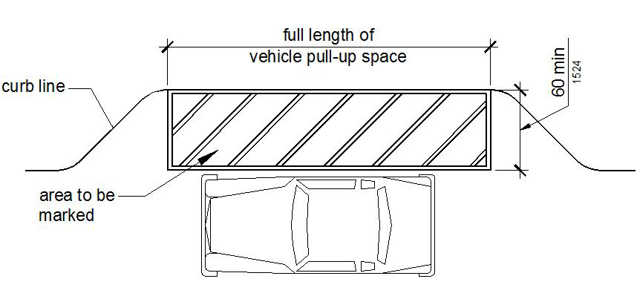

11B-503.4 Floor and ground surfaces. Vehicle pull-up spaces and access aisles serving them shall comply with Section 11B-302. Access aisles shall be at the same level as the vehicle pull-up space they serve. Changes in level are not permitted.

Exception: Slopes not steeper than 1:48 shall be permitted.

11B-503.5 Vertical clearance. Vehicle pull-up spaces, access aisles serving them, and a vehicular route from an entrance to the passenger drop-off and loading zone and from the passenger drop-off and loading zone to a vehicular exit shall provide a vertical clearance of 114 inches (2896 mm) minimum.

DSA

Advisory 11B-503.5 Vertical clearance. The minimum vertical clearance at designated passenger drop-off and loading zones, and along at least one vehicle access route to the area from site entrances and exits, is 114 inches. This differs from the 98 inch vertical clearance requirement for accessible parking spaces. Commercial vans used for accessible transit may be taller than the passenger vans.

Valet Parking and Mechanical Access Parking Garages

11B-209.4 Valet parking. Parking facilities that provide valet parking services shall provide at least one passenger drop-off and loading zone complying with Section 11B-503. The parking requirements of Section 11B-208.1 apply to facilities with valet parking.

DSA

Advisory 11B-209.4 Valet parking. Valet parking does not eliminate the requirement to provide accessible spaces. Some vehicles may be adapted with hand controls or lack a driver’s seat, and may not be operable by a valet parking attendant. The parking space requirements of Sections 11B-208 and 11B-502 apply to facilities with valet parking, including the requirements for an accessible route of travel to the entrance of the facility. In addition, when valet parking is provided, a passenger drop-off and loading zone complying with Section 11B-503 shall be located on an accessible route of travel to the entrance of the facility.

11B-209.5 Mechanical access parking garages. Mechanical access parking garages shall provide at least one passenger drop-off and loading zone complying with Section 11B-503 at vehicle drop-off and vehicle pick-up areas

