STATE OF CALIFORNIA  DEPARTMENT OF GENERAL SERVICES | DATE ISSUED: November 29, 2017
Administrative Order 17-02 | EXPIRES:  Until Rescinded
TO:  Deputy Directors Branch Chiefs Office Chiefs  All DGS Supervisors and Managers  SUBJECT:  Legislative Communications Policy | REFERENCES:
 | SUPERSEDES:

Purpose | It is the intent of the Department of General Services to ensure that communications with the Legislature be accurate, credible, and properly coordinated within DGS, with customer agencies, and with the Administration. It is also the intent of DGS to ensure that legislative communications reflect courtesy and professionalism.

Policy | DGS has designated the Office of Legislative Affairs to handle most legislative communications, other than routine business communications by personnel providing services to the Legislature.  Except as provided below, DGS staff shall refer inquiries from and discussions with the Legislature to the Office of Legislative Affairs for handling. DGS staff shall also refer inquiries from lobbyists or stakeholder groups about current, past, or potential legislation to the Office of Legislative Affairs for response.

Examples Covered by This Policy | Examples of inquiries and discussions that shall be referred to the Office of Legislative Affairs for resolution include:  - Any inquiry about current, past, or potential legislation.  - Legislative inquiries about DGS programs, policies, or processes.  - Legislative inquiries about specific contracts or activities.  - Legislative inquiries about issues involving individual constituents dealing with DGS or another state agency, or who have an interest in DGS services.  DGS staff members are cautioned to especially avoid expressing opinions or suggestions or making recommendations about pending or potential legislation affecting DGS.
Media Inquiries | Media inquiries about current, past, or potential legislation shall be referred to the Office of Public Affairs for response.

Some Routine Business Is Exempt | This policy does not apply to routine business communications about DGS services being provided to, or requested by, the Legislature. Examples include:  - Building-related issues in the Capitol, or when the Legislature is a tenant in a DGS-managed building.  - Leasing or planning for legislative members’ district offices.  - Printing and bill room services provided to the Legislature.  However, communications that deal with controversial issues or may be politically sensitive should be routed through the Office of Legislative Affairs, even if they arise from routine business.
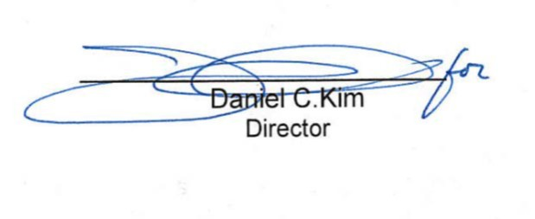
Budget Issues | Inquiries by budget committees, individual members, and the Legislative Analyst’s Office regarding items in the DGS budget should be referred to the Office of Fiscal Services for response.

Legislative Members on Boards and Commissions | This policy does not apply to:  - Discussions with legislators serving on the State Allocation Board by board staff about board business.  - Discussions with legislators serving on the California Commission on Disability Access by commission staff about commission business.  However, discussions about current, proposed, or potential legislation shall be referred to the Office of Legislative Affairs.
Requests for Outreach Events | The Division of the State Architect and Procurement Division may work directly with legislators’ offices regarding routine requests for outreach staff to make presentations at events organized or sponsored by the legislator.
Employee Association Activities | This policy is not intended to limit the ability of DGS staff, in accordance with state law and applicable bargaining unit contracts, to participate in employee association activities that include lobbying the Legislature.
Questions/ Contacts | The Office of Legislative Affairs can be reached at (916) 376-5045. A current staff list is available online at http://www.dgs.ca.gov/ola/ContactUs.aspx.
Approval
11-29-2017
Date:

