APPENDIX a: federal/state Complaints and
prelitigation letters received

In 2017, federal complaints accounted for 73 percent of the case filings (complaints received excluding prelitigation letters), in comparison to 67 percent in 2016; 47 percent in 2015; 52 percent in 2014; and 24 percent in 2013. At this time, CCDA is unable to ascertain the factors that are contributing to the growth in federal complaints.

Prelitigation letters continue to grow substantially for reasons unknown. They accounted for 38 percent of the 3,826 letters received in 2017 and grew by 87 percent over 2016.

2017 | Category | Total | Percent
2017 | Federal complaint | 1,722 | 45%
2017 | State complaint | 643 | 17%
2017 | Prelitigation letter* | 1,461 | 38%
2017 | Total | 3,826
2016 | Category | Total | Percent
2016 | Federal complaint | 1,730 | 52%
2016 | State complaint | 839 | 25%
2016 | Prelitigation letter* | 781 | 23%
2016 | Total | 3,340
2015 | Category | Total | Percent
2015 | Federal complaint | 1,083 | 37%
2015 | State complaint | 1,240 | 42%
2015 | Prelitigation letter* | 623 | 21%
2015 | Total | 2,946
2014 | Category | Total | Percent
2014 | Federal complaint | 1,532 | 48%
2014 | State complaint | 1,412 | 44%
2014 | Prelitigation letter* | 234 | 8%
2014 | Total | 3,178
2013 | Category | Total | Percent
2013 | Federal complaint | 605 | 21%
2013 | State complaint | 1,950 | 68%
2013 | Prelitigation letter* | 327 | 11%
2013 | Total | 2,882

*CCDA is unable to ascertain whether prelitigation letters resulted in an actual case being filed in federal or state court.
APPENDIX a: federal/state Complaints and
prelitigation letters received

APPENDIX b: Federal/State complaints and prelitigation letters receiveD by CATEGORY

CCDA organizes alleged constructed-related access violations into six categories. As indicated by the table below, parking-related violations are the largest category and represented 37 percent of the 10,608 alleged violations in 2017; 44 percent of the 11,468 alleged violations in 2016; and 42 percent of the 9,643 alleged violations in 2015.

2017 | Category | Total | Percent
2017 | Toilet Rooms and Bathrooms | 1,497 | 14%
2017 | Parking | 3,888 | 37%
2017 | Accessible Route and Entry | 2,705 | 26%
2017 | Access within Public Facility | 1,304 | 12%
2017 | Equipment within Public Facility | 573 | 5%
2017 | General Alleged Violations | 641 | 6%
2017 | Total | 10,608

2016 | Category | Total | Percent
2016 | Toilet Rooms and Bathrooms | 1,756 | 15%
2016 | Parking | 5,047 | 44%
2016 | Accessible Route and Entry | 2,801 | 24%
2016 | Access within Public Facility | 1,214 | 11%
2016 | Equipment within Public Facility | 219 | 2%
2016 | General Alleged Violations | 431 | 4%
2016 | Total | 11,468
2015 | Category | Total | Percent
2015 | Toilet Rooms and Bathrooms | 1,681 | 17%
2015 | Parking | 4,037 | 42%
2015 | Accessible Route and Entry | 2,210 | 23%
2015 | Access within Public Facility | 1,256 | 13%
2015 | Equipment within Public Facility | 147 | 2%
2015 | General Alleged Violations | 312 | 3%
2015 | Total | 9,643

APPENDIX b: Federal/State complaints and
prelitigation letters RECEIVED by CATEGORY

2014 | Category | Total | Percent
2014 | Toilet Rooms and Bathrooms | 2,212 | 21%
2014 | Parking | 3,926 | 38%
2014 | Accessible Route and Entry | 2,206 | 21%
2014 | Access within Public Facility | 1,276 | 12%
2014 | Equipment within Public Facility | 245 | 2%
2014 | General Alleged Violations | 542 | 5%
2014 | Total | 10,407
2013 | Category | Total | Percent
2013 | Toilet Rooms and Bathrooms | 1,905 | 22%
2013 | Parking | 3,552 | 41%
2013 | Accessible Route and Entry | 1,730 | 20%
2013 | Access within Public Facility | 999 | 12%
2013 | Equipment within Public Facility | 296 | 3%
2013 | General Alleged Violations | 167 | 2%
2013 | Total | 8,649

APPENDIX C: ADA VIOLATION CODES LIST

CCDA categorizes the types of construction-related alleged ADA violations using 51 key codes consistent with Title 24 of the California Code of Regulations.
CATEGORY | KEY  CODE | DESCRIPTION
Toilet  Rooms  And  Bathrooms | 1 | Entry doors are not accessible or not on an accessible route.
Toilet  Rooms  And  Bathrooms | 2 | Clear Floor Space. Non-accessible fixtures and controls or insufficient turn around space.
Toilet  Rooms  And  Bathrooms | 3 | Doors [Toilet stalls]. Non-accessible doors to toilet stalls.
Toilet  Rooms  And  Bathrooms | 4 | Door space is not compliant.
Toilet  Rooms  And  Bathrooms | 5 | Lavatories and mirrors are not accessible.
Toilet  Rooms  And  Bathrooms | 6 | The location/height of toilets, urinals, flush controls, or toilet paper dispensers is not compliant.
Toilet  Rooms  And  Bathrooms | 7 | Grab Bars. Grab bars in bathroom are non-existent, or existing grab bars are not compliant.
Toilet  Rooms  And  Bathrooms | 8 | Insufficiently covered, coat racks too high, light switch too high.
Toilet  Rooms  And  Bathrooms | 9 | Faucets. Non-accessible lever-operated, push-type, or electronically controlled mechanisms.
Toilet  Rooms  And  Bathrooms | 10 | Bathtubs or showers are not accessible.
Toilet  Rooms  And  Bathrooms | 39 | Toilet seat cover dispenser not accessible.
Toilet  Rooms  And  Bathrooms | 40 | Hand sanitizer, liquid soap or paper towel dispenser not accessible.
Toilet  Rooms  And  Bathrooms | 46 | Lack of unisex ADA bathrooms or any accessible bathrooms.
Parking | 11 | Number of spaces. Parking lot does not contain minimum number of accessible parking spaces.
Parking | 12 | Parking Spaces. Existing parking spaces are not compliant.
Parking | 13 | No sign showing the symbol of accessibility.
Parking | 14 | Loading zones/van access aisles are not compliant or non-existent.
Accessible  Route and  Entry  To  Public  Facility | 15 | Routes to and from parking lot or public right of way are not accessible. May include uneven surfaces.
Accessible  Route and  Entry  To  Public  Facility | 16 | Ramps. Curb ramps or entrance ramps are not compliant or non-existing.
Accessible  Route and  Entry  To  Public  Facility | 17 | General. Entry doors are not accessible or missing sign/symbol of accessibility.
Accessible  Route and  Entry  To  Public  Facility | 18 | Door Hardware. Thresholds, handles, pulls, latches, locks, or other operating devices are not accessible.
Accessible  Route and  Entry  To  Public  Facility | 45 | Accessible path is too far away or path is not clear for the accessible route.
Access  Within  Public  Facility | 20 | Access aisles within building are not accessible, e.g., dining or work surfaces are not on an accessible route.
Access  Within  Public  Facility | 21 | Maneuvering Clearances at Doors. Required clearances are not compliant.
Access  Within  Public  Facility | 22 | Stairs or Guardrails. Stairs are not compliant or lack guardrails.
Access  Within  Public  Facility | 23 | Handrails non-existent or not accessible.
Access  Within  Public  Facility | 24 | Route with inadequate signage.
Access  Within  Public  Facility | 25 | Wheelchair spaces in assembly areas are non-existent or not compliant.
Access  Within  Public  Facility | 26 | Access Height. Heights of surfaces such as counters, bars, or tables are not compliant.
Equipment  Within  Public  Facility | 27 | Audible signals.
Equipment  Within  Public  Facility | 28 | Public telephones are not wheelchair accessible.
Equipment  Within  Public  Facility | 29 | Public telephones do not have accessible volume control.
Equipment  Within  Public  Facility | 30 | General Public Equipment. Gas pumps, automatic teller machines, or fare machines are not compliant.
Equipment  Within  Public  Facility | 37 | General Pool. Pool lifts, sloped entries, transfer walls, transfer systems, and pool stairs are not accessible.
Equipment  Within  Public  Facility | 38 | Drinking Fountains and water coolers are not accessible.
General  Violations | 31 | Dressing, fitting, or locker rooms are not compliant.
General  Violations | 32 | Sleeping rooms, units or suites are not accessible or insufficient number of accessible guest rooms.
General  Violations | 33 | Patient bedrooms or baths are not accessible.
General  Violations | 34 | Audible and visual alarms and notification appliances are not compliant.
General  Violations | 35 | Amusement rides are not accessible.
General  Violations | 36 | Bus stop, bus stop pad, station, terminal, building or other transportation facility is not accessible.
General  Violations | 41 | Service dog not allowed in building.
General  Violations | 42 | Lamp not accessible.
General  Violations | 43 | Shuttle van/bus not accessible.
General  Violations | 44 | Accessible features not maintained.
General  Violations | 47 | Website does not offer ADA options or is not accessible.
General  Violations | 48 | Lack of separate call button.
General  Violations | 49 | Insufficient documentation/lack of ADA access issue.
General  Violations | 50 | Lack of temporary hand controls to test drive vehicles.
General  Violations | 51 | Staff provided barrier to access.

APPENDIX d: Attorneys and plaintiffs SUBMISSIONS

In 2017, 23 percent of plaintiffs named on complaints received by CCDA filed 10 or more complaints in court. Those plaintiffs collectively filed 81 percent of the 2,365 complaints received (excludes prelitigation letters).

Plaintiffs Involved in 10 or More State and Federal Complaints  (Excludes Prelitigation Letters) | 2017 | 2016
 | 81% | 75%

The chart below shows the percentage of complaints (excludes prelitigation letters) reported to CCDA by the top four law firms in 2017. For example, 33 percent of the 2,365 complaints received were filed by one law firm. Of the 2,365 complaints received, 74 percent were filed by four law firms.

Complaints Filed by Law Firms in Order of Reporting Frequency (Excludes Prelitigation Letters) | 2017 | 2016
1 | 33% | 27%
2 | 16% | 21%
3 | 13% | 10%
4 | 12% | 7%
Total | 74%* | 65%*

*The percentage calculation will not total 100 percent because it only references the top four law firms.

APPENDIX E: 2017 TOP 10 VIOLATIONS

Rank # | Key  Code | Violation Description | Total  Number  of  Violations | Percent  of  Total
1 | 11 | Parking: parking lot does not contain the minimum number of accessible parking spaces | 1,792 | 17%
2 | 16 | Accessible Route and Entry: curb ramps or entrance ramps are non-compliant or non-existent | 1,091 | 10%
3 | 12 | Parking: the existing parking spaces are not compliant | 947 | 9%
4 | 15 | Accessible Route and Entry: routes to and from the parking lot or public right-of-way are not accessible | 830 | 8%
5 | 14 | Parking: van-accessible parking, van access aisles and/or loading zones are non-compliant or non-existent | 645 | 6%
6 | 26 | Access within Public Facility: heights of surfaces such as counters, bars, and tables, for example, are non-compliant | 608 | 6%
7 | 13 | Parking: signage in parking lot is non-compliant. For example, spaces need to be designated as reserved by a sign showing the symbol of accessibility | 504 | 5%
8 | 44 | General Violations: accessible features are not maintained | 434 | 4%
9 | 18 | Accessible Route and Entry: handles, pulls,  latches, locks, or other operating devices are not accessible | 405 | 4%
10 | 20 | Access within Public Facility: access aisles or path of travel within building are not accessible | 367 | 3%
Total |  |  | 7,623 | 72%

APPENDIX F: COMPLAINTS/prelitigation letters

by place of public accommodation

The below chart demonstrates the frequency by which various types of businesses were alleged to be in violation. In 2017 the top three places of public accommodation, as defined in ADA Title III, Technical Assistance Manual, where violations occurred included: Sales/Rental Establishments (e.g. bakeries, grocery stores, hardware stores, shopping centers) (38%); Service Establishments(e.g. laundromats, dry-cleaners, banks, funeral homes, gas stations, professional offices, beauty shops) ( 35%); and Food or Drinks Establishments (e.g. restaurants and bars) (19%). These location categories are consistent with the 2016 reported violations.

 | 2017 |  | 2015 |  | 2015
*Public Location Category | Total | % | Total | % | Total | %
- Places of Lodging | 250 | 6.5% | 135 | 4.0% | 113 | 3.8%
2. Establishments Serving Food or Drink | 727 | 19.0% | 888 | 26.6% | 810 | 27.5%
3. Places of Exhibition or Entertainment | 12 | 0.3% | 13 | 0.4% | 3 | 0.1%
4. Places of Public Gathering | 1 | 0.0% | 3 | 0.0% | 1 | 0.0%
5. Sales or Rental Establishments | 1,453 | 38.0% | 1,355 | 40.6% | 1,240 | 42.1%
6. Service Establishments | 1,343 | 35.1% | 853 | 25.5% | 657 | 22.3%
7. Public transportation terminals, depots, or stations | 2 | 0.1% | 26 | 25.5% | 50 | 1.7%
8. Places of Public Display or Collection | 2 | 0.1% | 3 | 0.1% | 4 | 0.1%
9. Places of Recreation | 2 | 0.1% | 22 | 0.7% | 34 | 1.2%
10. Places of Education | 2 | 0.1% | 4 | 0.1% | 10 | 0.3%
11. Social Service Center Establishments | 1 | 0.0% | 6 | 0.2% | 4 | 0.1%
12. Places of Exercise or Recreation | 31 | 0.8% | 32 | 1.0% | 20 | 0.7%
Total | 3,826 | 100% | 3,340 | 100% | 2,946 | 100%

appendix g: zip code location

of complaints letters filed

The below maps depict the various zip codes where alleged violations have occurred. In 2017, the number of complaints filed remains heavily concentrated in urban areas. Southern California had the highest number of filings, followed by Northern California (Bay Area). Central Valley region ranked third, followed by the Sacramento region. This is consistent with 2016 filings.

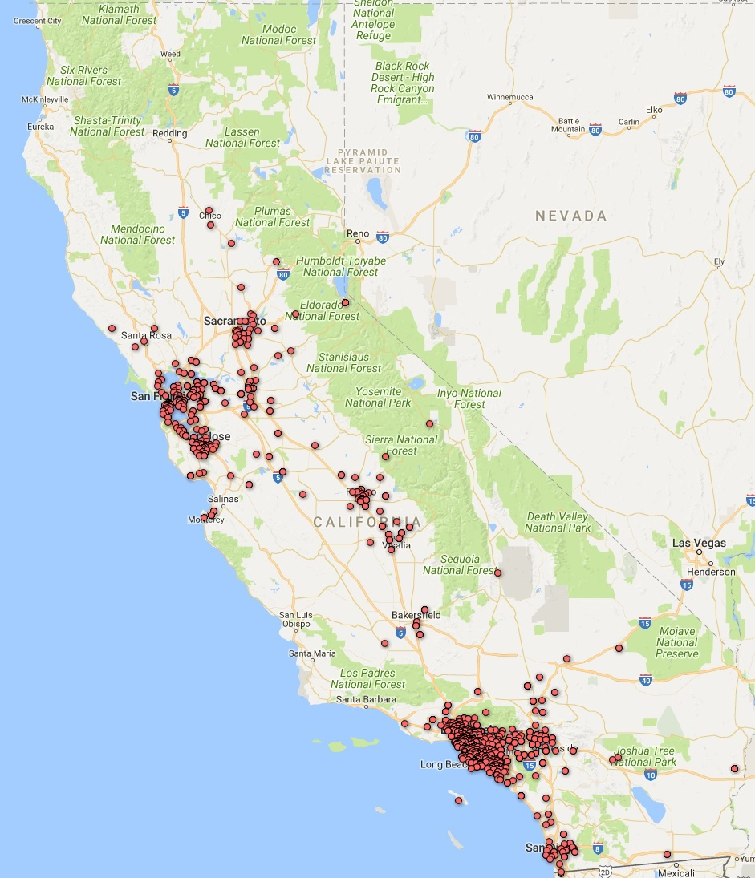
2017
2015

appendix h: case resoLutions

2017 Case Resolution Report Questions
Questions | Yes | Percent  Yes | No | Percent  No
Defendant requested an early evaluation conference | 39 | 2% | 1799 | 98%
Defendant requested a site inspection | 45 | 2% | 1791 | 98%
Plaintiff received injunctive relief | 1370 | 75% | 460 | 25%
Another favorable result was achieved | 952 | 52% | 874 | 48%
Plaintiff received damages or monetary settlement | 744 | 93% | 57 | 7%
2016 Case Resolution Report Questions
Question | Yes | Percent  Yes | No | Percent  No
Defendant requested an early evaluation conference | 42 | 2% | 1,997 | 98%
Defendant requested a site inspection | 33 | 2% | 2,011 | 98%
Plaintiff received injunctive relief | 1,222 | 73% | 447 | 27%
Another favorable result achieved | 766 | 47% | 869 | 53%
Plaintiff received damages or a monetary settlement | 734 | 58% | 522 | 42%

2015 Case Resolution Report Questions*
Question | Yes | Percent  Yes | No | Percent  No
Defendant requested an early evaluation conference | 0 | 0% | 516 | 100%
Defendant requested a site inspection | 0 | 0% | 520 | 100%
Plaintiff received injunctive relief**
Another favorable result achieved**
Plaintiff received damages or a monetary settlement | 143 | 30% | 330 | 70%

