CALIFORNIA BUILDING STANDARDS COMMISSION
July 16, 2026
CALGREEN CCRC WORKSHOP #1
DRAFT EXPRESS TERMS
CALIFORNIA GREEN BUILDING STANDARDS CODE,
(CALGreen), PART 11,
TITLE 24, CALIFORNIA CODE OF REGULATIONS
The state agency shall draft the regulations in plain, straightforward language, avoiding technical terms as much as possible and using a coherent and easily readable style. The agency shall draft the regulation in plain English. A notation shall follow the express terms of each regulation listing the specific statutes authorizing the adoption and listing specific statutes being implemented, interpreted, or made specific (Government Code Section 11346.2(a)(1)).

If using assistive technology, please adjust your settings to recognize underline, strikeout and ellipsis.

LEGEND for EXPRESS TERMS (California only codes - Parts 1, 6, 8, 11, 12)
- Existing California amendments appear upright
- Amended or new California amendments appear underlined
- Repealed California language appears upright and in strikeout
- Ellipses ( ...) indicate existing text remains unchanged

DRAFT EXPRESS TERMS
BSC is considering the following proposals under the authority granted by Health and Safety Code Section 18930.5.

ITEM 1
Chapter 2,
Section 202 Definitions
…
BIOGENIC CARBON. The carbon absorbed from the atmosphere by plants as they grow and then released back into the atmosphere through processes such as eating, burning, and decomposition.
…
EMBODIED CARBON BUDGET (ECB). An embodied carbon intensity (ECI) value used as a maximum acceptable limit for determining a project's compliance with embodied carbon reduction requirements and expressed in kgCO₂e/m².
…
EMBODIED CARBON INTENSITY (ECI). The total global warming potential (GWP) of a building per gross floor area and expressed in kgCO₂e/m².
…

ITEM 2
Chapter 5,
Section 5.402 Definitions
SECTION 5.402—DEFINITIONS
5.402.1 Definitions. The following terms are defined in Chapter 2.
…
BIOGENIC CARBON.
…
EMBODIED CARBON BUDGET (ECB).
EMBODIED CARBON INTENSITY (ECI).
…

ITEM 3
Chapter 5,
Section 5.409.3 Product GWP – prescriptive option
…
TABLE 5.409.3 – PRODUCT GWP LIMITS
Buy Clean California  Materials Product Category ¹ | Maximum acceptable GWP value (unfabricated)  (GWP _{allowed}) | Unit of Measurement
Hot-rolled structural steel sections | 1.77 1.26 | MT CO_{2e}/MT
Hollow structural sections | 3.00 2.14 | MT CO_{2e}/MT
Steel plate | 2.61 1.86 | MT CO_{2e}/MT
Concrete reinforcing steel | 1.56 0.94 | MT CO_{2e}/MT
Flat glass | 2.50 1.79 | MT CO_{2e}/MT
Light-density mineral wool board insulation | 5.83 3.35 | kg CO_{2e}/1 m²
Heavy-density mineral wool board insulation | 14.28 8.53 | kg CO_{2e}/1 m²
Concrete, Ready-Mixed ^{2, 3}
Concrete Product Category | Maximum GWP allowed value  (GWP _{allowed}) | Unit of Measurement
up to 2499 psi | 450 321 | kg CO_{2e}/m³
2500-3499 psi | 489 349 | kg CO_{2e}/m³
3500-4499 psi | 566 404 | kg CO_{2e}/m³
4500-5499 psi | 661 472 | kg CO_{2e}/m³
5500-6499 psi | 701 501 | kg CO_{2e}/m³
6500 psi and greater | 799 571 | kg CO_{2e}/m³
Concrete, Lightweight Ready-Mixed ²
Concrete Product Category | Maximum GWP allowed value  (GWP _{allowed}) | Unit of Measurement
up to 2499 psi | 875 625 | kg CO_{2e}/m³
2500-3499 psi | 956 683 | kg CO_{2e}/m³
3500-4499 psi | 1,039 742 | kg CO_{2e}/m³
1. Concrete High Early Strength ready-mixed shall be calculated at 130% of the Ready mixed concrete GWP allowed values for each product category.
…

REVISED LANGUAGE IF APPROVED
TABLE 5.409.3 – PRODUCT GWP LIMITS
Buy Clean California  Materials Product Category ¹ | Maximum acceptable GWP value (unfabricated)  (GWP _{allowed}) | Unit of Measurement
Hot-rolled structural steel sections | 1.26 | MT CO_{2e}/MT
Hollow structural sections | 2.14 | MT CO_{2e}/MT
Steel plate | 1.86 | MT CO_{2e}/MT
Concrete reinforcing steel | 0.94 | MT CO_{2e}/MT
Flat glass | 1.79 | MT CO_{2e}/MT
Light-density mineral wool board insulation | 3.35 | kg CO_{2e}/1 m²
Heavy-density mineral wool board insulation | 8.53 | kg CO_{2e}/1 m²
Concrete, Ready-Mixed ^{2, 3}
Concrete Product Category | Maximum GWP allowed value  (GWP _{allowed}) | Unit of Measurement
up to 2499 psi | 321 | kg CO_{2e}/m³
2500-3499 psi | 349 | kg CO_{2e}/m³
3500-4499 psi | 404 | kg CO_{2e}/m³
4500-5499 psi | 472 | kg CO_{2e}/m³
5500-6499 psi | 501 | kg CO_{2e}/m³
6500 psi and greater | 571 | kg CO_{2e}/m³
Concrete, Lightweight Ready-Mixed ²
Concrete Product Category | Maximum GWP allowed value  (GWP _{allowed}) | Unit of Measurement
up to 2499 psi | 625 | kg CO_{2e}/m³
2500-3499 psi | 683 | kg CO_{2e}/m³
3500-4499 psi | 742 | kg CO_{2e}/m³
1. Concrete High Early Strength ready-mixed shall be calculated at 130% of the Ready mixed concrete GWP allowed values for each product category.
…

ITEM 4
Chapter 5,
Section 5.409.4 Whole Building Life Cycle Assessment – performance option
5.409.4 Whole building life cycle assessment – performance option. Projects shall conduct a cradle-to-grave whole building life cycle assessment performed in accordance with ISO 14040 and ISO 14044, excluding operating energy, and shall demonstrate compliance with Section 5.409.4.1 carbon budget method, or Section 5.409.4.2 baseline building method. [The following language is moved to Section 5.409.4.2 with minor modifications.] demonstrating a minimum 10-percent reduction in global warming potential (GWP) as compared to a reference baseline building of similar size, function, complexity, type of construction, material specification, and geographic location that meets the requirements of the California Energy Code currently in effect. Software used to conduct the whole building life cycle assessment, including reference baseline building if applicable, shall have a data set compliant with ISO 14044, and ISO 21930 or EN 15804, and the software shall conform to ISO 21931 and/or EN 15978. [The following language is moved to Section 5.409.4.2.] The software tools and data sets shall be the same for evaluation of both the baseline building and the proposed building.
Exception: Biogenic carbon shall be excluded from the whole building life cycle assessment calculations.
Notes:
1. Software for calculating whole building life cycle assessment is available for free at Athena Sustainable Materials Institute (https://calculatelca.com/software/impact-estimator/) and OneClick LCA-Planetary (www.oneclicklca.com/planetary). Paid versions include, but are not limited to, Sphera GaBi Solutions (gabi.sphera.com), SimaPro (simapro.com), OneClick LCA (www.oneclicklca.com) and Tally for Revit (apps.autodesk.com).
1.2. ASTM E2921-22 “Standard Practice for Minimum Criteria for Comparing Whole Building Life Cycle Assessments for Use with Building Codes, Standards, and Rating Systems” may be consulted for the assessment.
2.3. In addition to the required documentation specified in Section 5.409.4.35, Worksheet WS-9 may be required by the enforcing entity to demonstrate compliance with the requirements.
5.409.4.1 Embodied carbon budget method. Demonstrate the building’s embodied carbon intensity (ECI) does not exceed the embodied carbon budget (ECB) specified in Table 5.409.4.1.
TABLE 5.409.4.1 – EMBODIED CARBON BUDGET (ECB) LIMITS
Primary Occupancy Group | Maximum acceptable ECB value (kgCO₂e/m²)
Storage (S) | 480
Education (E) & Business (B) | 660
Other occupancy groups | 750

5.409.4.1.1 Embodied Carbon Intensity (ECI) Calculation. To determine the Embodied Carbon Intensity (ECI), divide the building’s total Global Warming Potential (GWP) by gross floor area (GFA) in meters squared (m²).
5.409.4.1.1 EQUATION:
GWP/GFA (m²) = ECI (kgCO₂e/m²)
[The following language in new Section 5.409.4.2 is moved from Section 5.409.4 with minor modifications.]
5.409.4.2 Baseline building method. Demonstrate and demonstrating a minimum 10 percent reduction in global warming potential (GWP) as compared to a reference baseline building of similar size, function, complexity, type of construction, material specification, and geographic location that meets the requirements of the California Energy Code currently in effect. The software tools and data sets shall be the same for evaluation of both the baseline building and the proposed building.
5.409.4.13 Building components. Building enclosure components included in the assessment shall be limited to include, at a minimum, to glazing assemblies, insulation, and exterior finishes. Primary and secondary structural members included in the assessment shall be limited to include, at a minimum, footings and foundations, structural columns, beams, walls, roofs, and floors.
5.409.4.3.1 Previously used building materials or products that have been salvaged and then reused without substantial modification of their form shall have a GWP of zero for life cycle stages A1-A3. Such materials shall be minimally processed only, such as cleaning, repairing, resurfacing and resizing.
5.409.4.2 4 Reference study period. The reference study period of the proposed building shall be equal to the reference baseline building if applicable and shall be 60 years.
5.409.4.3 5 Verification of compliance. A summary of the GWP analysis produced by the software and Worksheet WS-4 signed by the design professional of record shall be provided in the construction documents as documentation of compliance. A copy of the whole building life cycle assessment which includes the GWP analysis produced by the software, in addition to maintenance and training information, shall be included in the operation and maintenance manual and shall be provided to the owner at the close of construction. The enforcing agency may require inspection and inspection reports in accordance with Sections 702.2 and 703.1 during and at completion of construction to demonstrate substantial conformance. Inspection shall be performed by the design professional of record or third party acceptable to the enforcing agency.

REVISED LANGUAGE IF APPROVED
5.409.4 Whole building life cycle assessment – performance option. Projects shall conduct a cradle-to-grave whole building life cycle assessment performed in accordance with ISO 14040 and ISO 14044, excluding operating energy, and shall demonstrate compliance with Section 5.409.4.1 carbon budget method, or Section 5.409.4.2 baseline building method. Software used to conduct the whole building life cycle assessment, including reference baseline building if applicable, shall have a data set compliant with ISO 14044, and ISO 21930 or EN 15804, and the software shall conform to ISO 21931 and/or EN 15978.
Exception: Biogenic carbon shall be excluded from the whole building life cycle assessment calculations.
Notes:
1. ASTM E2921-22 “Standard Practice for Minimum Criteria for Comparing Whole Building Life Cycle Assessments for Use with Building Codes, Standards, and Rating Systems” may be consulted for the assessment.
2. In addition to the required documentation specified in Section 5.409.4.5, Worksheet WS-9 may be required by the enforcing entity to demonstrate compliance with the requirements.
5.409.4.1 Carbon budget method. Demonstrate the building’s embodied carbon intensity (ECI) does not exceed the embodied carbon budget (ECB) specified in Table 5.409.4.1.
TABLE 5.409.4.1 – EMBODIED CARBON BUDGET (ECB) LIMITS
Primary Occupancy Group | Maximum acceptable ECB value (kgCO₂e/m²)
Storage (S) | 480
Education (E) & Business (B) | 660
Other occupancy groups | 750
5.409.4.1.1 Embodied Carbon Intensity (ECI) Calculation. To determine the Embodied Carbon Intensity (ECI), divide the building’s total Global Warming Potential (GWP) by gross floor area (GFA) in meters squared (m²).
5.409.4.1.1 EQUATION:
GWP/GFA (m²) = ECI (kgCO₂e/m²)

5.409.4.2 Baseline building method. Demonstrate a minimum 10 percent reduction in global warming potential (GWP) as compared to a reference baseline building of similar size, function, complexity, type of construction, material specification, and geographic location that meets the requirements of the California Energy Code currently in effect. The software tools and data sets shall be the same for evaluation of both the baseline building and the proposed building.
5.409.4.3 Building components. Building enclosure components included in the assessment shall include, at a minimum, glazing assemblies, insulation, and exterior finishes. Primary and secondary structural members included in the assessment shall include, at a minimum, footings and foundations, structural columns, beams, walls, roofs, and floors.
5.409.4.3.1 Previously used building materials or products that have been salvaged and then reused without substantial modification of their form shall have a GWP of zero for life cycle stages A1-A3. Such materials shall be minimally processed only, such as cleaning, repairing, resurfacing and resizing.
5.409.4.4 Reference study period. The reference study period of the proposed building shall be equal to the reference baseline building if applicable and shall be 60 years.
5.409.4.5 Verification of compliance. A summary of the GWP analysis produced by the software and Worksheet WS-4 signed by the design professional of record shall be provided in the construction documents as documentation of compliance. A copy of the whole building life cycle assessment which includes the GWP analysis produced by the software, in addition to maintenance and training information, shall be included in the operation and maintenance manual and shall be provided to the owner at the close of construction. The enforcing agency may require inspection and inspection reports in accordance with Sections 702.2 and 703.1 during and at completion of construction to demonstrate substantial conformance. Inspection shall be performed by the design professional of record or third party acceptable to the enforcing agency.
…

ITEM 5
Chapter 8,
Worksheet (WS-4)
WORKSHEET (WS-4)
Section 5.409.4 WHOLE BUILDING LIFE CYCLE ASSESSMENT – PERFORMANCE OPTION
Responsible Designer’s Declaration Statement:
I attest that the Whole Building Life Cycle Analysis has been performed according to the requirements of Section 5.409.4 and has complied with one of the following options:
- The building’s embodied carbon intensity (ECI) does not exceed the embodied carbon budget (ECB) specified in Table 5.409.4.1.
- The building has met the minimum 10 percent reduction in global warming potential as compared to a reference baseline building of similar size, function, complexity, type of construction, material specification, and geographic location that meets the requirements of the California Energy Code currently in effect.
Furthermore, I will ensure during construction that the material specifications will be reviewed for substantial conformance with the life cycle assessment indicated on the approved plans so at the close of construction the project’s ECB compliance or minimum reduction in global warming potential (GWP) is thereby secured.

ITEM 6
Chapter 8,
Worksheet (WS-7)
WORKSHEET (WS-7) [BSC-CG]
Section A5.409.4 WHOLE BUILDING LIFE CYCLE ASSESSMENT – PERFORMANCE OPTION
Responsible Designer’s Declaration Statement:
I attest that the Whole Building Life Cycle Analysis has been performed according to the requirements of Section A5.409.4 and has complied with one of the following options:
- The building’s embodied carbon intensity (ECI) does not exceed the embodied carbon budget (ECB) specified in Table A5.409.4.1.
- The building has met the minimum 15 percent (Tier 1) or 20 percent (Tier 2) reduction in global warming potential as compared to a reference baseline building of similar size, function, complexity, type of construction, material specification, and geographic location that meets the requirements of the California Energy Code currently in effect.
Furthermore, I will ensure during construction that the material specifications will be reviewed for substantial conformance with the life cycle assessment indicated on the approved plans so at the close of construction the project’s ECB compliance or minimum reduction in global warming potential (GWP) is thereby secured.
…

ITEM 7
Chapter 8,
Worksheet (WS-9)
WORKSHEET (WS-9)
Section 5.409.4 and Section A5.409.4 WHOLE BUILDING LIFE CYCLE ASSESSMENT – PERFORMANCE OPTION
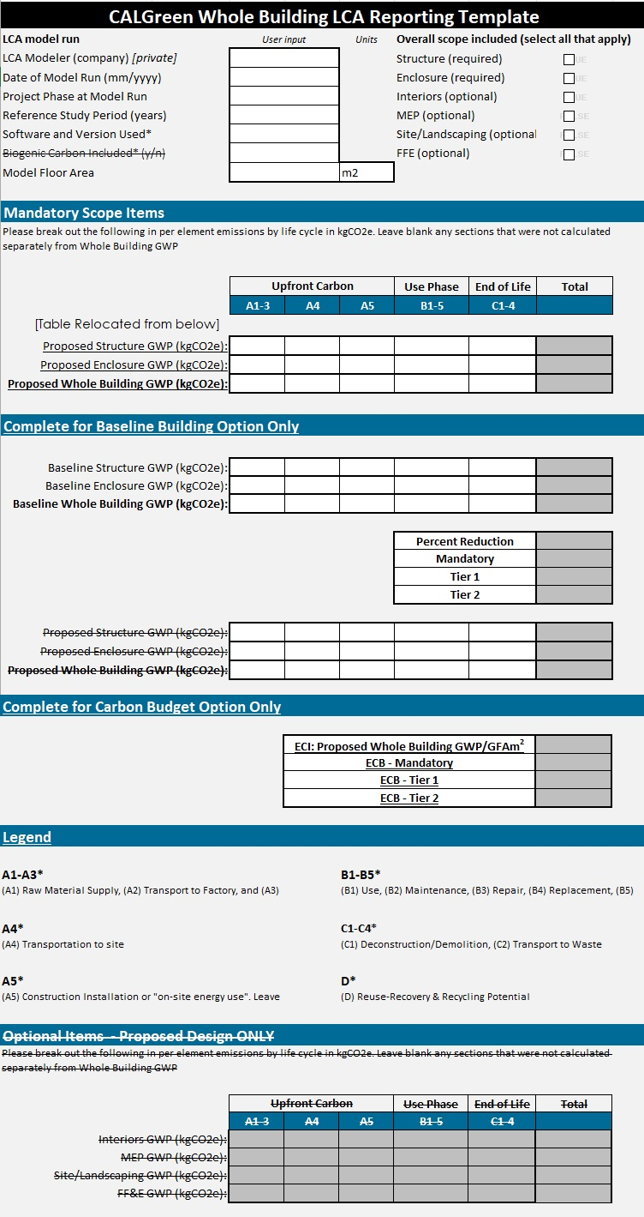

REVISED LANGUAGE IF APPROVED
WORKSHEET (WS-9)
Section 5.409.4 and Section A5.409.4 WHOLE BUILDING LIFE CYCLE ASSESSMENT – PERFORMANCE OPTION
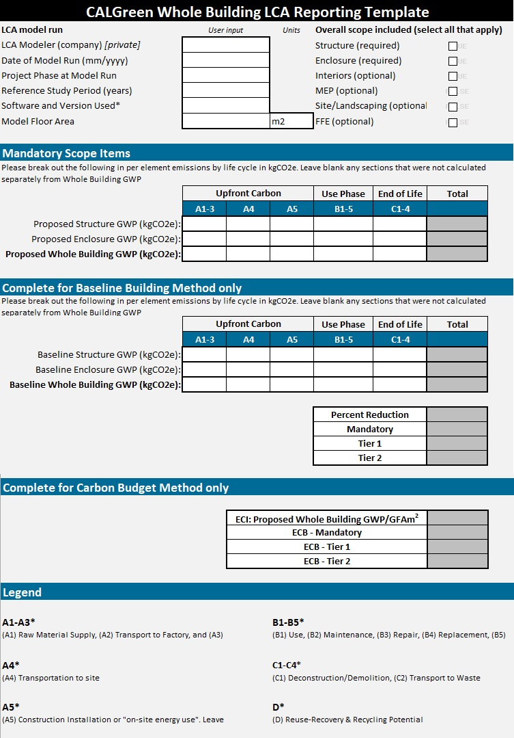

ITEM 8
Appendix A5,
Section A5.402 Definitions
SECTION A5.402—DEFINITIONS
A5.402.1 Definitions. The following terms are defined in Chapter 2.
…
BIOGENIC CARBON.
…
EMBODIED CARBON BUDGET (ECB).
EMBODIED CARBON INTENSITY (ECI).
…

ITEM 9
Appendix A5,
Section A5.409.3 Product GWP – prescriptive option
…
TABLE A5.409.3 PRODUCT GWP LIMITS TIER 1 AND TIER 2
Buy Clean California  Product Category ¹ | TIER 1  Maximum acceptable GWP value (unfabricated)  (GWP _{allowed}) | TIER 2  Maximum acceptable GWP value (unfabricated)  (GWP _{allowed}) | Unit of Measurement
Hot-rolled structural steel sections | 1.52 1.01 | 1.01 0.91 | MT CO2e/MT
Hollow structural sections | 2.57 1.71 | 1.71 1.54 | MT CO2e/MT
Steel plate | 2.24 1.49 | 1.49 1.34 | MT CO2e/MT
Concrete reinforcing steel | 1.34 0.76 | 0.89 0.68 | MT CO2e/MT
Flat glass | 2.15 1.43 | 1.43 1.29 | MT CO2e/MT
Light-density mineral wool board insulation | 5.00 2.68 | 3.33 2.41 | kg CO2e/1 m2
Heavy-density mineral wool board insulation | 12.24 6.82 | 8.16 6.14 | kg CO2e/1 m2
Concrete, Ready-Mixed ^{2, 3}
Concrete Product Category | TIER 1  Maximum acceptable GWP value (unfabricated)  (GWP _{allowed}) | TIER 2  Maximum acceptable GWP value (unfabricated)  (GWP _{allowed}) | Unit of Measurement
up to 2499 psi | 386 257 | 257 231 | kg CO2e/m3
2500-3499 psi | 419 279 | 279 251 | kg CO2e/m3
3500-4499 psi | 485 323 | 323 291 | kg CO2e/m3
4500-5499 psi | 567 378 | 378 340 | kg CO2e/m3
5500-6499 psi | 601 401 | 401 361 | kg CO2e/m3
6500 psi and greater | 685 456 | 456 410 | kg CO2e/m3
Concrete, Lightweight Ready-Mixed ²
Concrete Product Category | TIER 1  Maximum acceptable GWP value (unfabricated)  (GWP _{allowed}) | TIER 2  Maximum acceptable GWP value (unfabricated)  (GWP _{allowed}) | Unit of Measurement
up to 2499 psi | 750 500 | 500 450 | kg CO2e/m3
2500-3499 psi | 819 546 | 546 491 | kg CO2e/m3
3500-4499 psi | 891 594 | 594 535 | kg CO2e/m3
1. Concrete High Early Strength ready-mixed shall be calculated at 130% of the Ready mixed concrete GWP allowed values for each product category.
…

REVISED LANGUAGE IF APPROVED
…
TABLE A5.409.3 PRODUCT GWP LIMITS TIER 1 AND TIER 2
Buy Clean California  Product Category ¹ | TIER 1  Maximum acceptable GWP value (unfabricated)  (GWP _{allowed}) | TIER 2  Maximum acceptable GWP value (unfabricated)  (GWP _{allowed}) | Unit of Measurement
Hot-rolled structural steel sections | 1.01 | 0.91 | MT CO2e/MT
Hollow structural sections | 1.71 | 1.54 | MT CO2e/MT
Steel plate | 1.49 | 1.34 | MT CO2e/MT
Concrete reinforcing steel | 0.76 | 0.68 | MT CO2e/MT
Flat glass | 1.43 | 1.29 | MT CO2e/MT
Light-density mineral wool board insulation | 2.68 | 2.41 | kg CO2e/1 m2
Heavy-density mineral wool board insulation | 6.82 | 6.14 | kg CO2e/1 m2
Concrete, Ready-Mixed ^{2, 3}
Concrete Product Category | TIER 1  Maximum acceptable GWP value (unfabricated)  (GWP _{allowed}) | TIER 2  Maximum acceptable GWP value (unfabricated)  (GWP _{allowed}) | Unit of Measurement
up to 2499 psi | 257 | 231 | kg CO2e/m3
2500-3499 psi | 279 | 251 | kg CO2e/m3
3500-4499 psi | 323 | 291 | kg CO2e/m3
4500-5499 psi | 378 | 340 | kg CO2e/m3
5500-6499 psi | 401 | 361 | kg CO2e/m3
6500 psi and greater | 456 | 410 | kg CO2e/m3
Concrete, Lightweight Ready-Mixed ²
Concrete Product Category | TIER 1  Maximum acceptable GWP value (unfabricated)  (GWP _{allowed}) | TIER 2  Maximum acceptable GWP value (unfabricated)  (GWP _{allowed}) | Unit of Measurement
up to 2499 psi | 500 | 450 | kg CO2e/m3
2500-3499 psi | 546 | 491 | kg CO2e/m3
3500-4499 psi | 594 | 535 | kg CO2e/m3
1. Concrete High Early Strength ready-mixed shall be calculated at 130% of the Ready mixed concrete GWP allowed values for each product category.
…

ITEM 10
Appendix A5,
Section A5.409.4 Whole Building Life Cycle Assessment – performance option
A5.409.4 Whole building life cycle assessment – performance option. Projects shall meet the minimum requirements of Section A5.409.4 for Tier 1 or Tier 2 compliance.
A5.409.4.1 Tier 1. Projects shall conduct a cradle-to-grave whole building life cycle assessment meeting the requirements of Sections 5.409.4, 5.409.4.3 and 5.409.4.4 and performed in accordance with ISO14040 and 14044, excluding operating energy, and shall demonstrate compliance with Section A5.409.4.1 carbon budget method, or Section A5.409.4.2 baseline building method. [The following language is moved to Section A5.409.4.2.1 with minor modifications.] demonstrating a minimum 15 percent reduction in global warming potential (GWP) as compared to a reference baseline building of similar size, function, complexity, type of construction, material specification, and geographic location that meets the requirements of the California Energy Code currently in effect. Software used to conduct the whole building life cycle assessment, including reference baseline building if applicable, shall have a data set compliant with ISO 14044, and ISO 21930 or EN 15804, and the software shall conform to ISO 21931 and/or EN 15978. [The following language is moved to Section A5.409.4.2.] The software tools and datasets shall be the same for evaluation of both the baseline building and the proposed building.
Exception: For projects that include building reuse, the reference baseline building shall exclude the reused elements. The percent reduction in GWP shall be achieved through the design and construction of new project elements.
A5.409.4.1 Carbon budget method. Demonstrate the building’s embodied carbon intensity (ECI) does not exceed the embodied carbon budget (ECB) specified in Table A5.409.4.1.
TABLE A5.409.4.1 – EMBODIED CARBON BUDGET (ECB) LIMITS TIER 1 AND TIER 2
Primary Occupancy Group | TIER 1  Maximum acceptable ECB value (kgCO₂e/m²) | TIER 2  Maximum acceptable ECB value (kgCO₂e/m²)
Storage (S) | 370 | 310
Education (E) & Business (B) | 550 | 450
Other occupancy groups | 610 | 480
A5.409.4.1.1 Embodied Carbon Intensity (ECI) Calculation. To determine the Embodied Carbon Intensity (ECI), divide the building’s total Global Warming Potential (GWP) by gross floor area (GFA) in meters squared (m²).
A5.409.4.1.1 EQUATION:
GWP/GFA (m²) = ECI (kgCO₂e/m²)
[The following language in new Sections A5.409.4.2 and A5.409.4.2.1 is moved from Section A5.409.4.1 with minor modifications.]
A5.409.4.2 Baseline building method. Projects shall meet the minimum requirements of this section and Section A5.409.4.2.1 for Tier 1 compliance or Section A5.409.4.2.2 for Tier 2 compliance. The software tools and data sets shall be the same for evaluation of both the baseline building and the proposed building.
Exception: For projects that include building reuse, the reference baseline building shall exclude the reused elements. The percent reduction in GWP shall be achieved through the design and construction of new project elements.
A5.409.4.2.1 Tier 1. Demonstrate and demonstrating a minimum 15 percent reduction in global warming potential (GWP) as compared to a reference baseline building of similar size, function, complexity, type of construction, material specification, and geographic location that meets the requirements of the California Energy Code currently in effect.
A5.409.4.2.2 Tier 2. Projects shall conduct a cradle-to-grave whole building life cycle assessment meeting the requirements of Section 5.409.2 and performed in accordance with ISO14040 and ISO 14044, excluding operating energy, demonstrating Demonstrate a minimum 20 percent reduction in global warming potential (GWP) as compared to a reference baseline building of similar size, function, complexity, type of construction, material specification, and geographic location that meets the requirements of the California Energy Code currently in effect. Software used to conduct the whole building life cycle assessment, including reference baseline building, shall have a data set compliant with ISO-14044, and ISO 21930 or EN 15804, and the software shall conform to ISO 21931 and/or EN 15978. The software tools and datasets shall be the same for evaluation of both the baseline building and the proposed building.
Exception: For projects that include building reuse, the reference baseline building shall exclude the reused elements. The percent reduction in GWP shall be achieved through the design and construction of new project elements.
A5.409.4.3 Verification of compliance. A summary of the GWP analysis produced by the software and Worksheet WS-7 signed by the design professional of record shall be provided in the construction documents as documentation of compliance. A copy of the whole building life cycle assessment which includes the GWP analysis produced by the software, in addition to maintenance and training information, shall be included in the operation and maintenance manual and shall be provided to the owner at the close of construction. The enforcing agency may require inspection and inspection reports in accordance with Sections 702.2 and 703.1 during and at completion of construction to demonstrate substantial conformance. Inspection shall be performed by the design professional of record or third party acceptable to the enforcing agency.

REVISED LANGUAGE IF APPROVED
A5.409.4 Whole building life cycle assessment – performance option. Projects shall conduct a cradle-to-grave whole building life cycle assessment meeting the requirements of Sections 5.409.4, 5.409.4.3 and 5.409.4.4 and performed in accordance with ISO14040 and 14044, excluding operating energy, and shall demonstrate compliance with Section A5.409.4.1 carbon budget method, or Section A5.409.4.2 baseline building method. Software used to conduct the whole building life cycle assessment, including reference baseline building if applicable, shall have a data set compliant with ISO 14044, and ISO 21930 or EN 15804, and the software shall conform to ISO 21931 and/or EN 15978.
A5.409.4.1 Carbon budget method. Demonstrate the building’s embodied carbon intensity (ECI) does not exceed the embodied carbon budget (ECB) specified in Table A5.409.4.1.
TABLE A5.409.4.1 – EMBODIED CARBON BUDGET (ECB) LIMITS TIER 1 AND TIER 2
Primary Occupancy Group | TIER 1  Maximum acceptable ECB value (kgCO₂e/m²) | TIER 2  Maximum acceptable ECB value (kgCO₂e/m²)
Storage (S) | 370 | 310
Education (E) & Business (B) | 550 | 450
Other occupancy groups | 610 | 480
A5.409.4.1.1 Embodied Carbon Intensity (ECI) Calculation. To determine the Embodied Carbon Intensity (ECI), divide the building’s total Global Warming Potential (GWP) by gross floor area (GFA) in meters squared (m²).
A5.409.4.1.1 EQUATION:
GWP/GFA (m²) = ECI (kgCO₂e/m²)
A5.409.4.2 Baseline building method. Projects shall meet the minimum requirements of this section and Section A5.409.4.2.1 for Tier 1 compliance or Section A5.409.4.2.2 for Tier 2 compliance. The software tools and data sets shall be the same for evaluation of both the baseline building and the proposed building.
For projects that include building reuse, the reference baseline building shall not be of new construction and shall retain existing materials. The percent reduction in GWP shall be achieved through the design and construction of new project elements.
A5.409.4.2.1 Tier 1. Demonstrate a minimum 15 percent reduction in global warming potential (GWP) as compared to a reference baseline building of similar size, function, complexity, type of construction, material specification, and geographic location that meets the requirements of the California Energy Code currently in effect.
A5.409.4.2.2 Tier 2. Demonstrate a minimum 20 percent reduction in global warming potential (GWP) as compared to a reference baseline building of similar size, function, complexity, type of construction, material specification, and geographic location that meets the requirements of the California Energy Code currently in effect.
A5.409.4.3 Verification of compliance. A summary of the GWP analysis …

