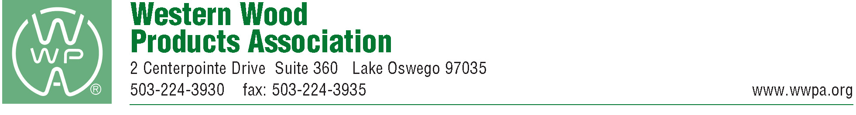
May 12, 2026
California Building Standards Commission
Attention: Public Comments
2525 Natomas Park Drive, Suite 130
Sacramento, CA 95833
Re: 45-Day Express Terms for Proposed Building Standards of the Office of State Fire Marshal Regarding the 2025 California Wildland-Urban Interface Code, California Code of Regulations, Title 24, Part 7

Western Wood Products Association (WWPA) represents lumber manufacturers in the 12 Western states and Alaska. The largest lumber association in the region, WWPA provides service covering over 8 billion board feet of annual Western lumber production, representing more than 60% of the lumber manufactured in the West each year.

WWPA would like to offer comments on the proposed revision to the 2025 California Wildland-Urban Interface Code:
Section 504.5
1. We would strike the non-mandatory bracketed sentence added before the provisions of Section 504.5 as it conflicts with other mandatory provisions of 504.5.

2. At the end of Item 2 we would strike “applied over exterior wall assemblies” as an exterior wall covering is already part of the exterior wall assembly.

3. We would strike the last sentence of Section 504.5 as it is unnecessary, and its ambiguity will likely lead to misinterpretations.

4. At the end of Item 1 we request that the following is added: “rated from the exterior side” to clarify that the 1-hour fire-resistance-rated exterior wall assembly must be rated from the exterior side.

6. The last sentence in Section 504.5.2 should be deleted because it conflicts with the charging language of 504.5, which requires compliance with either 504.5.1 or 504.5.2, but not necessarily both. Furthermore, the term “fire performance,” as used in this proposed new sentence, is ambiguous and undefined. It is not clear how compliance with this proposed new sentence would be demonstrated.

Thank you for the opportunity to comment and WWPA is happy to answer any questions the California Building Standards Committee may have and be of assistance to the Committee in any way possible.

Sincerely,
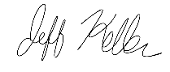
Jeff Keller
President
Western Wood Products Association

