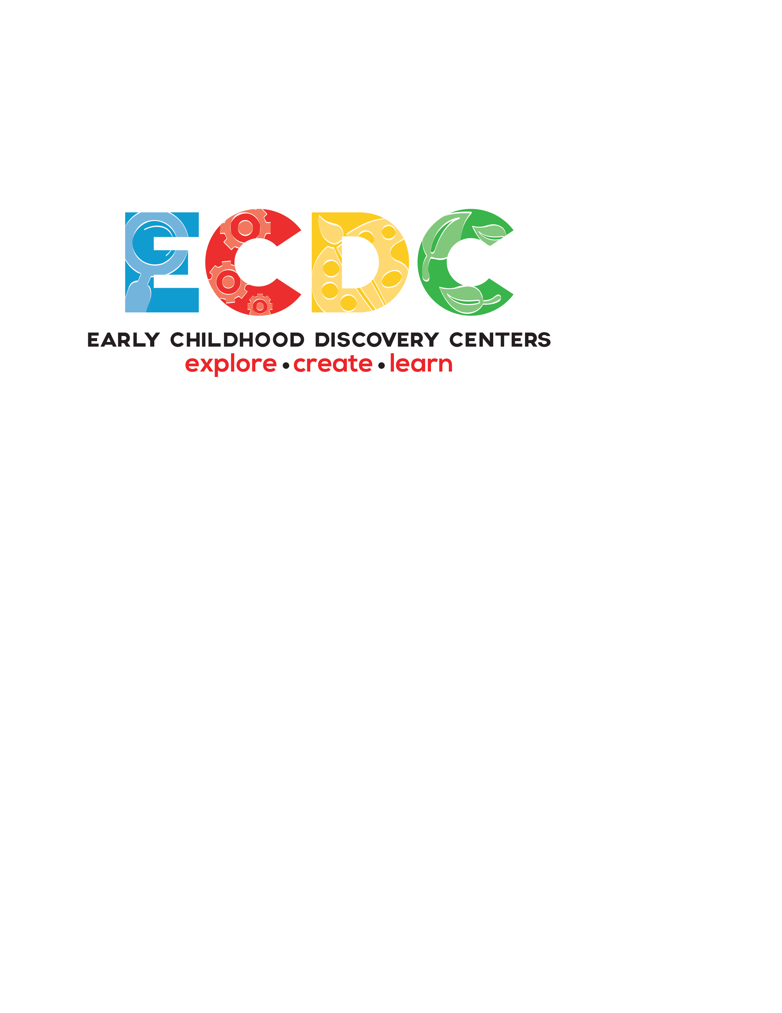

May 18, 2026

To the California Building Standards Commission:
On behalf of Early Childhood Discovery Centers, Inc., we appreciate the opportunity to submit public comments regarding the proposed amendments to the Intervening Supplement to the 2025 California Building Standards Code (Title 24), specifically relating to Parts 1, 2, and 10.
While we support the general intent of these amendments to ensure safety within the built environment, we wish to express significant concerns regarding the regulatory conflict between Title 22 and Title 24. This conflict currently centers on the threshold for reclassifying a childcare center from Group E (Educational) to Group I-4 (Institutional) when serving more than six children under 36 months of age.
Our primary concerns are as follows:
1. Prohibitive Costs of "Change of Occupancy" Requirements
Current code interpretations often require a "change of occupancy" designation to move from Group E to Group I-4. This triggers a suite of high-cost requirements, including the installation of smoke barriers and one-hour fire-resistive wall ratings. Furthermore, under Title 24, Part 9, local fire officials may mandate full automatic fire sprinkler systems for any occupancy change deemed "more hazardous." For our small business and nonprofit members, retrofitting older facilities with these systems can cost hundreds of thousands of dollars, often exceeding their entire expansion budgets and CCTR contract funding.
2. Impact on Child Care Capacity and Access
The financial burden of these building standards is preventing providers from utilizing their full licensed capacity. We are seeing a direct correlation between these strict I-4 requirements and a shortage of infant care slots. In many regions, providers with awarded expansion funding are unable to open new classrooms because the cost of fire safety upgrades is simply unsustainable.
3 Recommendation for Workable Solutions
We urge the Commission to consider more flexible amendments that maintain high safety standards without the prohibitive costs of full institutional reclassification. We advocate for solutions similar to those explored in Assembly Bill 176, which seek to bridge the gap between necessary safety and the practical financial realities of the childcare industry.
Early Childhood Discovery Centers, Inc., is hopeful that the Commission will address these concerns before the final approval of the Intervening Supplement. We believe that with minor adjustments to the language regarding infant care thresholds, California can support both child safety and the expansion of much-needed infant and toddler care slots.
Thank you for your time and for your consideration of these comments.
Sincerely,

Ken J. Herron
CFO/Co-Owner

