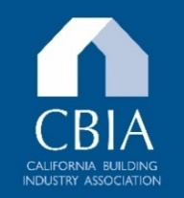

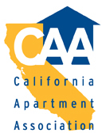

Date: May 20, 2026

To: Stoyan Bumbalov, Executive Director
California Building Standards Commission
stoyan.bumbalov@dgs.ca.gov

From: California Building Industry Association California Apartment Association
California Business Properties Association Building Owners & Managers Association

RE: Support for: Department of Housing & Community Development 45-Day Express Terms
2025 California Building Code, Part 2 (HCD 1-AC 01/25)
2025 California Electrical Code, Part 3 (HCD 1-AC 01/25)
2025 California Mechanical Code, Part 4 (HCD 1-AC 01/25)
2025 California Plumbing Code, Part 5 (HCD 1-AC 01/25)

The trade associations cited above, the Industry Coalition, represent California’s residential and non-residential construction and management industries. The Industry Coalition supports the Department of Housing’s proposed changes to the Disabled Accessibility provisions in the California Building Code, California Electrical Code, California Mechanical Code, and California Plumbing Code (HCD 1-AC 01/25).

