INITIAL EXPRESS TERMS
FOR PROPOSED BUILDING STANDARDS
OF THE CALIFORNIA DEPARTMENT OF HOUSING AND COMMUNITY DEVELOPMENT
REGARDING THE 2025 CALIFORNIA GREEN BUILDING STANDARDS CODE
CALIFORNIA CODE OF REGULATIONS, TITLE 24, PART 11
(HCD 01/25)
The state agency shall draft the regulations in plain, straightforward language, avoiding technical terms as much as possible and using a coherent and easily readable style. The agency shall draft the regulation in plain English. A notation shall follow the express terms of each regulation listing the specific statutes authorizing the adoption and listing specific statutes being implemented, interpreted, or made specific (Government Code Section 11346.2(a)(1)).
If using assistive technology, please adjust your settings to recognize underline, strikeout and ellipsis.

LEGEND for EXPRESS TERMS
- Existing California amendments appear upright
- Amended or new California amendments appear underlined
- Repealed California language appears upright and in strikeout
- Ellipses ( ...) indicate existing text remains unchanged

INITIAL EXPRESS TERMS

ITEM 1
Chapter 3 Green Building, Section 301.1.1 Additions and alterations. HCD proposes to continue to adopt the above-referenced section with amendments as follows:
301.1.1 Additions and alterations.
[HCD] The mandatory provisions of Chapter 4 shall be applied to additions or alterations of existing residential buildings where the addition and alteration increases the building’s conditioned area, volume or size. The requirements shall apply to and/or within the specific area of the addition or alteration.
The mandatory provisions of Section 4.106.4.2 may apply to additions or alterations of existing parking facilities or the addition of new parking facilities serving existing multifamily buildings, hotels and motels. See Section 4.106.4.3 4.106.4.5 for application.
NOTE: Repairs including, but not limited to, resurfacing, restriping, and repairing or maintaining existing lighting fixtures are not considered alterations for the purpose of this section.

Notation:
Authority: Health and Safety Code Sections 17040, 17921, 17928, 17958.12, 18941.10, 18941.11, 19990; and Government Code Sections, 12955.1 and 12955.1.1.
Reference(s): Health and Safety Code Sections 17040, 17921, 17928, 18938.3, 18941.5, 19990 and 19984; Government Code Section 12955.1; and Vehicle Code Section 22511.2.

ITEM 2
Chapter 4 Residential Mandatory Measures, Section 4.106.4.3 Electric vehicle charging for additions and alterations of parking facilities serving existing multifamily buildings, hotels and motels. HCD proposes to continue to adopt the above-referenced section with amendments as follows:
4.106.4.3 4.106.5 Electric vehicle charging for additions and alterations of parking facilities serving existing multifamily buildings, hotels and motels.
When existing parking facilities are altered or new parking spaces are added to existing parking facilities, and the work requires a building permit, each parking space added or altered shall have access to either a low power Level 2 EV charging receptacle or Level 2 EV charger, unless determined as infeasible by the project builder or designer and subject to concurrence of the local enforcing agency.
Exception: Where work requiring a permit is being performed for the installation of 120-volt electrical receptacle(s) for level 1 EV charging.

Notation:
Authority: Health and Safety Code Sections 17040, 17921, 17928, 17958.12, 18941.10, 18941.11, 19990; and Government Code Sections 12955.1 and 12955.1.1.
Reference(s): Health and Safety Code Sections 17040, 17921, 17928, 18938.3, 18941.5, 19990 and 19984; Government Code Section12955.1; and Vehicle Code Section 22511.2.

ITEM 3
Chapter 4 Residential Mandatory Measures, Section 4.106.4.4 Bicycle parking. HCD proposes to continue to adopt the above-referenced section with amendments as follows:
4.106.4.4 4.106.6. Bicycle parking. Comply with sections 4.106.4.4.1 4.106.6.1 through 4.106.4.4.3 4.106.6.3.
4.106.4.4.1 4.106.6.1 Short-term bicycle parking for multifamily buildings, hotels and motels. Provide on-site bicycle parking at a ratio of one parking space for every 10,000 square feet, but not less than two spaces. Short-term bicycle parking shall be located within 200 feet of building entrances, and readily visible to passers-by. Acceptable parking facilities shall be conveniently accessed from the street and may include, but not be limited to:
- Permanently anchored bicycle parking devices, racks, or lockers in an unsheltered, open area.
- Covered or uncovered enclosures with permanently anchored bicycle parking devices or racks.
4.106.4.4.2 4.106.6.2 Long-term bicycle parking for multifamily buildings. Provide on-site bicycle parking at a ratio of one parking space for every two dwelling units. Acceptable parking facilities shall be conveniently accessed from the street and may include, but not be limited to:
- Covered, lockable enclosures with permanently anchored bicycle parking devices or racks.
- Lockable bicycle storage rooms with permanently anchored bicycle parking devices or racks.
- Lockable, weatherproof, permanently anchored bicycle lockers.
4.106.4.4.3 4.106.6.3 Long-term bicycle parking for hotel and motel buildings. Provide one on-site long-term bicycle parking space for every 25,000 square feet, but not less than two. Acceptable parking facilities shall be conveniently accessed from the street and may include, but not be limited to:
- Covered, lockable enclosures with permanently anchored bicycle parking devices or racks.
- Lockable bicycle storage rooms with permanently anchored bicycle parking devices or racks.
- Lockable, weatherproof, permanently anchored bicycle lockers.

Notation:
Authority: Health and Safety Code Sections 17040, 17921, 17928, 17958.12, 19990; and Government Code Sections 12955.1 and 12955.1.1.
Reference(s): Health and Safety Code Sections 17040, 17921, 17928, 18938.3, 18941.5, 18944.19, 19984 and 19990; Government Code Section 12955.1; and Vehicle Code Section 22511.2.

ITEM 4
Chapter 4 Residential Mandatory Measures, Section 4.408.2 Construction waste management plan. HCD proposes to continue to adopt the above-referenced section with amendments as follows:
4.408.2 Construction waste management plan.
Submit a construction waste management plan in conformance with Items 1 through 5. The construction waste management plan shall be updated as necessary and shall be available during construction for examination by the enforcing agency.
- Identify the construction and demolition waste materials to be diverted from disposal by recycling, reuse on the project or salvage for future use or sale.
- Specify if construction and demolition waste materials will be sorted on-site (source-separated) or bulk mixed (single stream).
- Identify diversion facilities where the construction and demolition waste material will be taken.
Note: Carpet waste diversion facility locations and information are available on the CalRecycle Carpet Materials Management webpage at: https://calrecycle.ca.gov/carpet/.
- Identify construction methods employed to reduce the amount of construction and demolition waste generated.
- Specify that the amount of construction and demolition waste materials diverted shall be calculated by weight or volume, but not by both.

Notation:
Authority: Health and Safety Code Sections 17040, 17921, 17928, 17958.12, 19990; and Government Code Sections 12955.1 and 12955.1.1.
References: Health and Safety Code Sections 17040, 17921, 17928, 18938.3, 18941.5, 19990 and 19984; Government Code Section 12955.1; and Vehicle Code Section 22511.2.

ITEM 5
Chapter 4 Residential Mandatory Measures, Section 4.507.2 Heating and air-conditioning system design. HCD proposes to continue to adopt the above-referenced section with amendments as follows:
4.507.2. Heating and air-conditioning system design.
Heating and air-conditioning systems shall be sized, designed and have their equipment selected using the following methods:
- The heat loss and heat gain is established according to ANSI/ACCA 2 Manual J –2016 (Residential Load Calculation), ASHRAE handbooks, or other equivalent design software or methods. sections 150.0 (h)(1) and (2) of the California Energy Code.
- Duct systems are sized according to ANSI/ACCA 1 Manual D—2016 (Residential Duct Systems), ASHRAE handbooks, or other equivalent design software or methods.
- Select heating and cooling equipment according to ANSI/ACCA 3 Manual S—2014 (Residential Equipment Selection) or other equivalent design software or methods. section 150.0 (h)(5) of the California Energy Code.
Exception: Use of alternate design temperatures necessary to ensure the systems function are acceptable.

Notation:
Authority: Health and Safety Code Sections 17040, 17921, 17928, 17958.12, 19990; and Government Code Sections 12955.1 and 12955.1.1.
References: Health and Safety Code Sections 17040, 17921, 17928, 18938.3, 18941.5, 19990 and 19984; Government Code Section 12955.1; and Vehicle Code Section 22511.2.

ITEM 6
Appendix A4 Residential Voluntary Measures, Section A4.602 Residential Occupancies Application Checklist. HCD proposes to continue to adopt the above-referenced section with amendments as follows:
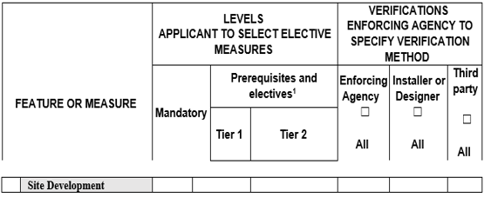
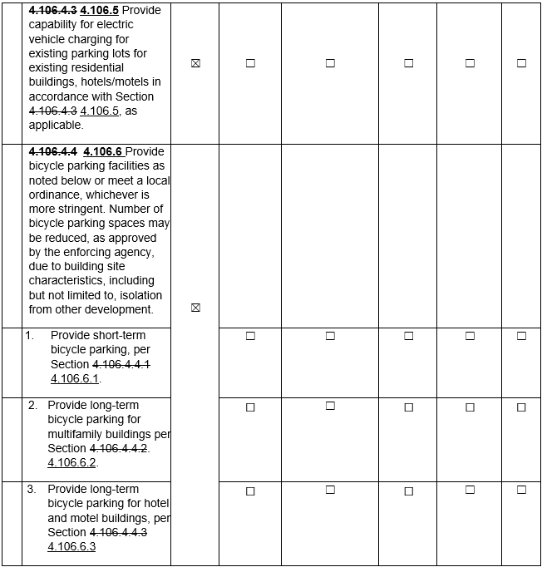

Notation:
Authority: Health and Safety Code Sections 17040, 17921, 17928, 17958.12, 18941.10, 18941.11, 19990; and Government Code Sections 12955.1 and 12955.1.1.
References: Health and Safety Code Sections 17040, 17921, 17928, 18938.3, 18941.5, 18944.19, 19984 and 19990; Government Code Section 12955.1; and Vehicle Code Section 22511.2.

