INITIAL EXPRESS TERMS
FOR PROPOSED BUILDING STANDARDS
OF THE CALIFORNIA DEPARTMENT OF HOUSING AND COMMUNITY DEVELOPMENT
REGARDING THE 2022 CALIFORNIA BUILDING CODE,
CALIFORNIA CODE OF REGULATIONS, TITLE 24, PART 2
(HCD 03/22)
The State agency shall draft the regulations in plain, straightforward language, avoiding technical terms as much as possible and using a coherent and easily readable style. The agency shall draft the regulation in plain English. A notation shall follow the express terms of each regulation listing the specific statutes authorizing the adoption and listing specific statutes being implemented, interpreted, or made specific (Government Code Section 11346.2(a)(1)).
If using assistive technology, please adjust your settings to recognize underline, strikeout, italic and ellipsis.

LEGEND for EXPRESS TERMS
- Model Code language appears upright
- Existing California amendments appear in italic
- Amended model code or new California amendments appear underlined & italic
- Repealed model code language appears upright and in strikeout
- Repealed California amendments appear in italic and strikeout
- Ellipses ( ...) indicate existing text remains unchanged

INITIAL EXPRESS TERMS

ITEM 1
Chapter 12 Interior Environment, Section 1202.3 Unvented attic and unvented enclosed rafter assemblies.
[HCD proposes to repeal a California amendment in Section 1202.3, Item 5.1 as follows:]
1202.3 Unvented attic and unvented enclosed rafter assemblies. Unvented attics and unvented enclosed roof framing assemblies created by ceilings applied directly to the underside of the roof framing members/rafters and the structural roof sheathing at the top of the roof framing members shall be permitted where all of the following conditions are met: [No change to model code text.]
- The unvented attic space is completely within the building thermal envelope. [No change to model code text.]
- No interior Class I vapor retarders are installed on the ceiling side (attic floor) of the unvented attic assembly or on the ceiling side of the unvented enclosed roof framing assembly. [No change to model code text.]
- Where wood shingles or shakes are used, not less than a 1/4-inch (6.4 mm) vented airspace separates the shingles or shakes and the roofing underlayment above the structural sheathing. [No change to model code text.]
- In Climate Zones 5, 6, 7 and 8, any air-impermeable insulation shall be a Class II vapor retarder or shall have a Class II vapor retarder coating or covering in direct contact with the underside of the insulation. [No change to model code text.]
  - [HCD 1 & HCD 2] In Climate Zones 14 and 16, a Class I or Class II vapor retarder shall be installed on the indirectly conditioned space side of all insulation in an unvented attic with air-permeable insulation, for condensation control.
- Insulation shall comply with either Item 5.1 or Item 5.2, and additionally Item 5.3. [No change to model code text.]
  - Item 5.1.1, 5.1.2, 5.1.3 or 5.1.4 shall be met, depending on the air permeability of the insulation directly under the structural roof sheathing. [HCD 1 & HCD 2] No insulation shall be required when roof tiles, wood shingles or wood shakes, or any other roofing system using battens and no continuous underlayment is installed. A continuous underlayment shall be considered to exist if sheathing, roofing paper or any continuous layer having a perm rate of no more than one perm under the dry cup method is present.
    - Where only air-impermeable insulation is provided, it shall be applied in direct contact with the underside of the structural roof sheathing. [No change to model code text.]
    - Where air-permeable insulation is provided inside the building thermal envelope, it shall be installed in accordance with Item 5.1.1. In addition to the air-permeable insulation installed directly below the structural sheathing, rigid board or sheet insulation shall be installed directly above the structural roof sheathing in accordance with the R-values in Table 1202.3 for condensation control. [No change to model code text.]
    - Where both air-impermeable and air-permeable insulation are provided, the air-impermeable insulation shall be applied in direct contact with the underside of the structural roof sheathing and shall be accordance with the R-values in Table 1202.3 for condensation control. The air-permeable insulation shall be installed directly under the air-impermeable insulation. [No change to model code text.]
    - Alternatively, sufficient rigid board or sheet insulation shall be installed directly above the structural roof sheathing to maintain the monthly average temperature of the underside of the structural roof sheathing above 45°F (7°C). For calculation purposes, an interior air temperature of 68°F (20°C) is assumed and the exterior air temperature is assumed to be the monthly average outside air temperature of the three coldest months. [No change to model code text.]
  - In Climate Zones 1, 2 and 3, … [No change to model code text.]
Notation:
Authority: Health and Safety Code Sections 17040, 17920.9, 17921, 17922, 17922.6, 17926, 17928, 17958.12, 18552, 18620, 18871.3, 18873, 18873.5, 18938.3, and 19990; and Government Code Sections 12955.1.
Reference(s): Health and Safety Code Sections 17040, 17042, 17921, 17922, 17922.6, 17922.15, 18300, 18400, 18620, 18866, 18873, 18938.3, 18941, 19984, 19990, and 19991; Business and Professions Code Sections 5537 and 6737.1; and Government Code Section 12955.1.

ITEM 2
Chapter 14 Exterior Walls, Sections 1404.3 Vapor retarders, Section 1404.3.2 Class III Vapor retarders and Table 1404.4(3) Class III Vapor Retarders.
[HCD proposes to repeal California amendments in Sections 1404.3 and 1404.3.2 and adopt Table 1404.3(3) as follows:]
1404.3 Vapor retarders. Vapor retarder materials shall be classified in accordance with Table 1404.3(1). A vapor retarder shall be provided on the interior side of frame walls in accordance with Tables 1404.3(2) and 1404.3(3), or an approved design using accepted engineering practice for hygrothermal analysis. The appropriate climate zone shall be selected in accordance with Chapter 3 of the California Energy Code.
Where a Class II vapor retarder is used in combination with foam plastic insulating sheathing installed as continuous insulation on the exterior side of frame walls, the continuous insulation shall comply with Table 1404.3(4) and the Class II vapor retarder shall have a vapor permeance greater than 1 perm when measured by ASTM E96 water method (Procedure B). Use of a Class I interior vapor retarder in frame walls with a Class I vapor retarder on the exterior side shall require an approved design. [No change to 2022 CBC text.]
[HCD 1 & HCD 2] Class I or II vapor retarders shall be provided on the interior side of frame walls of low-rise residential buildings in California Climate Zones 14 and 16, as required in the California Energy Code (see definition of "Low-rise residential building").
Exceptions: [No change to model code Exceptions 1 through 4.]
- Basement walls.
- Below-grade portion of any wall.
- Construction where accumulation, condensation or freezing of moisture will not damage the materials.
- Class I and II vapor retarders with vapor permeance greater than 1 perm when measured by ASTM E96 water method (Procedure B) shall be allowed on the interior side of any frame wall in all climate zones.
1404.3.2 Class III vapor retarders. Only Class III vapor retarders shall be used on the interior side of frame walls where foam plastic insulating sheathing with a perm rating of less than 1 is applied in accordance with Table 1404.3(3) on the exterior side of the frame wall. [Section deleted in the 2021 International Building Code (IBC) errata posted on January 4, 2021.]
[HCD 1 & HCD 2] Class III vapor retarders shall be permitted where any one of the conditions in Items 1, 2 or 3 below are met. This section shall apply to “Low-rise residential buildings” as defined in the California Energy Code.
- Vented cladding over fiberboard
- Vented cladding over gypsum
- Insulated sheathing with R-value ≥ R4
Spray foam with a minimum density of 2 lbs/ft³ applied to the interior cavity side of OSB, plywood, fiberboard, insulating sheathing or gypsum is deemed to meet the insulating sheathing requirement where the spray foam R-value meets or exceeds the specified insulating sheathing R-value.
TABLE 1404.3(3) CLASS III VAPOR RETARDERS
[Adopt without change to existing 2022 CBC text.]
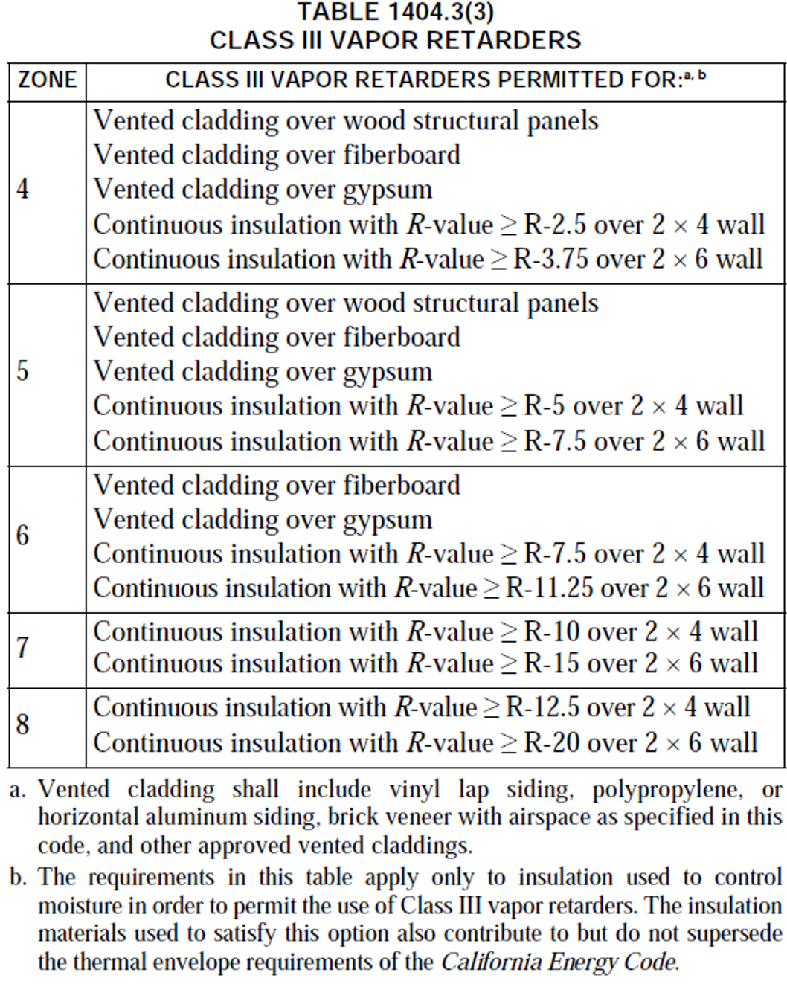
Notation:
Authority: Health and Safety Code Sections 17040, 17920.9, 17921, 17922, 17922.6, 17926, 17928, 17958.12, 18552, 18620, 18871.3, 18873, 18873.5, 18938.3, and 19990; and Government Code Sections 12955.1.
Reference(s): Health and Safety Code Sections 17040, 17042, 17921, 17922, 17922.6, 17922.15, 18300, 18400, 18620, 18866, 18873, 18938.3, 18941, 19984, 19990, 19991; Business and Professions Code Sections 5537 and 6737.1 and Government Code Section 12955.1.

