APPROVED BY THE CALIFORNIA BUILDING STANDARDS COMMISSION

DECEMBER 14, 2021

FINAL EXPRESS TERMS
FOR PROPOSED BUILDING STANDARDS
OF THE STATE FIRE MARSHAL
REGARDING THE 2022 CALIFORNIA PLUMBING CODE,

CALIFORNIA CODE OF REGULATIONS, TITLE 24, PART 5

(SFM 02/21)
The State agency shall draft the regulations in plain, straightforward language, avoiding technical terms as much as possible and using a coherent and easily readable style. The agency shall draft the regulation in plain English. A notation shall follow the express terms of each regulation listing the specific statutes authorizing the adoption and listing specific statutes being implemented, interpreted, or made specific (Government Code Section 11346.2(a)(1)).
If using assistive technology, please adjust your settings to recognize underline, strikeout, italic and ellipsis.

LEGEND for EXPRESS TERMS (Based on model codes - Parts 2, 2.5, 3, 4, 5, 9, 10)
- Model Code language appears upright
- Existing California amendments appear in italic
- Amended model code or new California amendments appear underlined & italic
- Repealed model code language appears upright and in strikeout
- Repealed California amendments appear in italic and strikeout
- Ellipsis ( ...) indicate existing text remains unchanged

The Office of the State Fire Marshal (SFM) proposes to adopt the 2021 edition of the Uniform Plumbing Code (UPC) into the 2022 edition of the California Plumbing Code (CMC). SFM further proposes to:

Repeal the adoption by reference of the 2018 Uniform Plumbing Code and incorporate and adopt by reference in its place the 2021 Uniform Plumbing Code for application and effectiveness in the 2022 California Plumbing Code.

Repeal certain amendments to the 2018 Uniform Plumbing Code and/or California Building Standards not addressed by the model code that are no longer necessary.

Adopt new building standards or necessary amendments to the 2021 Uniform Plumbing Code that address inadequacies of the 2021 Uniform Plumbing Code as they pertain to California laws.

Bring forward previously existing California building standards or amendments, which represent no change in their effect from the 2019 California Building Standards Code.

Codify non-substantive editorial and formatting amendments from the format based upon the 2018 Uniform Plumbing Code to the format of the 2021 Uniform Plumbing Code.

FINAL EXPRESS TERMS

CHAPTER 1
ADMINISTRATION
DIVISION I
CALIFORNIA ADMINISTRATION

Item 1-1
Chapter 1, Administration, Division I, California Administration, Section 1.1.1 Title

1.1.1 Title. These regulations shall be known as the California Plumbing Code, may be cited as such and will be referred to herein as “this code.” The California Plumbing Code is Part 5 of thirteen parts of the official compilation and publication of the adoption, amendment, and repeal of building regulations to the California Code of Regulations, Title 24, also referred to as the California Building Standards Code. This part incorporates by adoption the 2018 2021 Uniform Plumbing Code of the International Association of Plumbing and Mechanical Officials with necessary California amendments.

…

Item 1-2
Chapter 1, Administration, Division I, California Administration, Section 1.1.0 General through 1.1.12

[The SFM is proposing to maintain the adoption of those existing California provisions contained Sections 1.1.0 through 1.1.12.]

Item 1-3
Chapter 1, Administration, Division I, California Administration, Section 1.11.0 through 1.11.11

[The SFM is proposing to maintain the adoption of those existing California provisions contained in Sections 1.11.0 through 1.11.11.]

Item 1-4
Chapter 1, Administration, Division I, California Administration, Section 1.11.4.4 Fire Clearance Preinspection

[For Items 1-4 through Item 1-7, the SFM is proposing to maintain the adoption of those existing California provisions contained in Sections 1.11.0 through 1.11.11 with modifications as shown below.]

[The SFM is proposing to amend the section listed below]

1.11.4.4 Fire Clearance Preinspection. Pursuant to Health and Safety Code Section 13235, Fire Clearance Preinspection, fee, upon receipt of a request from a prospective licensee of a community care facility, as defined in Section 1502, of a residential care facility for the elderly, as defined in Section 1569.2, or of a child day care facility, as defined in Section 1596.750, the local fire enforcing agency, as defined in Section 13244, or State Fire Marshal, whichever has primary jurisdiction, shall conduct a preinspection of the facility prior to the final fire clearance approval. At the time of the preinspection, the primary fire enforcing agency shall price consultation and interpretation of the fire safety regulations and shall notify the prospective licensee of the facility in writing of the specific fire safety regulations which shall be enforced in order to obtain fire clearance approval. A fee equal to, but not exceeding, the actual cost of the of the preinspection services not more than $50.00 may be charged for the preinspection of a facility. with a capacity to serve 25 or fewer persons. A fee of not more than $100.00 may be charged for a preinspection of a facility with a capacity to serve 26 or more persons.

Item 1-5
Chapter 1, Administration, Division I, California Administration, Section 1.11.4.5 Care Facilities

[The SFM is proposing to amend the section listed below]

1.11.4.5 Care Facilities. The primary fire enforcing agency shall complete the final fire clearance inspection for a community care facility, residential care facility for the elderly, or child day care facility within 30 days of receipt of the request for the final inspection, or as of the date the prospective facility requests the final prelicensure inspection by the State Department of Social Services, whichever is later.
Pursuant to Health and Safety Code Section 13235, a preinspection fee equal to, but not exceeding, the actual cost of the of the preinspection services of not more than $50.00 may be charged for the preinspection of a facility. with a capacity to serve 25 or less clients. A fee of not more than $100.00 may be charged for a preinspection of a facility with a capacity to serve 26 or more clients.

…

Item 1-6
Chapter 1, Administration, Division I, California Administration, Section 1.11.6 Certificate of Occupancy

[The SFM is proposing to amend the section listed below]

1.11.6 Certificate of Occupancy. A Certificate of Occupancy shall be issued as specified in Title 24, Part 2, California Building Code, Section 111.

Exception: Group R, Division 3 and Group U occupancies. Certificates of occupancy are not required for work exempt from permits in accordance with Section 105.2 of the California Building Code.

Item 1-7
Chapter 1, Administration, Division I, California Administration, Section 1.11.7 Temporary Structures and Uses

[The SFM is proposing to amend the section listed below]

1.11.7 Temporary Structures and Uses. See Title 24, Part 2, California Building Code, Section 1078.

CHAPTER 1
ADMINISTRATION

DIVISION II
ADMINISTRATION

Item 1-8
Chapter 1, Administration, Division II, Administration

[The SFM proposes to not adopt Chapter 1, Administration, Division II Administration.]

Notation:
Authority: Health and Safety Code Sections 1250, 1569.72, 1569.78, 1568.02, 1502, 1597.44, 1597.45, 1597.46, 1597.54, 1597.65, 13108, 13108.5, 13114, 13143, 13143.2, 13143.6, 13146, 13210, 13211, 17921, 18949.2, 25500 through 25545, Government Code Section 51189, Public Education Code 17074.50
Reference(s): Health and Safety Code Sections 13143, 13211, 18949.2, 25500 through 25545, Government Code Sections 51176, 51177, 51178 and 51179, Public Resources Code Sections 4201 through 4204

CHAPTER 2
DEFINITIONS

Item 2-1
Chapter 2, Definitions

[The SFM proposes to adopt Chapter 2 without amendments.]

Notation:
Authority: Health and Safety Code Sections 1250, 1569.72, 1569.78, 1568.02, 1502, 1597.44, 1597.45, 1597.46, 1597.54, 1597.65, 13108, 13108.5, 13114, 13143, 13143.2, 13143.6, 13146, 13210, 13211, 17921, 18949.2, 25500 through 25545, Government Code Section 51189, Public Education Code 17074.50

Reference(s): Health and Safety Code Sections 13143, 13211, 18949.2, 25500 through 25545, Government Code Sections 51176, 51177, 51178 and 51179, Public Resources Code Sections 4201 through 4204

CHAPTER 3
GENERAL REGULATIONS

Item 3-1
Chapter 3, General Regulations

[The SFM proposes to adopt Chapter 3 and carry forward existing amendments.]

Notation:
Authority: Health and Safety Code Sections 1250, 1569.72, 1569.78, 1568.02, 1502, 1597.44, 1597.45, 1597.46, 1597.54, 1597.65, 13108, 13108.5, 13114, 13143, 13143.2, 13143.6, 13146, 13210, 13211, 17921, 18949.2, 25500 through 25545, Government Code Section 51189, Public Education Code 17074.50

Reference(s): Health and Safety Code Sections 13143, 13211, 18949.2, 25500 through 25545, Government Code Sections 51176, 51177, 51178 and 51179, Public Resources Code Sections 4201 through 4204

CHAPTER 4
PLUMBING FIXTURES AND FIXTURE FITTINGS

Item 4-1
Chapter 4, Plumbing Fixtures and Fixture Fittings

[The SFM proposes to not adopt Chapter 4.]

Notation:
Authority: Health and Safety Code Sections 1250, 1569.72, 1569.78, 1568.02, 1502, 1597.44, 1597.45, 1597.46, 1597.54, 1597.65, 13108, 13108.5, 13114, 13143, 13143.2, 13143.6, 13146, 13210, 13211, 17921, 18949.2, 25500 through 25545, Government Code Section 51189, Public Education Code 17074.50

Reference(s): Health and Safety Code Sections 13143, 13211, 18949.2, 25500 through 25545, Government Code Sections 51176, 51177, 51178 and 51179, Public Resources Code Sections 4201 through 4204

CHAPTER 5
WATER HEATERS

Item 5-1
Chapter 5, Water Heaters

[The SFM proposes to adopt Chapter 5 and carry forward existing amendments.]

Notation:
Authority: Health and Safety Code Sections 1250, 1569.72, 1569.78, 1568.02, 1502, 1597.44, 1597.45, 1597.46, 1597.54, 1597.65, 13108, 13108.5, 13114, 13143, 13143.2, 13143.6, 13146, 13210, 13211, 17921, 18949.2, 25500 through 25545, Government Code Section 51189, Public Education Code 17074.50

Reference(s): Health and Safety Code Sections 13143, 13211, 18949.2, 25500 through 25545, Government Code Sections 51176, 51177, 51178 and 51179, Public Resources Code Sections 4201 through 4204

CHAPTER 6
WATER SUPPLY AND DISTRIBUTION

Item 6-1
Chapter 6, Water Supply And Distribution,Section 603.5.14 Protection from Fire Systems

[The SFM is proposing to maintain the adoption by reference California amendment Section 603.5.14 Note.]

Item 6-2
Chapter 6, Water Supply and Distribution,Section 612.1 Where Required

[Associated proposals 6-3 and 17-1]

612.1 Installation. Residential Sprinkler Systems shall be installed in compliance with the California Residential Code or the California Fire Code. Where Required. Where residential sprinkler systems are required in one and two-family dwellings or townhouses, the systems shall be installed by personnel, installer, or both, certified in accordance with ASSE Series 7000 in accordance with this section or NFPA 13D. This section shall be considered equivalent to NFPA 13D. Partial residential sprinkler systems shall be permitted to be installed in buildings not required to be equipped with a residential sprinkler system.

Item 6-3
Chapter 6, Water Supply and Distribution, Sections 612.2 through 612.7.2

[Delete and remove Sections 612.2 through 612.7.2, including all Tables in Section 612. Associated proposals 6-2 and 17-1]

612.2 Types of Systems. This section shall apply to standalone and multipurpose wet-pipe sprinkler systems that do not include the use of antifreeze. A multipurpose fire sprinkler system shall provide potable water to both fire sprinklers and plumbing fixtures. A stand-alone sprinkler system shall be separate and independent from the potable water distribution system. A backflow preventer shall not be required to separate a stand-alone sprinkler system from the water distribution system where the sprinkler system material is in accordance with the requirements of Section 604.0.

612.3 Sprinklers. Sprinklers shall be installed in accordance with Section 612.3.1 through Section 612.3.7.

612.3.1 Required Sprinkler Locations. Sprinklers shall be installed to protect all floor areas of a dwelling unit in one and two-family dwellings or townhouses.

Exceptions:
(1) Attics, crawl spaces, and normally unoccupied concealed spaces that do not contain fuel-fired appliances do not require sprinklers. In attics, crawl spaces, and normally unoccupied concealed spaces that contain fuel-fired equipment, a sprinkler shall be provided to protect the equipment; however, sprinklers shall not be required in the remainder of the space.

(2) Clothes closets, linen closets, and pantries that do not exceed 24 square feet (2.2 m2 ) in area, with the smallest dimension not exceeding 3 feet (914 mm) and having wall and ceiling surfaces of gypsum board.

(3) Bathrooms and toilet rooms that do not exceed 55 square feet (5.1 m2) in area.

(4) Garages; carports; with no habitable space above; open attached exterior porches; unheated entry areas, such as mud rooms, that are adjacent to an exterior door; and similar areas.

(5) Covered unheated projections of the building at entrances/exits provided it is not the only means of egress from the dwelling unit.

(6) Ceiling pockets that meet the following requirements:

(a) The total volume of an unprotected ceiling pocket does not exceed 100 cubic feet (2.83 m3 ).

(b) The entire floor under the unprotected ceiling pocket is protected by the sprinklers at the lower ceiling elevation.

(c) Each unprotected ceiling pocket is separated from an adjacent unprotected ceiling pocket by not less than a 10 feet (3048 mm) horizontal distance.

(d) The interior finish of the unprotected ceiling pocket is noncombustible material.

(e) Skylights not exceeding 32 square feet (2.97 m2 ). 612.3.2 Sprinkler Installation. Sprinklers shall be listed residential sprinklers and shall be installed in accordance with the sprinkler manufacturer’s installation instructions. 612.3.3Temperature Rating and Separation from Heat Sources. Sprinklers shall have a temperature rating of not less than 135°F (57°C) and not more than 170°F (77°C). Sprinklers shall be separated from heat sources in accordance with the sprinkler manufacturer’s installation instructions.

612.3.2 Sprinkler Installation. Sprinklers shall be listed residential sprinklers and shall be installed in accordance with the sprinkler manufacturer’s installation instructions.

612.3.3 Temperature Rating and Separation from Heat Sources. Sprinklers shall have a temperature rating of not less than 135°F (57°C) and not more than 170°F (77°C). Sprinklers shall be separated from heat sources in accordance with the sprinkler manufacturer’s installation instructions.

Exception: Sprinklers located close to a heat source in accordance with Section 612.3.3.1 shall be intermediate temperature sprinklers.

612.3.3.1 Intermediate Temperature Sprinklers. Sprinklers shall have an intermediate temperature rating of not less than 175°F (79°C) and not more than 225°F (107°C) where installed in the following locations:

(1) Directly under skylights, where the sprinkler is exposed to direct sunlight.

(2) In attics and concealed spaces located directly beneath a roof.

(3) Within the distance to a heat source in accordance with Table 612.3.3.1.

612.3.4 Freezing Areas. The piping system shall be protected in accordance with the requirements of Chapter 3. Where sprinklers are required in areas that are subject to freezing, dry-sidewall or dry-pendent sprinklers extending from a non-freezing area into a freezing area shall be installed. Where fire sprinkler piping cannot be adequately protected against freezing, the system shall be designed and installed in accordance with NFPA 13D.

612.3.5 Coverage Area Limit. The area of coverage of a single sprinkler shall be based on the sprinkler listing and the sprinkler manufacturer’s installation instructions. The area of coverage of a single sprinkler shall not exceed 400 square feet (37.16 m2).

TABLE 612.3.3.1
LOCATIONS WHERE INTERMEDIATE TEMPERATURE
SPRINKLERS ARE REQUIRED
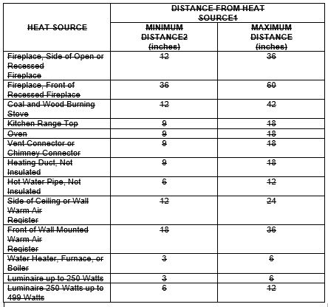
For SI units: 1 inch = 25.4 mm
Notes:
1 Distances shall be measured in a straight line from the nearest edge of the heat source to the nearest edge of the sprinkler.

2 Sprinklers shall not be located at distances less than the minimum table distance unless the sprinkler listing allows a lesser distance.

612.3.6 Obstructions to Sprinkler Coverage. The water discharge from a sprinkler shall not be blocked by obstructions unless additional sprinklers are installed to protect the obstructed area. Additional sprinklers shall not be required where sprinkler separation from obstructions is in accordance with the requirements of Table 612.3.6, or the minimum distances specified in the sprinkler manufacturer’s installation instructions.

612.3.6.1 Additional Requirements for Pendent Sprinklers. Pendent sprinklers located within 3 feet (914 mm) of the center of a ceiling fan, surface- mounted ceiling luminaire, or similar object shall be considered to be obstructed, and additional sprinklers shall be provided.

612.3.6.2 Additional Requirements for Sidewall Sprinklers. Sidewall sprinklers located within 5 feet (1524 mm) of the center of a ceiling fan, surface- mounted ceiling luminaire, or similar object shall be considered to be obstructed, and additional sprinklers shall be provided.

612.3.7 Sprinkler Modifications Prohibited. Sprinklers shall not be painted, caulked, or modified. A sprinkler that has been painted, caulked, modified, or damaged shall be replaced with a new sprinkler.

612.3.8 Backflow Protection. A backflow preventer shall not be required to separate a sprinkler system from the water distribution system, provided that:

(1) The system complies with NFPA 13D or Section R313, and

(2) Piping material are suitable for potable water in accordance with the California Plumbing Code, and

(3) The system does not contain antifreeze or have a fire department connection.

612.4 Sprinkler Piping System. Sprinkler piping systems shall be installed in accordance with Section 612.4.1 through Section 612.4.5.

612.4.1 General. Sprinkler piping shall be installed in accordance with the requirements for water distribution piping. Sprinkler piping shall comply with the material requirements for cold water distribution piping. For multipurpose piping systems, the sprinkler piping shall connect to and be a part of the cold water distribution piping system.

612.4.2 Nonmetallic Pipe and Tubing. Nonmetallic pipe and tubing, such as CPVC, PEX-AL-PEX, PE-RT, and PEX, shall be certified for residential sprinkler installations and shall have a pressure rating of not less than 130 psi (896 kPa) at 120°F (49°C).

612.4.2.1 Nonmetallic Pipe Protection. Nonmetallic pipe and tubing systems shall be protected from exposure to the occupied space by a layer of not less than 3⁄8 of an inch (9.5 mm) thick gypsum wallboard, 1⁄2 of an inch (12.7 mm) thick plywood, or other material having a 15-minute fire rating.
Exceptions:
(1) Pipe protection shall not be required in areas that are not required to be protected with sprinklers in accordance with Section 612.3.1.

(2) Pipe protection shall not be required where exposed piping is permitted by the pipe third party listing.

612.4.2.2 Sprinkler Installation on Systems Assembled with Solvent Cement. The solvent cementing of fittings shall be completed, and threaded adapters for sprinklers shall be verified as being clear of excess cement before the installation of sprinklers on systems assembled with solvent cement.

612.4.3 Shutoff Valves Prohibited. Shutoff valves shall not be installed in a location where the valve would isolate piping serving one or more sprinklers. Shutoff valves shall only be permitted for the entire water distribution system.

612.4.4 Single Dwelling Limit. The sprinkler piping beyond the service valve located at the beginning of the water distribution system shall serve only one dwelling unit.

612.4.5 Drain. A 1⁄2 inch (15 mm) drain for the sprinkler system shall be provided on the system side of the water distribution shutoff valve.

TABLE 612.3.6
MINIMUM SEPARATION FROM OBSTRUCTION
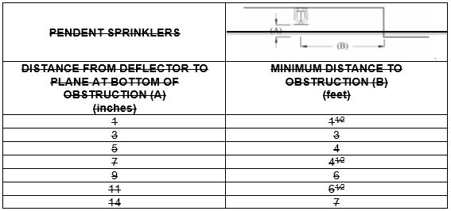
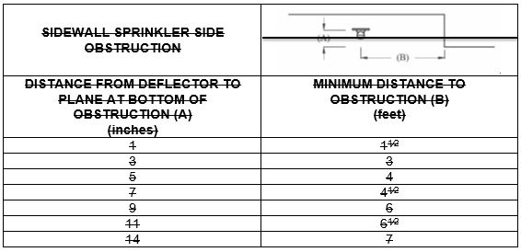

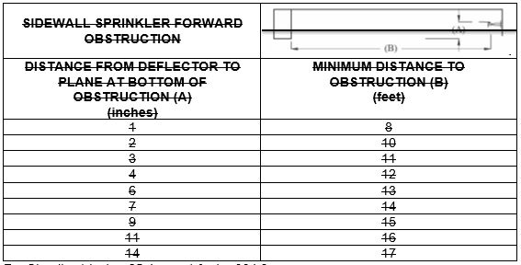
For SI units: 1 inch = 25.4 mm, 1 foot = 304.8 mm

612.5 Sprinkler Piping Design. Sprinkler piping systems shall be sized in accordance with Section 612.5.1 through Section 612.5.3.2.2.

612.5.1 Determining System Design Flow. The sizing of the sprinkler piping system shall be based on the flow rate and pressure of each sprinkler in accordance with Section 612.5.1.1 and the number of sprinklers in accordance with Section 612.5.1.3.

612.5.1.1 Determining Required Flow Rate for Each Sprinkler. The minimum flow rate and pressure for each residential sprinkler shall be in accordance with the manufacturer’s published data for the specific sprinkler model based on the following:
(1) The area of coverage.

(2) The ceiling configuration.

(3) The temperature rating.

(4) Additional conditions specified by the sprinkler manufacturer.

612.5.1.2 System Flow Rate. The flow rate used for sizing the sprinkler piping system shall be based on the following:
(1) The flow rate for a room having only one sprinkler shall be the flow rate required for the sprinkler in accordance with Section 612.5.1.1.

(2) The flow rate for a room having two or more sprinklers shall be determined by identifying the sprinkler in the room with the highest required flow rate in accordance with Section 612.5.1.1 and multiplying that flow rate by 2.

(3) Where the sprinkler manufacturer specifies different criteria for ceiling configurations that are not smooth, flat, and horizontal the required flow rate for that room shall be in accordance with the sprinkler manufacturer’s instructions.

(4) The flow rate used for sizing the sprinkler system shall be the flow required by the room with the largest flow rate in accordance with Section 612.5.1.2(1), Section 612.5.1.2(2), and Section 612.5.1.2(3).

(5) For the purpose of this section, it shall be permissible to reduce the flow rate for a room by subdividing the space into two or more rooms, where each room is evaluated separately on the required design flow rate. Each room shall be bounded by walls and a ceiling. Openings in walls shall have a lintel not less than 8 inches (203 mm) in depth, and each lintel shall form a solid barrier between the ceiling and the top of the opening.

612.5.1.3 Fire Sprinklers Attached Garages, and Carports with Habitable Space Above. Attached garages, and carports with habitable space above shall be protected by fire sprinklers in accordance with this section and Section R313. Protection shall be provided in accordance with one of the following:
(1) Residential Sprinklers installed in accordance with their listing.

(2) Extended Coverage sprinklers discharging water not less than their listed flow rate for Light Hazard in accordance with NFPA 13.

(3) Quick-Response spray sprinklers at light hazard spacing in accordance with NFPA 13 designed to discharge at 0.05 gpm/ft2 density (minimum). The system demand shall be permitted to be limited to the number of sprinklers in the compartment but shall not exceed two sprinklers for hydraulic calculation purposes. Garage doors shall not be considered obstructions and shall be permitted to be ignored for placement and calculation of sprinklers.

612.5.2 Sprinkler Pipe Water Supply. The water supply for a multipurpose or stand-alone sprinkler system shall be provided by the public water main, private water main, private well system, or storage tank. The water supply required shall be determined in accordance with Section 612.5.1.2 at a pressure not less than that used in accordance with Section 612.5.3. Where a water supply serves both domestic and fire sprinkler systems, 5 gpm (19 L/min) shall be added to the sprinkler system demand at the point where the systems are connected, to determine the size of common piping and the size of the total water supply requirements where no provision is made to prevent flow into the domestic water system upon operation of a sprinkler.

612.5.2.1 Water Pressure from Individual Sources. Where a dwelling unit water supply is from a tank system, a private well system, a pump, or a combination of these, the available water pressure shall be based on the minimum pressure control setting of the pump.

612.5.2.2 Required Capacity. The water supply shall have the capacity to provide the required flow rate to the sprinklers for a period of time as follows:
(1) Seven minutes for one story dwelling units less than 2000 square feet (185.8 m2) in area. For the purpose of determining the area of the dwelling unit, the area of attached garages and attached open carports, porches, balconies and patios shall not be included.

(2) Ten minutes for multi-level dwelling units and one story dwelling units not less than 2000 square feet (185.8 m2) in the area. For the purpose of determining the area of the dwelling unit, the area of attached garages and attached open carports, porches, balconies, and patios shall not be included. Where a well system, a water supply tank system, a pump, or a combination thereof is used the water supply shall serve both domestic and fire sprinkler systems. A combination of well capacity and tank storage shall be permitted to meet the capacity requirement.

612.5.3 Sprinkler Pipe Sizing. The sprinkler piping shall be sized for the flow rate in accordance with Section 612.5.1. The flow rate required to supply the plumbing fixtures shall not be required to be added to the sprinkler design flow for multipurpose or stand alone piping systems. The sizing of the water supply to the plumbing fixtures shall be determined in accordance with this chapter. For multipurpose piping systems, the largest pipe size required based on either the sprinkler piping calculations or the water distribution piping calculations shall be installed.

612.5.3.1 Sprinkler Pipe Sizing Method. The sprinkler pipe shall be sized using the prescriptive method in Section 612.5.3.2 or by hydraulic calculation in accordance with NFPA 13D. The sprinkler pipe size from the water supply source to a sprinkler shall be not less than 3⁄4 of an inch (20 mm) in diameter. Threaded adapter fittings at the point where sprinklers are attached to the piping shall be not less than 1⁄2 of an inch (15 mm) in diameter.

612.5.3.2 Prescriptive Pipe Sizing Method. The sprinkler pipe shall be sized by determining the available pressure to offset friction loss in piping and based on the piping material, diameter and length using the equation in Section 612.5.3.2.1 and the procedure in Section 612.5.3.2.2.

612.5.3.2.1 Available Pressure Equation. The available system pressure (Pt) for sizing the sprinkler piping shall be determined in accordance with the Equation 612.5.3.2.1.
(Equation 612.5.3.2.1)
Pt = Psup – PLws – PLm – PLd – PLe – Psp

Where:
Pt = Pressure used for sizing the system in Table 612.5.3.2(4) through Table 612.5.3.2(9)

Psup = Pressure available from the water supply source

PLws = Pressure loss in the water service pipe

PLm = Pressure loss through the water meter

PLd = Pressure loss from devices other than the water meter

PLe = Pressure loss associated with changes in elevation

Psp = Maximum pressure required by a sprinkler

612.5.3.2.2 Calculation Procedure. The following procedure shall be used to determine the minimum size of the residential sprinkler piping:

Step 1 - Determine Psup
Obtain the supply pressure available from the water main from the water purveyor, or for an individual source; the available supply pressure shall be in accordance with Section 612.5.2.1.

TABLE 612.5.3.2(1)
WATER SERVICE PRESSURE LOSS (PL_{ws})^{1, 2, 3}
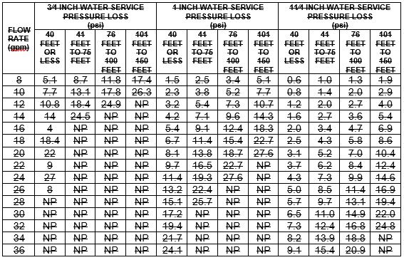
For SI units: 1 gallon per minute = 0.06 L/s, 1 pound-force per square inch= 6.89 kPa, 1 inch = 25 mm, 1 foot = 304.8 mm
Notes:
1 Values are applicable for underground piping materials and are based on polyethylene pipe having an SDR of 11 and a Hazen Williams C Factor of 150.

2 Values include the following length allowances for fittings: 25 percent length increase for actual lengths up to 100 feet (30 480 mm) and 15 percent length increase for actual lengths over 100 feet (30 480 mm).

3 NP – Means not permitted.

The pressure shall be the flowing pressure available at the flow rate used when applying Table 612.5.3.2(1).

Step 2 – Determine PLws
Use Table 612.5.3.2(1) to determine the pressure loss in the water service pipe based on the size of the water service. Where the water service supplies more than one dwelling unit, 5 gpm (0.3 L/s) shall be added to the sprinkler flow rate.

Step 3 – Determine PLm
Use Table 612.5.3.2(2) to determine the pressure loss from the water meter based on the water meter size.

Step 4 – Determine PLd
Determine the pressure loss from devices, other than the water meter, installed in the piping system supplying sprinklers such as pressure-reducing valves, backflow preventers, water softeners, or water filters. Device pressure losses shall be based on the device manufacturer’s specifications. The flow rate used to determine pressure loss shall be the sprinkler flow rate from Section 612.5.1.2. As an alternative to deducting pressure loss for a device, an automatic bypass valve shall be installed to divert flow around the device when a sprinkler activates.

Step 5 – Determine PLe
Use Table 612.5.3.2(3) to determine the pressure loss associated with changes in elevation. The elevation used in applying the table shall be the difference between the elevation where the water source pressure was measured and the elevation of the highest sprinkler.

Step 6 – Determine Psp
Determine the maximum pressure required by an individual sprinkler based on the flow rate from Section 612.5.1.1. The minimum pressure required is specified in the sprinkler manufacturer’s published data for the specific sprinkler model based on the selected flow rate.

Step 7 – Calculate Pt
Using Equation 612.5.3.2.1, calculate the available system pressure for sizing the sprinkler piping.

Step 8 – Determine the maximum allowable pipe length
Use Table 612.5.3.2(4) through Table 612.5.3.2(9) to select a material and size for the residential sprinkler piping. The piping material and size shall be acceptable where the developed length of pipe between the inside water service valve and the most remote sprinkler does not exceed the maximum allowable length specified by the applicable table. Interpolation of Pt between the tabular values shall be permitted. The maximum allowable length of piping in Table 612.5.3.2(4) through Table 612.5.3.2(9) incorporates an adjustment for pipe fittings, and no additional consideration of friction losses associated with pipe fittings shall be required.

TABLE 612.5.3.2(2)
MINIMUM WATER METER PRESSURE LOSS (PL_{m})^{1, 2}
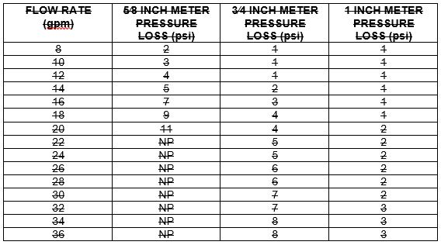
For SI units: 1 gallon per minute = 0.06 L/s, 1 pound-force per square inch =
6.89 kPa, 1 inch = 25 mm
Notes:
1 Table 612.5.3.2(2) establishes conservative values for water meter pressure loss for installations where the water meter loss is unknown. Where the actual water meter pressure loss is known, PLm shall be the pressure loss as specified by the meter manufacturer.

2 NP – Means not permitted.

612.6 Instructions and Signs.An owner’s manual for the fire sprinkler system shall be provided to the owner. A sign or valve tag shall be installed at the main shutoff valve to the water distribution system stating the following: “Warning, the water system for this home supplies fire sprinklers that require certain flow and pressure to fight a fire. Devices that restrict the flow, decrease the pressure, or automatically shut-off the water to the fire sprinkler system, such as water softeners, filtration systems, and automatic shutoff valves shall not be added to this system without a review of the fire sprinkler system by a fire protection specialist. Do not remove this sign.”

612.7 Inspection and Testing. The inspection and testing of sprinkler systems shall be in accordance with Section 612.7.1 and Section 612.7.2.

612.7.1 Pre-Concealment Inspection. The following shall be verified prior to the concealment of any sprinkler system piping:
(1) Sprinklers are installed in all areas in accordance with Section 612.3.1.

(2) Where sprinkler water spray patterns are obstructed by construction features, luminaires or ceiling fans, additional sprinklers are installed in accordance with Section 612.3.6.

(3) Sprinklers are the correct temperature rating and are installed at or beyond the required separation distances from heat sources in accordance with Section 612.3.3 and Section 612.3.3.1.

(4) The minimum pipe size in accordance with the requirements of Table 612.5.3.2(4) through Table 612.5.3.2(9) or, where the piping system was hydraulically calculated in accordance with Section 612.5.3.1, the size used in the hydraulic calculation.

(5) The pipe length does not exceed the length permitted by Table 612.5.3.2(4) through Table 612.5.3.2(9) or, where the piping system was hydraulically calculated in accordance with Section 612.5.3.1, pipe lengths and fittings shall not exceed those used in the hydraulic calculation.

(6) Nonmetallic piping that conveys water to sprinklers is certified as having a pressure rating of not less than 130 psi (896 kPa) at 120°F (49°C).

(7) Piping is properly supported.

(8) The piping system is tested in accordance with Section 609.4.

612.7.2 Final Inspection. Upon completion of the residential sprinkler system, the system shall be inspected. The following shall be verified during the final inspection:
(1) Sprinklers are not painted, damaged, or otherwise hindered from the operation.

(2) Where a pump is required to provide water to the system, the pump starts automatically upon system water demand.

(3) Pressure reducing valves, water softeners, water filters, or other impairments to water flow that were not part of the original design has not been installed.

(4) The sign or valve tag in accordance with Section 612.6 is installed, and the owner’s manual for the system is present.

TABLE 612.5.3.2(3)
ELEVATION LOSS (PL_{e})
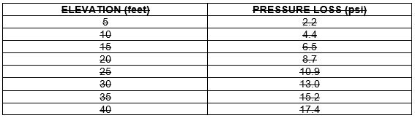
For SI units: 1 foot = 304.8 mm, 1 pound-force per square inch = 6.89 kPa

TABLE 612.5.3.2(4)
ALLOWABLE PIPE LENGTH FOR 3⁄4 INCH TYPE M COPPER WATER TUBING*
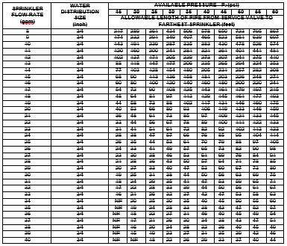
For SI units: 1 pound-force per square inch = 6.89 kPa, 1 gallon per minute = 0.06 L/s, 1 inch = 25 mm, 1 foot = 304.8 mm
* NP – Means not permitted.

TABLE 612.5.3.2(5)
ALLOWABLE PIPE LENGTH FOR 1 INCH TYPE M COPPER WATER TUBING
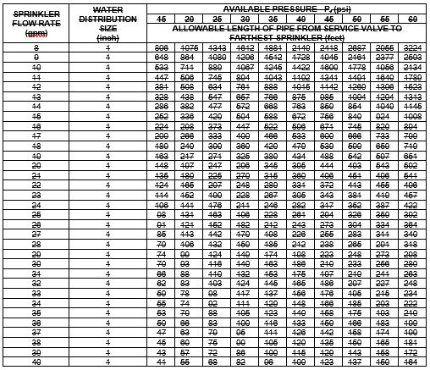
For SI units: 1 pound-force per square inch = 6.89 kPa, 1 gallon per minute = 0.06 L/s, 1 inch = 25 mm, 1 foot = 304.8 mm

TABLE 612.5.3.2(6)
ALLOWABLE PIPE LENGTH FOR 3⁄4 INCH IPS CPVC PIPE
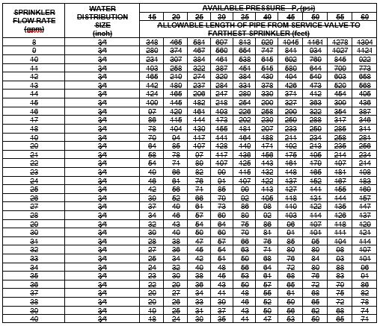
For SI units: 1 pound-force per square inch = 6.89 kPa, 1 gallon per minute = 0.06 L/s, 1 inch = 25 mm, 1 foot = 304.8 mm

TABLE 612.5.3.2(7)
ALLOWABLE PIPE LENGTH FOR 1 INCH IPS CPVC PIPE
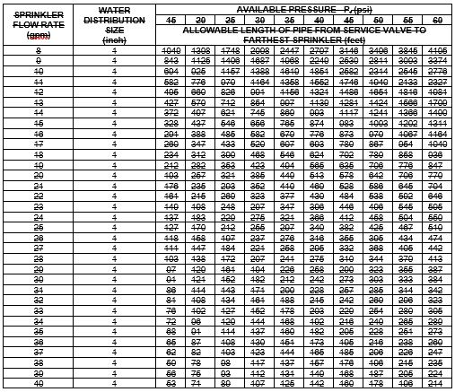
For SI units: 1 pound-force per square inch = 6.89 kPa, 1 gallon per minute = 0.06 L/s, 1 inch = 25 mm, 1 foot = 304.8 mm

TABLE 612.5.3.2(8)
ALLOWABLE PIPE LENGTH FOR 3⁄4 INCH PEX TUBING*
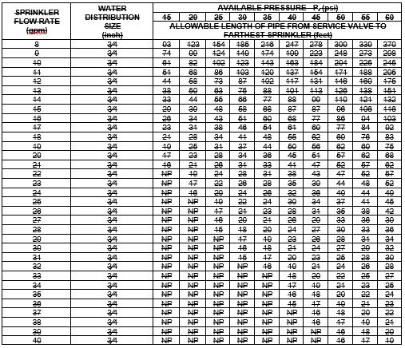
For SI units: 1 pound-force per square inch = 6.89 kPa, 1 gallon per minute = 0.06 L/s, 1 inch = 25 mm, 1 foot = 304.8 mm
* NP – Means not permitted.

TABLE 612.5.3.2(9)
ALLOWABLE PIPE LENGTH FOR 1 INCH PEX TUBING
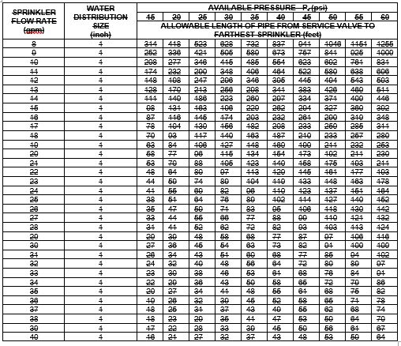
For SI units: 1 pound-force per square inch = 6.89 kPa, 1 gallon per minute = 0.06 L/s, 1 inch = 25 mm, 1 foot = 304.8 mm

Notation:
Authority: Health and Safety Code Sections 1250, 1569.72, 1569.78, 1568.02, 1502, 1597.44, 1597.45, 1597.46, 1597.54, 1597.65, 13108, 13108.5, 13114, 13143, 13143.2, 13143.6, 13146, 13210, 13211, 17921, 18949.2, 25500 through 25545, Government Code Section 51189, Public Education Code 17074.50

Reference(s): Health and Safety Code Sections 13143, 13211, 18949.2, 25500 through 25545, Government Code Sections 51176, 51177, 51178 and 51179, Public Resources Code Sections 4201 through 4204

CHAPTER 7
SANITARY DRAINAGE

Item 7-1
Chapter 7, Sanitary Drainage

[The SFM proposes to not adopt Chapter 7.]

Notation:
Authority: Health and Safety Code Sections 1250, 1569.72, 1569.78, 1568.02, 1502, 1597.44, 1597.45, 1597.46, 1597.54, 1597.65, 13108, 13108.5, 13114, 13143, 13143.2, 13143.6, 13146, 13210, 13211, 17921, 18949.2, 25500 through 25545, Government Code Section 51189, Public Education Code 17074.50

Reference(s): Health and Safety Code Sections 13143, 13211, 18949.2, 25500 through 25545, Government Code Sections 51176, 51177, 51178 and 51179, Public Resources Code Sections 4201 through 4204

CHAPTER 8
INDIRECT WASTES

Item 8-1
Chapter 8, Indirect Wastes

[The SFM proposes to not adopt Chapter 8.]

Notation:
Authority: Health and Safety Code Sections 1250, 1569.72, 1569.78, 1568.02, 1502, 1597.44, 1597.45, 1597.46, 1597.54, 1597.65, 13108, 13108.5, 13114, 13143, 13143.2, 13143.6, 13146, 13210, 13211, 17921, 18949.2, 25500 through 25545, Government Code Section 51189, Public Education Code 17074.50

Reference(s): Health and Safety Code Sections 13143, 13211, 18949.2, 25500 through 25545, Government Code Sections 51176, 51177, 51178 and 51179, Public Resources Code Sections 4201 through 4204

CHAPTER 9
VENTS

Item 9-1
Chapter 9, Vents

[The SFM proposes to not adopt Chapter 9.]

Notation:
Authority: Health and Safety Code Sections 1250, 1569.72, 1569.78, 1568.02, 1502, 1597.44, 1597.45, 1597.46, 1597.54, 1597.65, 13108, 13108.5, 13114, 13143, 13143.2, 13143.6, 13146, 13210, 13211, 17921, 18949.2, 25500 through 25545, Government Code Section 51189, Public Education Code 17074.50
Reference(s): Health and Safety Code Sections 13143, 13211, 18949.2, 25500 through 25545, Government Code Sections 51176, 51177, 51178 and 51179, Public Resources Code Sections 4201 through 4204

CHAPTER 10
TRAPS AND INTERCEPTORS

Item 10-1
Chapter 10, Traps and Interceptors

[The SFM proposes to not adopt Chapter 10.]

Notation:
Authority: Health and Safety Code Sections 1250, 1569.72, 1569.78, 1568.02, 1502, 1597.44, 1597.45, 1597.46, 1597.54, 1597.65, 13108, 13108.5, 13114, 13143, 13143.2, 13143.6, 13146, 13210, 13211, 17921, 18949.2, 25500 through 25545, Government Code Section 51189, Public Education Code 17074.50

Reference(s): Health and Safety Code Sections 13143, 13211, 18949.2, 25500 through 25545, Government Code Sections 51176, 51177, 51178 and 51179, Public Resources Code Sections 4201 through 4204

CHAPTER 11
STORM DRAINAGE

Item 11-1
Chapter 11, Storm Drainage

[The SFM proposes to not adopt Chapter 11.]

Notation:
Authority: Health and Safety Code Sections 1250, 1569.72, 1569.78, 1568.02, 1502, 1597.44, 1597.45, 1597.46, 1597.54, 1597.65, 13108, 13108.5, 13114, 13143, 13143.2, 13143.6, 13146, 13210, 13211, 17921, 18949.2, 25500 through 25545, Government Code Section 51189, Public Education Code 17074.50

Reference(s): Health and Safety Code Sections 13143, 13211, 18949.2, 25500 through 25545, Government Code Sections 51176, 51177, 51178 and 51179, Public Resources Code Sections 4201 through 4204

CHAPTER 12
FUEL GAS PIPING

Item 12-1
Chapter 12, Fuel Gas Piping, Section 1211.7 Earthquake-Actuated Gas Shutoff Valves

[The SFM proposes to adopt Chapter 12 carry forward existing amendments with the following editorial correction to Section 1211.7.]

1211.78 Earthquake-Actuated Gas Shutoff Valves. [Text remains unchanged]

Notation:
Authority: Health and Safety Code Sections 1250, 1569.72, 1569.78, 1568.02, 1502, 1597.44, 1597.45, 1597.46, 1597.54, 1597.65, 13108, 13108.5, 13114, 13143, 13143.2, 13143.6, 13146, 13210, 13211, 17921, 18949.2, 25500 through 25545, Government Code Section 51189, Public Education Code 17074.50

Reference(s): Health and Safety Code Sections 13143, 13211, 18949.2, 25500 through 25545, Government Code Sections 51176, 51177, 51178 and 51179, Public Resources Code Sections 4201 through 4204

CHAPTER 13
HEALTH CARE FACILITIES AND MEDICAL GAS AND MEDICAL VACUUM SYSTEMS

Item 13-1
Chapter 13, Health Care Facilities and Medical Gas And Medical Vacuum Systems

[The SFM proposes to adopt Chapter 13 without amendments.]

Notation:
Authority: Health and Safety Code Sections 1250, 1569.72, 1569.78, 1568.02, 1502, 1597.44, 1597.45, 1597.46, 1597.54, 1597.65, 13108, 13108.5, 13114, 13143, 13143.2, 13143.6, 13146, 13210, 13211, 17921, 18949.2, 25500 through 25545, Government Code Section 51189, Public Education Code 17074.50

Reference(s): Health and Safety Code Sections 13143, 13211, 18949.2, 25500 through 25545, Government Code Sections 51176, 51177, 51178 and 51179, Public Resources Code Sections 4201 through 4204

CHAPTER 14
FIRESTOP PROTECTION

Item 14-1
Chapter 14, Firestop Protection

[The SFM proposes to adopt Chapter 14 without amendments.]

Notation:
Authority: Health and Safety Code Sections 1250, 1569.72, 1569.78, 1568.02, 1502, 1597.44, 1597.45, 1597.46, 1597.54, 1597.65, 13108, 13108.5, 13114, 13143, 13143.2, 13143.6, 13146, 13210, 13211, 17921, 18949.2, 25500 through 25545, Government Code Section 51189, Public Education Code 17074.50

Reference(s): Health and Safety Code Sections 13143, 13211, 18949.2, 25500 through 25545, Government Code Sections 51176, 51177, 51178 and 51179, Public Resources Code Sections 4201 through 4204

CHAPTER 15
ALTERNATE WATER SOURCES FOR NONPOTABLE APPLICATIONS

Item 15-1
Chapter 15, Alternate Water Sources for Nonpotable Applications

[The SFM proposes to not adopt Chapter 15.]

Notation:
Authority: Health and Safety Code Sections 1250, 1569.72, 1569.78, 1568.02, 1502, 1597.44, 1597.45, 1597.46, 1597.54, 1597.65, 13108, 13108.5, 13114, 13143, 13143.2, 13143.6, 13146, 13210, 13211, 17921, 18949.2, 25500 through 25545, Government Code Section 51189, Public Education Code 17074.50

Reference(s): Health and Safety Code Sections 13143, 13211, 18949.2, 25500 through 25545, Government Code Sections 51176, 51177, 51178 and 51179, Public Resources Code Sections 4201 through 4204

CHAPTER 16
NONPOTABLE RAINWATER CATCHMENT SYSTEMS

Item 16-1
Chapter 16, Nonpotable Rainwater Catchment Systems

[The SFM proposes to not adopt Chapter 16.]

Notation:
Authority: Health and Safety Code Sections 1250, 1569.72, 1569.78, 1568.02, 1502, 1597.44, 1597.45, 1597.46, 1597.54, 1597.65, 13108, 13108.5, 13114, 13143, 13143.2, 13143.6, 13146, 13210, 13211, 17921, 18949.2, 25500 through 25545, Government Code Section 51189, Public Education Code 17074.50

Reference(s): Health and Safety Code Sections 13143, 13211, 18949.2, 25500 through 25545, Government Code Sections 51176, 51177, 51178 and 51179, Public Resources Code Sections 4201 through 4204

CHAPTER 17
REFERENCED STANDARDS

[The SFM proposes to adopt Chapter 17 with amendments.]

Item 17-1
Chapter 17, Table 1701.1, NFPA 13D Installation of Sprinkler Systems in One and Two Family Dwellings and Manufactured Homes

[The SFM proposes to delete and remove the reference standard for NFPA 13D Installation of Sprinkler Systems in One and Two Family Dwellings and Manufactured Homes. Associated proposals 6-2 and 6-3]

TABLE 1701.1 (continued)
REFERENCED STANDARDS
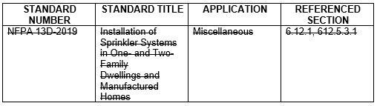

Item 17-2
Chapter 17, Table 1701.1, NFPA 30A Motor Fuel Dispensing Facilities and Repair Garages

NFPA 30A-201821

Item 17-3
Chapter 17, Table 1701.1, NFPA 31 Standard for the installation of Oil-Burning Equipment

NFPA 31-201620

Item 17-4
Chapter 17, Table 1701.1, NFPA 58 Liquefied Petroleum Gas Code

NFPA 58-201720

Item 17-5
Chapter 17, Table 1701.1, NFPA 70 National Electrical Code

NFPA 70-201720
*See California Electrical Code for amendments

Item 17-6
Chapter 17, Table 1701.1, NFPA 99 Health Care Facilities Code

NFPA 99-201721

Notation:
Authority: Health and Safety Code Sections 1250, 1569.72, 1569.78, 1568.02, 1502, 1597.44, 1597.45, 1597.46, 1597.54, 1597.65, 13108, 13108.5, 13114, 13143, 13143.2, 13143.6, 13146, 13210, 13211, 17921, 18949.2, 25500 through 25545, Government Code Section 51189, Public Education Code 17074.50

Reference(s): Health and Safety Code Sections 13143, 13211, 18949.2, 25500 through 25545, Government Code Sections 51176, 51177, 51178 and 51179, Public Resources Code Sections 4201 through 4204

APPENDICES

Item 18-1
Appendices, Appendix A through N

[The SFM proposes to not adopt Appendix A through N.]

Notation:
Authority: Health and Safety Code Sections 1250, 1569.72, 1569.78, 1568.02, 1502, 1597.44, 1597.45, 1597.46, 1597.54, 1597.65, 13108, 13108.5, 13114, 13143, 13143.2, 13143.6, 13146, 13210, 13211, 17921, 18949.2, 25500 through 25545, Government Code Section 51189, Public Education Code 17074.50

Reference(s): Health and Safety Code Sections 13143, 13211, 18949.2, 25500 through 25545, Government Code Sections 51176, 51177, 51178 and 51179, Public Resources Code Sections 4201 through 4204

USEFUL TABLES

Item 19-1
Useful Tables

[The SFM proposes to adopt Useful Tables without amendment.]

Notation:
Authority: Health and Safety Code Sections 1250, 1569.72, 1569.78, 1568.02, 1502, 1597.44, 1597.45, 1597.46, 1597.54, 1597.65, 13108, 13108.5, 13114, 13143, 13143.2, 13143.6, 13146, 13210, 13211, 17921, 18949.2, 25500 through 25545, Government Code Section 51189, Public Education Code 17074.50

Reference(s): Health and Safety Code Sections 13143, 13211, 18949.2, 25500 through 25545, Government Code Sections 51176, 51177, 51178 and 51179, Public Resources Code Sections 4201 through 4204

