APPROVED BY THE CALIFORNIA BUILDING STANDARDS COMMISSION

JULY 13, 2020

FINAL EXPRESS TERMS
FOR PROPOSED BUILDING STANDARDS
OF THE CALIFORNIA BUILDING STANDARDS COMMISSION
REGARDING THE 2019 CALIFORNIA PLUMBING CODE,

CALIFORNIA CODE OF REGULATIONS, TITLE 24, PART 5

(BSC 03/19)
The State agency shall draft the regulations in plain, straightforward language, avoiding technical terms as much as possible and using a coherent and easily readable style. The agency shall draft the regulation in plain English. A notation shall follow the express terms of each regulation listing the specific statutes authorizing the adoption and listing specific statutes being implemented, interpreted, or made specific (Government Code Section 11346.2(a)(1)).
If using assistive technology, please adjust your settings to recognize underline, strikeout, italic and ellipsis.

LEGEND for EXPRESS TERMS (Based on model codes - Parts 2, 2.5, 3, 4, 5, 9, 10)
- Model Code language appears upright
- Existing California amendments appear in italic
- Amended model code or new California amendments appear underlined & italic
- Repealed model code language appears upright and in strikeout
- Repealed California amendments appear in italic and strikeout
- Ellipsis (...) indicate existing text remains unchanged
FINAL EXPRESS TERMS

Chapter 4: PLUMBING FIXTURES AND FIXTURE FITTINGS

ITEM 1: PRE-RINSE SPRAY VALVE
420.3 Pre-Rinse Spray Valve. Commercial food service pre-rinse spray valves shall have a maximum flow rate of 1.6 gallons per minute (gpm) at 60 pounds-force per square inch (psi) (6.0 L/m at 414 kPa) and shall be equipped with an integral automatic shutoff.
420.3.1 Pre-rinse spray valve. [BSC-CG, DSA-SS, HCD 1 & HCD 2] When installed, shall meet the requirements in the California Code of Regulations, Title 20 (Appliance Efficiency Regulations), Section 1605.1(h)(4) Table H-2, Section 1605.3(h)(4)(A), and Section 1607(d)(7), and shall be equipped with an integral automatic shutoff.
FOR REFERENCE ONLY: The following table and code section have been reprinted from the California Code of Regulations, Title 20 (Appliance Efficiency Regulations), Section 1605.1(h)(4) and Section 1605.3(h)(4)(A).
Table H-2
Standards For Commercial Pre-Rinse Spray Valves Manufactured On Or After January 28, 2019.
Product Class (spray force in ounce force (ozf)) | Maximum Flow Rate (gpm)
Product Class 1 (≤ 5.0 ozf) | 1.00
Product Class 2 (> 5.0 ozf and ≤ 8.0 ozf) | 1.20
Product Class 3 (> 8.0 ozf) | 1.28
Title 20 Section 1605.3(h)(4)(A): Commercial pre-rinse spray valves manufactured on or after January 1, 2006, shall have a minimum spray force of not less than 4.0 ounces-force (ozf) [113 grams-force (gf)].
. . .
Notation:
Authority: Health & Safety Code Section 18940.5
Reference(s): Health & Safety Code Section 18940.5

ITEM 2: FIXTURE COUNT and OCCUPANT LOAD FACTOR
422.0 Minimum Number of Required Fixtures.
422.1 Fixture Count. Plumbing fixtures shall be provided for the type of building occupancy and in the minimum number shown in Table 422.1[OSHPD 1,1R,2,3,4 & 5] and Tables 4-2 and Table 4-3. The total occupant load and occupancy classification shall be determined in accordance with the California Building Code [BSC, DSA-SS & DSASS/CC] or Occupant Load Factor Table A. Occupancy classification not shown in Table 422.1 shall be considered separately by the Authority Having Jurisdiction.
Exception:
[BSC] Using occupancy classification, described as function of space, determine occupant load factor from Table 4-1 Occupant Load Factor, of this chapter.
The minimum number. . .

Chapter 4 / Table 4-1
TABLE A4-1
OCCUPANT LOAD FACTOR:
[BSC]
OCCUPANCY FUNCTION OF SPACE* ** | OCCUPANT LOAD FACTOR (square feet)
Group A Assembly - without fixed seats  - Auditoriums, convention halls, dance floors, lodge rooms, stadiums, and casinos (where no fixed seating is provided)  (Where fixed seating is provided use one-half the number of fixed seating.)  Auditorium, convention and dance hall, lodge, stage, indoor sport/spectator event, worship, arcade, gaming (standing space) | 15 11
- Conference rooms, dining rooms, drinking establishments, exhibit rooms, gymnasiums, lounges, stages, and similar uses, including restaurants classified as Group B occupancies.  Waiting, terminal (portable seating space) | 30 15
- Worship places; principal assembly area, educational and activity unit (where no fixed seating is provided)  (Where no fixed seating is provided use one-half the number of fixed seating.)  Conference, dining/drinking, lounge (portable seating/table space) | 30
Gallery, museum, exhibit (standing space) | 30
Assembly – with fixed seats | See CBC 1004.6  Use 50% of the fixed seating value
Group B  Office or public buildings (area accessible to the public) | 200
Business (office, sales/soliciting, administration, food processing, courtroom, ambulatory clinic) | 150  See CBC 1004.8
Dormitory | 50
Group E  Schools for day care, elementary, secondary | 50
Day care | 35
Educational Facilities Other than Group E  Colleges, universities, adult centers, etc. | 50
Education (classroom)  Through 12th grade | 30
Education (classroom)  Beyond 12th grade | 50
Exercise (fitness) | 50
Group F  Workshops, foundries and similar establishments | 2,000
Industrial (fabrication, foundry, workshop, component assembly, repair) | 500
Group H  Hazardous materials fabrication and storage | 2,000
Kitchen/food prep (commercial) | 50
Group I  Hospital general use area, health care facilities | 200
Laboratory  Educational | 50
Laboratory  Non-educational | 100
Library | 50
Group M  Retail or wholesale stores | 200
Mercantile (wholesale, retail) | 100
Mall building (covered/open) | See CBC 402.8.2
Group R  Congregate residence, Group R-1 | 200
Residential (long term: central toilet facilities) | 200
Group S  Warehouse | 5,000
Warehouse  Storage portions | 4000
Warehouse  Distribution portions (selecting, processing, packing, receiving, shipping) | 500

* Any uses not specifically listed shall be based on similar uses listed in this table.
** For a building or space with mixed occupancies, use appropriate occupancy group for each area (for example, a school may have an “A” occupancy for the gymnasium, a “B” occupancy for the office, an “E” occupancy for the classrooms, etc.). Accessory areas (for example: hallway, restroom, stair enclosure) such as, but not limited to, hallways/corridors, stairways, ramps, toilet rooms, mechanical rooms, closets and fixed equipment, may be excluded.
. . .
Notation:
Authority: Health & Safety Code Section 18934.5
Reference(s): Health & Safety Code Sections 18928, 18928.1 and 18934.5

Chapter 15: Alternate Water Sources for Nonpotable Applications

ITEM 3: ALTERNATE WATER SOURCES FOR NONPOTABLE APPLICATIONS
. . .
1502.3 Cross-Connection Inspection and Testing. An initial visual inspection and initial cross-connection test shall be performed on both the potable and alternate water source systems before the initial operation of the alternate water source system. During an initial or subsequent cross-connection test, The the potable and alternate water source system shall be isolated from each other and independently inspected and tested to ensure there is no cross-connection in accordance with Section 1502.3.1 through Section 1502.3.3.
. . .
1502.3.2 Cross-Connection Test. A cross-connection test …
. . .
(5) The alternate water source system shall then be activated and pressurized. When an alternate water source is not available for the initial cross-connection test, a temporary connection to a potable water supply shall be required. At the conclusion of the initial cross-connection test, the temporary connection to the potable water supply shall be disconnected.
1503.3 Connections to Potable and Reclaimed (Recycled) Water Systems. Gray water systems shall have no direct connection to a potable water supply, on-site treated nonpotable water supply, or reclaimed (recycled) water supply systems.
Exceptions:
- Potable water, on-site treated nonpotable water, reclaimed (recycled) water, or rainwater is permitted to be used as makeup water for a non-pressurized storage tank provided the connection is protected by an air gap in accordance with this code.
- A potable water supply may be connected temporarily for the initial cross-connection testing of the untreated graywater system as required in Section 1502.3.2.
. . .
1506.0 On-Site Treated Nonpotable Gray Water Systems.
1506.1 General. The provisions…
. . .
1506.4 Connections to Potable or Reclaimed (Recycled) Water Systems. On-site treated nonpotable gray water systems shall have no direct connection to a potable water supply or reclaimed (recycled) water supply system.
Exceptions:
- Potable or reclaimed (recycled) water is permitted to be used as makeup water for a non-pressurized storage tank provided the makeup water supply inlet is protected by an air gap in accordance with this code.
- A potable water supply may be connected temporarily for the initial cross-connection testing of the on-site treated nonpotable gray water system as provided in Section 1502.3.2.
. . .

Chapter 16: Nonpotable Rainwater Catchment Systems

ITEM 4: NONPOTABLE RAINWATER CATCHMENT SYSTEMS
. . .
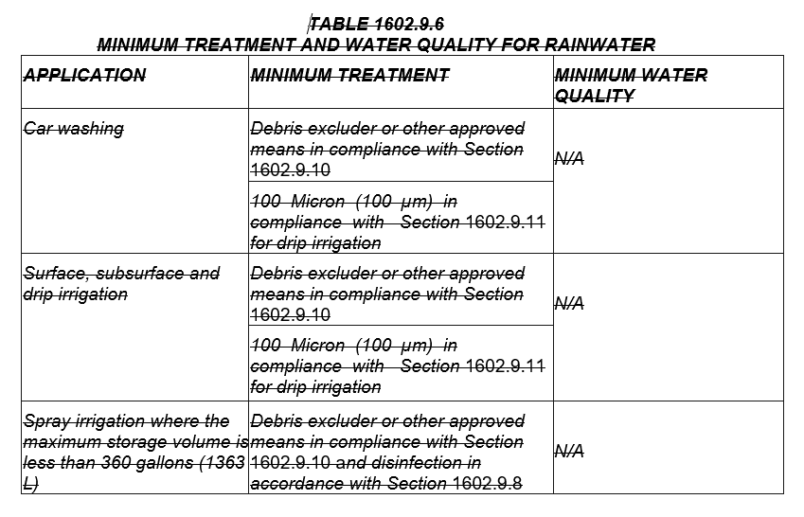
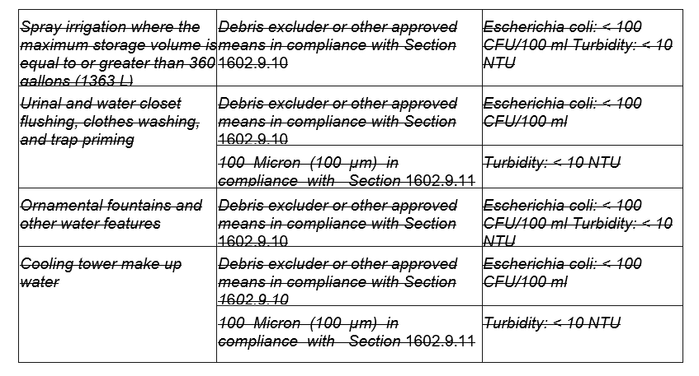

TABLE 1602.9.6
MINIMUM WATER QUALITY
APPLICATION | MINIMUM TREATMENT | MINIMUM WATER QUALITY
Car washing | Debris excluder or other approved means in accordance with Section 1603.14, and 100 microns (100 µm) in accordance with Section 1603.15 for drip irrigation. | N/A
Surface, Subsurface and drip irrigation | Debris excluder or other approved means in accordance with Section 1603.14, and 100 microns (100 µm) in accordance with Section 1603.15 for drip irrigation. | N/A
Spray irrigation where the maximum storage volume is less than 360 gallons  (1363 L) | Debris excluder or other approved means in accordance with Section 1603.14, and disinfection in accordance with Section 1603.12. | N/A
Spray irrigation where the maximum storage volume is equal to or more than 360 gallons (1363 L) | Debris excluder or other approved means in accordance with Section 1603.14. | Escherichia coli: < 100 CFU/100 mL,  and Turbidity:  < 10 NTU
Urinal and water closet flushing, clothes washing, and trap priming | Debris excluder or other approved means in accordance with Section 1603.14, and 100 microns (100 µm) in accordance with Section 1603.15. | Escherichia coli: < 100 CFU/100 mL,  and Turbidity:  < 10 NTU
Ornamental fountains and other water features | Debris excluder or other approved means in accordance with Section 1603.14. | Escherichia coli: < 100 CFU/100 mL, and Turbidity: < 10 NTU
Cooling tower make-up water | Debris excluder or other approved means in accordance with Section 1603.14, and 100 microns (100 µm) in accordance with Section 1603.15. | Escherichia coli: < 100 CFU/100 mL, and Turbidity: < 10 NTU
For SI units: 1 micron = 1 µm, 1 gallon = 3.785 L
1605.0 Inspection and Testing.
. . .
1605.3 Cross-Connection Inspection and Testing. An initial visual inspection and an initial cross-connection test in accordance with Section 1602.5 shall be performed on both the potable and rainwater catchment water systems before the initial operation of the rainwater catchment system. During an initial or subsequent cross-connection test, The the potable and rainwater catchment water systems shall be isolated from each other and independently inspected and tested to ensure there is no cross-connection in accordance with Section 1602.5. Initial or subsequent inspections or tests shall be performed in accordance with Section 1605.3.1 through Section 1605.3.3.
. . .
1605.3.2 Cross-Connection Test. A cross-connection test shall be performed in the presence of the Authority Having Jurisdiction or other authorities having jurisdiction to determine whether a cross-connection has occurred as follows:
. . .
(6) The rainwater catchment water system shall then be activated and pressurized. When rainwater is not available for the initial cross-connection test, a temporary connection to a potable water supply shall be required. At the conclusion of the initial cross-connection test, the temporary connection to the potable water supply shall be disconnected.
. . .
Notation:
Authority: Health and Safety Code Sections 18928, 18928(b), 18928.1, 18930.5, 18934.5, 18940.5, 18941.8, and Water Code Section 14877.1.
Reference(s): Health and Safety Code Sections 18928, 18928(b), 18928.1, 18930.5, 18934.5, 18940.5, 18941.8, and Water Code Section 14877.1.

