FINAL EXPRESS TERMS
FOR PROPOSED BUILDING STANDARDS
OF THE DIVISION OF THE STATE ARCHITECT
REGARDING THE 2019 CALIFORNIA BUILDING CODE,
CALIFORNIA CODE OF REGULATIONS, TITLE 24, PART 2
(DSA-AC 01-19)
The state agency shall draft the regulations in plain, straightforward language, avoiding technical terms as much as possible and using a coherent and easily readable style. The agency shall draft the regulation in plain English. A notation shall follow the express terms of each regulation listing the specific statutes authorizing the adoption and listing specific statutes being implemented, interpreted, or made specific (Government Code Section 11346.2(a)(1)).
If using assistive technology, please adjust your settings to recognize underline, strikeout, italic and ellipsis.

LEGEND for EXPRESS TERMS (Based on model codes - Parts 2, 2.5, 3, 4, 5, 9, 10)
- Model Code language appears upright
- Existing California amendments appear in italic
- Amended model code or new California amendments appear underlined & italic
- Repealed model code language appears upright and in strikeout
- Repealed California amendments appear in italic and strikeout
- Ellipsis (...) indicate existing text remains unchanged

FINAL EXPRESS TERMS

CHAPTER 1
SCOPE AND ADMINISTRATION
DIVISION I
CALIFORNIA ADMINISTRATION

Item 1.01
SECTION 1.9
DIVISION OF THE STATE ARCHITECT
1.9.1 Division of the State Architect—Access Compliance.
1.9.1.3 Application ─ public housing and private housing available for public use. See Government Code Sections 4450 and Section 12955.1(c) and the definition for public housing in Chapter 2.
Notation:
Authority: Government Code Section 12955.1(c).
Reference(s): Government Code Section 12955.1(c) and Health and Safety Code Section 18949.1.

CHAPTER 2
DEFINITIONS

Item 2.01
SECTION 202
DEFINITIONS
BLENDED TRANSITION. [DSA-AC] A raised pedestrian street crossing, depressed corner or similar connection that has a grade of 5 percent or less between the pedestrian access route a circulation path at the level of the sidewalk or walk and the level of the pedestrian street crossing a vehicular way that has a grade of 5 percent or less.
Notation:
Authority: Government Code Section 4450.
Reference(s): Government Code Sections 4450 through 4461 and Health and Safety Code Section 18949.1.

Item 2.02
SECTION 202
DEFINITIONS
BOTTLE FILLING STATION. A fixture that is designed and intended for filling personal use drinking water bottles or containers. Such fixtures can be separate from or integral to a drinking fountain.
Notation:
Authority: Government Code Section 4450.
Reference(s): Government Code Sections 4450 through 4461 and Health and Safety Code Section 18949.1.

Item 2.03
SECTION 202
DEFINITIONS
CIRCULATION PATH. [DSA-AC] An accessible or non-accessible prepared exterior or interior way of passage provided for pedestrian travel, including but not limited to, walks, sidewalks, hallways, courtyards, elevators, platform lifts, ramps, stairways and landings.
Notation:
Authority: Government Code Section 4450.
Reference(s): Government Code Sections 4450 through 4461 and Health and Safety Code Section 18949.1.

Item 2.04
SECTION 202
DEFINITIONS
CURB RAMP. A sloping prepared surface, pedestrian way, intended for pedestrian traffic, which provides access between a walk or sidewalk and a surface located above or below an adjacent curb face.
Notation:
Authority: Government Code Section 4450.
Reference(s): Government Code Sections 4450 through 4461 and Health and Safety Code Section 18949.1.

Item 2.05
SECTION 202
DEFINITIONS
DETECTABLE WARNING. A standardized surface feature built in or applied to walking surfaces or other elements to warn persons with visual impairments of hazards on a circulation path.
Notation:
Authority: Government Code Section 4450.
Reference(s): Government Code Sections 4450 through 4461and Health and Safety Code Section 18949.1.

Item 2.06
SECTION 202
DEFINITIONS
DRIVE AISLE. A vehicular way provided within a parking facility that connects vehicular entrances, parking stalls, electric vehicle charging stations, passenger loading zones, and vehicular exits.
Notation:
Authority: Government Code Section 4450.
Reference(s): Government Code Sections 4450 through 4461 and Health and Safety Code Section 18949.1.

Item 2.07
SECTION 202
DEFINITIONS
DRIVEWAY. A vehicular way providing access between a public way and a building, parking facility, or other off-street area. A driveway may provide access to drive aisles in a parking facility.
Notation:
Authority: Government Code Section 4450.
Reference(s): Government Code Sections 4450 through 4461and Health and Safety Code Section 18949.1.

Item 2.08
SECTION 202
DEFINITIONS
PEDESTRIAN WAY. A route by which a pedestrian may pass.
Notation:
Authority: Government Code Section 4450.
Reference(s): Government Code Sections 4450 through 4461 and Health and Safety Code Section 18949.1.

Item 2.09
SECTION 202
DEFINITIONS
PUBLIC HOUSING. [DSA-AC] Housing facilities owned, operated, or constructed or altered by, for, or on behalf of a public entity, or constructed or altered as part of a public entity’s program to provide housing pursuant to United States Code of Federal Regulations, 28 CFR Part 35, Section 35.102(a), including but not limited to the following:
1. Publically owned and/or operated one One-or two-family dwelling units, or congregate residences;
2. Publically owned and/or operated buildings Buildings or complexes with three or more residential dwellings units;
3. Reserved.
4.3.Publically owned and/or operated homeless Homeless shelters, group homes, halfway houses and similar social service establishments;
5.4.Publically owned and/or operated transient Transient lodging, such as hotels, motels, hostels and other facilities providing accommodations of a short term nature of not more than 30 days duration;
6.5.Housing at a place of education owned or operated by a public entity, such as housing on or serving a public school, public college or public university campus;.
7. Privately owned housing made available for public use as housing
Note: A public entity’s program to provide housing may include but is not limited to: the allocation of local, state, or federal financial assistance, Community Development Block Grants, Low Income Housing Tax Credits, the California Multifamily Housing Program, loan agreements and housing bonds. Examples that are not considered a public entity’s program to provide housing may include but are not limited to: density bonuses, the receipt of public funds for the installation of energy efficiency features, seismic strengthening, water conservation and fire safety features. For additional information see “Guide to Public Housing Regulated in Chapter 11B of the California Building Code” and the “California Access Compliance Advisory Reference Manual” available on the Division of the State Architect’s website.
Notation:
Authority: Government Code Section 12955.1(c).
Reference(s): Government Code Section 12955.1(c) and Health and Safety Code Section 18949.1.

Item 2.10
SECTION 202
DEFINITIONS
PUBLIC USE. [DSA-AC] Interior or exterior rooms, spaces or elements that are made available to the public. Public use may be provided at a building or facility that is privately or publicly owned. Private interior or exterior rooms, spaces or elements associated with a residential dwelling unit provided by a public housing program or in a public housing facility are not public use areas and shall not be required to be made available to the public. In the context of public housing, public use is the provision of housing programs by, for or on behalf of a public entity.
Notation:
Authority: Government Code Section 4450.
Reference(s): Government Code Sections 4450 through 4461and12955.1(c); Health and Safety Code Section 18949.1.

CHAPTER 11B
ACCESSIBILITY TO PUBLIC BUILDINGS, PUBLIC ACCOMMODATIONS, COMMERCIAL BUILDINGS AND PUBLIC HOUSING

Item 11B.01
DIVISION 2: SCOPING REQUIREMENTS
11B-202.4 Path of travel requirements in alterations, additions and structural repairs. When alterations or additions are made to existing buildings or facilities, an accessible path of travel to the specific area of alteration or addition shall be provided. The primary accessible path of travel shall include:
- A primary entrance to the building or facility,
- Toilet and bathing facilities serving the area,
- Drinking fountains serving the area,
- Public telephones serving the area, and
- Signs.
Exceptions: …
10. Alterations solely for the purpose of installing electric vehicle charging stations (EVCS) at facilities where vehicle fueling, recharging, parking or storage is a primary function shall comply with Section 11B-202.4 to the maximum extent feasible without exceeding 20 percent of the cost of the work directly associated with the installation of EVCS. A “primary function” is a major activity for which the facility is intended.
Alterations solely for the purpose of installing EVCS at facilities where vehicle fueling, recharging, parking or storage is not a primary function shall not be required to comply with Section 11B-202.4.
Notation:
Authority: Government Code Section 4450.
Reference(s): Government Code Sections 4450 through 4461and Health and Safety Code Section 18949.1.

Item 11B.02
DIVISION 2: SCOPING REQUIREMENTS
11B-203.8 Residential facilities. In residential facilities, common use areas that do not serve residential dwelling units required to provide mobility features complying with Sections 11B-809.2 through 11B-809.4 and or adaptable features complying with Chapter 11A, Division IV Sections 11B-809.6 through 11B-809.12 shall not be required to comply with these requirements or to be on an accessible route.
Notation:
Authority: Government Code Section 12955.1(c).
Reference(s): Government Code Section 12955.1(c) and Health and Safety Code Section 18949.1.

Item 11B.03
DIVISION 2: SCOPING REQUIREMENTS
11B-205.1 General. Operable parts on accessible elements, accessible routes, and in accessible rooms and spaces shall comply with Section 11B-309.
Exceptions:
- Operable parts that are intended for use only by service or maintenance personnel shall not be required to comply with Section 11B-309.
- Electrical or communication receptacles serving a dedicated use shall not be required to comply with Section 11B-309.
- Reserved.
- Floor electrical receptacles shall not be required to comply with Section 11B-309.
- HVAC diffusers shall not be required to comply with Section 11B-309.
- Except for light switches, where redundant controls are provided for a single element, one control in each space shall not be required to comply with Section 11B-309.
- Cleats and other boat securement devices shall not be required to comply with Section 11B-309.3.
- Exercise machines and exercise equipment shall not be required to comply with Section 11B-309.
9. In residential dwelling units with mobility features where receptacles are provided in a kitchen at a corner work surface, one receptacle shall be located 36 inches (915 mm) from either wall at the inside corner.
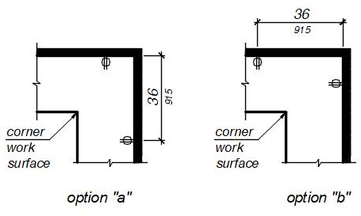
FIGURE 11B-205.1 Ex. 9
ELECTRICAL RECEPTACLES AT CORNER WORKSURFACES.
Notation:
Authority: Government Code Section 12955.1(c).
Reference(s): Government Code Section 12955.1(c) and Health and Safety Code Section 18949.1.

Item 11B.04
DIVISION 2: SCOPING REQUIREMENTS
11B-206.2.3 Multi-story buildings and facilities. At least one accessible route shall connect each story and mezzanine in multi-story buildings and facilities.
Exceptions:
4. In residential facilities, an accessible route shall not be required to connect stories where residential dwelling units with mobility features required to comply with Sections 11B-809.2 through 11B-809.4, residential dwelling units with adaptable features complying with Chapter 11A, Division IV, Sections 11B-809.6 through 11B-809.12, all common use areas serving residential dwelling units with mobility features required to comply with Sections 11B-809.2 through 11B-809.4, all common use areas serving residential dwelling units with adaptable features complying with Chapter 11A, Division IV Sections 11B-809.6 through 11B-809.12, and public use areas serving residential dwelling
Notation:
Authority: Government Code Section 12955.1(c).
Reference(s): Government Code Section 12955.1(c) and Health and Safety Code Section 18949.1.

Item 11B.05
DIVISION 2: SCOPING REQUIREMENTS
11B-206.7.6 Guest rooms and residential dwelling units. Platform lifts shall be permitted to connect levels within transient lodging guest rooms required to provide mobility features complying with Section 11B-806.2 or residential dwelling units required to provide mobility features complying with Sections 11B-809.2 through 11B-809.4 and or adaptable features complying with Chapter 11A, Division IV. Sections 11B-809.6 through 11B-809.12.
Notation:
Authority: Government Code Section 12955.1(c).
Reference(s): Government Code Section 12955.1(c) and Health and Safety Code Section 18949.1.

Item 11B.06
DIVISION 2: SCOPING REQUIREMENTS
11B-208.1 General. Where parking spaces are provided, parking spaces shall be provided in accordance with Section 11B-208. For the purposes of this section, electric vehicle charging stations are not parking spaces; see Section 11B-228.
Exception: Exceptions:
- Parking spaces used exclusively for buses, trucks, other delivery vehicles, or vehicular impound shall not be required to comply with Section 11B-208 provided that lots accessed by the public are provided with a passenger drop-off and loading zone complying with Section 11B-503.
- In public housing facilities, electric vehicle chargers are permitted to be installed at an accessible parking space assigned to the resident.
Notation:
Authority: Government Code Section 12955.1(c).
Reference(s): Government Code Section 12955.1(c); Health and Safety Code Section 18949.1; and Vehicle Code Section 22511.8.

Item 11B.07
DIVISION 2: SCOPING REQUIREMENTS
11B-208.2.3 Residential facilities. Parking spaces provided to serve residential facilities shall comply with Section 11B-208.2.3.
11B-208.2.3.1 Parking for residents. …
11B-208.2.3.2 Additional parking spaces for residents. …
11B-208.2.3.3 Parking for guests, employees, and other non-residents. …
NOTE: When assigned parking is provided, Chapter 11A indicates designated accessible parking for the adaptable residential dwelling units shall be provided on requests of residents with disabilities on the same terms and with the full range of choices (e.g., off-street parking, carport or garage) that are available to other residents.
Notation:
Authority: Government Code Section 12955.1(c).
Reference(s): Government Code Section 12955.1(c) and Health and Safety Code Section 18949.1.

Item 11B.08
DIVISION 2: SCOPING REQUIREMENTS
11B-208.3.2 Residential facilities. In residential facilities containing residential dwelling units required to provide mobility features complying with Sections 11B-809.2 through 11B-809.4, and adaptable features complying with Chapter 11A, Division IV Sections 11B-809.6 through 11B-809.12 parking spaces provided in accordance with Section 11B-208.2.3.1 shall be located on the shortest accessible route to the residential dwelling unit entrance they serve. Spaces provided in accordance with Section 11B-208.2.3.2 shall be dispersed throughout all types of parking provided for the residential dwelling units.
Notation:
Authority: Government Code Section 12955.1(c).
Reference(s): Government Code Section 12955.1(c) and Health and Safety Code Section 18949.1.

Item 11B.09
DIVISION 2: SCOPING REQUIREMENTS
11B-211 Drinking fountains and bottle filling stations
…
11B-211.4 Bottle filling stations. Where bottle filling stations are provided they shall comply with Section 11B-602.10.
Exception: In detention or correctional facilities, bottle filling stations only serving holding or housing cells not required to comply with Section 11B-232 shall not be required to comply with Section 11B-211.4.
Notation:
Authority: Government Code Section 4450.
Reference(s): Government Code Sections 4450 through 4461 and Health and Safety Code Section 18949.1.

Item 11B.10
DIVISION 2: SCOPING REQUIREMENTS
11B-224.8 Social service center establishments. Group homes, halfway houses, shelters, or similar social service center establishments that provide either temporary sleeping accommodations or residential dwelling units subject to this section shall comply with Sections 11B-224.1 through 11B-224.6 and Section 11B-233.3.
Notation:
Authority: Government Code Section 4450.
Reference(s): Government Code Sections 4450 through 4461, 12955.1(c); and Health and Safety Code Section 18949.1.

Item 11B.11
DIVISION 2: SCOPING REQUIREMENTS
11B-226.4 Baby changing tables. Baby diaper changing station. Baby changing tables Baby diaper changing stations shall comply with Sections 11B-309 and 11B-902. Baby changing tables Baby diaper changing stations when deployed shall not obstruct the required width of an accessible route except as allowed by Section 11B-307.2. Baby changing tables Baby diaper changing stations shall not be located in toilet compartments complying with Section 11B-604.8 within a multiple accommodation toilet facility.
Notation:
Authority: Government Code Section 4450.
Reference(s): Government Code Section 4450 through 4461 and Health and Safety Code Section 18949.1.

Item 11B.12
DIVISION 2: SCOPING REQUIREMENTS
11B-228.2 Mail boxes. Where mail boxes are provided in an interior location, at least 5 percent, but no fewer than one, of each type shall comply with Section 11B-309. In residential facilities, where mail boxes are provided for each residential dwelling unit, mail boxes complying with Section 11B-309 shall be provided for each residential dwelling unit required to provide mobility features complying with Sections 11B-809.2 through 11B-809.4 and adaptable features complying with Chapter 11A, Division IV. Sections 11B-809.6 through 11B-809.12.
Notation:
Authority: Government Code Section 12955.1(c).
Reference(s): Government Code Section 12955.1(c) and Health and Safety Code Section 18949.1.

Item 11B.13

NOTICE TO THE READER: Items 11B.13, 11B.27, and 11B.44 regarding scoping and technical requirements for electric vehicle charging stations will be heard at the California Building Standards Commission’s meeting tentatively scheduled for August 13-14, 2020. These items will not be heard at the commission’s meeting tentatively scheduled for July 13, 14 & 15.

Item 11B.14
DIVISION 2: SCOPING REQUIREMENTS
11B-233.3 Public housing facilities. Public housing facilities with residential dwelling units shall comply with Section 11B-233.3.
Note: Senior citizen housing may also be subject to Civil Code, Division 1. Part 2. Sections 51.2, 51.3 and 51.4.
11B-233.3.1 Minimum number: new construction. Newly constructed facilities with residential dwelling units shall comply with Section 11B-233.3.1.
Exception: …
11B-233.3.1.1 Residential dwelling units with mobility features. …
11B-233.3.1.2 Residential dwelling units with adaptable features. In facilities with residential dwelling units, adaptable residential dwelling units complying with Chapter 11A, Division IV – Dwelling Unit Features Sections 11B-809.6 through 11B-809.12. shall be provided as required by Sections 11B-233.3.1.2.1 through 11B-233.3.1.2.6. Adaptable residential dwelling units shall be on an accessible route as required by Section 11B-206.
Exception: …
11B-233.3.1.2.1 Elevator buildings. …
11B-233.3.1.2.2 Non-elevator buildings. …
11B-233.3.1.2.3 Ground floors above grade. …
11B-233.3.1.2.4 Multi-story residential dwelling units in buildings with one or more elevators. In elevator buildings, facilities with multi-story residential dwelling units shall comply with the following:
- The primary entry of the multi-story residential dwelling unit shall be on an accessible route.
- At least one powder room or bathroom and kitchen shall be located on the primary entry level.
- Rooms or spaces located on the primary entry level shall be served by an accessible route and comply with Chapter 11A, Division IV – Dwelling Units features. Sections 11B-809.6 through 11B-809.12.
11B-233.3.1.2.5 Multi-story residential dwelling units in buildings with no elevator. In non-elevator buildings, a minimum of 10 percent but not less than one of the ground floor multi-story residential dwelling units shall be calculated using the total number of multi-story residential dwelling units in buildings on a site and shall comply with the following:
- The primary entry of the multi-story residential dwelling unit shall be on an accessible route.
- At least one powder room or bathroom shall be located on the primary entry level.
- Rooms or spaces located on the primary entry level shall be served by an accessible route and comply with Chapter 11A, Division IV – Dwelling Units features. Sections 11B-809.6 through 11B-809.12.
Notation:
Authority: Government Code Section 12955.1(c).
Reference(s): Government Code Section 12955.1(c) and Health and Safety Code Section 18949.1.

Item 11B.15
DIVISION 2: SCOPING REQUIREMENTS
11B-233.3.1.2.6 Public housing facility site impracticality. The number of adaptable residential dwelling units required in non-elevator building public housing facilities shall be determined in accordance with Chapter 11A, Section 1150A.1. The remaining ground floor residential dwelling units shall comply with the following requirements:
- Grab bar reinforcement complying with Section 11B-609.
- Doors complying with Section 11B-404.
- Communication features complying with Section 11B-809.5.5.
- Electrical receptacle and switches complying with Section 11B-308.1.
- Toilet and bathing facilities complying with Section 11B-809.4.
- Kitchen sink removable cabinets complying with Section 11B-606.2, Exception 3.
11B-233.3.1.2.6 Public housing facility site impracticality. The site impracticality tests in this section may be used to determine the number of required residential dwelling units with adaptable features in buildings without an elevator, located on sites with difficult terrain conditions or unusual characteristics.
Except as provided for in Section 11B-233.3.1.2.5, the provisions of this section do not apply to multistory dwelling units in non-elevator buildings.
11B-233.3.1.2.6.1 Single building with one common (lobby) entrance. The following may only be used for determining required access to multifamily dwelling units, in a single building with one common (lobby) entrance, located on a site with difficult terrain conditions or unusual characteristics:
All ground floor units in non-elevator buildings shall be adaptable and on an accessible route unless an accessible route to the common (lobby) entrance is not required as determined by Test No. 1, Individual Building Test, or Test No. 3, Unusual Characteristics Test, as described in this section.
Sites where either Test No. 1 or Test No. 3 is used and it is determined that an accessible route to the common (lobby) entrance is not required, a minimum of 20 percent of the ground floor dwelling units shall comply with Section 11B-809.6, and all remaining ground floor dwelling units shall comply with the features listed in Section 11B-233.3.1.2.6.2 unless exempted by Test No. 3, Unusual Characteristics Test.
Test No. 1 -- Individual Building Test may only be used if the site has terrain over 15 percent slope.
Test No. 3 -- Unusual Characteristics Test may be used if applicable.
Provisions to Test Nos. 1 and 2. Where a building elevator is provided only as means of creating an accessible route to dwelling units on a ground floor, the building is not considered to be an elevator building for purposes of this code; hence, only the ground floor dwelling units would be covered.
11B-233.3.1.2.6.2 Test number one, individual building test
It is not required by this code to provide an accessible route when the terrain of the site is such that both of the following apply:
- The slopes of the undisturbed site measured in a straight line between the planned entrance and all vehicular or pedestrian arrival points within 50 feet (15,240 mm) of the planned entrance exceed 15 percent; and
- The slopes of the planned finished grade measured between the entrance and all vehicular or pedestrian arrival points within 50 feet (15,240 mm) of the planned entrance also exceed 15 percent.
If there are no vehicular or pedestrian arrival points within 50 feet (15,240 mm) of the planned entrance, the slope for the purposes of Test No. 1 will be measured to the closest vehicular or pedestrian arrival point.
For purposes of these requirements, vehicular or pedestrian site arrival points include public or resident parking areas, public transportation stops, passenger loading zones and public streets or sidewalks. To determine site impracticality, the slope would be measured at ground level from the point of the planned entrance on a straight line to:
- Each vehicular or pedestrian arrival point that is within 50 feet (15,240 mm) of the planned entrance, or
- If there are no vehicular or pedestrian arrival points within the specified area, the vehicular or pedestrian arrival point closest to the planned entrance.
In the case of sidewalks, the closest point to the entrance will be where a public sidewalk entering the site intersects with the walk to the entrance. In the case of resident parking areas, the closest point to the planned entrance will be measured from the entry point to the parking area that is located closest to the planned entrance.
11B-233.3.1.2.6.3 Test number two, site analysis test
For a site having multiple buildings, or a site with a single building with multiple entrances, it is not required to provide a building entrance on an accessible route to all ground floor units under the following conditions:
- Calculate the percentage of the total buildable area of the undisturbed site with a natural grade less than 10 percent slope. The analysis of the existing slope (before grading) shall be done on a topographic survey with 2 foot (610 mm) contour intervals with slope determination made between each successive interval. The accuracy of the slope analysis shall be certified by a licensed engineer, landscape architect, architect or surveyor.
- Determine the requirement of providing an accessible route to planned multifamily dwellings based on the topography of the existing natural terrain. The minimum percentage of ground floor units required on an accessible route shall equal the percentage of the total buildable area (not restricted-use areas, flood plains or wetlands) of the undisturbed site with an existing natural grade of less than 10 percent slope.
- In addition to the percentage established in paragraph (2), all ground floor units in a building, or ground floor units served by a particular entrance on an accessible route defined by a calculation of the straight line slope not exceeding 8.33 percent, between their planned entrances and an arrival point, shall be on an accessible route and comply with the provisions of Section 11B-809.6.
- All additional ground floor units in a building, or ground floor units served by a particular entrance, not on an accessible route shall comply with the features listed in Section 11B-233.3.1.2.6.5.
- In no case shall less than 20 percent of the ground floor dwelling units be on an accessible route and comply with the provisions of Sections 11B-809.6 through 11B-809.12.
11B-233.3.1.2.6.4 Test number three, unusual characteristics test
Unusual characteristics include sites located in a state or federally designated floodplain or coastal high-hazard areas and sites subject to other similar requirements of law or code that require the lowest floor or the lowest structural member of the lowest floor be designed to a specified level at or above the base flood elevation. An accessible route to a building entrance is impractical due to unusual characteristics of the site when:
- The original site characteristics result in a difference in finished grade elevation exceeding 30 inches (762 mm) and 10 percent measured between an entrance and all vehicular or pedestrian arrival points within 50 feet (15 240 mm) of the planned entrance; or
- If there are no vehicular or pedestrian arrival points within 50 feet (15 240 mm) of the planned entrance, the unusual characteristics result in a difference in finished grade elevation exceeding 30 inches (762 mm) and 10 percent measured between an entrance and the closest vehicular or pedestrian arrival point.
11B-233.3.1.2.6.5 Additional requirements.
- Grab bar reinforcement complying with Sections 11B-809.10.5.2, 11B-809.10.6.4, or 11B-809.10.7.3.
- Interior door opening width complying with Section 11B-404.3.1.
- Door and gate hardware complying with Section 11B-404.2.7.
- Door signal devices complying with Section 11B-809.8.1.
- Door maneuvering clearance complying with Section 11B-809.8.
- Water closet seat height complying with Section 11B-809.10.7.4.
- Electrical receptacles, switches and controls complying with Section 11B-809.12.
- Faucets complying with Section 11B-809.10.8.6.
- Water closet, bathtub and lavatory maneuvering clearances complying with Section 11B-809.10.
- Removable base cabinets complying with Section 11B-809.9.3.
Notation:
Authority: Government Code Section 12955.1(c).
Reference(s): Government Code Section12955.1(c) and Health and Safety Code Section 18949.1.

Item 11B.16
DIVISION 2: SCOPING REQUIREMENTS
11B-233.3.2 Residential dwelling units for sale. Residential dwelling units designed and constructed or altered by public entities that will be offered for sale to individuals shall provide accessible features to the extent required by this chapter.
11B-233.3.2.1 Buyer identified residential dwelling units for sale. The requirements of Section 11B-233.3.2 also apply to housing programs that are operated by public entities where design and construction of particular residential dwelling units take place only after a specific buyer has been identified. In such programs, the covered entity must provide the units that comply with the requirements for accessible features to those pre-identified buyers with disabilities who have requested such a unit.
Exception: Existing residential dwellings or residential dwelling units acquired by public entities that will be offered for resale to individuals without additions or alterations shall not be required to comply with this chapter.
Notation:
Authority: Government Code Section 12955.1(c).
Reference(s): Government Code Section 12955.1(c) and Health and Safety Code Section 18949.1.

Item 11B.17
DIVISION 2: SCOPING REQUIREMENTS
11B-233.3.4.2 Alterations to individual residential dwelling units. In public housing facilities with individual residential dwelling units, where a bathroom or a kitchen is substantially altered, and at least one other room is altered, the requirements of Section 11B-233.3.1 shall apply to the altered residential dwelling units until the total number of residential dwelling units complies with the minimum number required by Sections 11B-233.3.1.1, and 11B-233.3.1.3. Residential dwelling units required to comply with Section 11B-233.3.1.1 shall be on an accessible route as required by Section 11B-206.
Notation:
Authority: Government Code Section 12955.1(c).
Reference(s): Government Code Section 12955.1(c) and Health and Safety Code Section 18949.1.

Item 11B.18
DIVISION 2: SCOPING REQUIREMENTS
11B-247.1.2.5 Hazardous vehicular areas. If a walk crosses or adjoins a vehicular way, and the walking surfaces are not separated by curbs, railings or other elements between the pedestrian areas and vehicular areas, the boundary between the areas shall be defined by a continuous detectable warning complying with Sections 11B-705.1.1 and 11B-705.1.2.5. Blended transitions. Blended transitions shall have detectable warnings complying with Sections 11B-705.1.1 and 11B-705.1.2.5.
Notation:
Authority: Government Code Section 4450.
Reference(s): Government Code Section 4450 through 4461 and Health and Safety Code Section 18949.

Item 11B.19
DIVISION 2: SCOPING REQUIREMENTS
11B-250 Circulation paths
11B-250.1 General. Circulation paths shall be physically separated from vehicular traffic. Vehicular traffic includes travel through parking facilities, into and out of parking spaces, into and out of electric vehicle charging spaces, and along roadways, driveways and drive aisles. Physical separation shall be provided with circulation paths raised 4 inches (102 mm) minimum above the area where vehicular traffic occurs.
Exceptions:
- At locations where circulation paths cross driveways or drive aisles, circulation paths shall not be required to be raised and detectable warnings shall not be permitted along the sides of the crossing.
- At locations where sidewalks and walks in the public right-of-way cross driveways without yield or stop traffic control, compliance with this section shall not be required.
- Curb ramps with detectable warnings complying with Section 11B-247.1.2.2 and blended transitions with detectable warnings complying with Section 11B-247.1.2.5 shall not be required to comply with this section.
- Access aisles serving parking spaces complying with Section 11B-502, passenger drop-off and loading zones complying with Section 11B-503, and electric vehicle charging station vehicle spaces complying with Section 11B-812 shall not be required to comply with this section.
- In alterations to existing parking facilities, physical separation may be provided with detectable warnings complying with Sections 11B-247 and 11B-705.1 in lieu of raised circulation paths.
Notation:
Authority: Government Code Section 4450.
Reference(s): Government Code Section 4450 through 4461 and Health and Safety Code Section 18949.1.

Item 11B.20
DIVISION 3: BUILDING BLOCKS
11B-304.2 Floor or ground surfaces. Floor or ground surfaces of a turning space shall comply with Section 11B-302. Changes in level, slopes exceeding 1:48, and detectable warnings shall not be permitted. are not permitted.
Exception: Slopes not steeper than 1:48 shall be permitted. Reserved.
Notation:
Authority: Government Code Section 4450.
Reference(s): Government Code Sections 4450 through 4461 and Health and Safety Code Section 18949.1.

Item 11B.21
DIVISION 3: BUILDING BLOCKS
11B-305.2 Floor or ground surfaces. Floor or ground surfaces of a clear floor or ground space shall comply with Section 11B-302. Changes in level, slopes exceeding 1:48, and detectable warnings shall not be permitted. are not permitted.
Exception: Slopes not steeper than 1:48 shall be permitted. Reserved.
Notation:
Authority: Government Code Section 4450.
Reference(s): Government Code Sections 4450 through 4461 and Health and Safety Code Section 18949.1.

Item 11B.22
DIVISION 4: ACCESSIBLE ROUTES
11B-404.2.4.4 Floor or ground surface. Floor or ground surface within required maneuvering clearances shall comply with Section 11B-302. Changes in level, slopes exceeding 1:48, and detectable warnings shall not be permitted. are not permitted.
Exceptions:
- Slopes not steeper than 1:48 shall be permitted. Reserved.
- Changes in level at thresholds complying with Section 11B-404.2.5 shall be permitted.
Notation:
Authority: Government Code Section 4450.
Reference(s): Government Code Section 4450 through 4461 and Health and Safety Code Section 18949.1.

Item 11B.23
DIVISION 4: ACCESSIBLE ROUTES
11B-404 Doors, doorways, and gates
11B-404.2 Manual doors, doorways, and manual gates.
11B-404.2.9 Door and gate opening force.
Exception: When, at a single location, one of every eight exterior door leafs, or fraction of eight, is a powered door, other exterior doors at the same location, serving the same interior space, may have a maximum opening force of 8.5 pounds (37.8 N). The powered leaf(s) shall be located closest to the accessible route.
c. Powered doors shall be controlled on both the interior and exterior sides of the doors by sensing devices, push plates, vertical actuation bars or other similar operating devices complying with Sections 11B-304, 11B-305 and 11B-308 Section 11B-309.
Notation:
Authority: Government Code Section 4450.
Reference(s): Government Code Section 4450 through 4461 and Health and Safety Code Section 18949.1.

Item 11B.24
DIVISION 4: ACCESSIBLE ROUTES
11B-405.7.1 Slope. Landings shall comply with Section 11B-302. Changes in level, slopes exceeding 1:48, and detectable warnings shall not be permitted. are not permitted.
Exception: Slopes not steeper than 1:48 shall be permitted. Reserved.
Notation:
Authority: Government Code Section 4450.
Reference(s): Government Code Section 4450 through 4461 and Health and Safety Code Section 18949.1.

Item 11B.25
DIVISION 4: ACCESSIBLE ROUTES
11B-406.3 Parallel curb ramps. Parallel curb ramps shall comply with Sections 11B-406.3 and 11B-406.5. A parallel curb ramp may be provided with one sloping segment or two opposing sloping segments.
Notation:
Authority: Government Code Section 4450.
Reference(s): Government Code Section 4450 through 4461 and Health and Safety Code Section 18949.1.

Item 11B.26
DIVISION 4: ACCESSIBLE ROUTES
11B-406.5.10 Diagonal curb ramps. Diagonal or corner type curb ramps are perpendicular or parallel curb ramps that are oriented diagonally at an intersection. Diagonal or corner type curb ramps with returned curbs or other well-defined edges shall have the edges parallel to the direction of pedestrian flow. Diagonal curb ramps with flared sides shall have a segment of curb 24 inches (610 mm) long minimum located on each side of the curb ramp and within the marked crossing.
Notation:
Authority: Government Code Section 4450.
Reference(s): Government Code Section 4450 through 4461 and Health and Safety Code Section 18949.1.

Item 11B.27

NOTICE TO THE READER: Items 11B.13, 11B.27, and 11B.44 regarding scoping and technical requirements for electric vehicle charging stations will be heard at the California Building Standards Commission’s meeting tentatively scheduled for August 13-14, 2020. These items will not be heard at the commission’s meeting tentatively scheduled for July 13, 14 & 15.

Item 11B.28
DIVISION 5: GENERAL SITE AND BUILDING ELEMENTS
11B-502.4 Floor or ground surfaces. Parking spaces and access aisles serving them shall comply with Section 11B-302. Access aisles shall be at the same level as the parking spaces they serve. Changes in level, slopes exceeding 1:48, and detectable warnings shall not be permitted. are not permitted.
Exception: Slopes not steeper than 1:48 shall be permitted Reserved.
Notation:
Authority: Government Code Section 4450.
Reference(s): Reference(s): Government Code Section 4450 through 4461 and Health and Safety Code Section 18949.1.

Item 11B.29
DIVISION 5: GENERAL SITE AND BUILDING ELEMENTS
11B-503.4 Floor or ground surfaces. Vehicle pull-up spaces and access aisles serving them shall comply with Section 11B-302. Access aisles shall be at the same level as the vehicle pull-up space they serve. Changes in level, slopes exceeding 1:48, and detectable warnings shall not be permitted. are not permitted.
Exception: Slopes not steeper than 1:48 shall be permitted Reserved.
Notation:
Authority: Government Code Section 4450.
Reference(s): Government Code Section 4450 through 4461 and Health and Safety Code Section 18949.1.

Item 11B.30
DIVISION 5: GENERAL SITE AND BUILDING ELEMENTS
11B-504.4 Tread surface. Stair treads shall comply with Section 11B-302. Changes in level, slopes exceeding 1:48, and detectable warnings shall not be permitted. are not permitted.
Exception: Treads shall be permitted to have a slope not steeper than 1:48. Reserved.

Notation:
Authority: Government Code Section 4450.
Reference(s): Government Code Section 4450 through 4461 and Health and Safety Code Section 18949.1.

Item 11B.31
DIVISION 6: PLUMBING ELEMENTS AND FACILITIES
11B-602 Drinking fountains and bottle filling stations
11B-602.1 General. Drinking fountains shall comply with Sections 11B-307 and 11B-602.
11B-602.10 Bottle filling stations. Bottle filling stations shall comply with Sections 11B-307 and 11B-309.
Exception: Where bottle filling stations are provided at a drinking fountain for standing persons, the bottle filling station is not required to comply with this section provided a bottle filling station is located at the drinking fountain complying with Sections 11B-602.2 through 11B-602.6.
Notation:
Authority: Government Code Section 4450.
Reference(s): Government Code Section 4450 through 4461 and Health and Safety Code Section 18949.1.

Item 11B.32
DIVISION 6: PLUMBING ELEMENTS AND FACILITIES
11B-603.5 Accessories. Where towel or sanitary napkin dispensers, waste receptacles, or other accessories are provided in toilet facilities, at least one of each type shall be located on an accessible route. All operable parts, including coin slots, shall be 40 inches (1016 mm) maximum above the finish floor.
Exception: Baby changing tables Baby diaper changing stations are not required to comply with Section 11B-603.5.
Notation:
Authority: Government Code Section 4450.
Reference(s): Government Code Section 4450 through 4461 and Health and Safety Code Section 18949.1.

Item 11B.33
DIVISION 6: PLUMBING ELEMENTS AND FACILITIES
11B-604.3.2 Overlap.
Exception: In residential dwelling units, a lavatory complying with Section 11B-606 shall be permitted on the rear wall 18 inches (457 mm) 26 inches (660 mm) minimum from the water closet centerline to allow for the installation of a grab bar where the clearance at the water closet is 66 inches (1676 mm) minimum measured perpendicular from the rear wall.
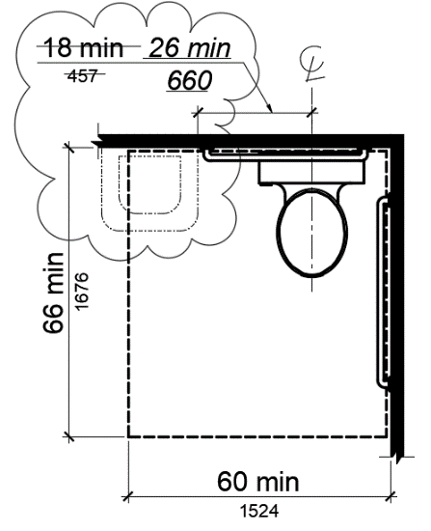
Figure 11B-604.3.2 (Exception)
OVERLAP OF WATER CLOSET CLEARANCE IN RESIDENTIAL DWELLING UNITS
Notation:
Authority: Government Code Section 12955.1(c).
Reference(s): Government Code Section 12955.1(c) and Health and Safety Code Section 18949.1.

Item 11B.34
DIVISION 6: PLUMBING ELEMENTS AND FACILITIES
11B-604.8.1.2 Doors. Toilet compartment doors… Doors shall be located in the front partition or in the side wall or partition farthest from the water closet. Where located in the front partition, the door opening shall be 4 inches (102 mm) maximum from the side wall or partition farthest from the water closet. Where located in the side wall or partition, the door opening shall be 4 inches (102 mm) maximum from the front partition the door opening shall be farthest from the water closet and shall be 54 inches (1372 mm) minimum from the rear wall. …
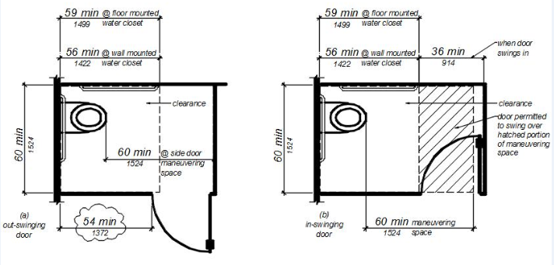FIGURE 11B-604.8.1.1.2
MANEUVERING SPACE WITH SIDE-OPENING DOOR
Notation:
Authority: Government Code Section 4450.
Reference(s): Government Code Section 4450 through 4461 and Health and Safety Code Section 18949.1.

Item 11B.35
DIVISION 6: PLUMBING ELEMENTS AND FACILITIES
11B-608.5 Controls. Controls, faucets, and shower spray units shall comply with Section 11B-309.4. Controls and faucets shall allow the user to close and open the water supply.
11B-608.5.1 Transfer type shower compartments.
11B-608.5.2 Standard roll-in type shower compartments. In standard roll-in type shower compartments, operable parts of controls and faucets shall be installed on the controls, faucets, and the shower spray unit shall be located on the back wall of the compartment adjacent to the seat wall 19 inches (483 mm) minimum and 16 inches (406 mm) minimum and 27 inches (686 mm) maximum from the seat wall; and shall be located above the grab bar, but no higher than 48 inches (1219 mm) above the shower floor. , with their centerline at 39 inches (991 mm) to 41 inches (1041 mm) above the shower floor.
Operable parts of the shower spray unit, including the handle, shall be installed on the back wall adjacent to the seat wall 19 inches (483 mm) minimum and 27 inches (686 mm) maximum from the seat wall; and shall be located above the grab bar, but no higher than 48 inches (1219 mm) above the shower floor.
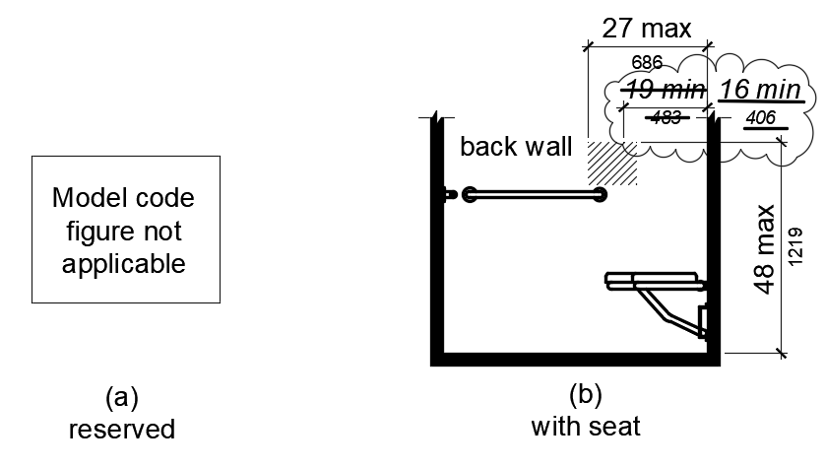
Figure 11B-608.5.2
STANDARD ROLL-IN TYPE SHOWER COMPARTMENT CONTROL LOCATION
11B-608.5.3 Alternate roll-in type shower compartments. In alternate roll-in type shower compartments, operable parts of controls and faucets shall be installed the controls, faucets, and shower spray unit shall be located on the side wall of the compartment adjacent to the seat wall 19 inches (483 mm) minimum and 16 inches (406 mm) minimum and 27 inches (686 mm) maximum from the seat wall; or shall be located on the back wall opposite the seat 15 inches (381 mm) maximum, left or right of the centerline of the seat. and The operable parts of controls, faucets, and shower spray units shall be located above the grab bar, but no higher than 48 inches (1219 mm) above the shower floor., with their centerline at 39 inches (991 mm) to 41 inches (1041 mm) above the shower floor. Operable parts of the shower spray unit, including the handle, shall be installed on the side wall of the compartment adjacent to the seat wall 17 inches (432 mm) minimum and 19 inches (483 mm) maximum from the seat wall or on the back wall opposite the seat 15 inches (381 mm) maximum, left or right, of the centerline of the seat; and shall be located above the grab bar, but no higher than 48 inches (1219 mm) above the shower floor.
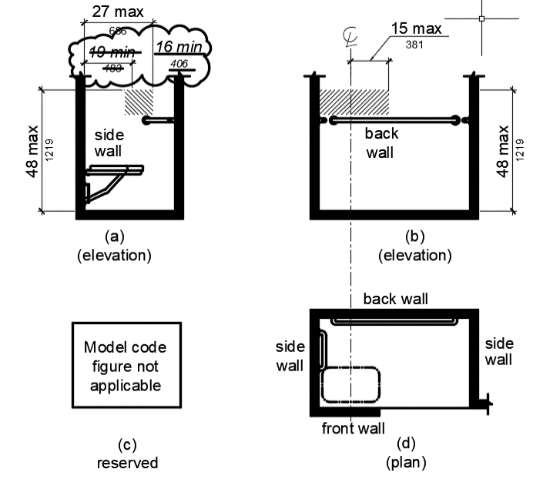
Figure 11B-608.5.3
ALTERNATE ROLL-IN TYPE SHOWER COMPARTMENT CONTROL LOCATION
Notation:
Authority: Government Code Section 4450.
Reference(s): Government Code Sections 4450 through 4461, 12955.1(c); and Health and Safety Code Section 18949.1.

Item 11B.36
DIVISION 7: COMMUNICATION ELEMENTS AND FEATURES
11B-705.1.1.3 Color and contrast. Detectable warning surfaces at transit boarding platform edges, bus stops, hazardous vehicular areas, reflecting pools, and track crossings shall comply with Section 11B-705.1.1.3.1. Detectable warnings at other locations shall comply with either Section 11B-705.1.1.3.1 or Section 11B-705.1.1.3.2. The material used to provide visual contrast comply with this section shall be an integral part of the detectable warning surface.
Exceptions:
- Replacement of less than 20 percent of existing detectable warnings at a single contiguous location shall be permitted to be in-kind at existing curb ramps, islands, or cut-through medians with detectable warnings in compliance with the code requirements in effect at the time of installation.
- Existing installed detectable warnings at curb ramps, islands, or cut-through medians may comply with Section 11B-705.1.1.3.2 in lieu of Section 11B-705.1.1.3.1.
11B-705.1.1.3.1 Detectable warning surfaces shall be yellow and approximate FS 33538 of Federal Standard 595C 33538 of SAE AMS-STD-595A.
Notation:
Authority: Government Code Section 4450.
Reference(s): Government Code Section 4450 through 4461 and Health and Safety Code Section 18949.1.

ITEM 11B.37
DIVISION 7: COMMUNICATION ELEMENTS AND FEATURES
11B-705.1.2.2 Curb ramps. Detectable warnings at curb ramps shall comply with Section 11B-705.1.2.2.
11B-705.1.2.2.1 Perpendicular curb ramps. Detectable warnings at perpendicular curb ramps shall extend 36 inches (914 mm) in the direction of travel. Detectable warnings shall extend the full width of the ramp run less 2 inches (51 mm) maximum on each side, excluding any flared sides. Detectable warnings shall be located so the edge nearest the curb is 6 inches (152 mm) minimum and 8 inches (203 mm) maximum from the demarcation line at the face of the curb marking the transition between the curb and the gutter, street or highway.
Exception: On parallel curb ramps, detectable warnings shall be placed on the turning space at the flush transition between the street and sidewalk.
11B-705.1.2.2.2 Parallel curb ramps. Detectable warnings at parallel curb ramps shall be located so the edge nearest the curb is 6 inches (152 mm) minimum and 8 inches (203 mm) maximum from the demarcation line at the face of the curb between the curb and the gutter, street or highway. Detectable warnings shall extend the full width of the turning space at the flush transition demarcation between the street and the sidewalk less 2 inches (51 mm) maximum on each side.
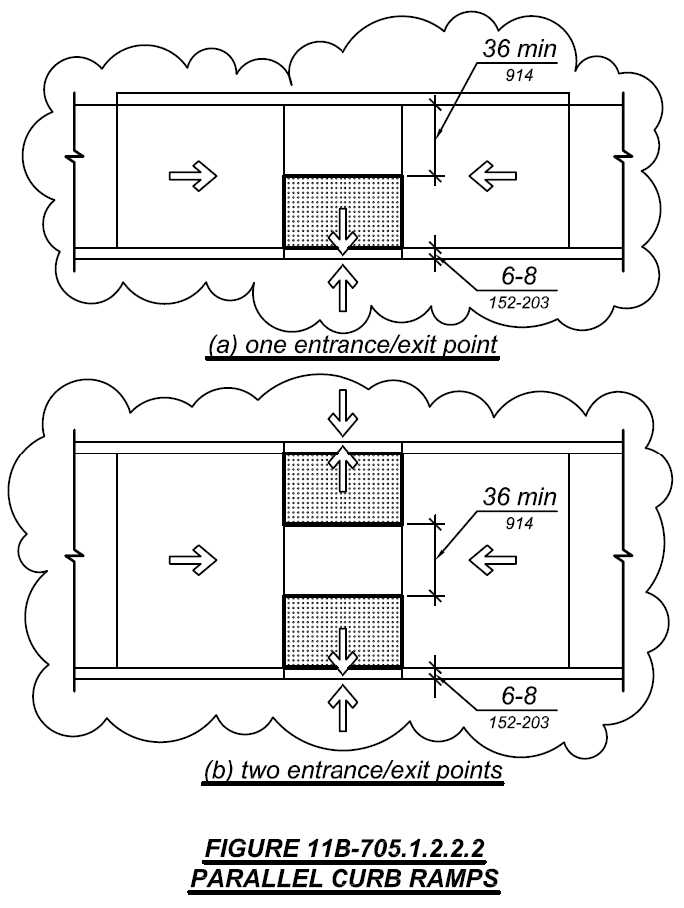
11B-705.1.2.2.2.1 One entrance/exit point. Where the turning space has one entrance/exit point other than the sloped ramp segments, detectable warnings shall be 36 inches (914 mm) deep, as measured perpendicular to the curb, and the turning space shall provide a minimum 36 inches (914 mm) wide portion without detectable warnings to allow pedestrian travel in the direction of the sidewalk without travelling over the detectable warnings.
Exceptions:
- Where it is technically infeasible to provide a minimum 72 inches (1828 mm) wide turning space, as measured perpendicular to the curb, the depth of detectable warnings may be reduced to 24 inches (610 mm) minimum.
- Existing parallel curb ramps with detectable warnings in compliance with the code requirements in effect at the time of installation shall not be required to provide a minimum 36 inches (914 mm) wide portion of the turning space without detectable warnings.
11B-705.1.2.2.2.2 Two entrance/exit points. Where the turning space has two entrance/exit points other than the sloped ramp segments, detectable warnings shall be 36 inches (914 mm) deep at both entrance/exit points, as measured perpendicular to the curb, and the turning space shall provide a minimum 36 inches (914 mm) wide portion without detectable warnings to allow pedestrian travel in the direction of the sidewalk without travelling over the detectable warnings.
Exceptions:
- Where it is technically infeasible to provide a minimum 108 inches (2743 mm) wide turning space, as measured perpendicular to the curb, the depth of detectable warnings may be reduced to 24 inches (610 mm) minimum.
- Existing parallel curb ramps with detectable warnings in compliance with the code requirements in effect at the time of installation shall not be required to provide a minimum 36 inches (914 mm) wide portion of the turning space without detectable warnings.
Notation:
Authority: Government Code Section 4450.
Reference(s): Government Code Sections 4450 through 4461, and 14679; and Health and Safety Code Section 18949.1.

Item 11B.38
DIVISION 7: COMMUNICATION ELEMENTS AND FEATURES
11B-705.1.2.5 Hazardous vehicular areas Blended transitions. Detectable warnings at hazardous vehicular areas blended transitions shall be 36 inches (914 mm) in width.
Notation:
Authority: Government Code Section 4450.
Reference(s): Government Code Section 4450 through 4461 and Health and Safety Code Section 18949.1.

Item 11B.39
DIVISION 8: SPECIAL ROOMS, SPACES, AND ELEMENTS
11B-802.1.1 Floor or ground surface. The floor or ground surface of wheelchair spaces shall comply with Section 11B-302. Changes in level, slopes exceeding 1:48, and detectable warnings shall not be permitted. are not permitted.
Exception: Slopes not steeper than 1:48 shall be permitted. Reserved.
Notation:
Authority: Government Code Section 4450.
Reference(s): Government Code Section 4450 through 4461 and Health and Safety Code Section 18949.1.

Item 11B.40
DIVISION 8: SPECIAL ROOMS, SPACES, AND ELEMENTS
11B-804 Kitchens, kitchenettes, and wet bars.
11B-804.1 General. Kitchens, kitchenettes, and wet bars shall comply with Section 11B-804.
11B-804.2.3 Turning space. In kitchens within multi-bedroom housing units and on floors containing accessible sleeping rooms with adaptable features in undergraduate student housing, turning spaces complying with Section 11B-304 shall be provided.
Notation:
Authority: Government Code Section 4450.
Reference(s): Government Code Section 4450 through 4461, 12955.1(c) and Health and Safety Code Section 18949.1.

Item 11B.41
DIVISION 8: SPECIAL ROOMS, SPACES, AND ELEMENTS
11B-804.3 Kitchen work surface. In residential dwelling units required to comply with Section 11B-809, at least one 30 inches (762 mm) wide minimum section of counter shall provide a kitchen work surface that complies with Section 11B-804.3. In kitchens within multi-bedroom housing units and on floors containing accessible sleeping rooms with adaptable features in undergraduate student housing, at least one 30 inches (762 mm) wide minimum section of counter shall provide a kitchen work surface that complies with Section 11B-804.3.
Notation:
Authority: Government Code Section 4450.
Reference(s): Government Code Section 4450 through 4461, and 12955.1(c); Health and Safety Code Section 18949.1.

Item 11B.42
DIVISION 8: SPECIAL ROOMS, SPACES, AND ELEMENTS
11B-809.6 Residential dwelling units with adaptable features. Multi-family residential dwelling units with adaptable features shall comply with Sections 11B-809.7 through 11B-809.12.
11B-809.7 Accessible routes. An accessible route shall be provided complying with Section 11B-809.7. The accessible route shall pass through the primary entry door, through all rooms within the dwelling unit and exterior decks and balconies. The accessible route shall adjoin or overlap clear floor spaces and connect all exterior doors.
Exceptions:
- An accessible route shall not be required from the interior of the unit into a basement.
- An accessible route to a garage shall comply with Section 11B-208.3.3.
- An accessible route shall not be required to rooms or spaces not located on the primary entry level of a multistory dwelling unit.
11B-809.7.1 Width. The clear width for the accessible route shall be 36 inches (914 mm) minimum.
Exception: The clear width shall be permitted to be reduced to 32 inches (813 mm) minimum at doors.
11B-809.7.2 Changes in level. Changes in level shall comply with Sections 11B-303.2 and 11B-303.3. Ramps complying with Section 11B-405, elevators complying with Section 11B-407 or platform lifts complying with Section 11B-410 shall be provided where changes in level exceed 1/2 inch (12.7 mm) high.
11B-809.8 Doors. Primary entry doors, required exit doors, secondary exterior doors and interior doors intended for user passage shall comply with this section and Section 11B-404.2. Doors to small mechanical closets specifically dedicated to furnaces or hot water heaters shall not be required to comply with this section.
Exceptions: At primary entry doors, required exit doors, secondary exit doors and interior doors the following exceptions apply:
- The floor or landing at primary entry doors, required exit doors, and secondary exit doors where a change in elevation occurs between the interior and the exterior surface of the floor or landing, shall comply with the following:
  - Exterior landings of impervious construction (e.g., concrete, brick, flagstone) serving primary entry doors and required exit doors are limited to not more than 1/2 inch (12.7 mm) of change in height between floor surfaces. Changes in level shall comply with Section 11B-809.7.2.
  - Exterior landings of pervious construction (e.g., wood decking with spaces) shall be the same level as the interior landing, except that secondary exterior doors may have no more than 1/2 inch (12.7 mm) of change in height between floor surfaces. Changes in level shall comply with Section 11B-809.7.2.
  - Secondary exterior doors onto decks, patios, or balcony surfaces constructed of impervious materials (e.g., concrete, brick, flagstone) may have a maximum change in height from the interior landing of 4 inches (102 mm). Changes in height greater than 1/2 inch (12.7 mm) shall be accomplished by means of a ramp complying with Section 11B-405 or by means of a platform constructed to the level of the floor as illustrated in Figure 11B-809.8 (c).
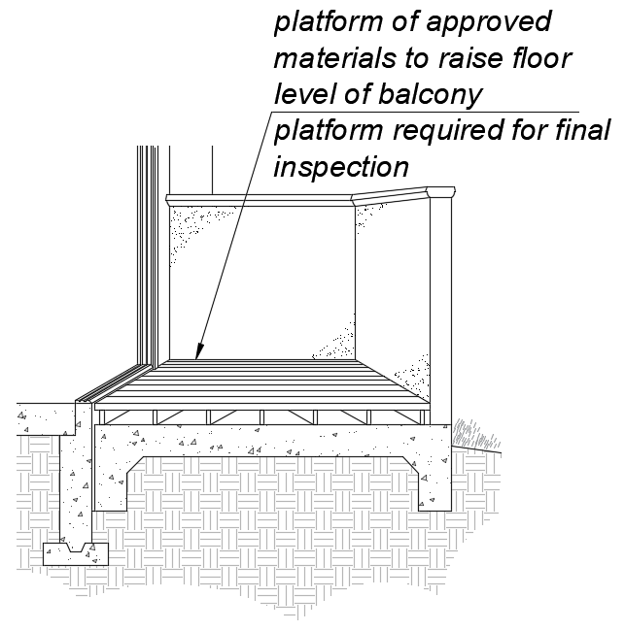
FIGURE 11B-809.8 Ex. 1(c)
PLATFORM AT SECONDARY EXTERIOR DOOR.
  - Secondary exterior doors onto decks, patios or balcony surfaces constructed of impervious materials (e.g., concrete, brick, flagstone) may have a maximum change in height from the interior landing of 1 inch (25 mm), provided a ramp with a maximum slope of 1:8 is permanently installed as illustrated in Figure 11B-809.8 (d).
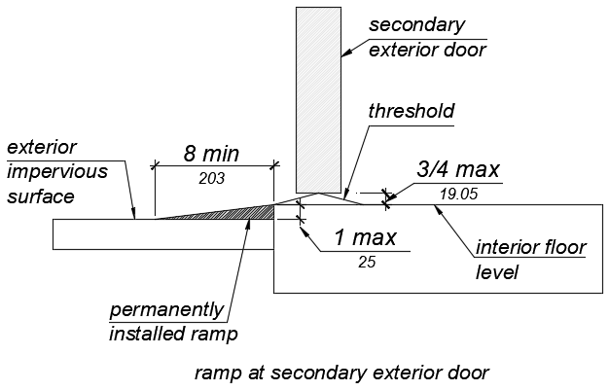
FIGURE 11B-809.8 Ex. 1(d)
RAMP AT SECONDARY EXTERIOR DOOR.
11B-809.8.1 Door Thresholds. Secondary exterior door thresholds, including sliding door tracks, shall be 3/4 inch (19.1 mm) high maximum with a 1:2 maximum slope.
11B-809.8.2 Door opening force. The opening force for primary entry exterior doors and secondary exterior doors shall be 8.5 pounds (38 N) maximum.
11B-809.8.3 Door maneuvering clearance.
- At the dwelling unit side of the primary entry doors, secondary exterior doors, and required exit doors maneuvering clearances shall be 44 inches (1118 mm) minimum in length measured perpendicular to the face of the door in the closed position. The width of the maneuvering clearance shall extend 18 inches (457 mm) beyond the strike edge at the pull side of the door.
- At interior doors maneuvering clearances shall be 42 inches (1067 mm) minimum in length on the both sides of the door measured perpendicular to the face of the door in the closed position. A 39 inch (991 mm) minimum length is allowed at interior doors when a clear opening width of 34 inches (864 mm) minimum is provided. The width of the maneuvering clearance shall extend 18 inches (457 mm) beyond the strike edge at the pull side of the door.
11B-809.8.4 Door signal devices. Every primary entrance to a residential dwelling unit with adaptable features shall be provided with a door buzzer, bell, chime or equivalent. The activating mechanism shall be mounted 48 inches (1219 mm) maximum above the floor and connected to permanent wiring.
11B-809.9 Kitchens. Kitchens shall be on an accessible route and shall comply with this section.
11B-809.9.1 Clear floor space. Clear floor spaces 30 inches (762 mm) by 48 inches (1219 mm), with centerlines aligned with the centerline of the work surface, appliance, sink or fixture, shall be provided in the following locations:
- For a parallel approach at the range.
- For parallel or forward approach at a cooktop.
- For a parallel or forward approach to the sink and to the work surface required by Sections 11B-809.9.3 and 11B-809.9.4.
- For a parallel or forward approach to all other fixtures or appliances.
11B-809.9.2 Clear width. Kitchens shall have a minimum clear width measured between any cabinet, work surface or the face of any appliance (excluding handles and controls) and the opposing cabinet, work surface, appliance or wall as follows:
- U-shaped kitchens, designed with parallel approach at a sink, range, cooktop or other fixtures and appliances located at the base of the U without knee and toe clearance, shall provide a clear width of 60 inches (1524 mm) minimum.
- U-shaped kitchens, with a cooktop, sink or work surface located at the base of the U, that provides knee and toe space complying Sections 11B-809.9.3 and 11B-809.9.4 to allow for a forward approach, shall provide a clear width of 48 inches (1219 mm) minimum.
- All other kitchen designs shall provide a clear width of 48 inches (1219 mm) minimum.
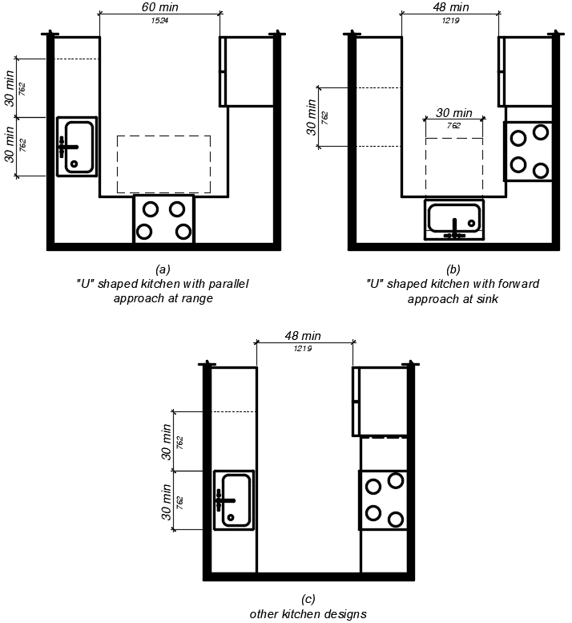
FIGURE 11B-809.9.2
CLEAR WIDTH AT KITCHENS.
11B-809.9.3 Removable base cabinets. Knee and toe space complying with Section 11B-306 shall be provided at sinks and work surfaces required to comply with Section 11B-809.9.4.
Exception: Removable base cabinets shall be permitted under sinks and work surfaces provided that all of the following conditions are met:
- base cabinets can be removed without the use of specialized tools or knowledge;
- the finish floor extends under the base cabinet; and
- the walls behind and surrounding the base cabinets are finished.
11B-809.9.4 Work surfaces. Work surfaces shall be 36 inches (914 mm) maximum above the finish floor with minimum lengths at the following locations as required by this section:
- Linear length of 30 inches (762 mm) minimum for installation of a sink.
- Linear length of 30 inches (762 mm) minimum for work surfaces.
- A sink and work surface in a single integral unit 60 inches (1524 mm) minimum in length, is permitted.
11B-809.9.5 Lower shelving. Lower shelving and/or drawer space shall be provided at a height of 48 inches (1219 mm) maximum above the finish floor.
11B-809.9.6 Controls. Controls for faucets shall comply with Section 11B-309.1. Hand-operated metering faucets shall remain open for 10 seconds minimum.
11B-809.9.7 Exposed pipes and surfaces. Exposed water supply and drain pipes under sinks and lavatories shall comply with Section 11B-606.5.
11B-809.10 Toilet and bathing rooms.
11B-809.10.1 General. All toilet and bathing rooms on an accessible route within residential dwelling units with adaptable features shall comply with Sections 11B-809.7, 11B-809.8, 11B-809.10.6.4, 11B-809.10.7.3 and 11B-809.12.
11B-809.10.2 Number of complying bathing rooms and fixtures. One bathing room and one fixture of each type within the dwelling unit shall be designed to comply with the following:
- Maneuvering space in toilet, bathing and shower rooms shall comply with Section 11B-809.10.4.
- Bathtubs complying with Section 11B-809.10.5.
- Showers complying with Section 11B-809.10.6.
- Water closets complying with Section 11B-809.10.7.
- Lavatories, vanities, mirrors and towel bars complying with Section 11B-809.10.8. When two or more lavatories are provided, at least one shall comply with Section 11B-809.10.8.
- Where both a tub and shower are provided in the bathroom, at least one shall be made accessible. Where two or more bathrooms are provided, when a bathtub is installed in the first bathroom in compliance with Section 11B-809.10.5 and a shower compartment is provided in a subsequent bathroom, at least one shower compartment shall comply with Section 11B-809.10.6.
11B-809.10.3 Powder rooms. Powder rooms shall be designed to comply with Sections 11B-809.7, 11B-809.8, 11B-809.10.5.2, 11B-809.10.6.4, 11B-809.10.7.3, and 11B-809.12. When the powder room is the only toilet facility located on an accessible level it shall, in addition, comply with Sections 11B-809.10.4, 11B-809.10.7 and 11B-809.10.8.
11B-809.10.4 Sufficient maneuvering space. Where doors swing into the toilet and bathing or powder rooms required to comply with Section 11B-809.10, a clear maneuvering space of 30 (762 mm) inches by 48 inches (1219 mm) minimum shall be provided outside the arc of the door swing. The clear maneuvering space shall be permitted to include knee and toe clearance under bathroom fixtures. Doors shall be permitted to encroach into the clear floor space or clearance for fixtures where clear maneuvering space is provided outside the arc of the door swing. A turning space is not required within the room.
11B-809.10.5 Bathtubs. Bathtubs required by Section 11B-809.10 shall comply with this section.
11B-809.10.5.1 Clear floor space. A clear floor space 30 inches (762 mm) minimum by 48 inches (1219 mm) minimum shall be located with the long edge of the clear floor space parallel to the side of the bathtub or bathtub-shower combination. Controls shall be located on the wall at the foot of the bathtub. The edge of the clear floor space shall be flush with the control wall surface. The area under a lavatory, located at the control end of the tub, shall be permitted to encroach on the clear floor space provided the lavatory is 19 inches (483 mm) maximum in depth, and knee and toe clearance complying with Section 11B-306 is provided. Cabinets under lavatories and toilets shall not encroach on the clear floor space.
11B-809.10.5.2 Reinforcement for grab bars. Reinforcement for grabs bars shall comply with the following:
- Where bathtubs are installed without surrounding walls reinforcement shall be provided for floor-mounted grab bars.

- Where bathtubs are installed with surrounding walls, grab bar reinforcement shall be installed as follows:
  - At the control end wall and head end wall, between 30 inches (762 mm) maximum to 38 inches (965 mm) minimum above the finish floor, extending 28 inches (711 mm) minimum from the front edge of the bathtub to the back wall of the bathtub. The grab bar reinforcement shall be 8 inches (203 mm) minimum in height.
  - At the back wall, from 5 inches (127 mm) maximum above the bathtub rim to 38 inches (965 mm) minimum above the finish floor. Grab bar backing shall be installed horizontally to permit the installation of a 48-inch (1219 mm) grab bar with each end 6 inches (152 mm) maximum from the end walls of the bathtub.
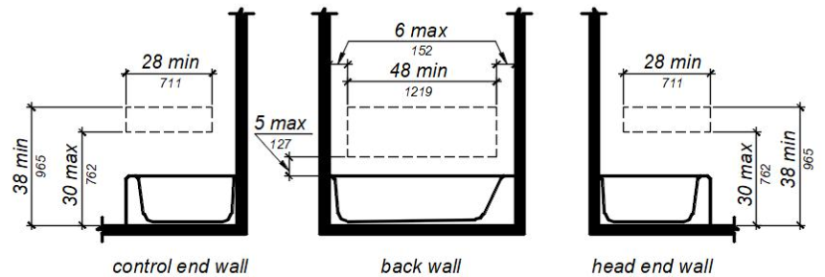
FIGURE 11B-809.10.5.2 REINFORCEMENT FOR GRAB BARS.
11B-809.10.5.3 Controls. Controls and operating mechanisms shall comply with Section 11B 309.4.
Exception: Shower spray units are not required in bathtubs.
11B-809.10.5.4 Bathtub enclosures. Doors and panels of bathtub enclosures shall be constructed from approved, shatter-resistant materials. Hinged doors shall open outward. Glazing used in doors and panels of bathtub enclosures shall be fully tempered, laminated safety glass or approved plastic. When glass is used, it shall be 1/8 inch (3.2 mm) thick minimum when fully tempered, or 1/4 inch (6.4 mm) thick minimum when laminated, and shall pass the test requirements of this part, Chapter 24 Glass and Glazing. Plastics used in doors and panels of bathtub enclosures shall be of a shatter-resistant type.
11B-809.10.6 Showers. Showers required by Section 11B-809.10 shall comply with this section.
11B-809.10.6.1 Size. When one or more shower stalls are provided within the same dwelling unit, as least one shower stall shall comply with one of the following:
  - A transfer type shower compartment 36 inches (914 mm) wide by 36 inches (914 mm) deep with an entrance opening 36 inches (914 mm) complying with Section 11B-608.1 or;
  - A shower stall 30 inches (762 mm) deep minimum by 60 inches (1524 mm) wide minimum with an entrance opening 60 inches (1524 mm) minimum. A water closet shall be permitted to project 12 inches (305 mm) maximum into the opening provided that 36 inches (914 mm) minimum clear space is maintained between the water closet and the shower wall as illustrated in Figure 11B-809.10.6.1 or;
  - A shower stall 36 inches (914 mm) deep by 60 inches (1524 mm) wide minimum with an entrance 36 inches (914 mm) minimum when a wall is installed on the opening side.
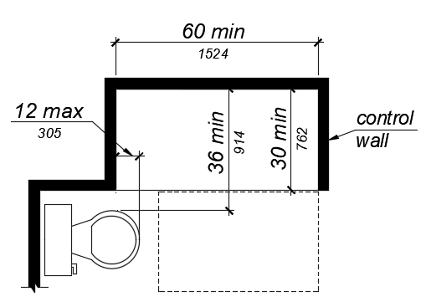
FIGURE 11B-809.10.6.1 SHOWERS.
11B-809.10.6.2 Slope. The slope of the shower floor shall be 1/4 inch (6.4 mm) per foot maximum in any direction and shall slope to a drain. The floor surfaces shall be of Carborundum, grit-faced tile or of material providing equivalent slip resistance.
11B-809.10.6.3 Floor space. A clear maneuvering space 30 inches (762 mm) wide minimum by 48 inches (1219 mm) minimum in length shall be located outside the shower, with the width flush with the control wall and the length parallel to the length of the shower.
11B-809.10.6.4 Reinforcement for grab bars. Reinforcement for grabs bars shall comply with the following: Continuous reinforcement shall be installed in the walls of showers 30 inches (762 mm) maximum to 38 inches (965 mm) minimum above the finish floor. The grab bar reinforcement shall be 8 inches (203 mm) minimum in height. Glass-walled shower stalls shall provide reinforcement for installation of floor-mounted or ceiling-mounted grab bars.
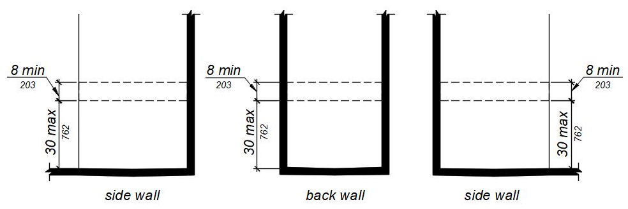
FIGURE 11B-809.10.6.4 REINFORCEMENT FOR GRAB BARS.
11B-809.10.6.5 Thresholds. Where provided thresholds shall be 2 inches (51 mm) maximum in height and have a beveled or sloped angle not exceeding 1 unit vertical in 2 units horizontal (26.6 degrees from the horizontal). Thresholds 1/2 inch (12.7 mm) or less in height shall have a beveled or sloped angle not exceeding 1 unit vertical in 1 unit horizontal (45 degrees from the horizontal).
11B-809.10.6.6 Controls. Controls and operating mechanisms shall comply with Section 11B 309.4.
11B-809.10.6.7 Shower enclosures. Doors and panels of shower enclosures shall comply with Section 11B-809.10.5.4.
11B-809.10.7 Water closets. Water closets required by Section 11B-809.10 shall comply with this section.
11B-809.10.7.1 Floor space. The floor space at water closets shall be 48 inches (1219 mm) wide minimum measured perpendicular to the side wall. A floor space 48 inches (1219 mm) wide minimum by 36 inches (914 mm) deep minimum shall be provided in front of the water closet.
Exception: The 48-inch (1219 mm) minimum clear width may be reduced to 36 inches (914 mm) minimum for lavatories, cabinets, wing walls, or privacy walls located immediately adjacent to a water closet which extend 24 inches (610 mm) maximum in depth.
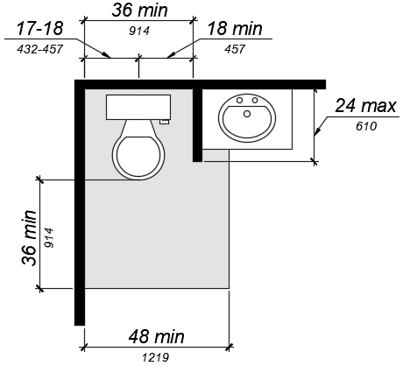
FIGURE 11B-809.10.7.1 FLOOR SPACE.
11B-809.10.7.2 Location. Water closets shall be located within bathrooms in a manner that permits a grab bar to be installed on at least one side of the fixture. The centerline of the water closet shall be 17 inches (432 mm) minimum to 18 inches (457 mm) maximum from a wall or partition that is 54 inches (1372 mm) minimum in length. In locations where water closets are adjacent to other walls, vanities, lavatories or bathtubs, the centerline of the fixture shall be 18 inches (457 mm) minimum from the obstacle.
11B-809.10.7.3 Reinforcement for grab bars. Reinforcement for grabs bars shall comply with the following:
- Where water closets are not placed adjacent to a side wall capable of accommodating a grab bar, the bathroom shall have provisions for installation of floor-mounted, foldaway or similar alternative grab bars.
- Where water closets are placed adjacent to a side wall, reinforcement shall be installed on both sides or one side and the back. Where reinforcement is installed at the back, it shall be installed between 30 inches (762 mm) maximum and 38 inches (965 mm) minimum above the finish floor. The grab bar reinforcement shall be 8 inches (203 mm) minimum in height. The backing shall 40 inches (1016 mm) minimum in length.
- Where the water closet is located adjacent to lavatories, cabinets, wing walls, or privacy walls the grab bar reinforcement shall be 36 inches (914 mm) in length. Reinforcement installed at the side wall of the water closet shall be between 30 inches (762 mm) minimum to 38 inches (965 mm) maximum above the finish floor. The reinforcement shall be 10 inches (254 mm) maximum from the rear wall and shall extend 30 inches (762 mm) minimum in front of the water closet. The grab bar reinforcement shall be 8 inches (203 mm) minimum in height.
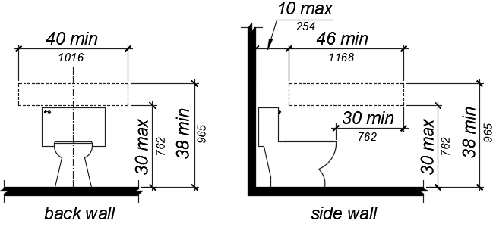
FIGURE 11B-809.10.7.3 REINFORCEMENT FOR GRAB BARS.
11B-809.10.7.4 Seat height. Water closet seats shall be 15 inches (381 mm) minimum and 19 inches (483 mm) maximum measured to the top of the seat above the finish floor.
11B-809.10.7.5 Controls. Controls shall be mounted 44 inches (1118 mm) maximum above the finish floor. The force required to activate controls shall be 5 pounds (22.2 mm) maximum.
11B-809.10.8 Lavatories, vanities, mirrors and towel bars. Bathing rooms or powder rooms required to comply with Section 11B-809.10 shall provide lavatories complying with this section. Where mirrors or towel bars are provided, no less than one of each shall comply with this section.
11B-809.10.8.1 Location. Lavatories without base cabinets shall be installed with the centerline 18 inches (457 mm) minimum from an adjoining wall or fixture to allow for forward approach. Lavatories with base cabinets shall be installed with the centerline 24 inches (610 mm) minimum from an adjoining wall or fixture to allow for a parallel approach. The top of the lavatory rim shall be 34 inches (864 mm) maximum above the finished floor.
11B-809.10.8.2 Floor space. A floor space 30 inches (762 mm) minimum by 48 inches (1219 mm) minimum shall be provided centered on the lavatory.
11B-809.10.8.3 Cabinets. Cabinets shall be removable without the use of specialized knowledge and/or tools. The finished floor shall extend to the wall under the lavatory.
11B-809.10.8.4 Knee and toe clearance. Knee and toe clearance shall be provided and comply with Section 11B-306.
11B-809.10.8.5 Plumbing protection. Plumbing protection shall comply with Section 11B-809.9.7.
11B-809.10.8.6 Controls. Faucet controls and operating mechanisms shall comply with Section 11B 309.4.
11B-809.10.8.7 Mirrors and towel bars. Where mirrors are provided the bottom edge of the reflective surface shall be 40 inches (1016 mm) maximum above the finish floor. Where towel bars are provided they shall be installed 40 inches (1016 mm) maximum above the finish floor to the top of the bar.
11B-809.11 Washing machines and clothes dryers. Where washing machines and clothes dryers are provided in residential dwelling units with adaptable features, one of each type shall be provided.
11B-809.12 Electrical receptacles, controls and switches. Electrical receptacles on branch circuits of 30 amperes or less, communication system receptacles, controls and switches shall be located as follows:
- Where there is no obstruction, 48 inches (1219 mm) maximum measured from the top of the receptacle box and 15 inches (381 mm) minimum measured from the bottom of the receptacle box to the finish floor.
- Where the reach is over an obstruction, electrical receptacles, controls and switches shall comply with Sections 11B-309.2 and 11B-308.3.
- When the reach is over a kitchen work surface and base cabinet, the work surface shall be 36 inches (914 mm) maximum above the finish floor and 25 1/2 inches (650 mm) maximum in depth. The base cabinet shall be 24 inches (610 mm) maximum in depth.
- Where receptacles are provided in a kitchen at a corner work surface, one receptacle shall be located 36 inches (915 mm) from either wall at the inside corner.
Exceptions:
- Electrical receptacles installed as part of permanently installed baseboard heaters.
- Electrical receptacles in floors adjacent to sliding panels or walls.
- Baseboard electrical receptacles in relocatable partitions, window walls or other electrical convenience floor outlets.
- Appliances (e.g., stoves, dishwashers, range hoods, microwave ovens and similar appliances) which have controls located on the appliance.
- Electrical receptacles dedicated to specific appliances.
- Circuit breakers.
FIGURE 11B-809.12
ELECTRICAL RECEPTACLES AT CORNER WORKSURFACES
Notation:
Authority: Government Code Section 12955.1(c).
Reference(s): Government Code Section 12955.1(c) and Health and Safety Code Section 18949.1.

Item 11B.43
DIVISION 8: SPECIAL ROOMS, SPACES, AND ELEMENTS
11B-812.3 Floor or ground surfaces. Vehicle spaces and access aisles serving them shall comply with Section 11B-302. Access aisles shall be at the same level as the vehicle space they serve. Changes in level, slopes exceeding 1:48, and detectable warnings shall not be permitted in vehicle spaces and access aisles.
Notation:
Authority: Government Code Section 4450.
Reference(s): Government Code Section 4450 through 4461 and Health and Safety Code Section 18949.1.

Item 11B.44

NOTICE TO THE READER: Items 11B.13, 11B.27, and 11B.44 regarding scoping and technical requirements for electric vehicle charging stations will be heard at the California Building Standards Commission’s meeting tentatively scheduled for August 13-14, 2020. These items will not be heard at the commission’s meeting tentatively scheduled for July 13, 14 & 15.

Item 11B.45
DIVISION 8: SPECIAL ROOMS, SPACES, AND ELEMENTS
11B-812 Electric vehicle charging stations
…
11B-812.9 Surface marking. EVCS vehicle spaces shall provide surface marking stating “EV CHARGING ONLY” in letters 12 inches (305 mm) high minimum. The centerline of the text shall be a maximum of 6 inches (152 mm) from the centerline of the vehicle space and its lower corner at, or lower side aligned with, the end of the parking vehicle space length.
Notation:
Authority: Government Code Section 4450.
Reference(s): Government Code Sections 4450 through 4461, and 14679; Health and Safety Code Section 18949.1 and Vehicle Code Section 22511.8.

