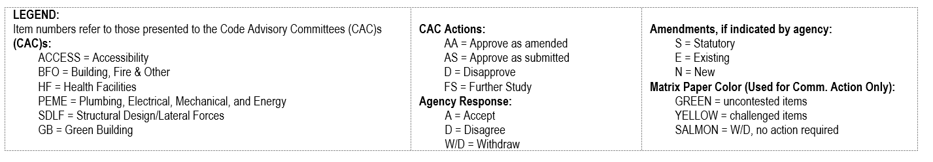
STRUCTURAL DESIGN / LATERAL FORCES (SD-LF) CODE ADVISORY COMMITTEE (DSA-SS/CC)

CHAPTER 2 – DEFINITIONS
Adopt entire Chapter with new amendment listed below
Item Number 3 | Code Section | Type of amend-  ment  (S, E, N) | CAC:  (AS, AA,  D, FS) | Agency Response to CAC  (A, D, W/D) | 45-Day Comments  (AS, AA, D, FS) | Annotations | CBSC Action (AS, AA, D, FS)
 | HIGH-RISE BUILDING | E | AS | A | 45 Day comments:  DSA-SS/CC commented on its own package regarding duplication of a def.  15 Day comments:  No comments received | DSA-SS/CC proposed removal of def. during 15-day comment period from 11/2/18 thru 11/17/18.

CHAPTER 16 – STRUCTURAL DESIGN
Adopt entire chapter as amended, amended sections listed below
Item Number 6 | Code Section | Type of amend-  ment  (S, E, N) | CAC:  (AS, AA,  D, FS) | Agency Response to CAC  (A, D, W/D) | 45-Day Comments  (AS, AA, D, FS) | Annotations | CBSC Action (AS, AA, D, FS)
 | 1616.5.1.2  Item 5. | E | -- | -- | 45 Day comments:  D. Gould – Approve as Amend  15 Day comments:  No comments received. | New item per DSA, added after 45 day comment period. See FET/FSOR.

CHAPTER 16A – STRUCTURAL DESIGN [RED COLORED TEXT INDICATES ITEMS CARRIED FORWARD WITHOUT CHANGE]
Adopt entire Chapter with existing amendments to be carried forward and new amendments listed below
Item Number 7 | Code Section | Type of amend-  ment  (S, E, N) | CAC:  (AS, AA,  D, FS) | Agency Response to CAC  (A, D, W/D) | 45-Day Comments  (AS, AA, D, FS) | Annotations | CBSC Action (AS, AA, D, FS)
 | 1615A.2  Definitions  HIGH-RISE  BUILDING | E | AS | A | 45 Day comments:  D. Gould – Further Study  15 Day comments:  No comments received. | Repeal model code section and state agency amendment and definition. See FET/FSOR

CHAPTER 17A – SPECIAL INSPECTIONS AND TESTS [RED COLORED TEXT INDICATES ITEMS CARRIED FORWARD WITHOUT CHANGE]
Adopt entire Chapter carry forward existing amendments with modification
Item Number 8 | Code Section | Type of amend-  ment  (S, E, N) | CAC:  (AS, AA,  D, FS) | Agency Response to CAC  (A, D, W/D) | 45-Day Comments  (AS, AA, D, FS) | Annotations | CBSC Action (AS, AA, D, FS)
 | Periodic special inspection | E | AS | A | 45 Day comments:  D. Gould – Further Study | Relocate def. to Ch. 2. DSA to consider possible duplication of definition.

CHAPTER 21 – MASONRY
Adopt entire Chapter carry forward existing amendments with modifications
Item Number 13 | Code Section | Type of amend-  ment  (S, E, N) | CAC:  (AS, AA,  D, FS) | Agency Response to CAC  (A, D, W/D) | 45-Day Comments  (AS, AA, D, FS) | Annotations | CBSC Action (AS, AA, D, FS)
 | 21145.8.10.1 | E | AS | A | 45 Day comments:  J. Chrysler – Disapprove  J. Thompson - Disapprove | Renumber existing section and amend

CHAPTER 21A – MASONRY
Adopt entire Chapter carry forward existing amendments with modifications
Item Number 14 | Code Section | Type of amend-  ment  (S, E, N) | CAC:  (AS, AA,  D, FS) | Agency Response to CAC  (A, D, W/D) | 45-Day Comments  (AS, AA, D, FS) | Annotations | CBSC Action (AS, AA, D, FS)
 | 2104A.1.3.1.2.2 | E | AS | A | 45 Day comments:  G. Peifer – Disapprove  J. Thompson - Disapprove | Amend section
 | 2105A.5 | N | AS | A | 45 Day comments:  J. Chrysler – Disapprove | Add new section
 | 2105A.6 | N | AS | A | 45 Day comments:  J. Chrysler – Disapprove | Add new section
 | 2107A.4 | N | AS | A | 45 Day comments:  J. Chrysler – Disapprove  J. Thompson - Disapprove | Add new section

