FINAL EXPRESS TERMS
FOR PROPOSED BUILDING STANDARDS
OF THE DIVISION OF THE STATE ARCHITECT (DSA-AC)
REGARDING THE 2019 CALIFORNIA BUILDING CODE,
CALIFORNIA CODE OF REGULATIONS, TITLE 24, PART 2
(DSA-AC 01/18)
The State agency shall draft the regulations in plain, straightforward language, avoiding technical terms as much as possible and using a coherent and easily readable style. The agency shall draft the regulation in plain English. A notation shall follow the express terms of each regulation listing the specific statutes authorizing the adoption and listing specific statutes being implemented, interpreted, or made specific (Government Code Section 11346.2(a)(1)).
If using assistive technology, please adjust your settings to recognize underline, strikeout, italics and ellipsis.

LEGEND FOR EXPRESS TERMS (Based on model codes - Parts 2, 2.5, 3, 4, 5, 9, 10)
- Model Code language appears upright.
- Existing California amendments appear in italics.
- Amended model code or new California amendments appear underlined and in italics.
- Repealed model code language appears upright and in strikeout.
- Repealed California amendments appear in italics and strikeout.
- Ellipsis (. . .) indicate existing text remains unchanged.

FINAL EXPRESS TERMS

CHAPTER 1

SCOPE AND ADMINISTRATION

DIVISION I

CALIFORNIA ADMINISTRATION

ITEM 1.01

SECTION 1.9

DIVISION OF THE STATE ARCHITECT

1.9.1.1.1 All buildings, structures, sidewalks, curbs and related facilities constructed in the state by the use of state, county or municipal funds, or the funds of any political subdivision of the state. For public housing see Section 1.9.1.3.

1.9.1.1.2 All buildings, structures and facilities that are leased, rented, contracted, sublet or hired by any municipal, county or state division of government, or by a special district. For public housing see Section 1.9.1.3.

1.9.1.1.3 All publicly funded buildings used for congregate residences or for one- or two-family dwelling unit purposes shall conform to the provisions applicable to living accommodations.

1.9.1.1.4 1.9.1.1.3 All existing publicly funded buildings and facilities when alterations, structural repairs or additions are made to such buildings or facilities. For detailed requirements on existing buildings, see Chapter 11B, Division 2, Section 11B-202. . For public housing see Section 1.9.1.3.

1.9.1.1.5 1.9.1.1.4 With respect to buildings, structures, sidewalks, curbs and related facilities not requiring a building permit, building standards published in the California Building Standards Code relating to access for persons with disabilities and other regulations adopted pursuant to Government Code Section 4450, and in effect at the time construction is commenced, shall be applicable.

ITEM 1.02 - WITHDRAWN

CHAPTER 2

DEFINITIONS

ITEM 2.01 - WITHDRAWN

ITEM 2.02 - WITHDRAWN

ITEM 2.03

SECTION 202

DEFINITIONS

RISER. The upright part between two adjacent stair treads, between either an upper or lower landing and an adjacent stair tread, or between two adjacent landings.

STEP. A riser and tread.

TREAD. The horizontal part of a step.

CHAPTER 11B
ACCESSIBILITY TO PUBLIC BUILDINGS, PUBLIC ACCOMMODATIONS,
COMMERCIAL BUILDINGS AND PUBLIC HOUSING

ITEM 11B.01

DIVISION 2: SCOPING REQUIREMENTS

11B-203.8 Residential facilities. In public housing residential facilities, common use areas that do not serve residential dwelling units required to provide mobility features complying with Sections 11B-809.2 through 11B-809.4 and adaptable features complying with Chapter 11A, Division IV shall not be required to comply with these requirements or to be on an accessible route.

ITEM 11B.02

DIVISION 2: SCOPING REQUIREMENTS

11B-206.2.19 Pedestrian street crossings. Where walks or sidewalks are provided, a curb ramp, blended transition, or a combination of curb ramps and blended transitions complying with Section 11B-406 shall connect the walks or sidewalks at each pedestrian street crossing. The curb ramp (excluding any flared sides) or blended transition shall be contained wholly within the width of the pedestrian street crossing served.

EXCEPTION: Compliance with Section 11B-206.2.19 shall not be required where pedestrian crossing is prohibited by the appropriate administrative authority.

ITEM 11B.03

DIVISION 2: SCOPING REQUIREMENTS

11B-207 Accessible means of egress

11B-207.1 General. Means of egress shall comply with Chapter 10, Section 1009.

Exceptions:

- Where means of egress are permitted by local building or life safety codes to share a common path of egress travel, accessible means of egress shall be permitted to share a common path of egress travel.

- Areas of refuge shall not be required in detention and correctional facilities.

- Accessible means of egress are not required to be provided in existing buildings.

ITEM 11B.04

DIVISION 2: SCOPING REQUIREMENTS

Table 11B-224.2 Guest Rooms with Mobility Features

Total Number of Guest Rooms Provided | Minimum  Number of Required Rooms Without  Roll-in Showers¹ | Minimum  Number of Required Rooms With  Roll-in Showers² | Total Number of Required Rooms
1 | 1 | 0 | 1
1 2 to 25 | 0 1 | 1 | 1 2
26 to 50 | 1 2 | 1 | 2 3
51 to 75 | 3 | 1 | 4
76 to 100 | 4 | 1 | 5
101 to 150 | 5 | 2 | 7
151 to 200 | 6 | 2 | 8
201 to 300 | 7 | 3 | 10
301 to 400 | 8 | 4 | 12
401 to 500 | 9 | 4 | 13
501 to 1000 | 2 percent of total | 1 percent of total | 3 percent of total
1001 and over | 20, plus 1 for each 100, or fraction thereof,  over 1000 | 10, plus 1 for each 100, or fraction thereof,  over 1000 | 30, plus 2 for each 100, or fraction thereof,  over 1000
- Provide either a bathtub complying with Section 11B-607 or a transfer type shower complying with Section 11B-608.2.1.
- Provide either a standard roll-in type shower complying with Section 11B-608.2.2 or an alternate type roll-in shower complying with Section 11B-608.2.3.

ITEM 11B.05

DIVISION 2: SCOPING REQUIREMENTS

11B-233 Residential Public housing facilities

11B-233.1 General. Public housing facilities with residential dwelling units available for public use shall comply with Section 11B-233. See Chapter 2, Section 202 of this code for the definition of Public Housing.

ITEM 11B.06

DIVISION 2: SCOPING REQUIREMENTS

11B-233.3.1 Minimum number: new construction. Newly constructed public housing facilities with residential dwelling units shall comply with Section 11B-233.3.1.

Exception: …..

11B-233.3.1.1 Residential dwelling units with mobility features. In public housing facilities with residential dwelling units, at least 5 percent, but no fewer than one unit, of the total number of residential dwelling units shall provide mobility features complying with Sections 11B-809.2 through 11B-809.4 and shall be on an accessible route as required by Section 11B-206.

11B-233.3.1.2 Residential dwelling units with adaptable features. In public housing facilities with residential dwelling units, adaptable residential dwelling units complying with Chapter 11A, Division IV – Dwelling Unit Features shall be provided as required by Sections 11B-233.3.1.2.1 through 11B-233.3.1.2.5. 11B-233.3.1.2.6. Adaptable residential dwelling units shall be on an accessible route as required by Section 11B-206.

Exception: …..

11B-233.3.1.2.1 Elevator buildings. …..

11B-233.3.1.2.2 Non-elevator buildings. …..

11B-233.3.1.2.3 Ground floors above grade. …..

11B-233.3.1.2.4 Multi-story residential dwelling units in buildings with one or more elevators. In elevator buildings, public housing facilities with multi-story residential dwelling units shall comply with the following:
- …..
- …..
- …..
11B-233.3.1.2.5 Multi-story residential dwelling units in buildings with no elevator. In non-elevator buildings in public housing facilities, a minimum of 10 percent but not less than one of the ground floor multi-story residential dwelling units shall be calculated using the total number of multi-story residential dwelling units in buildings on a site and shall comply with the following:
- …..
- …..
- …..

ITEM 11B.07 - WITHDRAWN

ITEM 11B.08

DIVISION 2: SCOPING REQUIREMENTS

11B-233.3 Public housing facilities.
…
11B-233.3.3 Additions. Where an addition to an existing public housing facility building results in an increase in the number of residential dwelling units, the requirements of Section 11B-233.3.1 shall apply only to the residential dwelling units that are added until the total number of residential dwelling units complies with the minimum number required by Section 11B-233.3.1. Residential dwelling units required to comply with Sections 11B-233.3.1.1 and 11B-233.3.1.2 shall be on an accessible route as required by Section 11B-206.

ITEM 11B.09

DIVISION 2: SCOPING REQUIREMENTS

11B-233.3 Public housing facilities.
…
11B-233.3.4 Alterations. Alterations to a public housing facility shall comply with Section 11B-233.3.4.

Exception: Where compliance with Section 11B-809.2, 11B-809.3, or 11B-809.4 for units with mobility features or Chapter 11A, Division IV for units with adaptable features is technically infeasible, or where it is technically infeasible to provide an accessible route to a residential dwelling unit, the entity shall be permitted to alter or construct a comparable residential dwelling unit to comply with Sections 11B-809.2 through 11B-809.4 or Chapter 11A, Division IV provided that the minimum number of residential dwelling units required by Sections 11B-233.3.1.1, 11B-233.3.1.2 and 11B-233.3.1.3, as applicable, is satisfied.

11B-233.3.4.1 Alterations to vacated buildings. Where a building is vacated for the purposes of alteration for use as public housing, and the altered building contains more than 15 residential dwelling units, at least 5 percent of the residential dwelling units shall comply with Sections 11B-809.2 through 11B-809.4 and shall be on an accessible route as required by Section 11B-206. Residential dwelling units with adaptable features shall be provided in compliance with Section 11B-233.3.1.2. In addition, at least 2 percent of the residential dwelling units shall comply with Section 11B-809.5.

Exception: Where any portion of a building’s exterior is preserved, but the interior of the building is removed, including all structural portions of floors and ceilings and a new building intended for use as public housing is constructed behind the existing exterior, the building is considered a new building for determining the application of this chapter.

11B-233.3.4.2 Alterations to individual residential dwelling units. In public housing facilities with individual residential dwelling units, where a bathroom or a kitchen is substantially altered, and at least one other room is altered, the requirements of Section 11B-233.3.1 shall apply to the altered residential dwelling units until the total number of residential dwelling units complies with the minimum number required by Sections 11B-233.3.1.1, 11B-233.3.1.2, and 11B-233.3.1.3. Residential dwelling units required to comply with Sections Section 11B-233.3.1.1 and 11B-233.3.1.2 shall be on an accessible route as required by Section 11B-206.

Exception: Where public housing facilities contain 15 or fewer residential dwelling units, the requirements of Sections 11B-233.3.1.1, 11B-233.3.1.2, and 11B-233.3.1.3. shall apply to the total number of residential dwelling units that are altered under a single contract, or are developed as a whole, whether or not located on a common site.

11B-233.3.4.3 Alterations to residential dwelling units with adaptable features. The building standards for residential dwelling units with adaptable features do not apply to the alteration, repair, rehabilitation or maintenance of residential dwelling units constructed for first occupancy on or prior to March 13, 1991. Multifamily dwelling units with adaptable features constructed for first occupancy after March 13, 1991 shall be maintained in compliance with the accessibility standards in effect at the time of construction.

Exception: Where any portion of a building’s exterior is preserved, but the interior of the building is removed, including all structural portions of floors and ceilings and a new building is constructed behind the existing exterior, the building is considered a new building for determining the application of this chapter.

ITEM 11B.10

DIVISION 2: SCOPING REQUIREMENTS

11B-233.3 Public housing facilities.
…
11B-233.3.5 Dispersion. In public housing facilities, residential Residential dwelling units required to provide mobility features complying with Sections 11B-809.2 through 11B-809.4 and residential dwelling units required to provide communication features complying with Section 11B-809.5, and adaptable features complying with Chapter 11A, Division IV shall be dispersed among the various types of residential dwelling units in the facility and shall provide choices of residential dwelling units comparable to, and integrated with, those available to other residents.

Exception: In public housing facilities where Where multi-story residential dwelling units are one of the types of residential dwelling units provided, one-story residential dwelling units shall be permitted as a substitute for multi-story residential dwelling units where equivalent spaces and amenities are provided in the one-story residential dwelling unit.

ITEM 11B.11

DIVISION 2: SCOPING REQUIREMENTS

11B-248 Common use areas and employee work areas.

11B-248.1 Common use areas. Common use areas shall comply with this chapter.

11B-248.2 Employee work areas. Employee work areas shall comply with this chapter.

ITEM 11B.12

DIVISION 2: SCOPING REQUIREMENTS

11B-249. Adult changing facilities.

11B-249.1 General. Adult changing facilities shall comply with Section 11B-249.

11B-249.1.1 Where adult changing facilities are provided, each adult changing facility shall comply with Section 11B-813.

11B-249.1.2 Newly constructed commercial places of public amusement shall provide no fewer than one adult changing facility in compliance with Section 11B-813.

RELATED ITEM 11B.12.01

CHAPTER 2, Section 202 – Definitions

Commercial place of public amusement. An auditorium, convention center, cultural complex, exhibition hall, permanent amusement park, sports arena, theater or movie house for which the maximum occupancy is 2,500 or more for the facility. Cultural complexes include but are not limited to art galleries, symphony, concert halls, and museums. A commercial place of public amusement does not include any public or private higher education facility or district agricultural associations.

District Agricultural Associations. Those associations regulated by the California Food and Agricultural Code, Division 3, Part 3.

Adult changing facility. A facility that is for use by persons with disabilities who need assistance with personal hygiene.

RELATED ITEM 11B.12.02

CHAPTER 11B

DIVISION 8: SPECIAL ROOMS, SPACES, AND ELEMENTS

11B-813. Adult changing facilities. Adult changing facilities shall comply with Section 11B-813.

11B-813.1 Location. Adult changing facilities shall be provided within a unisex (single-user or family) toilet room or other similar private room.

11B-813.2 Features. Adult changing facilities shall provide features in compliance with Section 11B-813.2.

11B-813.2.1 Adult changing table. Adult changing tables shall be fixed to the floor or a wall and shall comply with Section 11B-813.2.1.

11B-813.2.1.1 Size. Adult changing tables shall have a changing surface of 70 inches minimum length and 30 inches minimum width.

11B-813.2.1.2 Clearance. A 36 inches minimum width side clearance shall be provided along the entire length of one side of adult changing tables. At both ends of adult changing tables, clearance shall be provided measuring 36 inches minimum wide and a minimum length as long as the table width plus the width of the side clearance. End and side clearances shall be measured from the outermost extent of the table. Floor or ground surfaces of clearances shall comply with Section 11B-302. Changes in level are not permitted.

11B-813.2.1.3 Height and operation. Adult changing table height shall be adjustable from 17 inches above the floor or ground to 38 inches above the floor or ground, as measured to the top of the changing surface. Height adjustability shall be powered. Operable parts shall comply with Section 11B-309.

11B-813.2.1.4 Capacity. Adult changing tables shall provide a minimum weight capacity of 300 pounds.

11B-813.2.1.5 Obstructions. When deployed, changing tables shall not obstruct the required width of an accessible route except as allowed by Section 11B-307.2.

11B-813.2.2 Water closet. No fewer than one water closet in compliance with Section 11B-604.

11B-813.2.3 Lavatory. One lavatory in compliance with Section 11B-606.

11B-813.2.4 Waste receptacle. No fewer than one waste receptacle in compliance with Section 11B-603.5.

11B -813.2.5 Coat hook. No fewer than one coat hook shall be provided in close proximity to the changing table and within one of the reach ranges specified in Section 11B-308.

11B-813.2.6 Shelf. No fewer than one shelf shall be provided in close proximity to the changing table at 40 inches minimum and 48 inches maximum above the finish floor.

11B-813.2.7 Accessories. Where provided, no fewer than one of each accessory shall comply with Section 11B-603.5.

11B-813.2.8 Turning space. Turning space complying with Section 11B-304 shall be provided within adult changing facilities.

11B-813.2.9 Overlap. Required clear floor spaces, clearance at fixtures, and turning space shall be permitted to overlap.

11B-813.2.10 Door swing. A door, in any position, shall be permitted to encroach into the turning space by 12 inches maximum. Where a clear floor space complying with Section 11B-305.3 is provided within the room beyond the arc of the door swing, doors shall be permitted to swing into the clear floor space, clearance required for any fixture, and clearance required for adult changing tables.

11B-813.2.11 Privacy latch. Each door to adult changing facilities shall have a privacy latch.

11B-813.2.12 Signs. A room identification sign complying with Section 11B-216 shall be provided at entrances to adult changing facilities. The text of the room identification sign shall be “ADULT CHANGING FACILITY”.

An informational sign complying with Section 11B-216 shall be provided within adult changing facilities and in close proximity to the changing table. The informational sign shall indicate the maximum weight capacity of the adult changing table, as determined by the table manufacturer.

Where the commercial place of public amusement has a central directory, the central directory shall indicate the location of adult changing facilities. Where other directories indicate the location of toilet facilities, the other directories shall also indicate the location of adult changing facilities.

RELATED ITEM 11B.12.03

CHAPTER 11B

DIVISION 8: SPECIAL ROOMS, SPACES, AND ELEMENTS
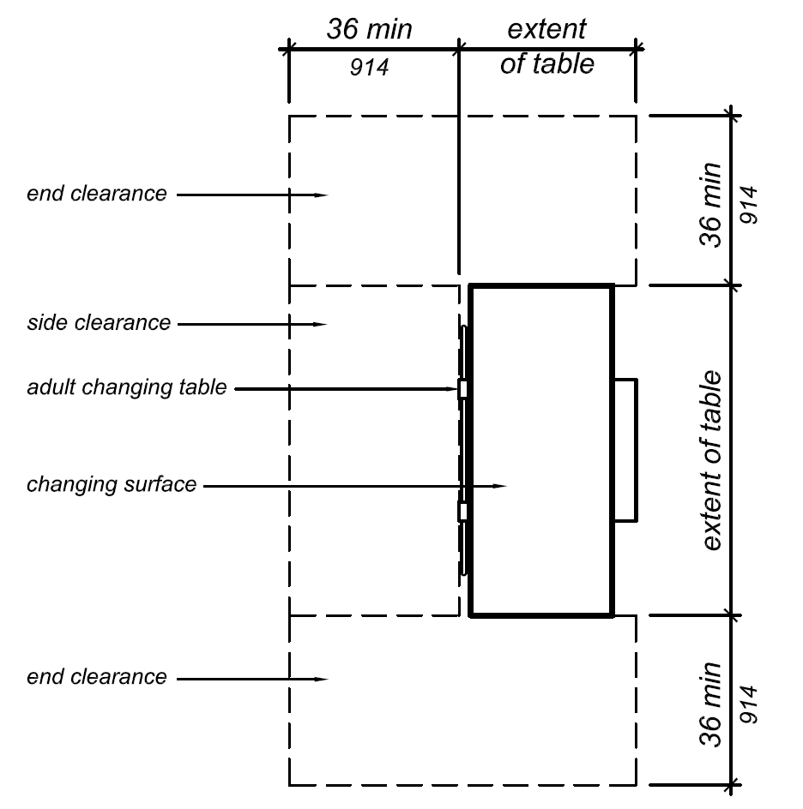

FIGURE 11B-813.2.1.2
CLEARANCE AROUND ADULT CHANGING TABLE

ITEM 11B.13

DIVISION 5: ACCESSIBLE ROUTES

11B-404.2.11 Vision lights. Doors, gates, and side lights adjacent to doors or gates, containing one or more glazing panels that permit viewing through the panels shall have the bottom of at least one glazed panel located 43 inches (1092 mm) maximum above the finish floor.

Exception: Exceptions:

- Glazing panels with the lowest part more than 66 inches (1676 mm) from the finish floor or ground shall not be required to comply with Section 11B-404.2.11.

- In detention and correctional facilities, vision lights used only by security personnel shall not be required to comply with Section 11B-404.2.11.

ITEM 11B.14

DIVISION 5: ACCESSIBLE ROUTES

11B-405 Ramps
11B-405.9 Edge protection. Edge protection complying with…

11B-405.9.2 Curb or barrier. A curb, 2 inches (51 mm) high minimum, or barrier shall be provided that prevents the passage of a 4 inch (102 mm) diameter sphere, where any portion of the sphere is within 4 inches (102 mm) of the finish floor or ground surface. To prevent wheel entrapment, the curb or barrier shall provide a continuous and uninterrupted barrier along the length of the ramp.

ITEM 11B.15

DIVISION 5: GENERAL SITE AND BUILDING ELEMENTS

11B-502 Parking spaces

11B-502.5 Vertical clearance. Parking spaces, access aisles and vehicular routes serving them shall provide a vertical clearance of 98 inches (2489 mm) minimum.

Exception: In existing multi-story parking facilities, car parking spaces, access aisles and vehicular routes serving them shall provide a vertical clearance of 80 inches (2032 mm) minimum. Existing vertical clearance in excess of 80 inches (2032 mm) and less than 98 inches (2489 mm) shall be maintained. This exception shall not apply to van parking spaces, access aisles, or vehicular routes serving them.

ITEM 11B.16

DIVISION 6: PLUMBING ELEMENTS AND FACILITIES

11B-604 Water closets and toilet compartments
…
11B-604.8 Toilet compartments.
…
11B-604.8.1 Wheelchair accessible compartments.
…
11B-604.8.1.2 Doors. Toilet compartment doors… Doors shall be located in the front partition or in the side wall or partition farthest from the water closet. Where located in the front partition, the door opening shall be 4 inches (102 mm) maximum from the side wall or partition farthest from the water closet. Where located in the side wall or partition, the door opening shall be 4 inches (102 mm) maximum from the front partition the door opening hinge side jamb for out-swinging doors shall be farthest from the water closet and the strike side jamb shall be 54 inches (1372 mm) minimum from the rear wall. …

RELATED ITEM 11B.16.01

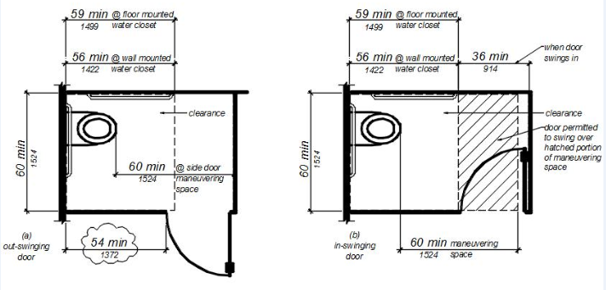
FIGURE 11B-604.8.1.2
MANEUVERING SPACE WITH SIDE-OPENING DOOR

ITEM 11B.17

DIVISION 6: PLUMBING ELEMENTS AND FACILITIES

11B-608 Shower compartments
…
11B-608.2 Size and clearances for shower compartments. Shower compartments shall have sizes and clearances complying with Section 11B-608.2.

11B-608.2.1 Reserved.

11B-608.2.1 Transfer Type Shower Compartments. Transfer type shower compartments shall be 36 inches (914 mm) by 36 inches (914 mm) clear inside dimensions measured at the center points of opposing sides and shall have a 36 inch (914 mm) wide minimum entry on the face of the shower compartment. Clearance of 36 inches (914 mm) wide minimum by 48 inches (1219 mm) long minimum measured from the control wall shall be provided. Transfer type shower compartments shall be permitted in transient lodging guest rooms, multi-bedroom housing units in undergraduate student housing and residential dwelling units; and shall not be permitted at other locations to meet the requirements of Section 11B-213.3.6.

RELATED ITEM 11B.17.01

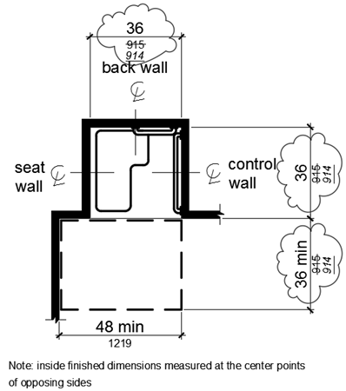

FIGURE 11B-608.2.1 TRANSFER TYPE SHOWER
COMPARTMENT SIZE AND CLEARANCE

RELATED ITEM 11B.17.02

Chapter 11B, Section 11B-213.3.6
11B-213 Toilet facilities and bathing facilities
…
11B-213.3 Plumbing fixtures and accessories. Plumbing fixtures…

11B-213.3.6 Bathing facilities. Where bathtubs or showers are provided, at least one bathtub complying with Section 11B-607 or at least one shower complying with Section 11B-608 shall be provided. Where two or more accessible showers are provided within the same functional area, at least one shower shall be opposite hand from the other or others (that is, one left-hand controls versus right-hand controls). Transfer type shower compartments shall be permitted in transient lodging guest rooms, multi-bedroom housing units in undergraduate student housing and residential dwelling units; and shall not be permitted at other locations to meet the requirements of Section 11B-213.3.6.

ITEM 11B.18

DIVISION 6: PLUMBING ELEMENTS AND FACILITIES

11B-608 Shower compartments
…
11B-608.3 Grab bars. Grab bars …

11B-608.3.1 Reserved.

11B-608.3.1 Transfer Type Shower Compartments. In transfer type compartments, grab bars shall be provided across the control wall and back wall to a point 18 inches (457 mm) from the control wall.

RELATED ITEM 11B.18.01

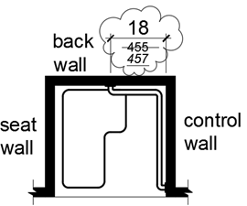

FIGURE 11B-608.3.1 GRAB BARS FOR
TRANSFER TYPE SHOWERS

ITEM 11B.19

DIVISION 6: PLUMBING ELEMENTS AND FACILITIES

11B-608 Shower compartments
…
11B-608.4 Seats. A folding seat shall be provided in roll-in type showers and transfer type shower compartments. Seats shall comply with Section 11B-610.

Exception: In residential dwelling units, seats shall not be required in shower compartments provided that reinforcement has been installed in walls so as to permit the installation of seats complying with Section 11B-608.4.

ITEM 11B.20

DIVISION 6: PLUMBING ELEMENTS AND FACILITIES

11B-608 Shower compartments
…

11B-608.5 Controls. Controls, faucets, and shower spray units shall comply with Section 11B-309.4. Controls and faucets shall be of a single-lever design allow the user to close and open the water supply.

11B-608.5.1 Reserved.

11B-608.5.1 Transfer Type Shower Compartments. In transfer type shower compartments, the controls, faucets, and shower spray unit shall be installed on the side wall opposite the seat 38 inches (965 mm) minimum and 48 inches (1219 mm) maximum above the shower floor and shall be located on the control wall 15 inches (380 mm) maximum from the centerline of the seat toward the shower opening.

RELATED ITEM 11B.20.01

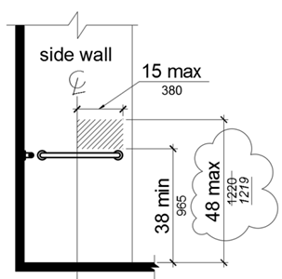

FIGURE 11B-608.5.1 TRANSFER TYPE SHOWER
COMPARTMENT CONTROL LOCATION

ITEM 11B.21

DIVISION 6: PLUMBING ELEMENTS AND FACILITIES

11B-608 Shower compartments
…
11B-608.7 Thresholds. Thresholds in roll-in type shower compartments shall be ½ inch (12.7 mm) high maximum in accordance with Section 11B-303. In transfer type shower compartments, thresholds ½ inch (12.7 mm) high maximum shall be beveled, rounded, or vertical.

Exception: Reserved.

Exception: A threshold 2 inches (51 mm) high maximum shall be permitted in transfer type shower compartments in existing facilities where provision of a ½ inch (12.7 mm) high threshold would disturb the structural reinforcement of the floor slab.

ITEM 11B.22

DIVISION 6: PLUMBING ELEMENTS AND FACILITIES

11B-610 Seats
…
11B-610.3 Shower compartment seats. A seat in a standard roll-in shower compartment shall be a folding type, shall be installed on the side wall adjacent to the controls, and shall extend from the back wall to a point within 3 inches (76 mm) of the compartment entry. A seat in an alternate roll-in type shower compartment shall be a folding type, shall be installed on the front wall opposite the back wall, and shall extend from the adjacent side wall to a point within 3 inches (76 mm) of the compartment entry. In transfer-type showers, the seat shall extend from the back wall to a point within 3 inches (76 mm) of the compartment entry. The top of the seat shall be 17 inches (432 mm) minimum and 19 inches (483 mm) maximum above the bathroom finish floor. When folded, the seat shall extend 6 inches (152 mm) maximum from the mounting wall. Seats shall comply with Section 11B-610.3.1 or 11B-610.3.2.

ITEM 11B.23

DIVISION 7: COMMUNICATION ELEMENTS AND FEATURES

11B-703 Signs
…
11B-703.7 Symbols of accessibility.
…
11B-703.7.2 Symbols
…
11B-703.7.2.7 Pedestrian traffic-control buttons.
Pole-supported pedestrian traffic-control buttons shall be identified with color coding consisting of a textured horizontal yellow band 2 inches (51 mm) in width encircling the pole, and a 1-inch-wide (25 mm) dark border band above and below this yellow band. Color coding shall be placed immediately above the control button. Control buttons shall be located no higher than 48 inches (1219 mm) above the ground surface adjacent to the pole.

ITEM 11B.24

DIVISION 8: SPECIAL ROOMS, SPACES, AND ELEMENTS

11B-812 Electric vehicle charging stations
…
11B-812.8 Identification signs.
…
11B-812.8.7 Location. Required identification signs shall be visible from the EVCS it serves. Signs shall be permanently posted either immediately adjacent to the vehicle space or within the projected vehicle space width at the head end of the vehicle space. Signs identifying van accessible vehicle spaces shall contain the designation “van accessible.” Signs shall be 60 inches (1525 mm) minimum above the finish floor or ground surface measured to the bottom of the sign. Signs located within an accessible route a circulation path shall be 80 inches (2032 mm) minimum above the finish floor or ground surface measured to the bottom of the sign. Signs may also be permanently posted on a wall at the interior end of the vehicle space.

Notation:
Authority: Government Code Section 4450.
Reference(s): Government Code Sections 4450 through 4461, 12955.1(c) and 14679; Health and Safety Code Sections 18949.1, 19952 through 19959; and Vehicle Code Section 22511.8.

