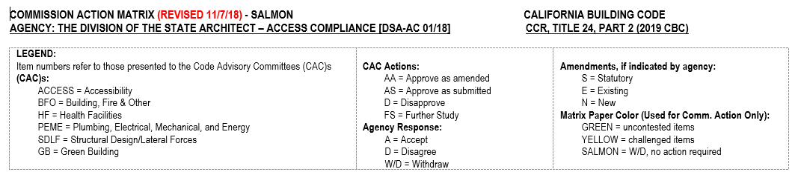

ACCESSIBILITY (ACCESS) CODE ADVISORY COMMITTEE

CHAPTER 1 - California ADMINISTRATION, DIVISION I, Section 1.9, division of the state architect
Adopt additional sections listed below
Item Number 1.02 | Code Section | Type of amend-  ment  (S, E, N) | CAC:  (AS, AA,  D, FS) | Agency Response to CAC  (A, D, W/D) | 45-Day Comments  (AS, AA, D, FS) | Annotations | CBSC Action (AS, AA, D, FS)
 | 1.9.1.3 | E | ST/FS | W/D | Natasha Reyes and Dara Schur of DRC, and Richard Skaff commented on this item, however, item has been withdrawn by the agency. | After further review DSA has withdrawn this item.

CHAPTER 2 – definitions
Adopt additional sections listed below
Item Number 2.01 | Code Section 2.02 | Type of amend-  ment  (S, E, N) | CAC:  (AS, AA,  D, FS) | Agency Response to CAC  (A, D, W/D) | 45-Day Comments  (AS, AA, D, FS) | Annotations | CBSC Action (AS, AA, D, FS)
 | PUBLIC HOUSING. [DSA-AC] | E | AS | W/D | Natasha Reyes and Dara Schur of DRC, and Richard Skaff commented on this item, however, item has been withdrawn by the agency. | After further review DSA has withdrawn this item.

CHAPTER 2 - definitions
Adopt additional sections listed below
Item Number 2.02 | Code Section 2.02 | Type of amend-  ment  (S, E, N) | CAC:  (AS, AA,  D, FS) | Agency Response to CAC  (A, D, W/D) | 45-Day Comments  (AS, AA, D, FS) | Annotations | CBSC Action (AS, AA, D, FS)
 | PUBLIC USE. [DSA-AC] | E | AS | W/D | Natasha Reyes and Dara Schur of DRC, and Richard Skaff commented on this item, however, item has been withdrawn by the agency. | After further review DSA has withdrawn this item.

CHAPTER 11B – DIVISION 2: SCOPING REQUIREMENTS
Adopt additional sections listed below
Item Number 11B.07 | Code Section | Type of amend-  ment  (S, E, N) | CAC:  (AS, AA,  D, FS) | Agency Response to CAC  (A, D, W/D) | 45-Day Comments  (AS, AA, D, FS) | Annotations | CBSC Action (AS, AA, D, FS)
 | 11B-233.3.2.1 | N | ST/FS | W/D | Natasha Reyes and Dara Schur of DRC, and Richard Skaff commented on this item, however, item has been withdrawn by the agency. | After further review DSA has withdrawn this item.

