FINAL EXPRESS TERMS

FOR PROPOSED BUILDING STANDARDS

OF THE
DEPARTMENT OF HOUSING AND COMMUNITY DEVELOPMENT
REGARDING THE ADOPTION OF THE
2019 CALIFORNIA EXISTING BUILDING CODE

CALIFORNIA CODE OF REGULATIONS, TITLE 24, PART 10

(HCD 05/18)

The Department of Housing and Community Development (HCD) proposes to adopt the 2018 edition of the International Existing Building Code (IEBC) for codification into the 2019 edition of the California Existing Building Code (CEBC) as presented on the following pages, including any necessary amendments.

If using assistive technology, please adjust your settings to recognize underline, strikeout, italics and ellipsis.

LEGEND FOR EXPRESS TERMS (Based on model codes - Parts 2, 2.5, 3, 4, 5, 9, 10)
- Model Code language appears upright.
- Existing California amendments appear in italics.
- Amended model code or new California amendments appear underlined and in italics.
- Repealed model code language appears upright and in strikeout.
- Repealed California amendments appear in italics and strikeout.
- Ellipsis (. . .) indicate existing text remains unchanged.

SUMMARY OF REGULATORY ACTION
HCD PROPOSES TO:
➢ Repeal the 2015 edition of the International Existing Building Code (IEBC)
➢ Repeal the 2016 edition of the California Existing Building Code (CEBC), including existing California amendments to the model code that are no longer necessary
➢ Adopt sections from the 2018 IEBC into the 2019 CEBC without amendments
➢ Adopt sections from the 2018 IEBC into the 2019 CEBC with existing amendments
➢ Bring forward existing California amendments from the 2016 CEBC for adoption into the 2019 CEBC without modifications
- Bring forward existing California amendments from the 2016 CEBC for adoption into the 2019 CEBC with nonsubstantive editorial modifications
- Adopt sections from the 2018 CEBC into the 2019 CEBC with new amendments that do not change the regulatory effect
- Bring forward existing California amendments from the 2016 CEBC for adoption into the 2019 CEBC with new modifications that do not change the regulatory effect
- Adopt sections from the 2018 IEBC into the 2019 CEBC with new amendments
- Bring forward existing California amendments from the 2016 CEBC for adoption into the 2019 CEBC with modifications
- Adopt new amendments into the 2019 CEBC
- Not adopt specified sections of the 2018 IEBC

- HCD proposes to bring forward Chapter 1, Division I, Sections 1.1 and 1.8, from the 2016 California Existing Building Code for adoption into the
2019 California Existing Building Code with modifications as follows:

CHAPTER 1

SCOPE AND ADMINISTRATION
DIVISION I
CALIFORNIA ADMINISTRATION

SECTION 1.1

GENERAL
1.1.1 Title. These regulations shall be known as the California Existing Building Code, may be cited as such and will be referred to herein as “this code.” The California Existing Building Code is Part 10 of thirteen parts of the official compilation and publication of the adoption, amendment and repeal of building regulations to the California Code of Regulations, Title 24, also referred to as the California Building Standards Code. This part incorporates by adoption the 2015 2018 International Existing Building Code of the International Code Council with necessary California amendments.
1.1.2 Purpose. (No change to existing California amendment)
1.1.3 Scope. (No change to existing California amendment)
1.1.3.1 Nonstate-regulated buildings, structures and applications. (No change to existing California amendment)
1.1.3.2 State-regulated buildings, structures and applications. (No change to existing California amendment)
1.1.4 Appendices. (No change to existing California amendment)
1.1.5 Referenced codes. (No change to existing California amendment)
1.1.6 Nonbuilding standards, orders and regulations. (No change to existing California amendment)
1.1.7 Order of precedence and use.
1.1.7.1 Differences. (No change to existing California amendment)
1.1.7.2 Specific provisions. (No change to existing California amendment)
1.1.7.3 Conflicts. (No change to existing California amendment)

1.1.7.3.1 Detached one-and two-family dwellings. Detached one-and two-family dwellings, efficiency dwelling units, lodging houses, live/work units, townhouses not more than three stories above grade plane in height with a separate means of egress, and their accessory structures, may be designed and constructed in accordance with the California Residential Code or the California Building Code, but not both, unless the proposed structure(s) or element(s) exceed the design limitations established in the California Residential Code, and the code user is specifically directed by the California Residential Code to use the California Building Code.
1.1.8 City, county, or city and county amendments, additions or deletions. (No change to existing California amendment)

1.1.8.1 Findings and filings.
- (No change to existing California amendment)
- (No change to existing California amendment)
- Findings prepared by fire protection districts shall be ratified by the local city, county, or city and county and filed with the California Department of Housing and Community Development, Division of Codes and Standards, P.O.
Box 1407, Sacramento, CA 95812-1407 or, 2020 W. El Camino Avenue,
Suite 250200, Sacramento, CA 95833-1829.
1.1.9 Effective date of this code. Only those standards approved by the California Building Standards Commission that are effective at the time an application for building permit is submitted shall apply to the plans and specifications for, and to the construction performed under, that permit. For the effective dates of the provisions contained in this code, see the History Note page of this code.
Exception: (HCD 1 & HCD 2) Plans approved by the Department of Housing and Community Development or a Department-approved design approval agency for factory built housing as defined by Health and Safety Code Section 19971. Approved plans, pursuant to the California Code of Regulations, Title 25, Division 1, Chapter 3, Subchapter 1, Article 3, Section 3048 remain valid for a period of 36 months from the date of plan approval.
1.1.10 Availability of codes. (No change to existing California amendment)
1.1.11 Format. (No change to existing California amendment)
1.1.12 Validity. (No change to existing California amendment)

SECTION 1.8
DEPARTMENT OF HOUSING AND COMMUNITY DEVELOPMENT
1.8.1 Purpose. (No change to existing California amendment)

SECTION 1.8.2
Authority and Abbreviations
1.8.2.1 General. (No change to existing California amendment)
1.8.2.1.1 Housing construction.
Application - Hotels, motels, lodging houses, apartments, dwellings, dormitories, condominiums, shelters for homeless persons, congregate residences, employee housing, factory-built housing and other types of dwellings containing sleeping accommodations with or without common toilet or cooking facilities including accessory buildings, facilities, and uses thereto. Sections of this code which pertain to applications listed in this section are identified using the abbreviation “HCD 1."
Enforcing Agency – (No change to existing California amendment)
Authority Cited: Health and Safety Code Sections 17040, 17050, 17920.9, 17921, 17921.3, 17921.5, 17921.6, 17921.10, 17922, 17922.6, 17922.12, 17922.14, 17926, 17927, 17928, 17959.6, 18300, 18552, 18554, 18620, 18630, 18640, 18670, 18690, 18691, 18865, 18871.3, 18871.4, 18873, 18873.1, 18873.2, 18873.3, 18873.4, through 18873.5, 18938.3, 18944.11, and 19990; and Government Code Section 12955.1.
Reference: Health and Safety Code Sections 17000 through 17062.5, 17910 through 17995.5, 18200 through 18700, 18860 through 18874, and Sections 19960 through 19997; Civil Code Sections 1101.4, 1101.5 and 1954.201; and Government Code Sections 12955.1 and 12955.1.1.
1.8.2.1.2 Housing accessibility.
Application – (No change to existing California amendment)
“HCD 1-AC” building standards generally do not apply to public use areas or public accommodations such as hotels and motels, and public housing. Public use areas, public accommodations, and public housing, as defined in Chapter 2 of the California Building Code, are subject to the Division of the State Architect (DSA-AC) in Chapter 11B of the California Building Code, and are referenced in Section 1.9.1.
Enforcing Agency – (No change to existing California amendment)
Authority Cited: Health and Safety Code Sections 17040, 17050, 17920.9, 17921, 17921.3, 17921.5, 17921.6, 17921.10, 17922, 17922.6, 17922.12, 17922.14, 17926, 17927, 17928, 17959.6, 18300, 18552, 18554, 18620, 18630, 18640, 18670, 18690, 18691, 18865, 18871.3, 18871.4, 18873, 18873.1, 18873.2, 18873.3, 18873.4, through 18873.5, 18938.3, 18944.11, and 19990; and Government Code Section 12955.1.

Reference: Health and Safety Code Sections 17000 through 17062.5, 17910 through 17995.5, 18200 through 18700, 18860 through 18874, and Sections 19960 through 19997; Civil Code Sections 1101.4, 1101.5 and 1954.201; and Government Code Sections 12955.1 and 12955.1.1.
1.8.2.1.3 Permanent buildings in mobilehome parks and special occupancy parks. (No change to existing California amendment)
Enforcing Agency – (No change to existing California amendment)
Authority Cited: Health and Safety Code Sections 17040, 17050, 17920.9, 17921, 17921.3, 17921.5, 17921.6, 17921.10, 17922, 17922.6, 17922.12, 17922.14, 17926, 17927, 17928, 17959.6, 18300, 18552, 18554, 18620, 18630, 18640, 18670, 18690, 18691, 18865, 18871.3, 18871.4, 18873, 18873.1, 18873.2, 18873.3, 18873.4, through 18873.5, 18938.3, 18944.11, and 19990; and Government Code
Section 12955.1.
Reference: Health and Safety Code Sections 17000 through 17062.5, 17910 through 17995.5, 18200 through 18700, 18860 through 18874, and Sections 19960 through 19997; Civil Code Sections 1101.4, 1101.5 and 1954.201; and Government Code Sections 12955.1 and 12955.1.1.

SECTION 1.8.3
LOCAL ENFORCING AGENCY
1.8.3.1 Duties and powers. (No change to existing California amendment)
1.8.3.2 Laws, rules and regulations. (No change to existing California amendment)
1.8.3.2.1 State Housing Law. (No change to existing California amendment)
1.8.3.2.2 Mobilehome Parks Act. (No change to existing California amendment)
1.8.3.2.3 Special Occupancy Parks Act. (No change to existing California amendment)
1.8.3.2.4 Employee Housing Act. (No change to existing California amendment)
1.8.3.2.5 Factory-Built Housing Law. (No change to existing California amendment)

SECTION 1.8.4
Permits, fees, applications AND INSPECTIONS
1.8.4.1 Permits. (No change to existing California amendment)
1.8.4.2 Fees. (No change to existing California amendment)
1.8.4.3 Plan review and time limitations. (No change to existing California amendment)
1.8.4.3.1 Retention of plans. (No change to existing California amendment)
1.8.4.4 Inspections. Construction or work for which a permit is required shall be subject to inspection by the building official, and such construction or work shall remain accessible and exposed for inspection purposes until approved. Approval as a result of an inspection shall not be construed to be an approval of a violation of the provisions of this code or other regulations of the Department of Housing and Community Development. Required inspections are listed in Chapter 1, Division II, Scope and Administration, Sections 109.3.1 through 109.3.910.

SECTION 1.8.5
RIGHT OF ENTRY FOR ENFORCEMENT
1.8.5.1 General. (No change to existing California amendment)

SECTION 1.8.6
LOCAL MODIFICATION BY ORDINANCE OR REGULATION
1.8.6.1 General. (No change to existing California amendment)
1.8.6.2 Findings, filings and rejections of local modifications. (No change to existing California amendment)

SECTION 1.8.7
ALTERNATE MATERIALS, designs, tests and methods of construction
1.8.7.1 General. (No change to existing California amendment)
1.8.7.2 Local building departments. (No change to existing California amendment)
1.8.7.2.1 Approval of alternates. (No change to existing California amendment)
1.8.7.3 Department of Housing and Community Development. The Department of Housing and Community Development may approve alternates for use in the erection, construction, reconstruction, movement, enlargement, conversion, alteration, repair, removal or demolition of apartments, condominiums, hotels, motels, lodging houses, dwellings or an accessory structures thereto and permanent buildings in mobilehome parks and special occupancy parks. The consideration and approval of alternates shall comply with the following:
1. (No change to existing California amendment)
2. (No change to existing California amendment)

SECTION 1.8.8

APPEALS BOARD
1.8.8.1 General. (No change to existing California amendment)
1.8.8.2 Definitions. (No change to existing California amendment)
1.8.8.3 Appeals. (No change to existing California amendment)

SECTION 1.8.9

Unsafe Buildings or Structures
1.8.9.1 Authority to enforce. (No change to existing California amendment)
1.8.9.2 Actions and proceedings. (No change to existing California amendment)

SECTION 1.8.10

OTHER Building REGULATIONs
1.8.10.1 Existing structures. (No change to existing California amendment)
1.8.10.2 Moved structures. (No change to existing California amendment)
NOTE:
Authority Cited: Health and Safety Code Sections 17040, 17050, 17920.9, 17921, 17921.5, 17921.6, 17921.10, 17922, 17922.6, 17922.12, 17922.14, 17926, 17927, 17928, 18300, 18552, 18554, 18620, 18630, 18640, 18670, 18690, 18691, 18865, 18871.3, 18871.4, 18873, 18873.1 through 18873.5, 18938.3, 18944.11, and 19990; and Government Code Section 12955.1.
Reference: Health and Safety Code Sections 17000 through 17062.5, 17910 through 17995.5, 18200 through 18700, 18860 through 18874, and 19960 through 19997; Civil Code Sections 1101.4, 1101.5 and 1954.201; and Government Code Sections 12955.1 and 12955.1.1.

- HCD proposes to adopt Chapter 1, Division II, Sections 101.2, 101.8, 105.2
(Building 1 – 6 only), 106.1, 106.2.1, 106.2.3, 106.2.4, 106.2.5, 106.2.6, 109.3, 109.3.1, 109.3.2, 109.3.3, 109.3.4, 109.3.4.1, 109.3.5, 109.3.6, 109.3.7, 109.3.8, 109.3.9, 109.3.10 ONLY with new and existing amendments as follows:
DIVISION II
SCOPE AND ADMINISTRATION
Division II is not adopted by the Department of Housing and Community Development except where specifically indicated.

SECTION 101

GENERAL
101.2 Scope. (No change to model code text)
101.8 Maintenance. (HCD 1, HCD 2) (No change to existing California amendment)

SECTION 106
CONSTRUCTION DOCUMENTS
106.2.3 Means of egress. (No change to model code text)
106.2.5 Exterior balconies and elevated walking surfaces. Where the scope of work involves balconies or other elevated walking surfaces exposed to water from direct or blowing rain, snow or irrigation, and the structural framing is protected by an impervious moisture barrier, the construction documents shall include details for all elements of the impervious moisture barrier system. The construction documents shall include manufacturer’s installation instructions.
(2016 CEBC) 106.2.6 Exterior balconies and elevated walking surfaces. [HCD 1 & HCD 2] Where the scope of work involves a balcony or other elevated walking surfaces exposed to water from direct or blowing rain, snow, or irrigation, and the structural framing is protected by an impervious moisture barrier, the construction documents shall include details for all elements of the impervious moisture barrier system. The construction documents shall include manufacturer’s installation instructions.

SECTION 109

INSPECTIONS
109.3.4.1 Moisture content verification. (HCD) (No change to existing California amendment)
109.3.6 Weather-exposed balcony and walking surface waterproofing. Where the scope of work involves balconies or other elevated walking surfaces exposed to water from direct or blowing rain, snow or irrigation, and the structural framing is protected by an impervious moisture barrier, all elements of the impervious moisture barrier system shall not be concealed until inspected and approved.
Exception: Where special inspections are provided in accordance with
Section 1705.1.1, Item 3, of the International Building Code.

(2016 CEBC) 109.3.7.1 Weather exposed balcony and walking surface waterproofing. [HCD 1 & HCD 2] Where the scope of work involves a balcony or other elevated walking surfaces exposed to water from direct or blowing rain, snow, or irrigation, and the structural framing is protected by an impervious moisture barrier, all elements of the impervious moisture barrier system shall not be concealed until inspected and approved.
Exception: Where special inspections are provided in accordance with
Section 1705.1.1, Item 3 of the California Building Code.
109.3.8 (Formerly 109.3.7) Other inspections. In addition to the inspections specified in Sections 109.2 through 109.3.7, the code official is authorized to make or require other inspections of any construction work to ascertain compliance with the provisions of this code and other laws that are enforced by the Department of Building Safety building official.
Note: All noncompliant plumbing fixtures in any residential real property shall be replaced with water-conserving plumbing fixtures. Plumbing fixture replacement is required prior to issuance of a certificate of final completion, certificate of occupancy, or final permit approval by the local building department. See Civil Code Section 1101.1, et seq., for the definition of a noncompliant plumbing fixture, types of residential buildings affected and other important enactment dates.
(2016 CEBC) 109.3.7 Other inspections. In addition to the inspections specified in Sections 109.2 through 109.3.7, the code official is authorized to make or require other inspections of any construction work to ascertain compliance with the provisions of this code and other laws that are enforced by the Department of Building Safety building official.
Note: Residential buildings undergoing permitted alterations, additions or improvements shall replace noncompliant plumbing fixtures with water-conserving plumbing fixtures. Plumbing fixture replacement is required prior to issuance of a certificate of final completion, certificate of occupancy or final permit approval by the local building department. See Civil Code Section 1101.1, et seq., for the definition of a noncompliant plumbing fixture, types of residential buildings affected and other important enactment dates.
109.3.9 (Formerly 109.3.8) Special inspections. (No change to existing California amendment)

NOTE:
Authority Cited: Health and Safety Code Sections 17040, 17050, 17920.9, 17921, 17921.5, 17921.6, 17921.10, 17922, 17922.6, 17922.12, 17922.14, 17926, 17927, 17928, 18300, 18552, 18554, 18620, 18630, 18640, 18670, 18690, 18691, 18865, 18871.3, 18871.4, 18873, 18873.1 through 18873.5, 18938.3, 18944.11, and 19990; and Government Code Section 12955.1.
Reference: Health and Safety Code Sections 17000 through 17062.5, 17910 through 17995.5, 18200 through 18700, 18860 through 18874, and 19960 through 19997; Civil Code Sections 1101.4, 1101.5 and 1954.201; and Government Code Sections 12955.1 and 12955.1.1.

- HCD proposes to adopt Chapter 2 from the 2018 International Existing Building Code into the 2019 California Existing Building Code with new and existing amendments as follows:

CHAPTER 2

DEFINITIONS

SECTION 202

GENERAL DEFINITIONS

APPROVED. Acceptable to the code official.
Exception: (HCD 1 & HCD 2) “approved” means meeting the approval of the Enforcing Agency, except as otherwise provided by law, when used in connection with any system, material, type of construction, fixture or appliance as the result of investigations and tests conducted by the agency, or by reason of accepted principles or tests by national authorities, or technical, health, or scientific organizations or agencies.
Notes:
1. See Health and Safety Code Section 17920 for “approved” as applied to residential construction and buildings or structures accessory thereto as referenced in
Section 1.8.2.
2. See Health and Safety Code Section 17921.1 for “approved” as applied to the use of hotplates in residential construction as referenced in Section 1.8.2.
3. See Health and Safety Code Section 19966 for “approved” as applied to Factory-Built Housing as referenced in Section 1.8.3.2.5.
4. See Health and Safety Code Section 18201 for “approved” as applied to Mobilehome Parks as referenced in Section 1.8.2.
5. See Health and Safety Code Section 18862.1 for “approved” as applied to Special Occupancy Parks as referenced in Section 1.8.2.

BUILDING. Any structure used or intended for supporting or sheltering any use or occupancy.
BUILDING. Any structure utilized or intended for supporting or sheltering any use or occupancy.
Exception: (HCD 1, HCD 2 & HCD 1-AC) (No change to existing California amendment)
BUILDING OFFICIAL. (HCD) (No change to existing California amendment)
CODE OFFICIAL. (No change to existing California amendment)
SUBSTANDARD BUILDING. (HCD 1, HCD 2) See Health and Safety Code Section 17920.3.
UNSAFE. Buildings, structures or equipment that are unsanitary, or that are deficient due to inadequate means of egress facilities, inadequate light and ventilation, or that constitute a fire hazard, or in which the structure or individual structural members meet the definition of “Dangerous,” or that are otherwise dangerous to human life or the public welfare, or that involve illegal or improper occupancy or inadequate maintenance shall be deemed unsafe. A vacant structure that is not secured against entry shall be deemed unsafe.
(HCD 1 & HCD 2) An unsafe building, as defined in this chapter, shall be considered substandard.
NOTE:
Authority Cited: Health and Safety Code Sections 17040, 17050, 17920.9, 17921, 17921.5, 17921.6, 17921.10, 17922, 17922.6, 17922.12, 17922.14, 17926, 17927, 17928, 18300, 18552, 18554, 18620, 18630, 18640, 18670, 18690, 18691, 18865, 18871.3, 18871.4, 18873, 18873.1 through 18873.5, 18938.3, 18944.11, and 19990; and Government Code Section 12955.1.
Reference: Health and Safety Code Sections 17000 through 17062.5, 17910 through 17995.5, 18200 through 18700, 18860 through 18874, and 19960 through 19997; Civil Code Sections 1101.4, 1101.5 and 1954.201; and Government Code Sections 12955.1 and 12955.1.1.

- HCD proposes to adopt Chapter 3, except Section 305, from the
2018 International Existing Building Code into the 2019 California Existing Building Code with new amendments as follows:

CHAPTER 3

PROVISIONS FOR ALL COMPLIANCE METHODS

SECTION 301

ADMINISTRATION
301.1 General. The repair, alteration, change of occupancy, addition or relocation of all existing buildings shall comply with Section 301.2, 301.3, or 301.4.
(HCD 1) In addition to the requirements in this chapter, maintenance, alteration, repair, addition, or change of occupancy to existing buildings and accessory structures under the authority of the Department of Housing and Community Development, as provided in Section 1.8.2.1.1, shall comply with California Code of Regulations, Title 25,
Division 1, Chapter 1, Subchapter 1.
Exceptions:
- (HCD 2) For moved buildings and maintenance, alteration, repair, addition, or change of occupancy to existing buildings and accessory structures in mobilehome parks or special occupancy parks as provided in
Section 1.8.2.1.3, see California Code of Regulations, Title 25, Division 1, Chapters 2 and 2.2.
- (HCD 1) Limited-density owner-built rural dwellings, as defined in Chapter 2 of the California Residential Code.
301.2 Repairs. (No change to model code text)
301.3 Alteration, addition or change of occupancy. The alteration, addition or change of occupancy of all existing buildings shall comply with one of the methods listed in Section 301.3.1, 301.3.2 or 301.3.3 as selected by the applicant. Sections 301.3.1 through 301.3.3 shall not be applied in combination with each other.
Note: (HCD 1 & HCD 2) Sections 301.3.2 and 301.3.3 shall be permitted only if the Performance compliance method and/or Work area compliance method are adopted by a local ordinance.

Exception: Subject to the approval of the code official, alterations complying with the laws in existence at the time the building or the affected portion of the building was built shall be considered in compliance with the provisions of this code. New structural members added as part of the alteration shall comply with the International California Building Code. This exception shall not apply to alterations that constitute substantial improvement in flood hazard areas, which shall comply with Section 503.2, 701.3 or 1301.3.3. This exception shall not apply to the structural provisions of Chapter 5 or to the structural provisions of Sections 706, 806 and 906.
301.3.1 Prescriptive compliance method. (No change to model code text)
301.3.2 Work area compliance method. Alterations, additions and changes of occupancy complying with the applicable requirements of Chapters 6 through 12 of this code shall be considered in compliance with the provisions of this code.
Note: (HCD 1 & HCD 2) The provisions contained in Chapters 6 through 12 are not adopted by HCD, but may be available for adoption by a local ordinance. (See
Section 1.1.11)
301.3.3 Performance compliance method. Alterations, additions and changes of occupancy complying with Chapter 13 of this code shall be considered in compliance with the provisions of this code.
Note: (HCD 1 & HCD 2) The provisions contained in Chapter 13 are not adopted by HCD, but may be available for adoption by a local ordinance. (See Section 1.1.11)
301.4 Relocated or moved buildings. Relocated or moved buildings shall comply with the requirements of Chapter 14.
301.5 Compliance with accessibility. Accessibility requirements for existing buildings shall comply with the 2009 edition of ICC A117.1.
(HCD 1-AC) Accessibility requirements for covered multifamily dwellings, as defined in Chapter 2 of the California Building Code, are promulgated under HCD authority and are located in Chapter 11A of the California Building Code.

SECTION 302

GENERAL PROVISIONS
302.1 Applicability. (No change to model code text)
302.2 (Formerly 401.3) Dangerous conditions. (No change to model code text)

302.3 Additional codes. Alterations, repairs, additions and changes of occupancy to, or relocation of, existing buildings and structures shall comply with the provisions for alterations, repairs, additions and changes of occupancy or relocation, respectively, in this code and the International Energy Conservation California Energy Code, International California Fire Code, International Fuel Gas Code, International California Mechanical Code, International California Plumbing Code, International Private Sewage Disposal Code, International Property Maintenance Code, International California Residential Code and NFPA 70 California Electrical Code. Where provisions of the other codes conflict with provisions of this code, the provisions of this code shall take precedence.
302.4 (Formerly 401.2.1) Existing materials. (No change to model code text)
302.5 (Formerly 401.2.2) New and replacement materials. Except as otherwise required or permitted by this code, materials permitted by the applicable code for new construction shall be used. Like materials shall be permitted for repairs and alterations, provided that unsafe conditions are not created. Hazardous materials shall not be used where the code for new construction would not permit their use in buildings of similar occupancy, purpose and location.
(HCD 1) Local ordinances or regulations shall permit the replacement, retention and extension of original materials, and the use of original methods of construction, for any building or accessory structure, provided such building or structure complied with the building code provisions in effect at the time of original construction and the building or accessory structure does not become or continue to be a substandard building. For additional information, see Health and Safety Code Sections 17912, 17920.3, 17922(d), 17922.3, 17958.8 and 17958.9.
302.5.1 New structural members and connections. (No change to model code text)
302.6 Occupancy and use. (No change to model code text)

SECTION 303
STRUCTURAL DESIGN LOADS AND
EVALUATION AND DESIGN PROCEDURES
303.1 (Formerly 402.3.1 & 403.3.1) Live loads. (No change to model code text)
303.2 Snow loads on adjacent buildings. (No change to model code text)
303.3 Seismic evaluation and design procedures. (No change to model code text)
303.3.1 (Formerly 401.2.3) Compliance with full seismic forces. (No change to model code text)
303.3.2 Compliance with reduced seismic forces. (No change to model code text)

SECTION 304
IN-SITU LOAD TESTS
304.1 General. (No change to model code text)

SECTION 305
ACCESSIBILITY FOR EXISTING BUILDINGS
(Not adopted by HCD)
305.1 Scope. The provisions of Sections 305.1 through 305.9 apply to maintenance, change of occupancy, additions and alterations to existing buildings, including those identified as historic buildings.
Note: (HCD 1-AC) Accessibility requirements for covered multifamily dwellings, as defined in Chapter 2 of the California Building Code, are promulgated under HCD authority and are located in Chapter 11A of the California Building Code.
NOTE:
Authority Cited: Health and Safety Code Sections 17040, 17050, 17920.9, 17921, 17921.5, 17921.6, 17921.10, 17922, 17922.6, 17922.12, 17922.14, 17926, 17927, 17928, 18300, 18552, 18554, 18620, 18630, 18640, 18670, 18690, 18691, 18865, 18871.3, 18871.4, 18873, 18873.1 through 18873.5, 18938.3, 18944.11, and 19990; and Government Code Section 12955.1.
Reference: Health and Safety Code Sections 17000 through 17062.5, 17910 through 17995.5, 18200 through 18700, 18860 through 18874, and 19960 through 19997; Civil Code Sections 1101.4, 1101.5 and 1954.201; and Government Code Sections 12955.1 and 12955.1.1.

- HCD proposes to adopt Chapter 4 from the 2018 International Existing Building Code into the 2019 California Existing Building Code with new amendments as follows:

CHAPTER 4

REPAIRS

SECTION 401

GENERAL
401.1 Scope. (No change to model code text)
401.2 Compliance. (No change to model code text)
401.3 Flood hazard areas. (No change to model code text)

SECTION 402
BUILDING ELEMENTS AND MATERIALS
402.1 Glazing in hazardous locations. (No change to model code text)
402.2 Existing materials. (HCD) Existing materials shall comply with Section 302.4.
402.3 New and replacement materials. (HCD) New and replacement materials used for repairs shall comply with Section 302.5.

SECTION 403
FIRE PROTECTION
403.1 General. (No change to model code text)

SECTION 404
MEANS OF EGRESS
404.1 General. (No change to model code text)

SECTION 405
STRUCTURAL
405.1 General. (No change to model code text)
405.2 Repairs to damaged buildings. (No change to model code text)
405.2.1 Repairs for less than substantial structural damage. (No change to model code text)
405.2.1.1 Snow damage. (No change to model code text)
405.2.2 Disproportionate earthquake damage. (No change to model code text)
405.2.3 Substantial structural damage to vertical elements of the lateral force-resisting system. (No change to model code text)
405.2.3.1 Evaluation. (No change to model code text)
405.2.3.2 Extent of repair for compliant buildings. (No change to model code text)
405.2.3.3 Extent of repair for noncompliant buildings. (No change to model code text)
405.2.4 Substantial structural damage to gravity load-carrying components. (No change to model code text)
405.2.4.1 Lateral force-resisting elements. (No change to model code text)
405.2.5 Flood hazard areas. (No change to model code text)

SECTION 406

ELECTRICAL
406.1 Material. (No change to model code text)
406.1.1 Receptacles. (No change to model code text)
406.1.2 Plug fuses. (No change to model code text)

SECTION 407

MECHANICAL
407.1 General. Existing mechanical systems undergoing repair shall not make the building less complying than it was before the damaged occurred.
(HCD 1 & HCD 2) Existing mechanical systems undergoing repair shall comply with the California Mechanical Code.
407.2 Mechanical draft systems for manually fired appliances and fireplaces. A mechanical draft system shall be permitted to be used with manually fired appliances and fireplaces where such a system complies with all of the following requirements:
1. The mechanical draft device shall be listed and installed in accordance with the manufacturer’s installation instructions.
2. A device shall be installed that produces visible and audible warning upon failure of the mechanical draft device or loss of electrical power at any time that the mechanical draft device is turned on. This device shall be equipped with a battery backup if it receives power from the building wiring.
3. A smoke detector shall be installed in the room with the appliance or fireplace. This device shall be equipped with a battery backup if it receives power from the building wiring.

SECTION 408

PLUMBING
408.1 Materials. Plumbing materials and supplies shall not be used for repairs that are prohibited in the International Plumbing Code.
(HCD 1 & HCD 2) Existing plumbing systems undergoing repair shall comply with the California Plumbing Code and Division 4.3 of CALGreen Code, as applicable.
408.2 Water closet replacement. The maximum water consumption flow rates and quantities for all replaced water closets shall be 1.6 1.28 gallons (6 4.8 L) per flushing cycle.
Exception: Blowout-design water closets [3.5 gallons (13 L) per flushing cycle].
NOTE:
Authority Cited: Health and Safety Code Sections 17040, 17050, 17920.9, 17921, 17921.5, 17921.6, 17921.10, 17922, 17922.6, 17922.12, 17922.14, 17926, 17927, 17928, 18300, 18552, 18554, 18620, 18630, 18640, 18670, 18690, 18691, 18865, 18871.3, 18871.4, 18873, 18873.1 through 18873.5, 18938.3, 18944.11, and 19990; and Government Code Section 12955.1.
Reference: Health and Safety Code Sections 17000 through 17062.5, 17910 through 17995.5, 18200 through 18700, 18860 through 18874, and 19960 through 19997; Civil Code Sections 1101.4, 1101.5 and 1954.201; and Government Code Sections 12955.1 and 12955.1.1.

- HCD proposes to repeal existing California amendments from Chapter 4 of the 2016 California Existing Building Code as follows:

SECTION 401

GENERAL
401.2.1 Existing materials. Materials already in use in a building in compliance with requirements or approvals in effect at the time of their erection or installation shall be permitted to remain in use unless determined by the building official to be unsafe per Section 115.
[HCD 1] Local ordinances or regulations shall permit the replacement, retention and extension of original materials, and the use of original methods of construction, for any building or accessory structure, provided such building or structure complied with the building code provisions in effect at the time of original construction and the building or accessory structure does not become or continue to be a substandard building. For additional information, see Health and Safety Code Sections 17912, 17920.3, 17922(d), 17922.3, 17958.8 and 17958.9.

SECTION 402

ADDITIONS
402.6 Carbon monoxide detection in existing portions of a building. (HCD) Where an addition is made to a Group R occupancy, located in a building with a fuel-burning appliance, fireplace, forced-air furnace, or an attached garage, the existing portion of the building, where no construction is taking place, shall be provided with carbon monoxide detection in accordance with Section 915 of the California Building Code, if carbon monoxide detection is not already installed.
When the new addition requires carbon monoxide detection, carbon monoxide detection shall be installed in accordance with Section 915 of the California Building Code.

SECTION 403

ALTERATIONS
403.1.1 Replacement, retention and extension of original materials. (HCD 1) Local ordinances or regulations shall permit the replacement, retention and extension of original materials, and the use of original methods of construction, for any building or accessory structure, provided such building or structure complied with the building code provisions in effect at the time of original construction and the building or accessory structure does not become or continue to be a substandard building. For additional information, see Health and Safety Code Sections 17912,17920.3, 17922(d), 17922.3, 17958.8 and 17958.9.
403.12 Carbon monoxide detection. (HCD) Pursuant to Health and Safety Code Section 17926, carbon monoxide detection shall be provided in all existing Group R buildings, as required in Section 915 of the California Building Code, or Section R315 of the California Residential Code.
When a fuel-burning appliance, fireplace, or forced-air furnace are added to an existing Group R building, not previously required to be provided with carbon monoxide detection, new carbon monoxide detection shall be installed in accordance with
Section 915 of the California Building Code, or Section R315 of the California Residential Code.

SECTION 404

REPAIRS
404.1.1 Replacement, retention and extension of original materials. (HCD 1) Local ordinances or regulations shall permit the replacement, retention and extension of original materials, and the use of original methods of construction, for any building or accessory structure, provided such building or structure complied with the building code provisions in effect at the time of original construction and the building or accessory structure does not become or continue to be a substandard building. For additional information, see Health and Safety Code Sections 17912, 17920.3, 17922(d), 17922.3, 17958.8 and 17958.9.

SECTION 409

MOVED STRUCTURES
409.1 Conformance. Structures moved into or within the jurisdiction shall comply with the provisions of this code for new structures.
Exception: (HCD 1 & HCD 2) After July 1, 1978, local ordinances or regulations for moved apartment houses and dwellings shall permit the retention of existing materials and methods of construction, provided the apartment house or dwelling complies with the building standards for foundations applicable to new construction and does not become or continue to be a substandard building. For additional information, see Health and Safety Code Section 17958.9.
NOTE:
Authority Cited: Health and Safety Code Sections 17040, 17050, 17920.9, 17921, 17921.5, 17921.6, 17921.10, 17922, 17922.6, 17922.12, 17922.14, 17926, 17927, 17928, 18300, 18552, 18554, 18620, 18630, 18640, 18670, 18690, 18691, 18865, 18871.3, 18871.4, 18873, 18873.1 through 18873.5, 18938.3, 18944.11, and 19990; and Government Code Section 12955.1.
Reference: Health and Safety Code Sections 17000 through 17062.5, 17910 through 17995.5, 18200 through 18700, 18860 through 18874, and 19960 through 19997; Civil Code Sections 1101.4, 1101.5 and 1954.201; and Government Code Sections 12955.1 and 12955.1.1.

- HCD proposes to adopt Chapter 5, except Sections 501.1.1, 503.14, 504, and 507 from the 2018 International Existing Building Code into the 2019 California Existing Building Code with new and existing amendments as follows:

CHAPTER 5 (Formerly Chapter 4)

PRESCRIPTIVE COMPLIANCE METHOD

SECTION 501

GENERAL
501.1 (Formerly 401.1) Scope. The provisions of this chapter shall control the alteration, addition and change of occupancy of existing buildings and structures, including historic buildings and structures as referenced in Section 301.3.2.
(HCD 1) In addition to the requirements in this chapter, maintenance, alteration, repair, addition, or change of occupancy to existing buildings and accessory structures under the authority of the Department of Housing and Community Development, as provided in Section 1.8.2.1.1, shall comply with California Code of Regulations, Title 25,
Division 1, Chapter 1, Subchapter 1.
Exceptions:
- Existing bleachers, grandstands and folding and telescopic seating shall comply with ICC 300.
- (HCD 2) For relocated or moved buildings and maintenance, alteration, repair, addition, or change of occupancy to existing buildings and accessory structures in mobilehome parks or special occupancy parks as provided in
Section 1.8.2.1.3. See California Code of Regulations, Title 25, Division 1, Chapters 2 and 2.2.
- (HCD 1) Limited-density owner-built rural dwellings.
501.1.1 Compliance with other methods. (Not Adopted by HCD)
501.2 Fire-resistance ratings. (No change to model code text)

SECTION 502

ADDITIONS
502.1 (Formerly 402.1) General. (No change to existing California amendment)
502.2 Disproportionate earthquake damage. (No change to model code text)
502.3 (Formerly 402.2) Flood hazard areas. (No change to model code text)
502.4 (Formerly 402.3) Existing structural elements carrying gravity load. (No change to model code text)
502.5 (Formerly 402.4.1) Existing structural elements carrying lateral load. (No change to model code text)
502.6 (Formerly 402.5) Smoke alarms in existing portions of a building. (No change to model code text)
502.7 Carbon monoxide alarms in existing portions of a building. Where an addition is made to a building or structure of Group I-1, I-2, I-4 or R occupancy, the existing building shall be provided with carbon monoxide alarms in accordance with Section 1103.9 of the International Fire Code or Section R315 of the International Residential Code, as applicable
Exceptions:
- Work involving the exterior surfaces of buildings, such as the replacement of roofing or siding, the addition or replacement of windows or doors, or the addition of porches or decks.
- Installation, alteration or repairs of plumbing or mechanical systems, other than fuel-burning appliances.

(HCD 1) Pursuant to Health and Safety Code Section 17926, carbon monoxide detection shall be provided in all existing Group R buildings, as required in Section 915 of the California Building Code or Section R315 of the California Residential Code, as applicable.

SECTION 503

ALTERATIONS
503.1 (Formerly 403.1) General. (No change to existing California amendment)
503.2 (Formerly 403.2) Flood hazard areas. (No change to model code text)
503.3 (Formerly 403.3) Existing structural elements carrying gravity load. (No change to model code text)
503.4 (Formerly 403.4.) Existing structural elements carrying lateral load. (No change to model code text)
503.5 (Formerly 403.4.2) Seismic Design Category F. (No change to model code text)
503.6 (Formerly 403.5) Bracing for unreinforced masonry parapets on reroofing. (No change to model code text)
503.7 Anchorage for concrete and reinforced masonry walls. (No change to model code text)
503.8 (Formerly 403.6) Anchorage for unreinforced masonry walls in major alterations. (No change to model code text)
503.9 (Formerly 403.7) Bracing for unreinforced masonry parapets in major alterations. (No change to model code text)
503.10 Anchorage of unreinforced masonry partitions in major alterations. (No change to model code text)
503.11 Substantial structural alteration. (No change to model code text)
503.12 (Formerly 403.8) Roof diaphragms resisting wind loads in high wind regions. (No change to model code text)
503.13 Voluntary lateral force-resisting system alterations. (No change to model code text)
503.14 (Formerly 403.10) Smoke alarms. (No change to model code text)
503.15 Carbon monoxide alarms. Carbon monoxide alarms shall be provided to protect sleeping units and dwelling units in Group I-1, I-2, I-4 and R Occupancies in accordance with Section 1103.9 of the International Fire Code.
Exceptions:
- Work involving the exterior surfaces of buildings, such as the replacement of roofing or siding, the addition or replacement of windows or doors, or the addition of porches or decks.
- Installation, alteration or repairs of plumbing or mechanical systems, other than fuel burning appliances.
(HCD 1) Pursuant to Health and Safety Code Section 17926, carbon monoxide detection shall be provided in all existing Group R buildings, as required in Section 915 of the California Building Code or Section R315 of the California Residential Code, as applicable.
503.16 (Formerly 403.11) Refuge areas. (No change to model code text)
503.16.1 (Formerly 403.11.1) Smoke compartments. (Not adopted by HCD)
503.16.2 (Formerly 403.11.2) Ambulatory care. (Not adopted by HCD)
503.16.3 (Formerly 403.11.3) Horizontal exits. (No change to model code text)

SECTION 504

FIRE ESCAPES
(Not Adopted by HCD)

SECTION 505

WINDOWS AND EMERGENCY ESCAPE OPENINGS
505.1 Replacement glass. (No change to model code text)
505.2 Replacement window opening control devices. In Group R-1, R-2 or
R-3 buildings containing dwelling or sleeping units, and one- and two-family dwellings and townhouses regulated by the International Residential Code, window opening control devices complying with ASTM F2090 shall be installed where an existing window is replaced and where all of the following apply to the replacement window:
1. (No change to model code text)
2. (No change to model code text)
3. One of the following applies:
3.1. In Group R-1, R-2 or R-3 buildings containing dwelling or sleeping units, the top of the sill of the window opening is at a height less than 36 inches (915 mm) above the finished floor.
3.2. (No change to model code text)
4. (No change to model code text)
5. (No change to model code text)
Exceptions: (No change to model code text)
505.3 Replacement window emergency escape and rescue openings. (No change to model code text)
505.4 Emergency escape and rescue openings. (No change to model code text)

SECTION 506

CHANGE OF OCCUPANCY
506.1 (Formerly 407.1) Compliance. (No change to model code text)
506.1.1 (Formerly 407.1.1) Change in the character of use. (No change to model code text)
506.2 (Formerly 407.2) Certificate of occupancy. (No change to model code text)
506.3 (Formerly 407.3) Stairways. (No change to model code text)
506.4 (Formerly 407.4) Structural. (No change to model code text)
506.4.1 Live Loads. (No change to model code text)
506.4.3 Seismic loads (seismic force-resisting system). (No change to model code text)

SECTION 507

HISTORIC BUILDINGS
(Not Adopted by HCD)
NOTE:
Authority Cited: Health and Safety Code Sections 17040, 17050, 17920.9, 17921, 17921.5, 17921.6, 17921.10, 17922, 17922.6, 17922.12, 17922.14, 17926, 17927, 17928, 18300, 18552, 18554, 18620, 18630, 18640, 18670, 18690, 18691, 18865, 18871.3, 18871.4, 18873, 18873.1 through 18873.5, 18938.3, 18944.11, and 19990; and Government Code Section 12955.1.
Reference: Health and Safety Code Sections 17000 through 17062.5, 17910 through 17995.5, 18200 through 18700, 18860 through 18874, and 19960 through 19997; Civil Code Sections 1101.4, 1101.5 and 1954.201; and Government Code Sections 12955.1 and 12955.1.1.

- HCD proposes NOT to adopt Chapters 6 through 13 from the
2018 International Existing Building Code into the 2019 California Existing Building Code. Chapters 6 through 13 may be available for adoption by a local ordinance.

CHAPTER 6

CLASSIFICATION OF WORK
Not adopted by the State of California
(May be available for adoption by local ordinance. See Section 1.1.11.)

CHAPTER 7

ALTERATIONS-LEVEL 1
Not adopted by the State of California
(May be available for adoption by local ordinance. See Section 1.1.11.)

CHAPTER 8

ALTERATIONS—LEVEL 2
Not adopted by the State of California
(May be available for adoption by local ordinance. See Section 1.1.11.)

CHAPTER 9

ALTERATIONS—LEVEL 3
Not adopted by the State of California
(May be available for adoption by local ordinance. See Section 1.1.11.)

CHAPTER 10

CHANGE OF OCCUPANCY
Not adopted by the State of California
(May be available for adoption by local ordinance. See Section 1.1.11.)

CHAPTER 11

ADDITIONS
Not adopted by the State of California
(May be available for adoption by local ordinance. See Section 1.1.11.)

CHAPTER 12

HISTORIC BUILDINGS
Not adopted by the State of California
(May be available for adoption by local ordinance. See Section 1.1.11.)

CHAPTER 13

PERFORMANCE COMPLIANCE METHODS
Not adopted by the State of California
(May be available for adoption by local ordinance. See Section 1.1.11.)

- HCD proposes to adopt Chapter 14 from the 2018 International Existing Building Code into the 2019 California Existing Building Code with new amendments as follows:

CHAPTER 14

RELOCATED OR MOVED BUILDINGS

SECTION 1401

GENERAL
1401.1 Scope. This chapter provides requirements for relocated or moved structures, including relocatable buildings as defined in Chapter 2.
(HCD) The provisions of Chapter 14 are not applicable to commercial modulars, manufactured homes, mobilehomes, multi-unit manufactured housing, and special purpose commercial modulars as defined in Health and Safety Code Sections 18001.8, 18007, 18008, 18008.7 and 18012.5, respectively. These structures are subject to installation/reinstallation requirements specified in the Mobilehome Parks Act (Health and Safety Code Section 18200 et seq.) and the California Code of Regulations, Title 25, Division 1, Chapter 2. Manufactured homes must meet unit identification (data plate) and certification label requirements as specified in the Code of Federal Regulations, Title 24, Subtitle B, Chapter XX, Part 3280 and Health and Safety Code Section 18032. Commercial modulars and special purpose commercial modulars must meet identification requirements in the California Code of Regulations, Title 25, Division 1, Chapter 3, Subchapter 2.
1401.2 Conformance. The building shall be safe for human occupancy as determined by the International Fire Code and the International Property Maintenance Code. Any repair, alteration or change of occupancy undertaken within the moved structure shall comply with the requirements of this code applicable to the work being performed. Any field-fabricated elements shall comply with the requirements of the International Building Code or the International Residential Code as applicable.
(HCD 1 & HCD 2) After July 1, 1978, local ordinances or regulations for relocated or moved apartment houses and dwellings shall permit the retention of existing materials and methods of construction, provided the apartment house or dwelling complies with the building standards for foundations applicable to new construction and does not become or continue to be a substandard building. For additional information, see Health and Safety Code Section 17958.9.

SECTION 1402

REQUIREMENTS
1402.1 Location on the lot. (No change to model code text)
1402.2 Foundation. (No change to model code text)
1402.2.1 Connection to the foundation. (No change to model code text)
1402.3 Wind loads. (No change to model code text)
1402.4 Seismic loads. (No change to model code text)
1402.5 Snow loads. (No change to model code text)
1402.6 Flood hazard areas. (No change to model code text)
1402.7 Required inspection and repairs. (No change to model code text)

NOTE:
Authority Cited: Health and Safety Code Sections 17040, 17050, 17920.9, 17921, 17921.5, 17921.6, 17921.10, 17922, 17922.6, 17922.12, 17922.14, 17926, 17927, 17928, 18300, 18552, 18554, 18620, 18630, 18640, 18670, 18690, 18691, 18865, 18871.3, 18871.4, 18873, 18873.1 through 18873.5, 18938.3, 18944.11, and 19990; and Government Code Section 12955.1.
Reference: Health and Safety Code Sections 17000 through 17062.5, 17910 through 17995.5, 18200 through 18700, 18860 through 18874, and 19960 through 19997; Civil Code Sections 1101.4, 1101.5 and 1954.201; and Government Code Sections 12955.1 and 12955.1.1.

- HCD proposes to adopt Chapter 15, Sections 1501, 1502 and 1503 only, from the 2018 International Existing Building Code into the 2019 California Existing Building Code with existing amendments as follows:

CHAPTER 15

CONSTRUCTION SAFEGUARDS
1501.6.1 Walkways. (No change to existing California amendment)
NOTE:
Authority Cited: Health and Safety Code Sections 17040, 17050, 17920.9, 17921, 17921.5, 17921.6, 17921.10, 17922, 17922.6, 17922.12, 17922.14, 17926, 17927, 17928, 18300, 18552, 18554, 18620, 18630, 18640, 18670, 18690, 18691, 18865, 18871.3, 18871.4, 18873, 18873.1 through 18873.5, 18938.3, 18944.11, and 19990; and Government Code Section 12955.1.
Reference: Health and Safety Code Sections 17000 through 17062.5, 17910 through 17995.5, 18200 through 18700, 18860 through 18874, and 19960 through 19997; Civil Code Sections 1101.4, 1101.5 and 1954.201; and Government Code Sections 12955.1 and 12955.1.1.

- HCD proposes to adopt Chapter 16 from the 2018 International Existing Building Code into the 2019 California Existing Building Code without amendments. HCD proposes to repeal existing amendments from the
2016 CEBC.

CHAPTER 16

REFERENCED STANDARDS

NOTE:
Authority Cited: Health and Safety Code Sections 17040, 17050, 17920.9, 17921, 17921.5, 17921.6, 17921.10, 17922, 17922.6, 17922.12, 17922.14, 17926, 17927, 17928, 18300, 18552, 18554, 18620, 18630, 18640, 18670, 18690, 18691, 18865, 18871.3, 18871.4, 18873, 18873.1 through 18873.5, 18938.3, 18944.11, and 19990; and Government Code Section 12955.1.
Reference: Health and Safety Code Sections 17000 through 17062.5, 17910 through 17995.5, 18200 through 18700, 18860 through 18874, and 19960 through 19997; Civil Code Sections 1101.4, 1101.5 and 1954.201; and Government Code Sections 12955.1 and 12955.1.1.

- HCD proposes to adopt Appendix A, Chapter A1 (from the 2018 International Existing Building Code into the 2019 California Existing Building Code with existing amendments as follows:
Appendix A: Guidelines for the Seismic Retrofit of Existing Buildings

CHAPTER A1

SEISMIC STRENGTHENING PROVISIONS
FOR UNREINFORCED MASONRY BEARING WALL BUILDINGS

SECTION A100

APPLICATION
A100.1 Vesting Authority. (No change to existing California amendment)

SECTION A103

DEFINITIONS
A103.1 Definitions. (No change to model code text)
BUILDING CODE. (HCD 1 & HCD 2) (No change to existing California amendment)

SECTION A105

GENERAL REQUIREMENTS
A105.4 Structural observation, testing and inspection. (No change to existing California amendment)

NOTE:
Authority Cited: Health and Safety Code Sections 17040, 17050, 17920.9, 17921, 17921.5, 17921.6, 17921.10, 17922, 17922.6, 17922.12, 17922.14, 17926, 17927, 17928, 18300, 18552, 18554, 18620, 18630, 18640, 18670, 18690, 18691, 18865, 18871.3, 18871.4, 18873, 18873.1 through 18873.5, 18938.3, 18944.11, and 19990; and Government Code Section 12955.1.
Reference: Health and Safety Code Sections 17000 through 17062.5, 17910 through 17995.5, 18200 through 18700, 18860 through 18874, and 19960 through 19997; Civil Code Sections 1101.4, 1101.5 and 1954.201; and Government Code Sections 12955.1 and 12955.1.1.

- HCD proposes to NOT adopt Appendix A, Chapter A2, from the
2018 International Existing Building Code.
Appendix A: Guidelines for the Seismic Retrofit of Existing Buildings

CHAPTER A2
EARTHQUAKE HAZARD REDUCTION IN EXISTING REINFORCED CONCRETE AND REINFORCED MASONRY WALL BUILDINGS WITH FLEXIBLE DIAPHRAGMS
NOTE:
Authority Cited: Health and Safety Code Sections 17040, 17050, 17920.9, 17921, 17921.5, 17921.6, 17921.10, 17922, 17922.6, 17922.12, 17922.14, 17926, 17927, 17928, 18300, 18552, 18554, 18620, 18630, 18640, 18670, 18690, 18691, 18865, 18871.3, 18871.4, 18873, 18873.1 through 18873.5, 18938.3, 18944.11, and 19990; and Government Code Section 12955.1.
Reference: Health and Safety Code Sections 17000 through 17062.5, 17910 through 17995.5, 18200 through 18700, 18860 through 18874, and 19960 through 19997; Civil Code Sections 1101.4, 1101.5 and 1954.201; and Government Code Sections 12955.1 and 12955.1.1.

- HCD proposes to adopt Appendix A, Chapter A3 (Sections A301.1 – A304.5.1, Tables A304.3.1 and A304.3.2, and Figures A304.1.3 – A304.4.2) from the
2018 International Existing Building Code into the 2019 California Existing Building Code with new and existing amendments as follows:
Appendix A: Guidelines for the Seismic Retrofit of Existing Buildings

CHAPTER A3
PRESCRIPTIVE PROVISIONS FOR SEISMIC STRENGTHENING OF CRIPPLE WALLS AND SILL PLATE ANCHORAGE OF LIGHT, WOOD-FRAME RESIDENTIAL BUILDINGS

SECTION A302

DEFINITIONS
A302.1 Definitions. (No change to existing California amendment)
CODE OFFICIAL. (No change to existing California amendment)
ENFORCING AGENCY. (No change to existing California amendment)

SECTION A304

STRENGTHENING REQUIREMENTS
A304.5 Quality control Inspections. (No change to model code text)
A304.6 Phasing of the strengthening work. (No change to existing California amendment)

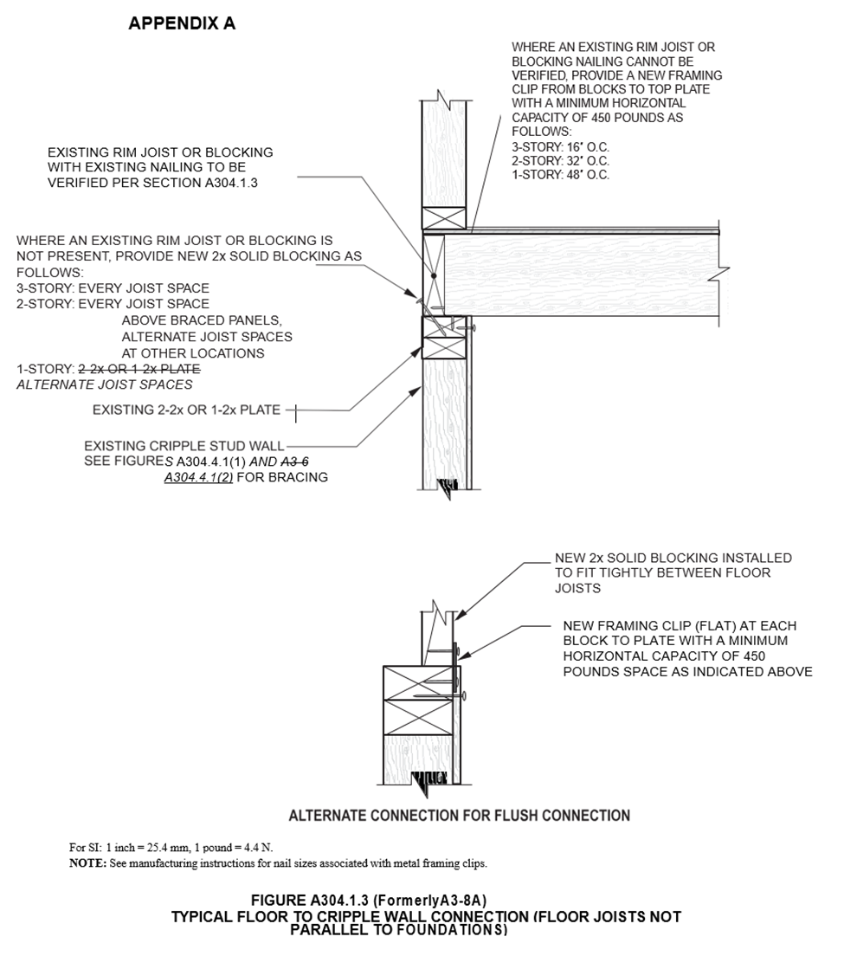
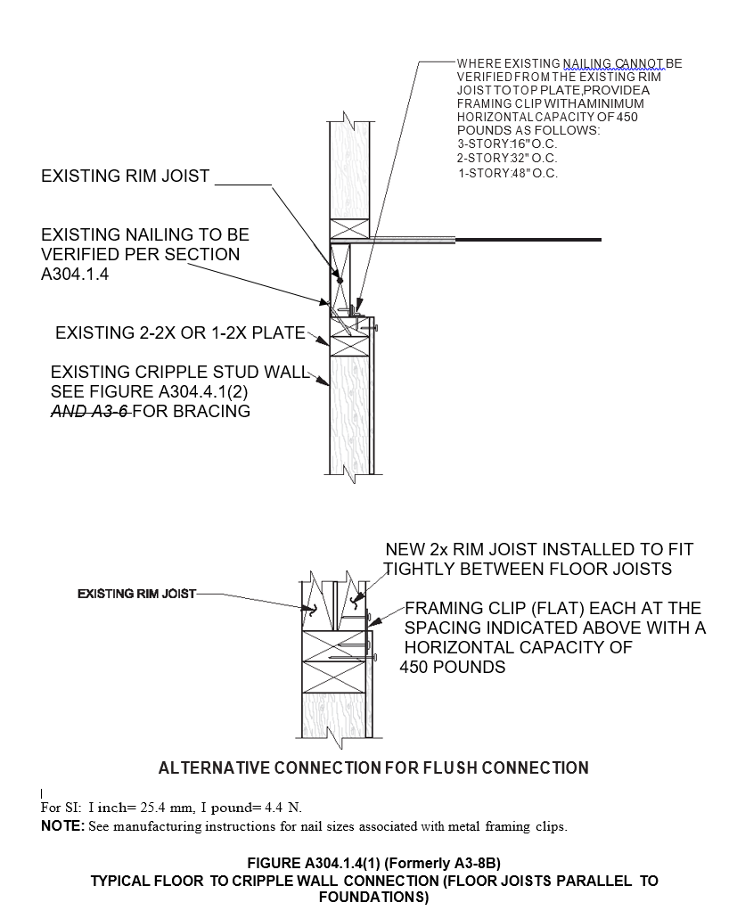

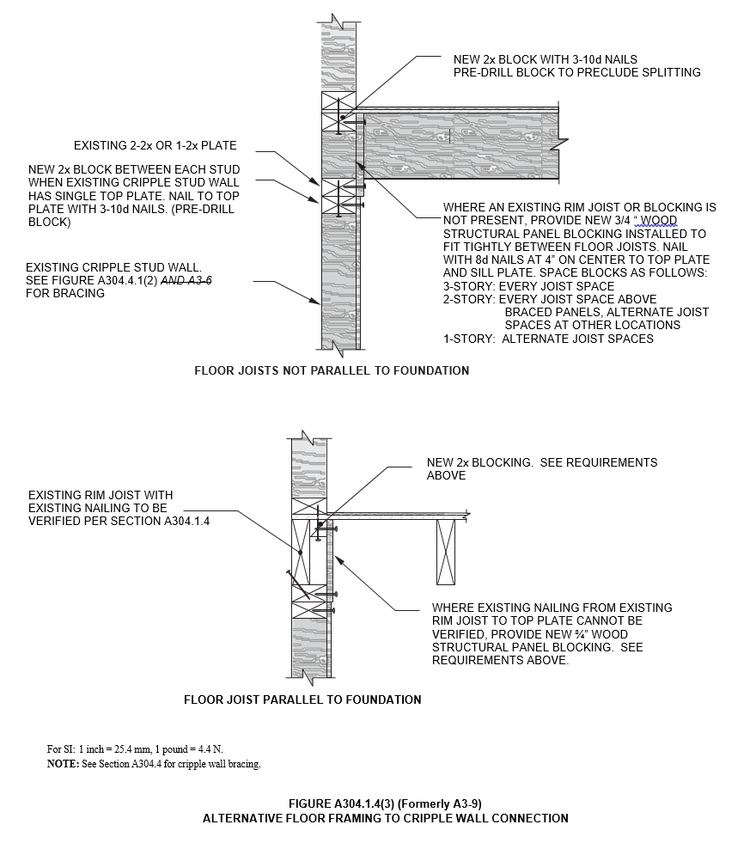
FIGURE A304.3.1(1) (Formerly A3-3)
SILL PLATE BOLTING ANCHORING TO EXISTING FOUNDATION
FIGURE A304.4.1(3) (Formerly A3-7)
PARTIAL CRIPPLE STUD WALL ELEVATION
FIGURE A304.4.2 (Formerly A3-10)
FLOOR PLAN-CRIPPLE WALL BRACING LAYOUT

(No change to Figures with existing California amendments)
NOTE:
Authority Cited: Health and Safety Code Sections 17040, 17050, 17920.9, 17921, 17921.5, 17921.6, 17921.10, 17922, 17922.6, 17922.12, 17922.14, 17926, 17927, 17928, 18300, 18552, 18554, 18620, 18630, 18640, 18670, 18690, 18691, 18865, 18871.3, 18871.4, 18873, 18873.1 through 18873.5, 18938.3, 18944.11, and 19990; and Government Code Section 12955.1.
Reference: Health and Safety Code Sections 17000 through 17062.5, 17910 through 17995.5, 18200 through 18700, 18860 through 18874, and 19960 through 19997; Civil Code Sections 1101.4, 1101.5 and 1954.201; and Government Code Sections 12955.1 and 12955.1.1.

- HCD proposes to NOT adopt Appendix A, Chapter A4, from the
2018 International Existing Building Code.
Appendix A: Guidelines for the Seismic Retrofit of Existing Buildings

CHAPTER A4
EARTHQUAKE RISK REDUCTION IN WOOD-FRAME RESIDENTIAL BUILDINGS WITH SOFT, WEAK OR OPEN FRONT WALLS
NOTE:
Authority Cited: Health and Safety Code Sections 17040, 17050, 17920.9, 17921, 17921.5, 17921.6, 17921.10, 17922, 17922.6, 17922.12, 17922.14, 17926, 17927, 17928, 18300, 18552, 18554, 18620, 18630, 18640, 18670, 18690, 18691, 18865, 18871.3, 18871.4, 18873, 18873.1 through 18873.5, 18938.3, 18944.11, and 19990; and Government Code Section 12955.1.
Reference: Health and Safety Code Sections 17000 through 17062.5, 17910 through 17995.5, 18200 through 18700, 18860 through 18874, and 19960 through 19997; Civil Code Sections 1101.4, 1101.5 and 1954.201; and Government Code Sections 12955.1 and 12955.1.1.

- HCD proposes to adopt Appendix A, Chapter A5, from the 2018 International Existing Building Code into the 2019 California Existing Building Code without amendments.
Appendix A: Guidelines for the Seismic Retrofit of Existing Buildings

CHAPTER A5

REFERENCED STANDARDS
NOTE:
Authority Cited: Health and Safety Code Sections 17040, 17050, 17920.9, 17921, 17921.5, 17921.6, 17921.10, 17922, 17922.6, 17922.12, 17922.14, 17926, 17927, 17928, 18300, 18552, 18554, 18620, 18630, 18640, 18670, 18690, 18691, 18865, 18871.3, 18871.4, 18873, 18873.1 through 18873.5, 18938.3, 18944.11, and 19990; and Government Code Section 12955.1.
Reference: Health and Safety Code Sections 17000 through 17062.5, 17910 through 17995.5, 18200 through 18700, 18860 through 18874, and 19960 through 19997; Civil Code Sections 1101.4, 1101.5 and 1954.201; and Government Code Sections 12955.1 and 12955.1.1.

- HCD proposes to NOT adopt Appendix B from the 2018 International Existing Building Code.
APPENDIX B
SUPPLEMENTARY ACCESSIBILITY REQUIREMENTS FOR EXISTING BUILDINGS AND FACILITIES
NOTE:
Authority Cited: Health and Safety Code Sections 17040, 17050, 17920.9, 17921, 17921.5, 17921.6, 17921.10, 17922, 17922.6, 17922.12, 17922.14, 17926, 17927, 17928, 18300, 18552, 18554, 18620, 18630, 18640, 18670, 18690, 18691, 18865, 18871.3, 18871.4, 18873, 18873.1 through 18873.5, 18938.3, 18944.11, and 19990; and Government Code Section 12955.1.
Reference: Health and Safety Code Sections 17000 through 17062.5, 17910 through 17995.5, 18200 through 18700, 18860 through 18874, and 19960 through 19997; Civil Code Sections 1101.4, 1101.5 and 1954.201; and Government Code Sections 12955.1 and 12955.1.1.

- HCD proposes to NOT adopt Appendix C, Chapter C1, from the
2018 International Existing Building Code.
APPENDIX C: Guidelines for the Wind Retrofit of Existing Buildings

CHAPTER C1
GABLE END RETROFIT FOR HIGH-WIND AREAS
NOTE:
Authority Cited: Health and Safety Code Sections 17040, 17050, 17920.9, 17921, 17921.5, 17921.6, 17921.10, 17922, 17922.6, 17922.12, 17922.14, 17926, 17927, 17928, 18300, 18552, 18554, 18620, 18630, 18640, 18670, 18690, 18691, 18865, 18871.3, 18871.4, 18873, 18873.1 through 18873.5, 18938.3, 18944.11, and 19990; and Government Code Section 12955.1.
Reference: Health and Safety Code Sections 17000 through 17062.5, 17910 through 17995.5, 18200 through 18700, 18860 through 18874, and 19960 through 19997; Civil Code Sections 1101.4, 1101.5 and 1954.201; and Government Code Sections 12955.1 and 12955.1.1.

- HCD proposes to NOT adopt Appendix C, Chapter C2, from the
2018 International Existing Building Code.
APPENDIX C: Guidelines for the Wind Retrofit of Existing Buildings

CHAPTER C2
ROOF DECK FASTENING FOR HIGH-WIND AREAS
NOTE:
Authority Cited: Health and Safety Code Sections 17040, 17050, 17920.9, 17921, 17921.5, 17921.6, 17921.10, 17922, 17922.6, 17922.12, 17922.14, 17926, 17927, 17928, 18300, 18552, 18554, 18620, 18630, 18640, 18670, 18690, 18691, 18865, 18871.3, 18871.4, 18873, 18873.1 through 18873.5, 18938.3, 18944.11, and 19990; and Government Code Section 12955.1.
Reference: Health and Safety Code Sections 17000 through 17062.5, 17910 through 17995.5, 18200 through 18700, 18860 through 18874, and 19960 through 19997; Civil Code Sections 1101.4, 1101.5 and 1954.201; and Government Code Sections 12955.1 and 12955.1.1.

- HCD proposes to NOT adopt Resource A from the 2018 International Existing Building Code.

RESOURCE A
GUIDELINES ON FIRE RATINGS OF ARCHAIC MATERIALS AND ASSEMBLIES
NOTE:
Authority Cited: Health and Safety Code Sections 17040, 17050, 17920.9, 17921, 17921.5, 17921.6, 17921.10, 17922, 17922.6, 17922.12, 17922.14, 17926, 17927, 17928, 18300, 18552, 18554, 18620, 18630, 18640, 18670, 18690, 18691, 18865, 18871.3, 18871.4, 18873, 18873.1 through 18873.5, 18938.3, 18944.11, and 19990; and Government Code Section 12955.1.
Reference: Health and Safety Code Sections 17000 through 17062.5, 17910 through 17995.5, 18200 through 18700, 18860 through 18874, and 19960 through 19997; Civil Code Sections 1101.4, 1101.5 and 1954.201; and Government Code Sections 12955.1 and 12955.1.1.

