ELECTRONIC FUND TRANSFER FOR DEPARTMENT OF 8471.2
GENERAL SERVICES' INVOICES
(Deleted and incorporated in 8471 11/2020)

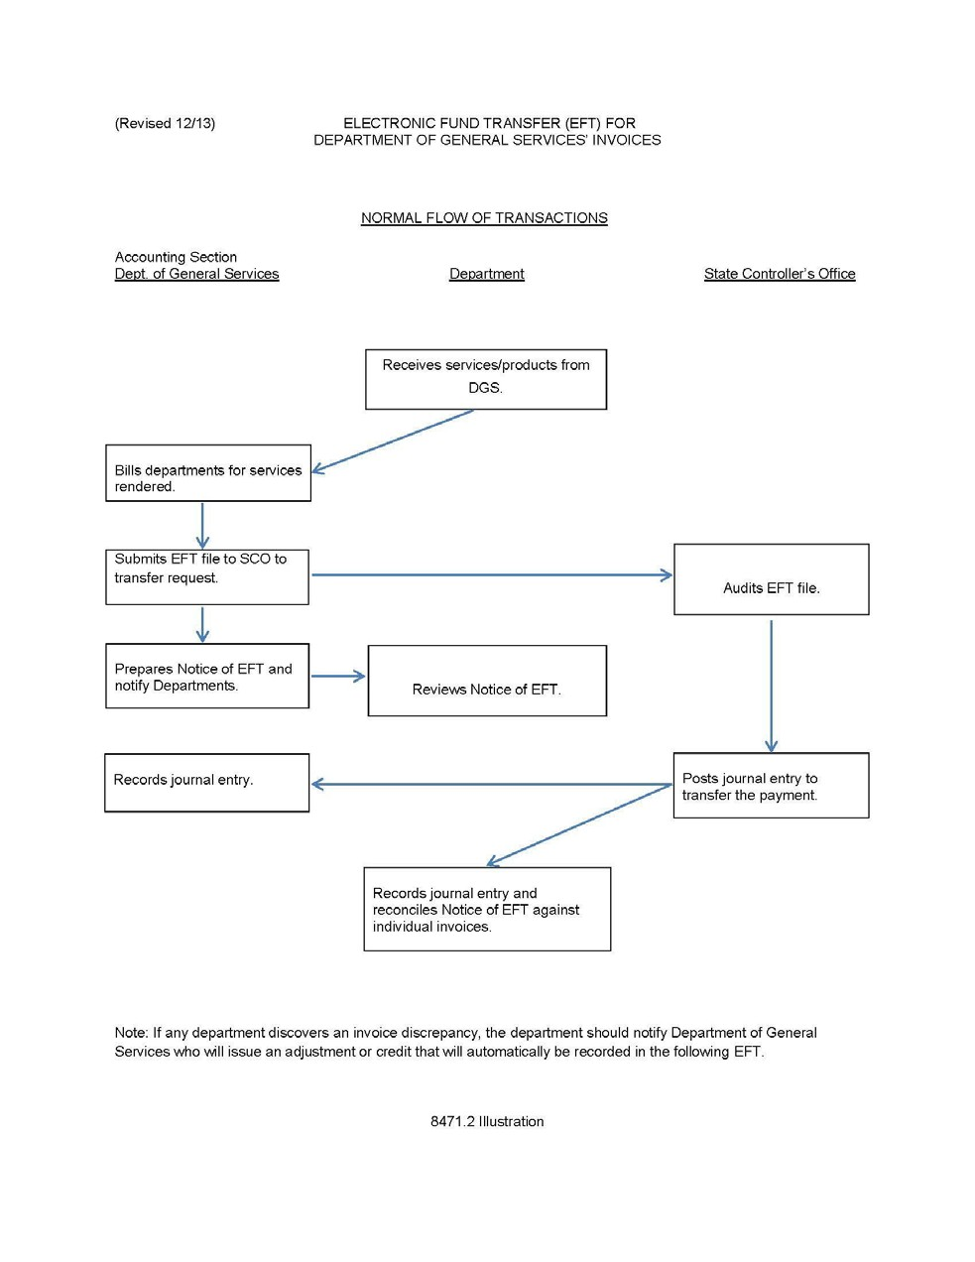

Deleted
AW 11/10/2020
RS 11/10/2020

