ANNUAL INFORMATION RETURNS - 8422.191
REPORTING
(Revised 11/2020)

Reporting Payments on 1099 Forms

At the end of each calendar year, reportable payments must be identified on 1099 forms to comply with IRS and FTB requirements.

Section below was moved from 8422.190

Payments that must be reported are:

- Payments for services to medical corporations, legal service corporations, and non-corporate entities (except governmental units) will be reported.
- These may include: fees, commissions, other forms of compensation for services (to the extent not reported on Form W–2), interest, rent, royalties, prizes, awards, and "gross proceeds" connected with legal services.

Payments are reportable if all three of the following points can be answered yes:

- Payment is within the conduct of trade or business.
- The payee is not a corporation. (Note: All payments to medical corporations for services provided and attorneys or legal services corporations including gross proceeds are reportable).
- Payment is for rents, fees, commissions, prizes, awards, or services (including construction contract services) rendered and not solely for merchandise

- The following identifies (1) the various recurring payment types that are required to be reported and (2) the box on the Form 1099 MISC in which they are to be reported:

The payment types that must be reported on IRS 1099-MISC, Miscellaneous Income, and the corresponding box numbers on the forms are provided below:

Box No. | 1099-MISC, Miscellaneous Income
1 | Rent of real or personal property
2 | Royalties (e.g. oil, gas, copyrights)
3 | Other income (including prizes, awards, and punitive damages not involving physical injury or sickness).
4 | Federal income tax withheld (backup withholding).
6 | Medical and health care payments, including doctors, medical corporations, dentists, audiologists, optometrists, psychologists, psychiatrists, etc.
10 | Payments to Attorneys - Gross Proceeds pursuant to IRC section 6045(f); that consist of (1) amounts intended to be paid to the client; and (2) amounts intended for the attorney.
15 | State income tax withheld

Payments must be reported on IRS 1099-NEC, Non-Employee Compensation, if the following four conditions are met:

- Payment to someone who is not your employee
- Payment is for services in the course of your trade or business (including government agencies and nonprofit organizations)
- Payment to an individual, partnership, estate, or, in some cases, a corporation
- Payments to the payee of at least $600 during the year.

The payment types that must be reported on IRS 1099-NEC and the corresponding box numbers on the forms are provided below:

Box No. | 1099-NEC, Non-Employee Compensation
1 | Nonemployee Compensation  Include fees, commissions, prizes and awards for services rendered as a nonemployee (e.g. bonuses not reported in W-2). Commissions to non-employees. Commissions to real estate brokers. Consulting fees to non-employees. Professional fees.  Payments to entertainers.  Construction service contracts (roads, streets, buildings, etc.)
4 | Federal income tax withheld
5 | State tax withheld

- Interest (other than tax-exempt government obligations; interest by or to nonresident aliens and most foreign entities; corporations; tax-exempt retirement plans, custodians and nominees, brokers, registered dealers in securities and commodities, and U.S. state governments, including their subdivisions and wholly- owned agencies/departments and instrumentalities) must be reported on Form 1099-INT. Form 1099-INT payments are not subject to state backup withholding.

- Payments that are not reported:

- Payments to governmental entities.
- Payments to most corporations for goods and services. However, payments to medical corporations and legal corporations are reported.
- Payments for merchandise (including freight, storage, and similar charges) and utilities (such as electricity, gas, oil, water, telephone, and similar services).
- Payments of non-punitive damages (for physical injury or sickness) awarded by the courts. However, interest payments are reportable.
- Salaries and wages paid from the State Payroll Revolving Fund or otherwise reported on Form W–2.
- Scholarships, fellowships, and stipends (except where such payments are subject to the performance of services).
- Per diem and travel expense reimbursements are generally not considered reportable income. Refer to IRS Instructions for Forms 1099-MISC and 1099-NEC.
Below is some guidance relating to payments that include reportable and non-reportable items:
- When a payment to an individual includes both reportable and non-reportable items, state agencies/departments usually have the option of reporting the total payment or only the reportable portion.
- If the agreement is only for a lump sum, then the full amount will be reported (including gross proceeds paid to an attorney in connection with legal services).
- However, when a payment includes both interest and non-reportable principal, only the interest will be reported.
- When a payment to an external consultant includes a stated amount for travel expenses, per diem, or other expenses, as well as an amount for services, the total amount will be reported.

Questions regarding the determination of reportable payments should be directed to the FI$Cal/SCO Vendor Management Group at FISVMsupportunit@sco.ca.gov.

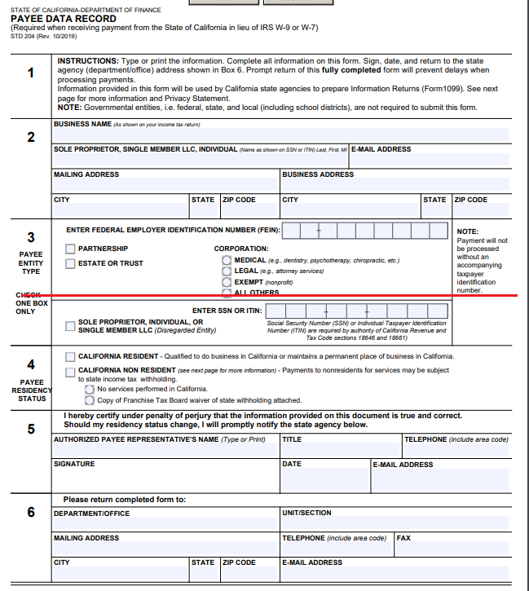

) Deleted and added link to STD 204

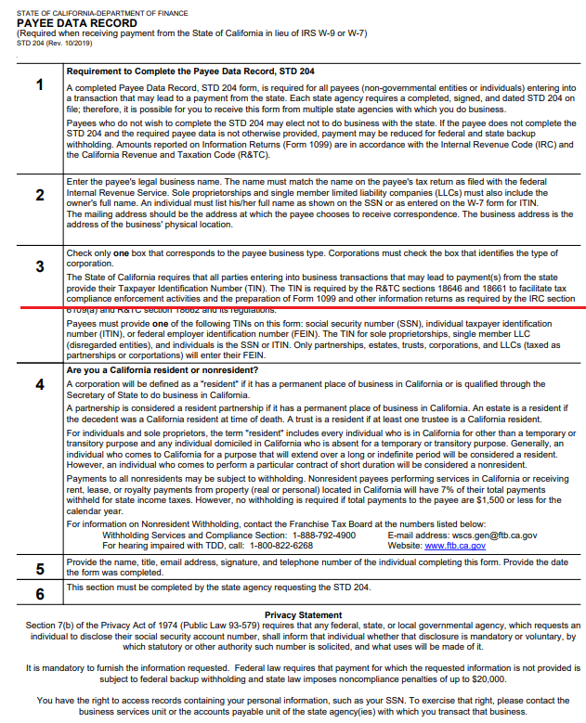

Deleted and added link to STD 204

1099 Reporting for Agencies/Departments Deferred/Exempt from Using FI$Cal

This section only applies to agencies/departments that are deferred or exempt from using FI$Cal and choose not to use FI$Cal/SCO VMG as their reporting agent. These agencies/departments may send their annual information returns (Form 1099) to the IRS and FTB directly and mail a paper Form 1099 to the payee. For the latest filing information, go to General Instructions for Certain Information Returns at IRS.gov/1099GeneralInstructions. The Guide to Information Returns provides the filing due date for all returns and the date for other information returns that are due to the recipient.

Agencies/departments filing 250 or more Form 1099’s must file electronically. For less than 250 Form 1099’s, agencies/departments are encouraged to file electronically; however, paper returns can be filed with the IRS. Further information regarding the two methods is described below.

- Filing 250 or more
Agencies/departments that file their own electronic returns are encouraged to use the IRS Combined Federal/State Filing Program. An application to participate in this program should be submitted directly to the IRS. When the application is approved by the IRS, the agency/department will annually send the returns to the IRS only. IRS will then forward the information to FTB. To request approval to participate in the IRS Combined Federal/State Filing Program, see IRS Publication 1220, Specifications for Filing Forms 1097-BTC, 1098, 1099, 3921, 3922, 5498, 8935, and W-2G or call IRS Information Reporting at (866) 455-7438.
- Filing less than 250
Agencies/departments filing less than 250 returns of one type are encouraged to file electronic returns through the IRS Combined Federal/State Filing Program as described above. However, agencies/departments may file paper Form 1099 with the IRS Form 1096 (Return Transmittal Form) and send them to the IRS . The IRS will forward copies of returns filed with the Form 1096 to the FTB. In this case, the agencies/departments do not send paper copies to FTB. To order 1099 forms from the IRS, call 1-800-TAX-FORM (1-800-829-3676) or order them on-line at www.irs.gov.

For information reporting questions, refer to the IRS website at www.irs.gov or call IRS Information Reporting Program Customer Service Section at (866) 455-7438. Additional information is available at www.ftb.ca.gov, or contact FTB at (916) 845-6304 or IRPhelp@ftb.ca.gov.
AW 11/10/2020
RS 11/10/2020

