Map Viewer User Guide for the 2022 Water Grant Program

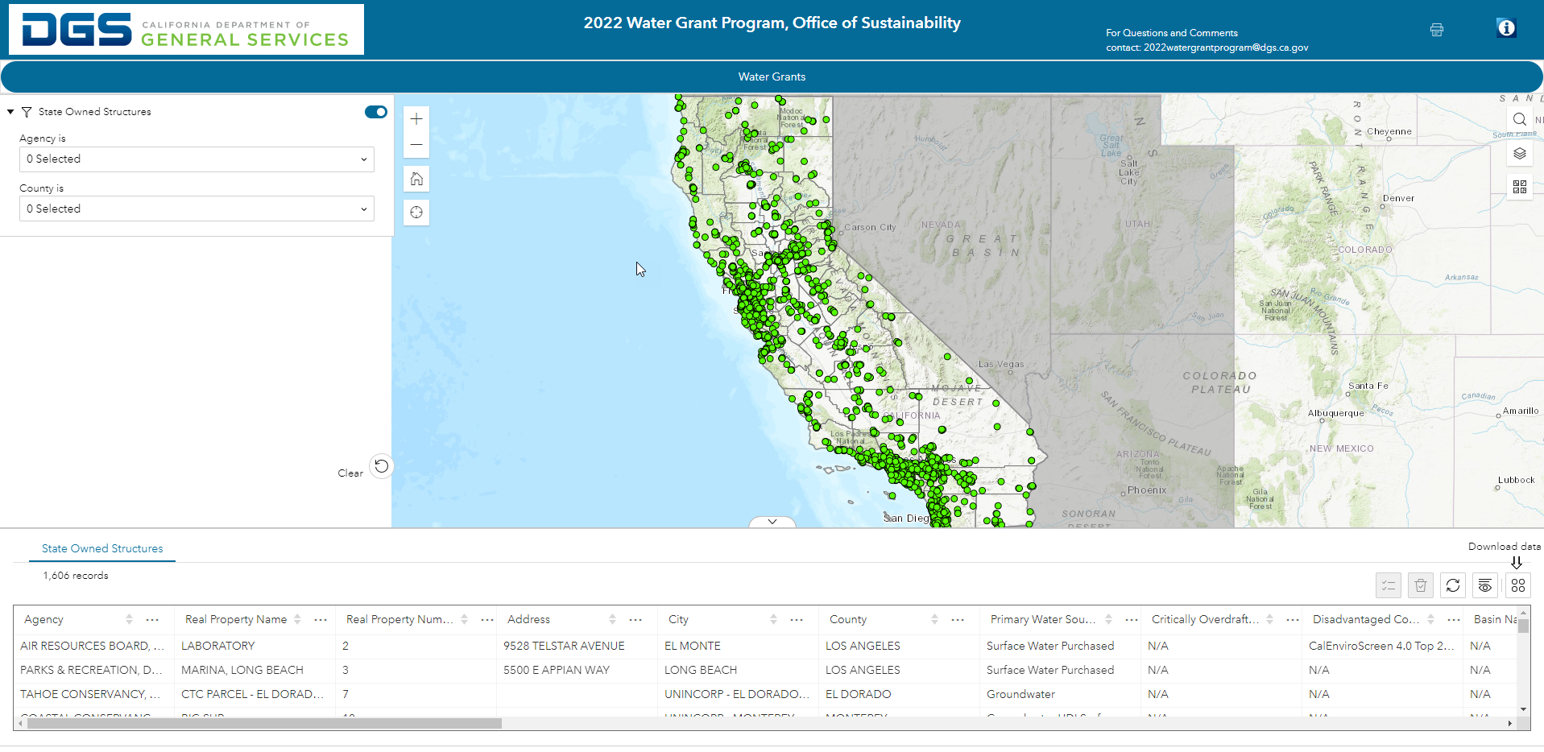
Figure 1: Map Viewer User Guide for the 2022 Water Grant Program

Table of Contents
Contents
Table of Contents 2
Terms 3
Data Sources 4
Overview of the Map 6
Performing a Query 7
Exporting Query Results 13
Changing the Basemap 14
Viewing the Layer List 15
Viewing the Legend 16
Printing a Map 17
Researching a Real Property or Structure Number in the SPI Map Viewer 19

Terms
CSV Export File: Microsoft Excel file type
JSON Export File: For more information on JSON go to: JSON
GeoJSON Export File: For more information on GeoJSON go to: GeoJSON—Portal for ArcGIS | Documentation for ArcGIS Enterprise

SPI: The Statewide Property Inventory (SPI) is a detailed inventory of the State's real property assets including land, structures/improvements, leased space and State-owned space leased to others.

*Structure number: The structure number is required by the grant application and is assigned by the Department of General Services to each building.
Instructions on how to find the structure number is on page 19 of this guide. If a structure number can’t be found or if help is needed, then please contact 2022watergrantprogram@dgs.ca.gov
Value of (0): When found in a column, 0 means the data was not available, applicable, or is absent from that location. Since the required format for the column is numeric, N/A cannot be used.
Value of N/A: Means that data was not available, applicable, or is absent from that location.
Widget: A component of the map interface, that enables a user to perform a function.

Data Sources

Data Source
Fields: Agency, Real Property Name, Real Property Number, Address, City, County, Latitude, and Longitude
Source: Statewide Property Inventory
URL: https://spigis.apps.dgs.ca.gov/

Data Source
Fields: Primary Water Source
Source: California Department of Water Resources
URL: https://data.ca.gov/dataset/drinking-water-public-water-system-information

Data Source
Fields: Critically Overdrafted Basin
Source: California Department of Water Resources
URL: https://water.ca.gov/Programs/Groundwater-Management/Bulletin-118/Critically-Overdrafted-Basins

Data Source
Fields: Disadvantaged Communities Status
Source: Office of Environmental Health Hazard Assessment - SB 535 Disadvantaged Communities
URL: https://oehha.ca.gov/calenviroscreen/sb535

Data Source
Fields: CE4 (CalEnviroScreen)
Source: Office of Environmental Health Hazard Assessment - CalEnviroScreen 4.0
URL: https://oehha.ca.gov/calenviroscreen/report/calenviroscreen-40

Data Source
Fields: MWD Service Area
Source: Metropolitan Water District
URL: https://www.sdcwa.org/projects-programs/programs/metropolitan-water-district/

Data Source
Fields: Heat Island Value
Source: California Environmental Protection Agency
URL: https://calepa.ca.gov/urban-heat-island-interactive-maps-2/

Data Source
Fields: Air District
Source: California Air Resources Board
URL: https://ww2.arb.ca.gov/geographical-information-system-gis-library

Data Source
Fields: Small Water Risk Score
Source: California Department of Water Resources
URL: https://sandbox.data.ca.gov/dataset/drought-and-water-shortage-risk-small-suppliers-and-rural-communities/e9d98d68-399b-4275-9056-45a3d45c51a9

Data Source
Fields: Water System Number, Water System Name, Population, Regulating Agency, Address Line 1, Address Line 2, City, State, Zip Code, Service Connections, Contact Phone Number, and Contact Email
Source: California Water Resources Control Board
URL: https://gispublic.waterboards.ca.gov/portalserver/rest/services/Drinking_Water/California_Drinking_Water_System_Area_Boundaries/FeatureServer

Overview of the Map Viewer
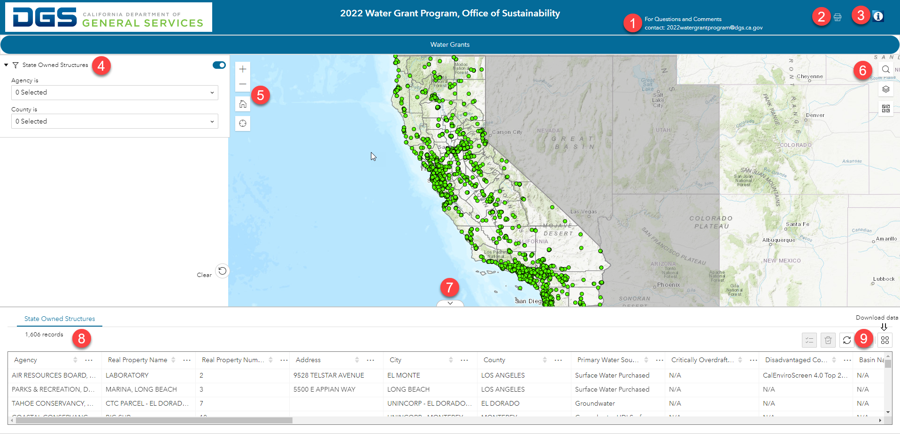
- Contact information for questions, concerns, technical issues: 2022watergrantprogram@dgs.ca.gov
- Print Function
- Help Document
- Query Widget – Perform searches based on a set of criteria
- Navigational Tools – Zoom In, Zoom Out, Return to full extent (Home button)
- Additional Widgets – Search Tool, Layer List/Legend, Basemap Gallery
- Opens or Lowers the Attribute Table
- Attribute Table – Displays records from your query
- Download Data – Export attribute table data into a CSV file

Performing a Query
  - Search Options:
    - Select an agency from the dropdown list
    - Select a county from the dropdown list
    - Clear your selected results
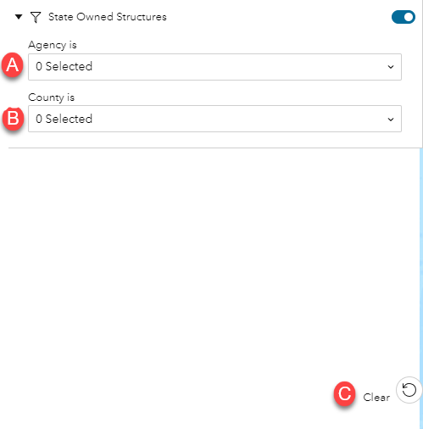

  - Search by Agency:
    - Select the dropdown arrow to display Agency options
    - Use the search tool to quickly find an Agency
    - Click the checkbox next to the Agency you want included in your search (you can select multiple)
    - You can view all Agencies or only the ones you have selected
    - Click the trashcan to remove all selected Agencies
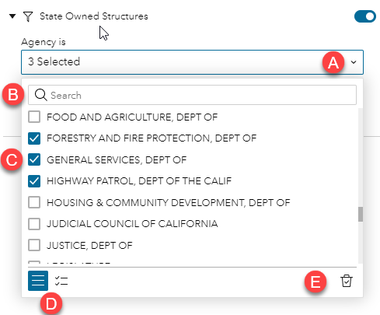

  - Search by County: (Agencies selected in the previous step will affect which counties are available to choose from in this step)
    - Shows how many Agencies were selected in the previous step
    - Select the dropdown arrow to display County options
    - Use the search tool to quickly find a County
    - Click the checkbox next to the County you want included in your search (you can select multiple)
    - You can view all Counties or only the ones you have selected
    - Click the trashcan to remove all selected Counties
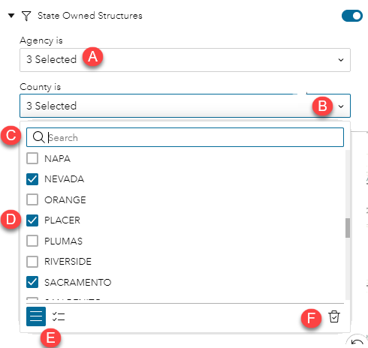

  - Search Results:
    - Total Agencies that were selected
    - Total Counties that were selected
    - Map zoomed to search results
    - Attribute Table with record count and data for each point on the map

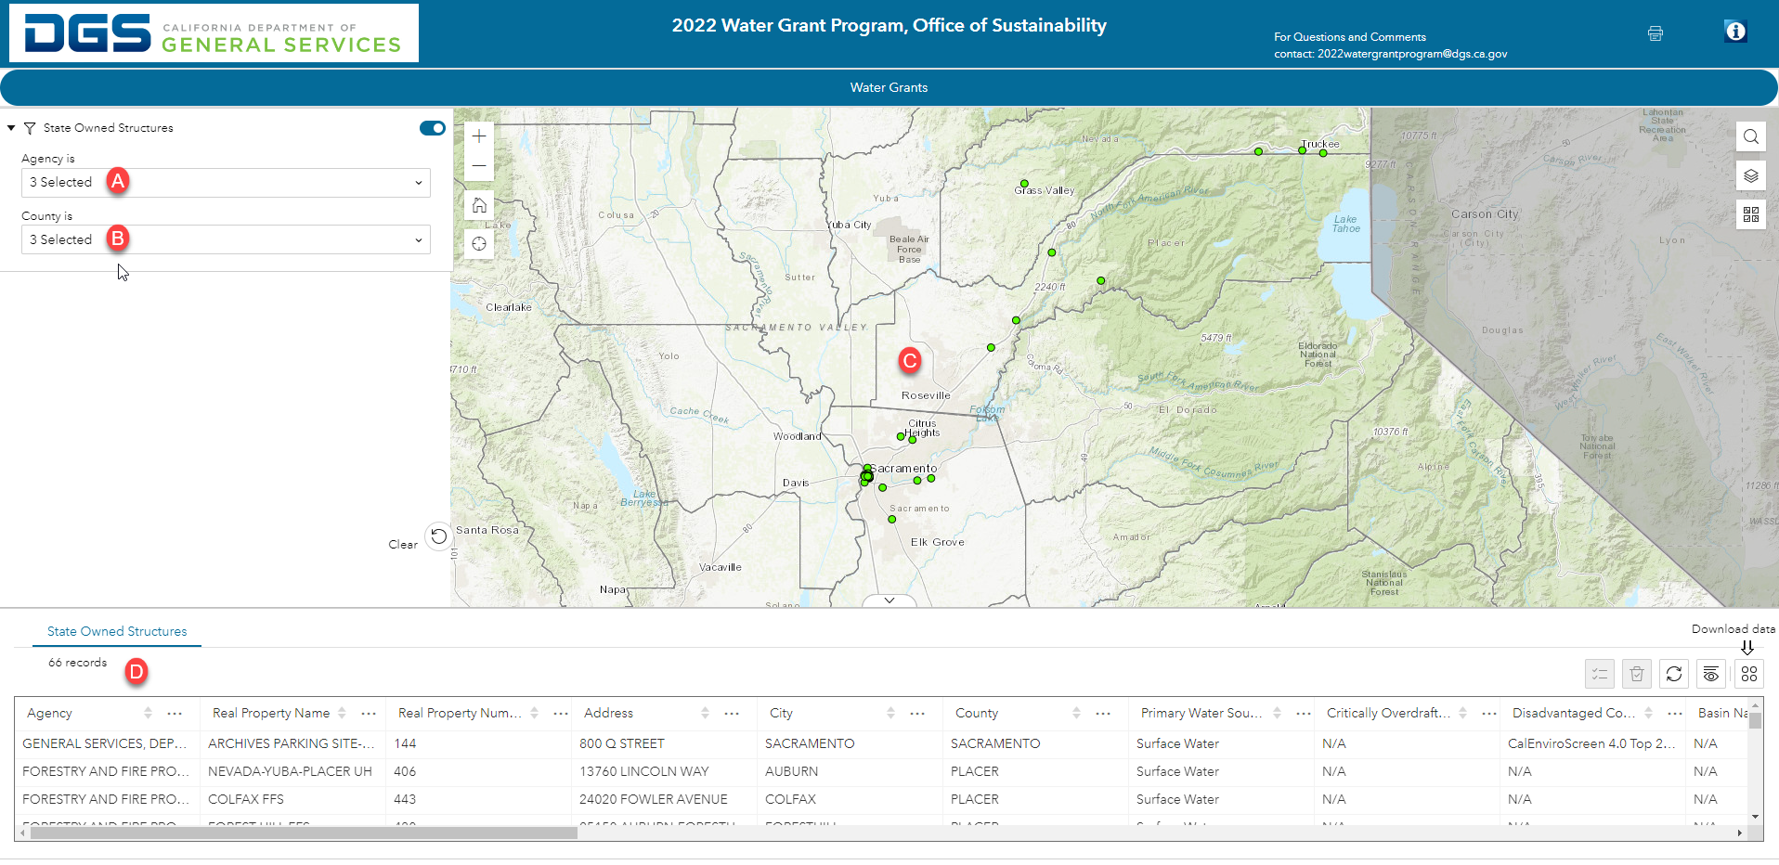
  - Search Results:
    - Click on a record in the attribute table to zoom to that structure on the map
    - The selected record will have a dark black circle and will blink yellow 3 times

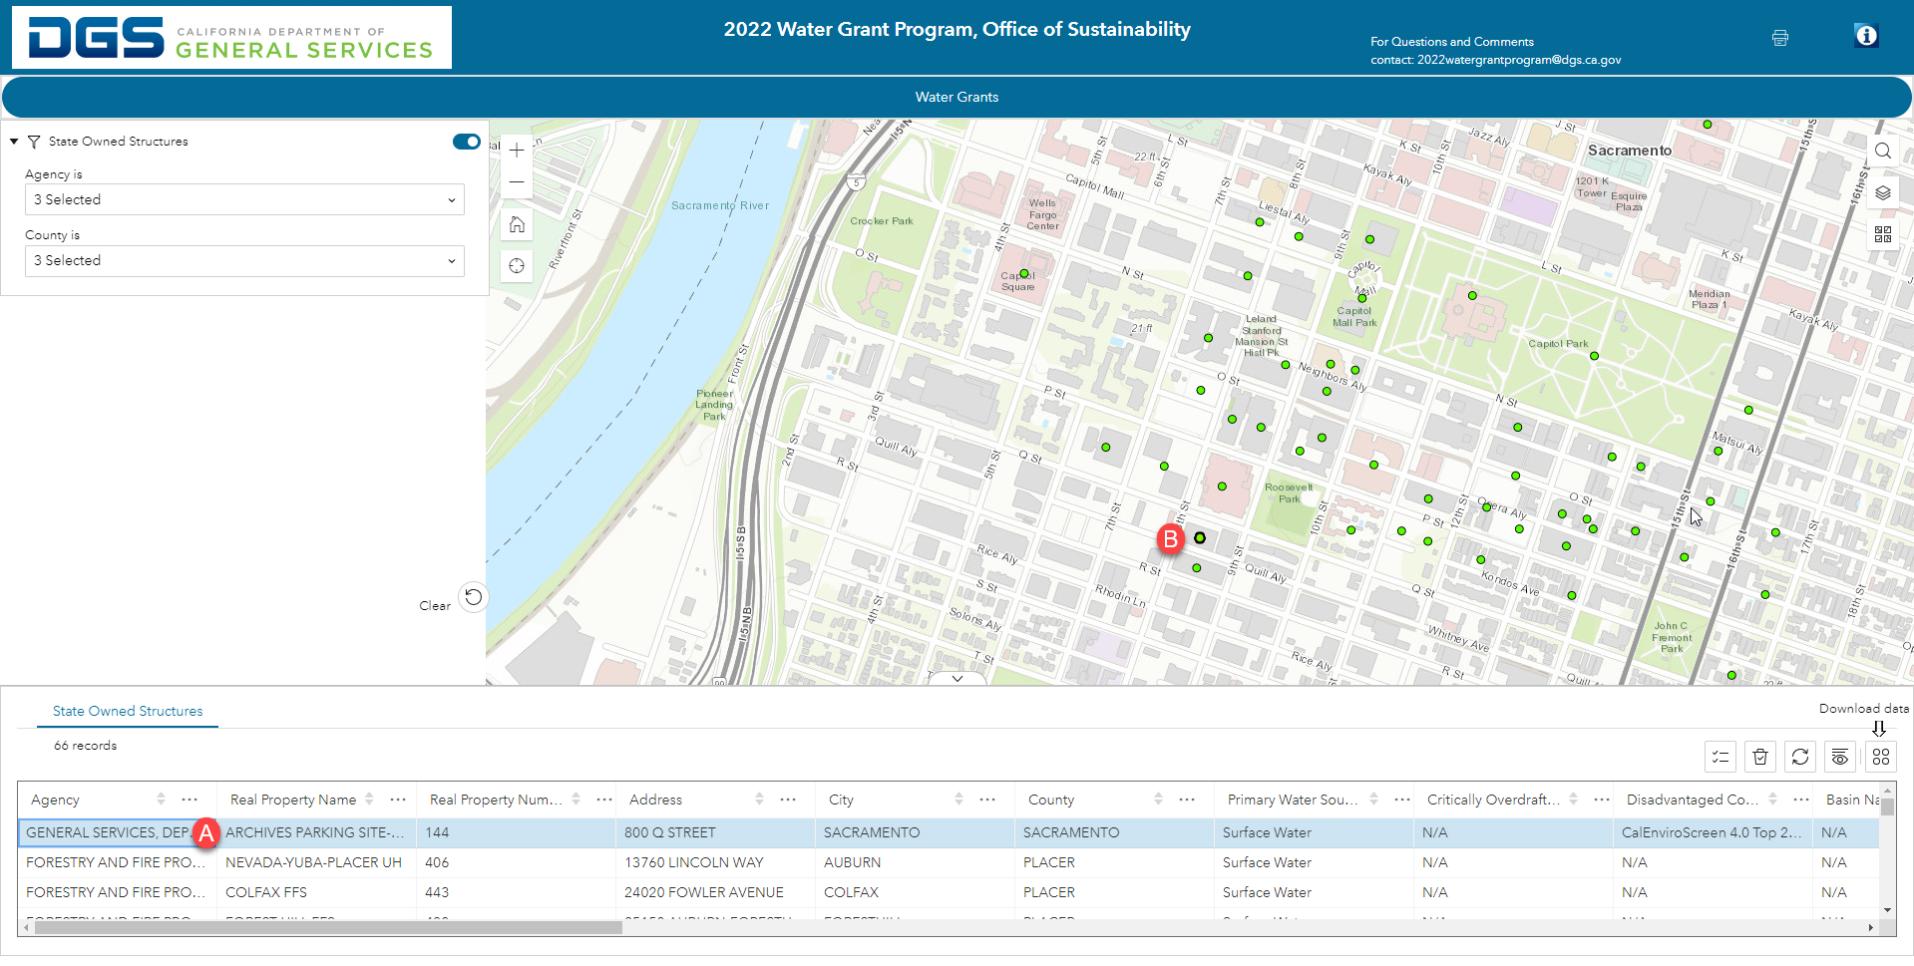

  - Search Results:
    - Clicking on a point (green dot) will bring up that structures information
    - The pop up window will display all available information for that structure

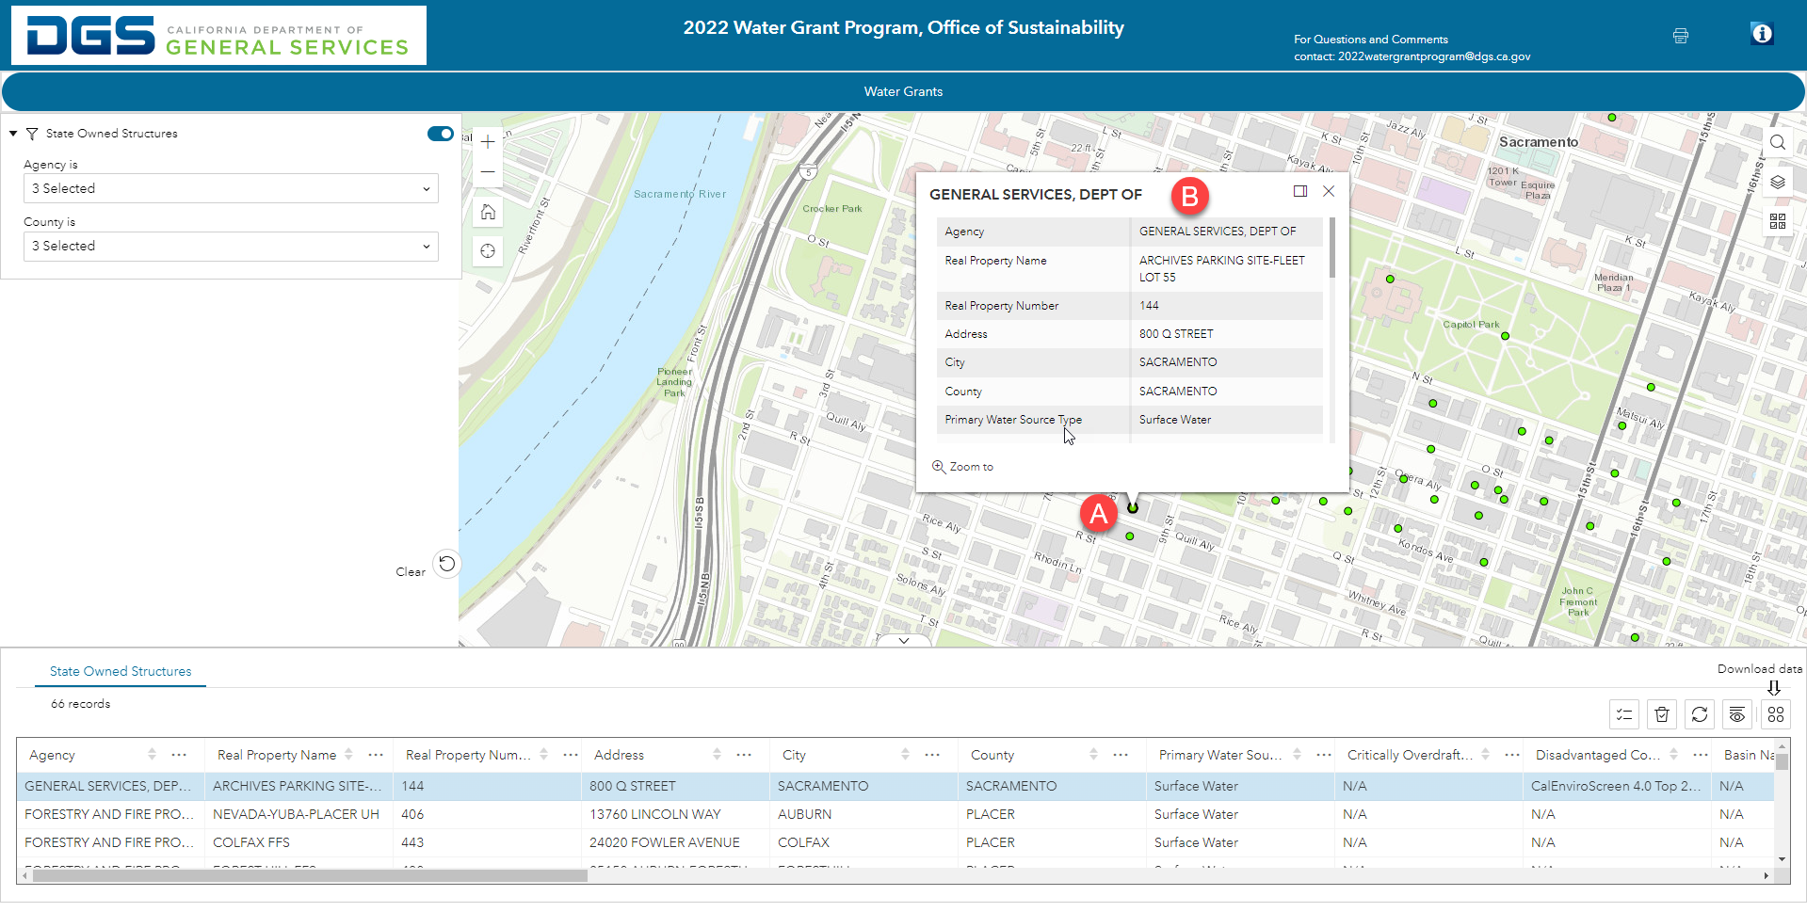

Exporting Search Results
- Exporting Search Results:
- Click the download data button (4 dots)
- Click the Export all option
- There are 3 options for exporting the data. Export to CSV will produce an Excel file. For more information on JSON and GeoJSON, please visit the Terms section of this Help Document

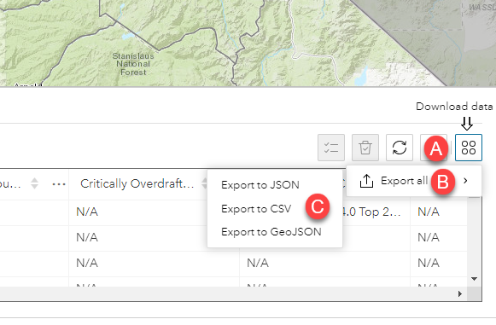

Changing the Basemap
- How to change the basemap:
- Click the Basemap button to select from the available option to change the background image

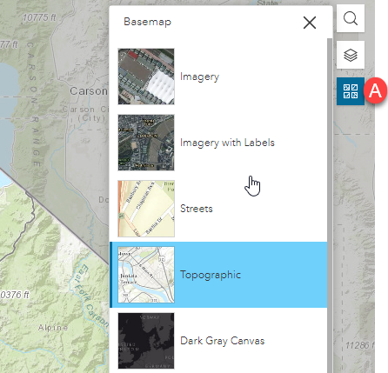

Viewing the Layer List
- Layer List:
  - Click the Layers button to view all Layers available on the Map
  - A layer with an eyeball shows that the layer is currently active/visible on the map
  - A layer with a slash through the eyeball shows a layer available on the map but is not currently active/visible on the map. You can click the eyeball to toggle the layers visibility on the map on or off

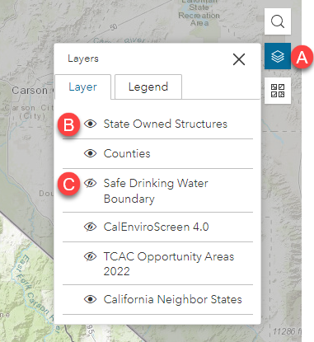

Viewing the Legend

- Legend:
  - Click the Layers button to bring up the Layers and Legends tabs
  - Select the Legend tab to view active/visible Layers on the map
  - Layers currently active/visible on the map will display with their unique symbol and name

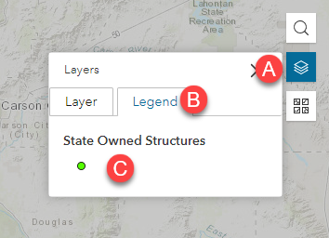

Printing a Map from the Water Grant Map Viewer
- Printing a Map From the Water Grant Map Viewer
a. Select the print button
b. Use the dark grey corner to maximize the window size
c. Give your map a title
d. Choose your map size
e. Select Current map scale
f. Click Print

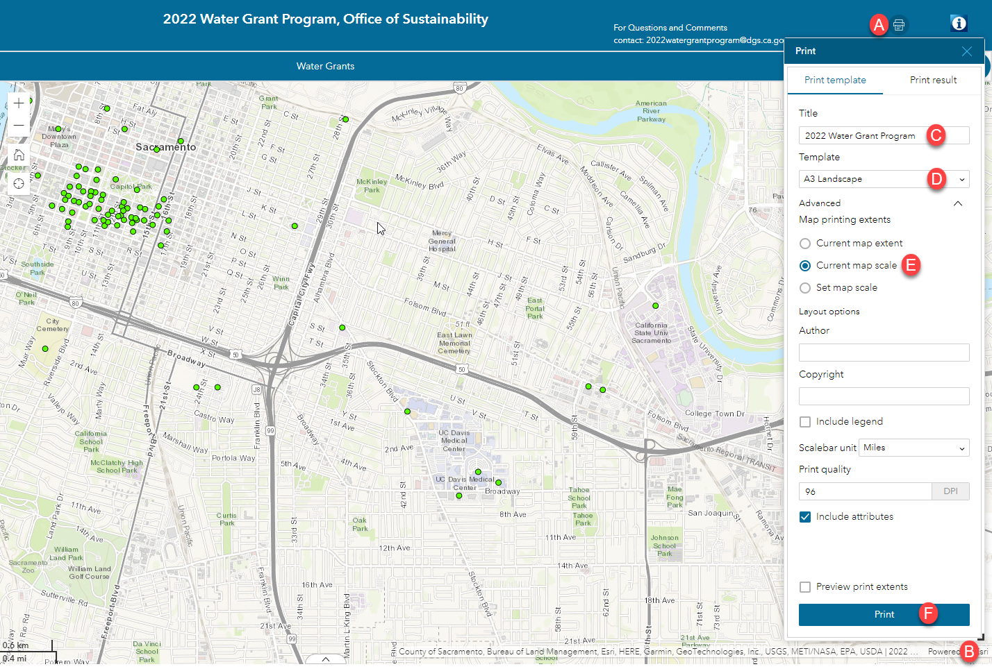

2. Printing a Map
a. Click the Print result tab
b. Click on the title of the map you created to view

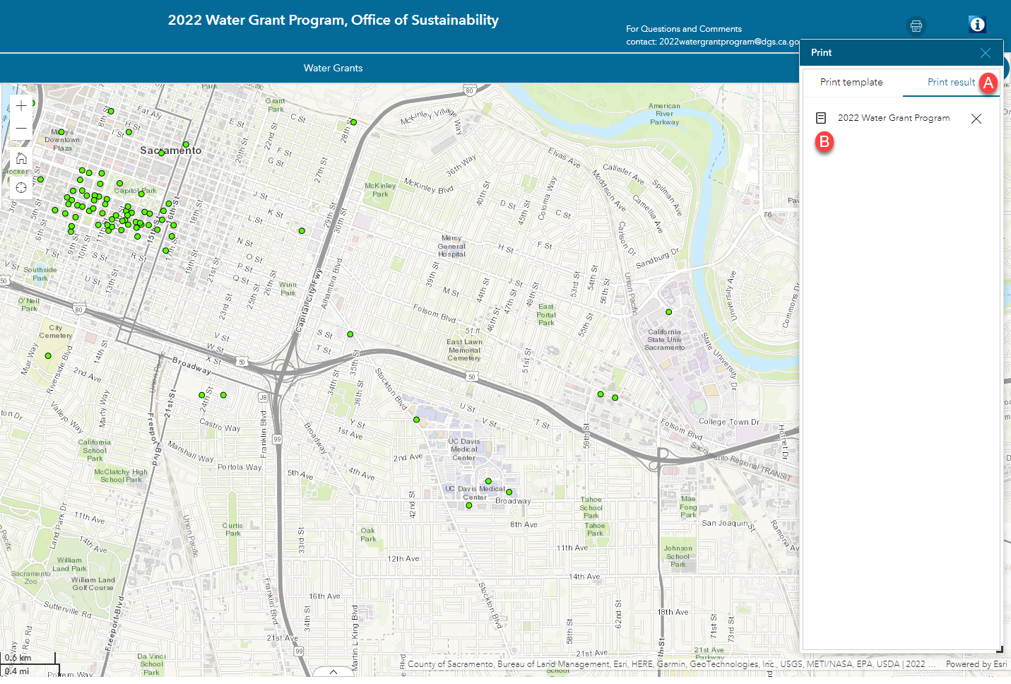

Researching a Real Property or Structure Number in the Public SPI Map Viewer

**The following two pages are instructions on the SPI viewer only!**
- How to locate a Structure Number or Real Property in the SPI Map Viewer
  - Go to SPI GIS Map Viewer (ca.gov)
  - Click the Real Property Checkbox
  - Enter in the Real Property Number you want to search for from the Office of Sustainability - Water Grants 2022 (arcgis.com) map
  - Click the search button to execute your query.

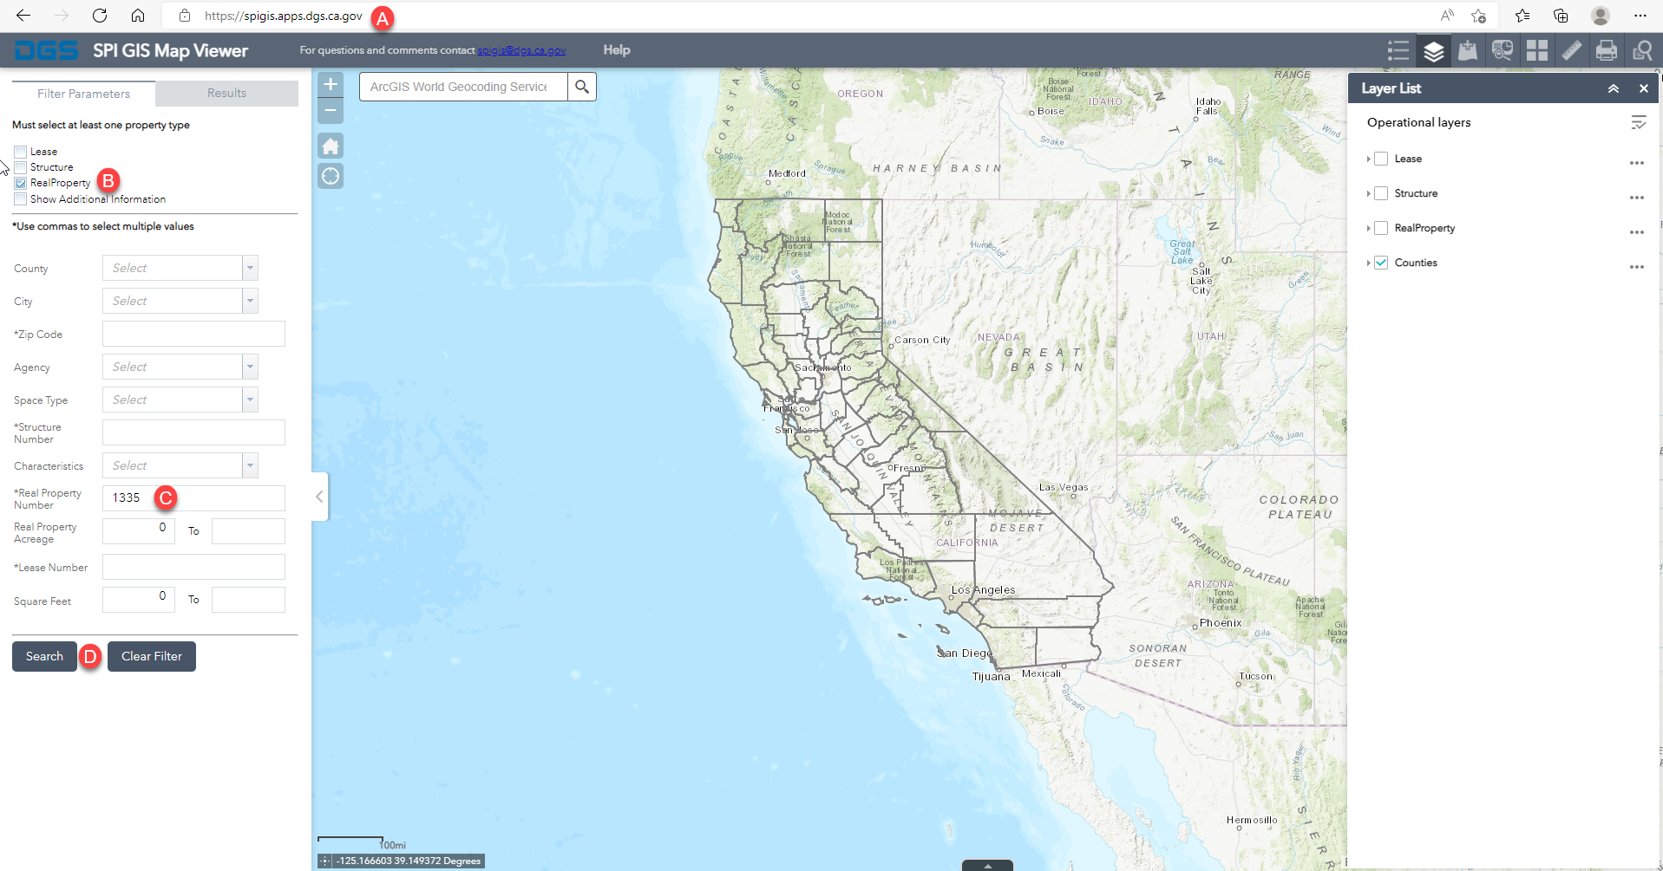

Researching a Real Property or Structure Number in the Public SPI Map Viewer
- How to locate a Structure Number or Real Property in the SPI Map Viewer
  - Zoom into the Real Property square symbol on the map
  - The Attribute Table will display the information for the Real Property
  - Click on the Layer List button
  - Select the checkbox for Structure to display them on the map
  - Click on a Structure symbol (green circle) to bring up its Structure information

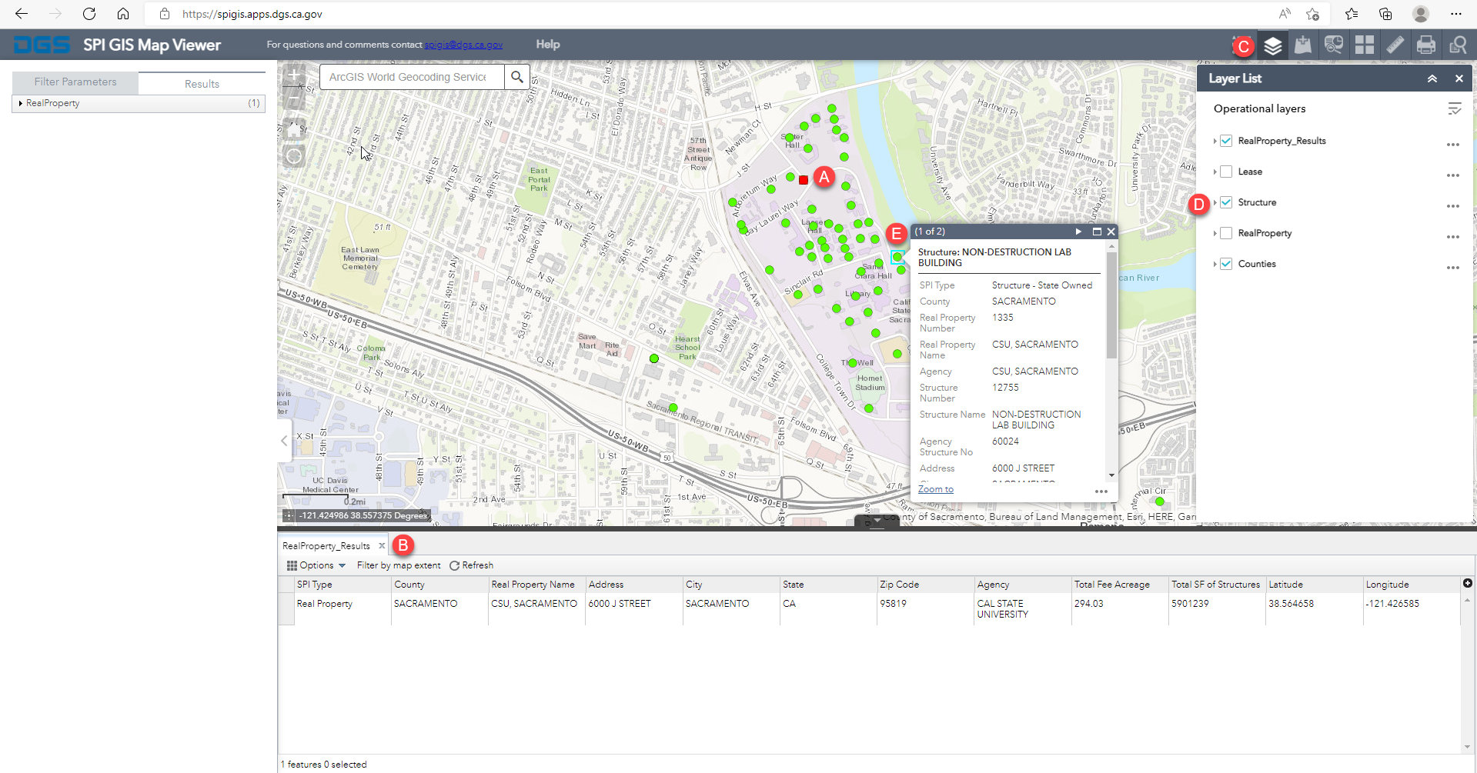

Researching a Real Property or Structure Number in the Public SPI Map Viewer
- Another way to locate a Structure Number or Real Property in the SPI Map Viewer
a. Select the data you want to search by. You must make a selection.
b. Search by County
c. Search by City
d. Search by Zip Code
e. Search by Agency
f. Search by Space Type
g. Search by Structure Number
h. Search by Real Property Number
i. Search by Lease Number

