Creating a Concur Profile: A Step-by-Step Guide

To begin, you will need a registration link from your department’s travel coordinator that will bring you to the Concur registration page. Fill out the required fields and submit the registration request. If your department does not have a registration link, contact your department travel coordinator to create an account for you.
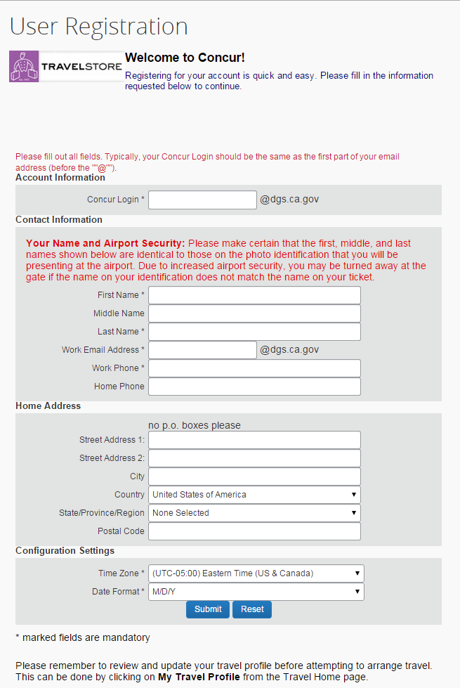

Once the registration process is completed, you will receive two emails from Concur: one will be a “Welcome” email and the second email will contain a link to your Concur Profile. When you click the link, you will be taken directly into your Profile where you need to change your password. All future logins can be done by going to CalTravelStore or www.caltravelstore.com and clicking on the Concur link for access to the login screen, or going directly to the Concur login screen or www.concursolutions.com.

Creating a Concur Profile: A Step-by-Step Guide Page 2
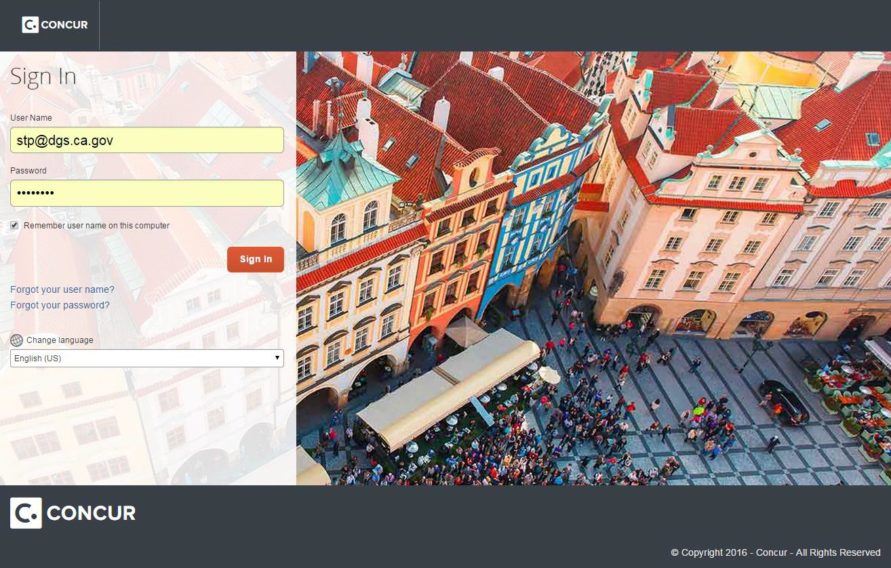

After you log in, you will be brought to the home page. In the upper right- hand corner, click on the down arrow next to “Profile” and select “Profile Settings.”
IMPORTANT NOTE: You must complete the required fields of the Profile before you can book a trip.
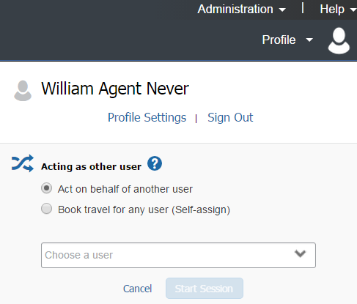

Creating a Concur Profile: A Step-by-Step Guide Page 3

You will then be brought to the Profile page. There are only a few required fields, but you may make your Profile as thorough or as limited as you would like. To make edits or complete your profile, click the appropriate links on the left or in the center of the page. We recommend starting with the “Personal Information” section.
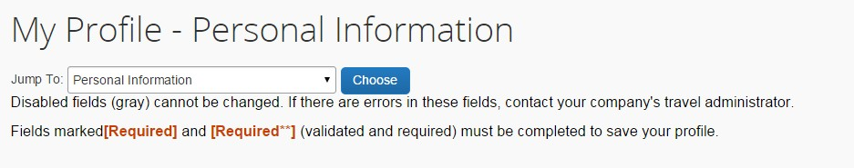

When you enter your name, it is important that you enter it EXACTLY how it shows on your photo identification, such as your driver license. The name you enter here is how your name will be printed on your ticket.

If after you have saved your Profile, you realized that you had a typo in the spelling of your name or in any other grayed-out area, you will need to contact the Statewide Travel Program at (916) 376-3974 in order for it to be changed.
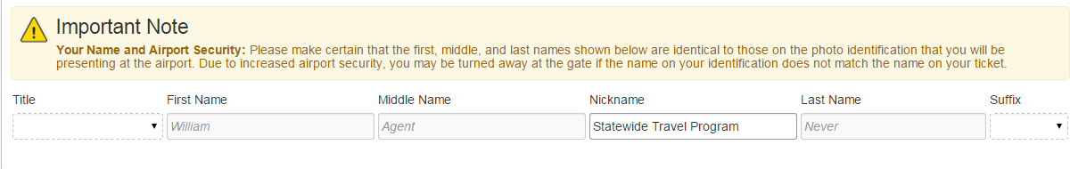

The next section is your company information. This may or may not be a required field for your department, but it allows you to enter in some of your department information.

While there is an option to save after every section, when you are first creating your Profile, you will not be able to use it because there are required fields not filled in yet. However, after your Profile is complete, you can go to any section that needs to be changed, make the change, and save immediately without scrolling down to the bottom of the page.

Creating a Concur Profile: A Step-by-Step Guide Page 4

The next section is your work address. This is the physical address of the department where you work. If you work in a satellite office, enter your office’s address, not the department headquarters.
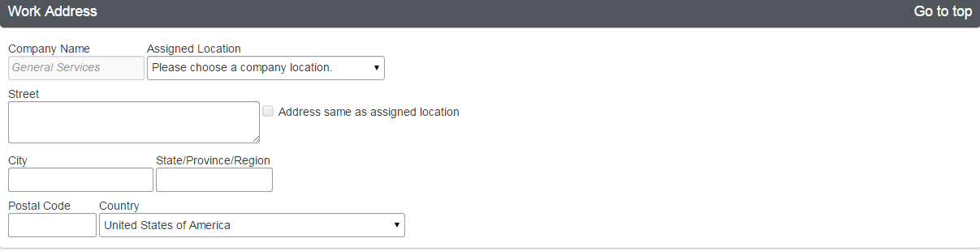

Your home address is not a required field.
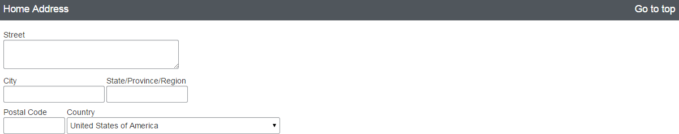

When entering your contact information, it is necessary to enter AT LEAST your work phone number or your home phone number. You may enter both, or you may substitute your cell phone number for your home number.
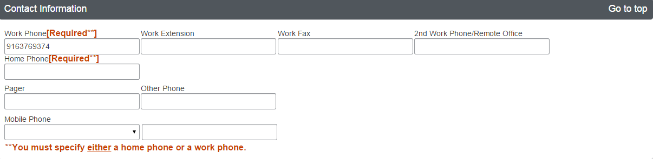

Creating a Concur Profile: A Step-by-Step Guide Page 5

Your work email address (the one used as your login) will automatically populate in the email address field. You have the option of being able to add more addresses. You can have your itinerary be sent to your manager, your personal email address, or even your spouse. If you are booking travel for someone else, they will automatically receive a copy.

The emergency contact information is not a required field, but is preferred. In case there is an emergency, we would like to know who to contact on your behalf.
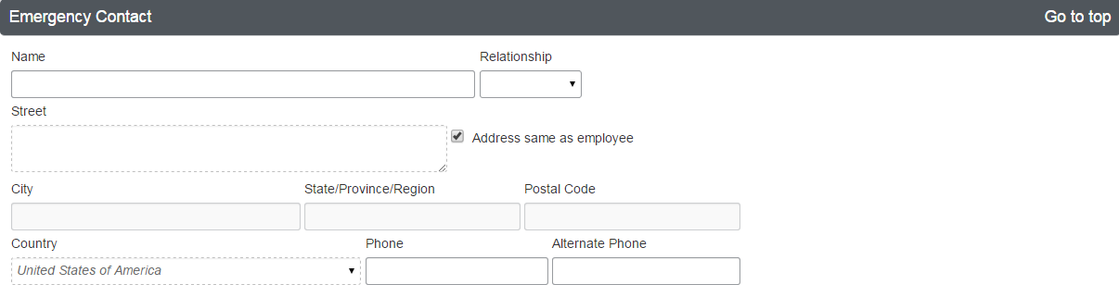

Please select any discount programs you may belong to, but be prepared to show the proper identification/membership cards. If you choose a rate with an AARP discount, you will need to show your AARP membership card at the counter. The government discount refers to federal government rates so you do not need to check the box unless you have a Federal ID; otherwise, Concur automatically searches for the state government rates.

The travel preference sections will allow the traveler to filter their searches by desired amenities as well as transmit any travel needs/requests to the vendor.

Creating a Concur Profile: A Step-by-Step Guide Page 6

Entering your preferred departure airport into your Profile ensures it will automatically populate when searching for tickets. You will also be able to alter this in the search screen without returning to your Profile. This section also gives you a chance to notify the airline of any medical restrictions you may have.
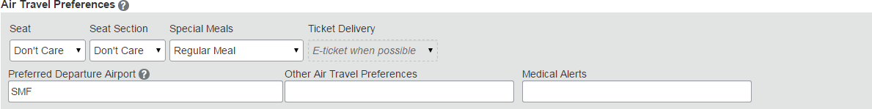

Your hotel preferences will make sure to highlight hotels that have amenities that match your needs in the “search results” section.
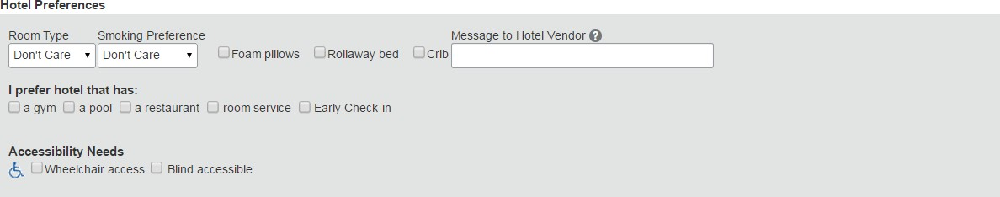

Your car preferences will also be reflected in the “search results” section. Note that the state does not reimburse a traveler who rents a GPS system.
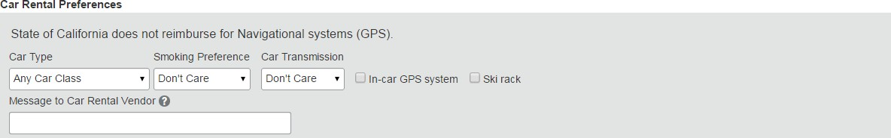

The state follows federal guidelines allowing travelers to retain frequent traveler benefits for personal use. You may add any of your rewards programs. To add, click on the red “Add a Program” button.
To change or delete the program number(s), please click on the pencil (edit) or the red “X” (delete) next to the rewards card.
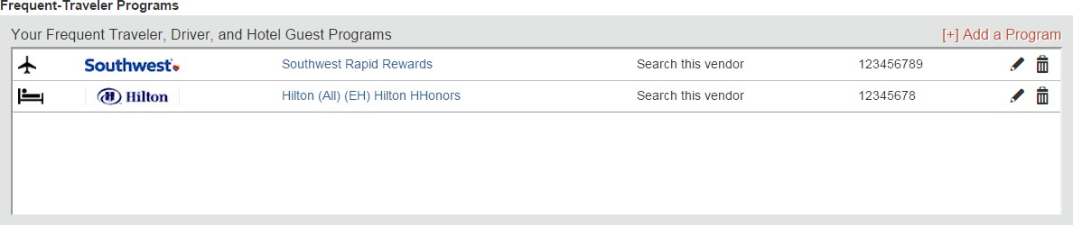

Creating a Concur Profile: A Step-by-Step Guide Page 7

You can add up to five (5) programs at a time in the popup box. After adding your programs, click “Save” at the bottom of the popup. If you have more than five (5) rewards program numbers, you may click the “Add a Program” link again to add any additional numbers.
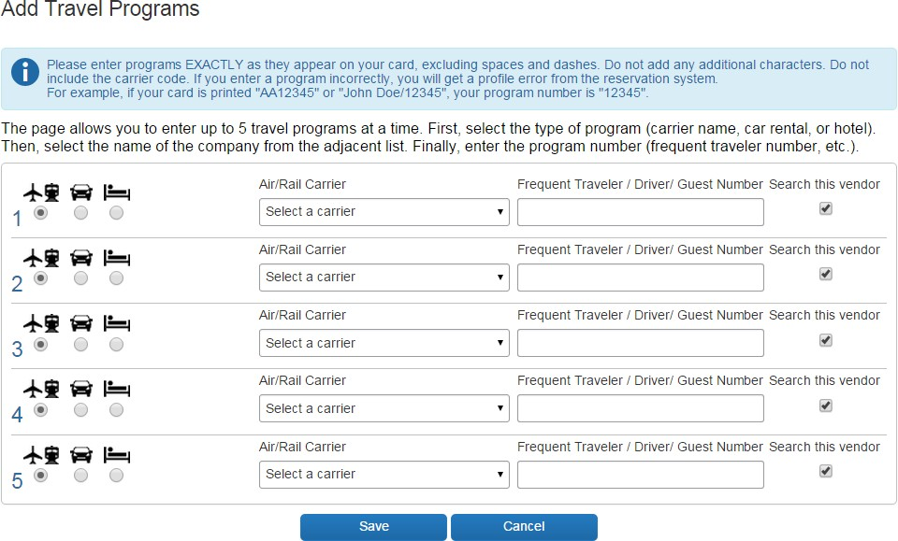

During the initial Profile setup, if you have pending Southwest ticket credits from before creating your Concur Profile, you can enter them by clicking on “Add ticket credit”.
The Unused Tickets section will automatically display Unused Ticket Credits / Travel Funds when a booked flight is canceled. To apply any unused ticket credits / travel funds to a new flight, you will need to call CalTravelStore and have an agent apply the funds.
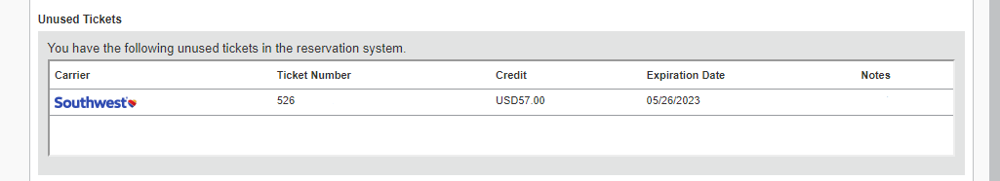

Creating a Concur Profile: A Step-by-Step Guide Page 8

Your gender and date of birth are required information for the TSA, and if you have a TSA PreCheck Known Traveler Number, you are welcome to enter it. If you should choose to participate in the PreCheck program, please note it is a non-reimbursable expense.
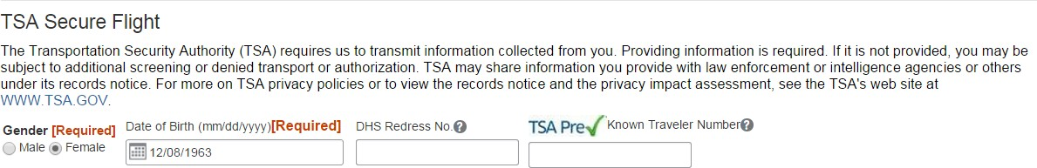

If you have a passport or visa, you are welcome to add the information to your Profile.
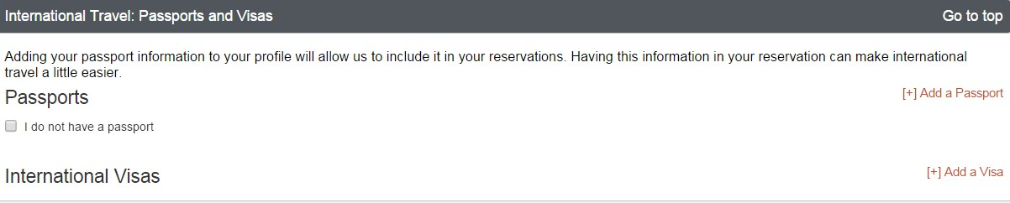

You can have as many travel assistants as you want, but only one can be your primary assistant. Assistants are authorized to book travel on your behalf. You can add an assistant by clicking the “Add an Assistant” link.
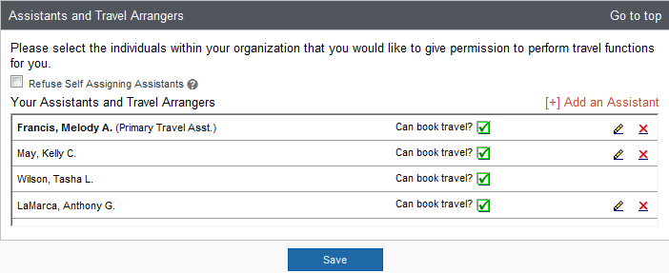

The “Add an Assistant” popup window operates similarly to Microsoft Outlook. Type the person’s name and it brings up their information. Whomever you choose to be your travel assistant MUST have a Concur Profile before you can search for and choose them.

Creating a Concur Profile: A Step-by-Step Guide Page 9
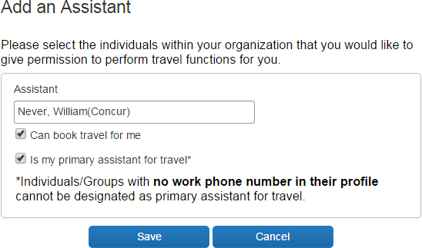

The final section of the Profile is your credit card information. The flight, rail and rental car are billed to your department’s travel account, but your credit card is needed to hold and reserve any hotel room(s). Your credit card information will be encrypted. Once it is entered, even you don’t have access to it.
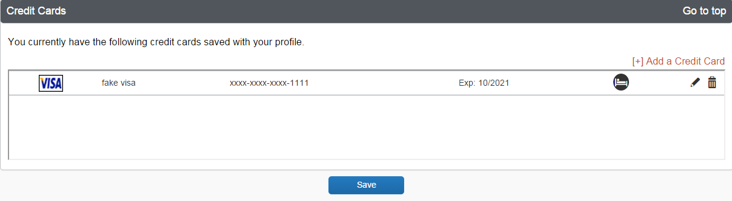

Once you have completed the entire profile, click any of the visible “Save” buttons. That will prompt the entire profile to save you and will now be able to book travel. Click the “Travel” link in the top toolbar to return to the homepage.

If you have questions about completing the Concur Profile, please contact your department travel coordinator, or the DGS Statewide Travel Program, at (916) 376-3974 or by STP email (statewidetravelprogram@dgs.ca.gov).

