INITIAL EXPRESS TERMS
FOR PROPOSED BUILDING STANDARDS
OF THE CALIFORNIA DEPARTMENT OF HOUSING AND COMMUNITY DEVELOPMENT
REGARDING THE 2025 CALIFORNIA GREEN BUILDING STANDARDS CODE,
CALIFORNIA CODE OF REGULATIONS, TITLE 24, PART 11
(HCD 04/24)
The State agency shall draft the regulations in plain, straightforward language, avoiding technical terms as much as possible and using a coherent and easily readable style. The agency shall draft the regulation in plain English. A notation shall follow the express terms of each regulation listing the specific statutes authorizing the adoption and listing specific statutes being implemented, interpreted, or made specific (Government Code Section 11346.2(a)(1)).
If using assistive technology, please adjust your settings to recognize underline, strikeout, italic and ellipsis.

LEGEND for EXPRESS TERMS
- Existing California amendments appear upright
- Amended or new California amendments appear underlined
- Repealed California language appears upright and in strikeout
- Ellipsis (...) indicate existing text remains unchanged

INITIAL EXPRESS TERMS
The California Department of Housing and Community Development (HCD) proposes to adopt mandatory and voluntary green building standards for occupancies within its authority, and further proposes to make amendments and clarifications to the 2025 California Green Building Standards Code, California Code of Regulations, Title 24, Part 11 (CALGreen).

ITEM 1
Chapter 2 Definitions
HCD proposes to continue adoption of this section with the following amendment:
SECTION 202
DEFINITIONS
Residential Long-Term Bicycle Parking. [HCD] A secure locker, protected enclosure or storage room that provides bicycle parking for more than twelve hours that allows individual locking of bicycles to a permanently anchored parking device or rack.
Residential Short-Term Bicycle Parking. [HCD] A permanently anchored bicycle parking device, rack or lockers, in an unsheltered, open area, that provides bicycle parking for twelve hours or less that allows individual locking of bicycles to the parking device or rack.
Notation:
Authority: Health and Safety Code Sections 17040, 17921, 17928, 18938.3, 18941.10, 18941.11, 19984, 19990; and Government Code Sections 12955, 12955.1 and 12955.1.1.
References: Health and Safety Code Sections 17040, 17042, 17921, 17928, 17958.12, 18938.3, 18941.5, 18944.19, 19990 and 19984; Government Code Sections 12955, 12955.1.

ITEM 2
Chapter 4 Residential Mandatory Measures, Section 4.106.4.2.2 Multifamily dwellings, hotels and motels.
HCD proposes to continue adoption of the referenced section with amendments as follows:
4.106.4.2.2 Multifamily dwellings, hotels and motels.
- EV Ready Parking Spaces with Receptacles.
  - Hotels and Motels. Forty (40) percent of the total number of parking spaces shall be equipped with low power Level 2 EV charging receptacles.
b. a. Multifamily Parking Facilities with Assigned Parking. Forty (40) percent of the total number of parking spaces shall be equipped with low power Level 2 EV charging receptacles. EV charging receptacles required by this section shall be located in at least one assigned parking space per dwelling unit where assigned parking is provided but need not exceed forty (40) percent of the total number of assigned parking spaces provided on the site. Where dwelling units are provided with assigned parking spaces equal to or greater than the number of dwelling units, at least one low power Level 2 EV charging receptacle shall be provided at an assigned parking space for each dwelling unit.
1. Where the total number of dwelling units exceeds the number of assigned parking spaces, all assigned parking spaces shall be provided with one low power Level 2 EV charging receptacle.
Exception: Areas of parking facilities served by parking lifts, including but not limited to, automated mechanical-access open parking garages as defined in the California Building Code; or parking facilities otherwise incapable of supporting electric vehicle charging.
b. Multifamily Parking Facilities with Unassigned Parking. Where dwelling units are provided with unassigned parking spaces equal to or greater than the number of dwelling units, at least one low power Level 2 EV charging receptacle shall be provided at an unassigned parking space for each dwelling unit.
1. Where the total number of dwelling units exceeds the number of unassigned parking spaces, all unassigned parking spaces shall be provided with one low power Level 2 EV charging receptacle.
Exception: Areas of parking facilities served by parking lifts, including but not limited to, automated mechanical-access open parking garages as defined in the California Building Code; or parking facilities otherwise incapable of supporting electric vehicle charging.
c. Multifamily Parking Facilities with Assigned and Unassigned Parking. Where multifamily buildings are provided with both assigned and unassigned parking spaces equal to or greater than the number of dwelling units, at least one low power Level 2 EV charging receptacle shall be provided for each dwelling unit at either the assigned or unassigned parking space, but not both.
c. d. Receptacle Power Source. EV charging receptacles in multifamily parking facilities at assigned parking spaces shall be provided with a dedicated branch circuit connected to the dwelling unit’s electrical panel, unless determined as infeasible by the project builder or designer and subject to concurrence of the local enforcing agency.
Exception: Areas of parking facilities served by parking lifts, including but not limited to automated mechanical-access open parking garages as defined in the California Building Code; or parking facilities otherwise incapable of supporting electric vehicle charging.
d. e. Receptacle Configurations. 208/240V EV charging receptacles shall comply with one of the following configurations:
    - For 20- ampere receptacles, NEMA 6-20R
    - For 30- ampere receptacles, NEMA 14-30R
    - For 50- ampere receptacles, NEMA 14-50R
- EV Ready Parking Spaces with EV Chargers.
  - Hotels and Motels. Ten (10) percent of the total number of parking spaces shall be equipped with Level 2 EV chargers. At least fifty (50) percent of the required EV chargers shall be equipped with J1772 connectors.
- b. Multifamily Parking Facilities with Unassigned or Common Use Parking. Ten (10) percent of the total number of parking spaces shall be equipped with Level 2 EV chargers. At least fifty (50) percent of the required EV chargers shall be equipped with J1772 connectors. Where common use parking or unassigned parking is provided, EV chargers shall be located in common use or unassigned parking areas and shall be available for use by all residents or guests. In addition to the low power Level 2 EV charging receptacle requirements of section 4.106.4.2.2 (1), twenty-five (25) percent of unassigned or common use parking spaces shall be equipped with Level 2 EV chargers and shall be made available for use by all residents or guests.
Where low power Level 2 EV charging receptacles or Level 2 EV chargers are installed beyond the minimum required, an automatic load management system (ALMS) may be used to reduce the maximum required electrical capacity to each space served by the ALMS. The electrical system and any on-site distribution transformers shall have sufficient capacity to deliver at least 3.3 kW simultaneously to each EV charging station (EVCS) served by the ALMS. The branch circuit shall have a minimum capacity of 40 amperes, and installed EV chargers shall have a capacity of not less than 30 amperes.
- EV Charger Connectors. EV chargers shall be equipped with J1772 or J3400 connectors.
- An automatic load management system (ALMS) may be used to reduce the maximum required electrical capacity to each space served by the ALMS. The electrical system and any on-site distribution transformers shall have sufficient capacity to deliver at least 3.3 kW simultaneously to each EV charging station (EVCS) served by the ALMS. The branch circuit shall have a minimum capacity of 40 amperes, and installed EV chargers shall have a capacity of not less than 30 amperes.
Notation:
Authority: Health and Safety Code Sections 17040, 17921, 17928, 18938.3, 18941.10, 18941.11, 19984, 19990; and Government Code Sections 12955, 12955.1 and 12955.1.1.
References: Health and Safety Code Sections 17040, 17042, 17921, 17928, 17958.12, 18938.3, 18941.5, 19990 and 19984; Government Code Sections 12955, 12955.1; and Vehicle Code Section 22511.2.

ITEM 3
Chapter 4 Residential Mandatory Measures, Section 4.106.4.2.6 Hotels and motels.
HCD proposes to adopt the above referenced section as follows:
4.106.4.2.6 Hotels and motels.
- EV Ready Parking Spaces with Receptacles.
- Hotels and Motels. Forty (40) percent of the total number of parking spaces shall be equipped with low power Level 2 EV charging receptacles.
Exception: Areas of parking facilities served by parking lifts, including but not limited to automated mechanical-access open parking garages as defined in the California Building Code; or parking facilities otherwise incapable of supporting electric vehicle charging.
- Receptacle Configurations. 208/240V EV charging receptacles shall comply with one of the following configurations:
    - For 20- ampere receptacles, NEMA 6-20R
    - For 30- ampere receptacles, NEMA 14-30R
    - For 50- ampere receptacles, NEMA 14-50R
- EV Ready Parking Spaces with EV Chargers.
  - Hotels and Motels. Twenty-five (25) percent of the total number of parking spaces shall be equipped with Level 2 EV chargers.
  - EV Charger Connectors. EV chargers shall be equipped with J1772 or J3400 connectors.
Exception: Areas of parking facilities served by parking lifts, including but not limited to automated mechanical-access open parking garages as defined in the California Building Code; or parking facilities otherwise incapable of supporting electric vehicle charging.
  - An automatic load management system (ALMS) may be used to reduce the maximum required electrical capacity to each space served by the ALMS. The electrical system and any on-site distribution transformers shall have sufficient capacity to deliver at least 3.3 kW simultaneously to each EV charging station (EVCS) served by the ALMS. The branch circuit shall have a minimum capacity of 40 amperes, and installed EV chargers shall have a capacity of not less than 30 amperes.
Notation:
Authority: Health and Safety Code Sections 17040, 17921, 17928, 18938.3, 18941.10, 18941.11, 19984, 19990; and Government Code Sections 12955, 12955.1 and 12955.1.1.
References: Health and Safety Code Sections 17040, 17042, 17921, 17928, 17958.12, 18938.3, 18941.5, 19990 and 19984; Government Code Sections 12955, 12955.1; and Vehicle Code Section 22511.2.

ITEM 4
Chapter 4 Residential Mandatory Measures, Section 4.106.4.3 Electric vehicle charging for additions and alterations of parking facilities serving existing multifamily buildings.
HCD proposes to adopt the above referenced section with the following amendment:
4.106.4.3 Electric vehicle charging for additions and alterations of parking facilities serving existing multifamily buildings, hotels, and motels.
Where new parking facilities are added, or electrical systems or lighting of existing parking facilities are added or altered and the work requires a building permit, ten (10) percent of the total number of parking spaces added or altered shall be electric vehicle charging spaces (EV capable spaces) capable of supporting to support future Level 2 EVSE electric vehicle supply equipment. The service panel or subpanel circuit directory shall identify the overcurrent protective device space(s) reserved for future EV charging purposes as “EV CAPABLE.” When existing parking facilities are altered or new parking spaces are added to existing parking facilities, and the work requires a building permit, each parking space added or altered shall have access to either a low power Level 2 EV charging receptacle or Level 2 EV charger, unless determined as infeasible by the project builder or designer and subject to concurrence of the local enforcing agency.
Notes:
- Construction documents are intended to demonstrate the project’s capability and capacity for facilitating future EV charging.
- There is no requirement for EV spaces to be constructed or available until EV chargers are installed for use.
Exception: Where minor work requiring a permit is being performed such as installation of a single 120-volt electrical receptacle for level 1 EV charging with a permit valuation of one thousand dollars ($1000) or less, level 2 EV charging is not required to be installed.
Notation:
Authority: Health and Safety Code Sections 17040, 17921, 17928, 18938.3, 18941.10, 18941.11, 19984, 19990; and Government Code Sections 12955, 12955.1 and 12955.1.1.
References: Health and Safety Code Sections 17040, 17042, 17921, 17928, 17958.12, 18938.3, 18941.5, 19990 and 19984; Government Code Sections 12955, 12955.1; and Vehicle Code Section 22511.2.

ITEM 5
Chapter 4 Residential Mandatory Measures, Section 4.106.4.4 Bicycle parking. HCD proposes to relocate and amend existing requirements from Appendix A4.106.9 into a new section 4.106.4.4:
4.106.4.4. Bicycle parking. Comply with sections 4.106.4.4.1 through 4.106.4.4.3.
4.106.4.4.1 Short-term bicycle parking for multifamily buildings, hotels and motels. Provide on-site bicycle parking at a ratio of one parking space for every 10,000 square feet, but not less than two spaces. Short-term bicycle parking shall be located within 200 feet of building entrances, and readily visible to passers-by. Acceptable parking facilities shall be conveniently accessed from the street and may include, but not be limited to:
- Permanently anchored bicycle parking devices, racks, or lockers in an unsheltered, open area.
- Covered or uncovered enclosures with permanently anchored bicycle parking devices or racks.
4.106.4.4.2 Long-term bicycle parking for multifamily buildings. Provide on-site bicycle parking at a ratio of one parking space for every two dwelling units. Acceptable parking facilities shall be conveniently accessed from the street and may include, but not be limited to:
- Covered, lockable enclosures with permanently anchored bicycle parking devices or racks.
- Lockable bicycle storage rooms with permanently anchored bicycle parking devices or racks.
- Lockable, weatherproof, permanently anchored bicycle lockers.
4.106.4.4.3 Long-term bicycle parking for hotel and motel buildings. Provide one on-site long-term bicycle parking space for every 25,000 square feet, but not less than two. Acceptable parking facilities shall be conveniently accessed from the street and may include, but not be limited to:
- Covered, lockable enclosures with permanently anchored bicycle parking devices or racks.
- Lockable bicycle storage rooms with permanently anchored bicycle parking devices or racks.
- Lockable, weatherproof, permanently anchored bicycle lockers.
Notation:
Authority: Health and Safety Code Sections 17040, 17921, 17928, 18938.3, 18941.10, 18941.11, 19984, 19990; and Government Code Sections 12955, 12955.1 and 12955.1.1.
References: Health and Safety Code Sections 17040, 17042, 17921, 17928, 17958.12, 18938.3, 18941.5, 18944.19, 19990 and 19984; Government Code Sections 12955, 12955.1.

ITEM 6
Chapter 4 Residential Mandatory Measures, Section 4.303.1.4.5 Pre-rinse spray valves.
HCD proposes to adopt the above referenced section with the following amendment:
4.303.1.4.5 Pre-rinse spray valves. When installed, Commercial Pre-Rinse Spray Valves shall meet the requirements in the California Plumbing Code, Section 420.3. California Code of Regulations, Title 20 (Appliance Efficiency Regulations), Section 1605(h)(4) Table H-2, Section 1605.3(h)(4)(A), and Section 1607(d)(7), and shall be equipped with an integral automatic shutoff.
FOR REFERENCE ONLY: The following table and code section have been reprinted from the California Code of Regulations, Title 20 (Appliance Efficiency Regulations), Section 1605.1(h)(4) and Section 1605.3(h)(4)(A).
TABLE H-2
STANDARDS FOR COMMERCIAL PRE-RINSE SPRAY VALVES MANUFACTURED ON OR AFTER JANUARY 28, 2019.

Product Class  [spray force in ounce force (ozf)] | Maximum Flow Rate  (gpm)
Product Class 1 (≤ 5.0 ozf) | 1.00
Product Class 2 (> 5.0 ozf and ≤ 8.0 ozf) | 1.20
Product Class 3 (> 8.0 ozf) | 1.28
Title 20 Section 1605.3(h)(4)(A): Commercial pre-rinse spray valves manufactured on or after January 1, 2006, shall have a minimum spray force of not less than 4.0 ounces-force (ozf) [113 grams-force (gf)].
Authority: Health and Safety Code Sections 17040, 17921, 17928, 18938.3, 18941.10, 18941.11, 19984, 19990; and Government Code Sections 12955, 12955.1 and 12955.1.1.
References: Health and Safety Code Sections 17040, 17042, 17921, 17928, 17958.12, 18938.3, 18941.5, 18944.19, 19990 and 19984; Government Code Sections 12955, 12955.1.

ITEM 7
Appendix A4 Residential Voluntary Measures, Section A4.106.8.2 New multifamily dwellings, hotels and motels.
HCD continues to adopt the above referenced section with the following amendment:
A4.106.8.2 New multifamily dwellings, hotels and motels. New multifamily dwellings, hotels and motels shall meet the following requirements.
Tier 1. New multifamily dwellings, hotels and motels. Tier 1 consists of Option A and Option B. One or both may be adopted as voluntary measures.
Option A for New multifamily dwellings, hotels and motels.
- EV Ready Parking Spaces with Receptacles.
  - Hotels and Motels. Fifty (50) Sixty (60) percent of the total number of parking spaces shall be equipped with low power Level 2 EV charging receptacles.
  - Multifamily Parking Facilities. Fifty (50) percent of the total number of parking spaces shall be equipped with low power Level 2 EV charging receptacles. EV charging receptacles required by this section shall be located in at least one assigned parking space per dwelling unit where assigned parking is provided but need not exceed fifty (50) percent of the total number of assigned parking spaces provided on the site. Raceway Capacity Requirements. To allow for future upgrades to the electrical conductors serving low power Level 2 EV charging receptacles, the listed raceway serving such receptacles shall be sized to allow the installation of a dedicated 208/240-volt 40-ampere branch circuit. Where no raceway is used, the conductors shall be sized to accommodate a 208/240-volt 40-ampere receptacle.
Exceptions:
    - Areas of parking facilities served by parking lifts, including but not limited to automated mechanical-access open parking garages as defined in the California Building Code; or parking facilities otherwise incapable of supporting electric vehicle charging.
2. 1. Hotels and motels may substitute Level 2 EV chargers for some or all of the required EV charging receptacles. Where Level 2 EV chargers are installed in place of low power Level 2 receptacles, at least fifty (50) percent of the installed EV chargers shall be equipped with J1772 connectors.
- EV Ready Parking Spaces with EV Chargers.
  - Hotels and Motels. Fifteen (15) Forty (40) percent of the total number of parking spaces for hotels and motels shall be equipped with Level 2 EV chargers. At least fifty (50) percent of the required EV chargers shall be equipped with J1772 connectors.
  - Multifamily Parking Facilities with Unassigned or Common Use Parking. Fifteen (15) percent of the total number of parking spaces shall be equipped with Level 2 EV chargers. At least fifty (50) percent of the required EV chargers shall be equipped with J1772 connectors. Where common use parking or unassigned parking is provided, EV chargers shall be located in common use or unassigned parking areas and shall be available for use by all residents or guests. In addition to the low power Level 2 EV charging receptacle requirements of Section A4.106.8 (Tier 1, subsection 1), forty (40) percent of the total number of parking spaces shall be equipped with Level 2 EV chargers and shall be made available for use by all residents or guests.
Exception: Areas of parking facilities served by parking lifts, including but not limited to automated mechanical-access open parking garages as defined in the California Building Code; or parking facilities otherwise incapable of supporting electric vehicle charging.
An automatic load management system (ALMS) may be used to reduce the maximum required electrical capacity to each space served by the ALMS. The electrical system and any on-site distribution transformers shall have sufficient capacity to deliver at least 3.3 kW simultaneously to each EV charging station (EVCS) served by the ALMS. The branch circuit shall have a minimum capacity of 40 amperes, and installed EV chargers shall have a capacity of not less than 30 amperes.
Option B Multifamily dwellings.
- EV Ready Parking Spaces with Receptacles. For multifamily parking facilities, install low power Level 2 EV charging receptacles in at least one parking space for each dwelling unit with assigned parking.
Exceptions:
  - Areas of parking facilities served by parking lifts, including but not limited to automated mechanical-access open parking garages as defined in the California Building Code; or parking facilities otherwise incapable of supporting electric vehicle charging.
  - Where the number of parking spaces available for residents is less than the total number of dwelling units.
- EV Ready Parking Spaces with EV Chargers. Ten (10) percent, but not less than one, of common use parking spaces shall be equipped with Level 2
EV chargers for use by all residents or guests. At least fifty (50) percent of the required EV chargers shall be equipped with J1772 connectors.
Exceptions:
  - Areas of parking facilities served by parking lifts, including but not limited to automated mechanical-access open parking garages as defined in the California Building Code; or parking facilities otherwise incapable of supporting electric vehicle charging.
  - Where no common use parking spaces are provided.
An automatic load management system (ALMS) may be used to reduce the maximum required electrical capacity to each space served by the ALMS. The electrical system and any on-site distribution transformers shall have sufficient capacity to deliver at least 3.3 kW simultaneously to each EV charging station (EVCS) served by the ALMS. The branch circuit shall have a minimum capacity of 40 amperes, and installed EV chargers shall have a capacity of not less than 30 amperes.
Tier 2. Tier 2 consists of Option A and Option B. One or both may be adopted as voluntary measures.
Option A for New multifamily dwellings, hotels and motels.
- EV Ready Parking Spaces with Receptacles.
  - Hotels and Motels. Fifty-five (55) percent of the total number of parking spaces shall be equipped with low power Level 2 EV charging receptacles.
  - Multifamily Parking Facilities. Fifty-five (55) percent of the total number of parking spaces shall be equipped with low power Level 2 EV charging receptacles. EV charging receptacles required by this section shall be located in at least one assigned parking space per dwelling unit where assigned parking is provided but need not exceed fifty-five (55) percent of the total number of assigned parking spaces provided on the site.
Exceptions:
    - Areas of parking facilities served by parking lifts, including but not limited to automated mechanical-access open parking garages as defined in the California Building Code; or parking facilities otherwise incapable of supporting electric vehicle charging.
    - Hotels and motels may install Level 2 EV chargers instead of all or portions of the required percentage of low power Level 2 receptacles for EV charging. Where Level 2 EV chargers are installed in place of low power Level 2 receptacles, at least fifty (50) percent of the installed EV chargers shall be equipped with J1772 connectors.
- EV Ready Parking Spaces with EV Chargers.
  - Hotels and Motels. Twenty (20) percent of the total number of parking spaces for hotels and motels shall be equipped with Level 2 EV chargers. At least fifty (50) percent of the required EV chargers shall be equipped with J1772 connectors.
  - Multifamily Parking Facilities. Twenty (20) percent of the total number of parking spaces shall be equipped with Level 2 EV chargers. At least fifty (50) percent of the required EV chargers shall be equipped with J1772 connectors. Where common use parking or unassigned parking is provided, EV chargers shall be located in the common use or unassigned parking areas and shall be available for use by all residents or guests.
Exceptions:
- Areas of parking facilities served by parking lifts, including but not limited to automated mechanical-access open parking garages as defined in the California Building Code; or parking facilities otherwise incapable of supporting electric vehicle charging.
- Where no common use parking spaces are provided.
An automatic load management system (ALMS) may be used to reduce the maximum required electrical capacity to each space served by the ALMS. The electrical system and any on-site distribution transformers shall have sufficient capacity to deliver at least 3.3 kW simultaneously to each EV charging station (EVCS) served by the ALMS. The branch circuit shall have a minimum capacity of 40 amperes, and installed EV chargers shall have a capacity of not less than 30 amperes.
Option B Multifamily Developments.
- EV Ready Parking Spaces with Receptacles. Install one low power Level 2 EV charging receptacle for each parking space available for use by residents.
Exception: Areas of parking facilities served by parking lifts, including but not limited to automated mechanical-access open parking garages as defined in the California Building Code; or parking facilities otherwise incapable of supporting electric vehicle charging.
- EV Ready Parking Spaces with EV Chargers. Twenty (20) percent of parking available for nonresidents or guests shall be equipped with Level 2 EV chargers. At least fifty (50) percent of the required EV chargers shall be equipped with J1772 connectors. Where common use parking is provided, EV chargers shall be located in the common use parking area and shall be available for use by all residents or guests.
Exceptions:
  - Areas of parking facilities served by parking lifts, including but not limited to automated mechanical-access open parking garages as defined in the California Building Code; or parking facilities otherwise incapable of supporting electric vehicle charging.
  - Where no common use parking spaces are provided.
An automatic load management system (ALMS) may be used to reduce the maximum required electrical capacity to each space served by the ALMS. The electrical system and any on-site distribution transformers shall have sufficient capacity to deliver at least 3.3 kW simultaneously to each EV charging station (EVCS) served by the ALMS. The branch circuit shall have a minimum capacity of 40 amperes, and installed EV chargers shall have a capacity of not less than 30 amperes.
Notation:
Authority: Health and Safety Code Sections 17040, 17921, 17928, 18938.3, 18941.10, 18941.11, 19984, 19990; and Government Code Sections 12955, 12955.1 and 12955.1.1.
References: Health and Safety Code Sections 17040, 17042, 17921, 17928, 17958.12, 18938.3, 18941.5, 19990 and 19984; Government Code Sections 12955, 12955.1; and Vehicle Code Section 22511.2.

ITEM 8
Appendix A4 Residential Voluntary Measures, Section A4.106.9 Bicycle parking. HCD proposes to repeal the above referenced section:
A4.106.9 Bicycle parking.
Comply with Sections A4.106.9.1 through A4.106.9.3 or meet a local ordinance, whichever is more stringent.
Exception: Number of bicycle parking spaces shall be permitted to be reduced, as approved by the enforcing agency, due to building site characteristics, including but not limited to, isolation from other development.
A4.106.9.1 Short-term bicycle parking. Provide permanently anchored bicycle racks within 100 feet of the visitor’s entrance, readily visible to passers-by, for 5 percent of visitor motorized vehicle parking capacity with a minimum of one two-bike capacity rack.
A4.106.9.2 Long-term bicycle parking for multifamily buildings. Provide on-site bicycle parking for at least one bicycle per every two dwelling units. Acceptable parking facilities shall be conveniently reached from the street and may include, but not be limited to:
- Covered, lockable enclosures with permanently anchored racks for bicycles.
- Lockable bicycle rooms with permanently anchored racks.
- Lockable, permanently anchored bicycle lockers.
A4.106.9.3 Long-term bicycle parking for hotel and motel buildings. Provide one on-site bicycle parking space for every 25,000 square feet, but not less than two. Acceptable parking facilities shall be conveniently reached from the street and may include, but not be limited to:
- Covered, lockable enclosures with permanently anchored racks for bicycles.
- Lockable bicycle rooms with permanently anchored racks.
- Lockable, permanently anchored bicycle lockers.
Notation:
Authority: Health and Safety Code Sections 17040, 17921, 17928, 18938.3, 18941.10, 18941.11, 19984, 19990; and Government Code Sections 12955, 12955.1 and 12955.1.1.
References: Health and Safety Code Sections 17040, 17042, 17921, 17928, 17958.12, 18938.3, 18941.5, 18944.19, 19990 and 19984; Government Code Sections 12955, 12955.1.

ITEM 9
Appendix A4 Residential Voluntary Measures, Section A4.602 Residential Occupancies Application Checklist. HCD proposes to continue adoption of the above referenced section with amendments as follows:
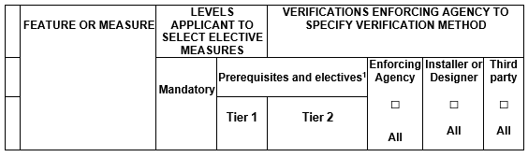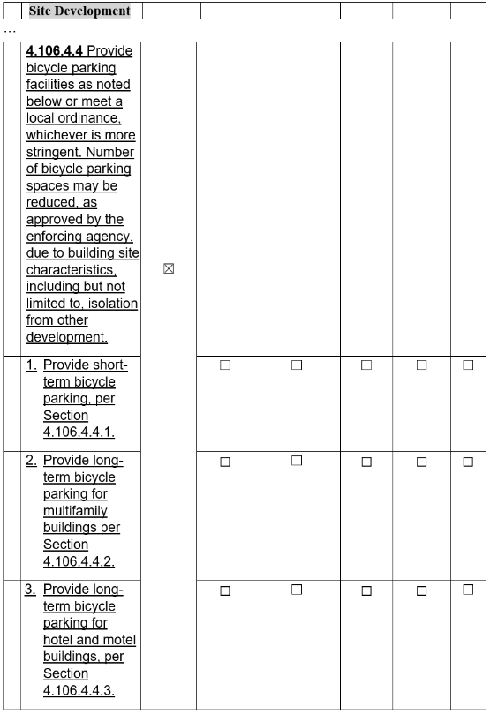
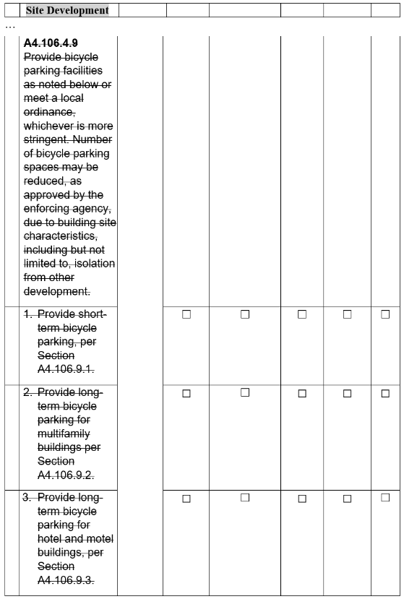
Notation:
Authority: Health and Safety Code Sections 17040, 17921, 17928, 18938.3, 18941.10, 18941.11, 19984, 19990; and Government Code Sections 12955, 12955.1 and 12955.1.1.
References: Health and Safety Code Sections 17040, 17042, 17921, 17928, 17958.12, 18938.3, 18941.5, 18944.19, 19990 and 19984; Government Code Sections 12955, 12955.1; and Vehicle Code Section 22511.2.

